Unit 7 Handouts
Physics 200 (Stapleton ) Name: ___________________________
Chapter 8: Momentum/Impulse/Collisions

Notes - 8.1 Linear Momentum and Force

1. Write the symbol and equation for momentum.

2. Why is the symbol for momentum a lowercase p?

3. What are the units for momentum?

4. Calculate the momentum of a 110-kg football player running at 8.00 m/s.

Notes - 8.2 Impulse

5. Use Newton’s 2nd Law and the basic acceleration formula to write an equation for ∆p in terms of Force and time.

6. F_{net} Δt (more commonly written as Ft) is called ________________.

7. Impulse is equivalent to a change in ______________________.

8. Imagine a ball falling to the floor and then bouncing upward to a height of 40cm. Now imagine someone throwing the same ball upward a height of 40cm. In which case is a greater impulse applied to the ball? Why?

9. The effect of a force on an object depends on the force’s _____________________ and __________________. A very large force acting for a short time will have a great effect on the momentum of a tennis ball. A small force could cause the same change in momentum, but it would have to act for a ________________________. Quantitatively, the effect we are talking about is the change in __________________.

10. Use the impulse formula to show how the same change in momentum can be accomplished by a variety of forces and times.

11. Example Problem: Suppose a 60kg human is falling from the sky at a rate of 20m/s. If the human is brought to a stop by hitting the bare ground, the average force applied to the person during impact is 24,000N. What is the duration over which the impact force is applied?

12. Name a few ways in which an understanding of impulse can save lives:

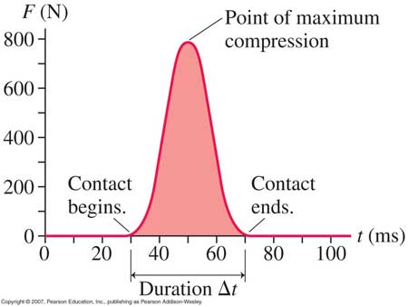
13. What does the area under a force-time graph represent? Can you guess what was being graphed here?

Notes - 8.3 Conservation of Momentum

14. For mechanical purposes, an isolated system is defined to be one in which the net force acting on the system = _____.
15. For an entire isolated system, since F_{net} Δt = Δp, when F_{net} = 0 then
Δ p_{Tot} = __________ (i.e. the total momentum is constant).
15.5. Use Newton’s 3rd Law to prove that momentum is conserved during any collision.

16. Conservation of momentum formula for 2 objects (does not apply if the system is not closed! In that case, an outside force adds or removes momentum to or from the total.)

17. Example Problem: A 3kg object has a velocity of 2m/s before it crashes into a second object that has been traveling with a velocity of -5m/s. After the collision, the 3kg object has a velocity of 1m/s, and the other object has a velocity of 2m/s. What is the mass of the second object?

Notes - 8.4 & 8.5 Elastic and Inelastic Collisions

18. How are elastic and inelastic collisions defined?

19. When a collision is inelastic (not elastic), where does the “lost” kinetic energy go?

20. Give some examples of nearly elastic collisions between macroscopic objects.

21. When collisions are perfectly elastic, both momentum and KE are conserved, so one can use a system of 2 equations to find two unknowns when two objects collide (e.g. when objects with known masses, and initial velocities collide, we can find both final velocities). One equation comes from conservation of momentum. The other comes from conservation of KE. However, the math can get ugly. A simpler alternative is to solve this type of problem using the coefficient of restitution…

Coefficient of Restitution: a number from zero to one that tells how elastic a collision is; a ratio of the separation speed of objects after a collision to their approach (or “closing”) speed before the collision.

Coefficient of Restitution = 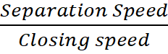
When e =1…
- objects separate as fast as they came together
- collision is perfectly elastic.
- No kinetic energy is lost.
- Example: A perfectly bouncy ball approaches the ground at 2m/s (closing speed) and then bounces back up with a speed of 2m/s (separation speed). e = 2/2 = 1

When e=0…
- objects do not separate
- the collision is perfectly inelastic.
- Kinetic energy is lost to friction.
- Example: a bullet approaches a ballistic pendulum at 500m/s (closing speed) and the bullet and pendulum then swing upward together (separation speed = 0; no separation). e =0/2

When 1>e>0, objects separate, but not as fast as they came together. Some energy is lost to friction.

Coefficient of Restitution Formula = 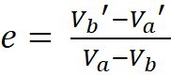 …where Va = initial velocity of object A, Vb = initial velocity of object B, and Va’ and Vb’ = their final velocities.

When e=1, 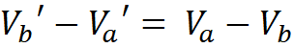

22. Example Problem: Cart A has a mass of 4kg and an initial velocity of -2m/s. Cart B has a mass of 3kg and an initial velocity of 0m/s. If the carts collide with perfect elasticity (e=1), what are the carts’ velocities after the collision?

Ballistic Pendulums

Consider the system below, which includes a ballistic pendulum (target/box) and a projectile (circle). Assume that the string supports of the pendulum have negligible friction, that air resistance is also negligible, and that the projectile does not drop significantly before it hits the pendulum…
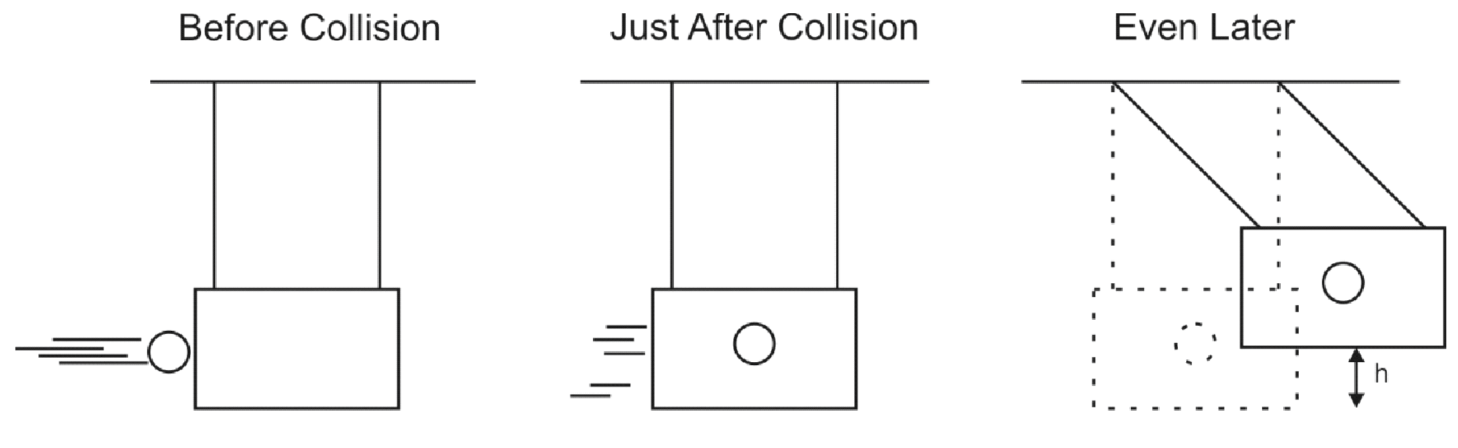
…when is momentum conserved? How do we know?

…when is momentum not conserved? How do we know?

…when is energy conserved? How do we know?

…when is energy not conserved? How do we know?
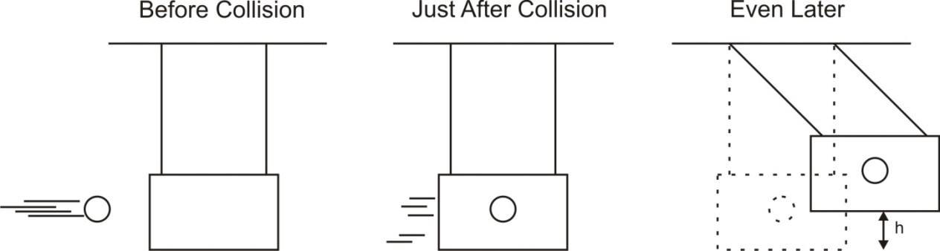

 | Launch 1 | Launch 2 | Your Launch
Projectile Mass (kg) | 0.01 | 0.5
Pendulum Mass (kg) | 1 | 0.02
Swing Height, “h” (m) | 0.5 | 0.4
Projectile Initial Velocity (m/s)

As a class, answers the following questions using “launch 1” data. Complete the rest on your own.
1. What is the total potential energy of the ball and pendulum in the “even later” picture?

2. What was the total kinetic energy of the ball and pendulum in the “just after” picture?

3. What was the shared velocity of the ball and pendulum in the “just after” picture?

4. What was the net momentum of the ball and pendulum in the “just after” picture?

5. What was the momentum of the ball before the collision?

6. What was the velocity of the ball before the collision?

7. Is this an elastic or inelastic collision? How can you tell?

Momentum and Impulse problems

1. What is the magnitude of the momentum of a 28-g sparrow flying with a speed of 8.4 m/s?

2. A constant friction force of 25 N acts on a 65-kg skier for 20s. What is the skier’s change in velocity?

3. A 0.145-kg baseball pitched at 39.0 m/s is hit in a horizontal line drive straight back toward the pitcher at 52.0 m/s. If the contact time between bat and ball is 3.00x10⁻³s, calculate the average force between the ball and bat during contact.

4. Calculate the force of a rocket’s thrust, given that the propelling gases are expelled at a rate of 1500 kg/s with a speed of 4.00x10⁴m/s (at the moment of takeoff). The force on the gas can be found from its change in momentum.

5. A golf ball of mass 0.045 kg is hit off of a tee at a speed of The golf club was in contact with the ball for Find (a) the impulse imparted to the golf ball, and (b) the average force exerted on the ball by the golf club.

6. You are the design engineer in charge of the crashworthiness of new automobile models. Cars are tested by smashing them into fixed, massive barriers at (30 mph). A new model of mass 1500 kg takes 0.15 s from the time of impact until it is brought to rest. (a) Calculate the average force exerted on the car by the barrier. (b) Calculate the average deceleration of the car.

Conservation of Momentum – Basic Problems

7.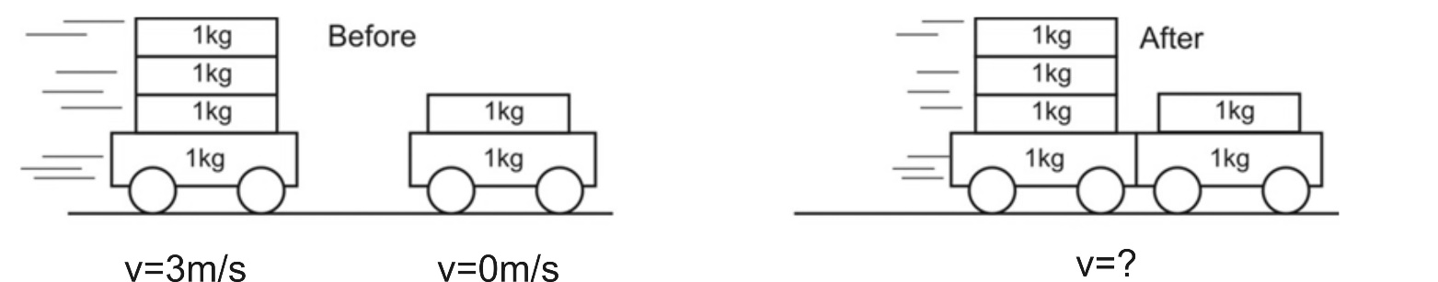

8.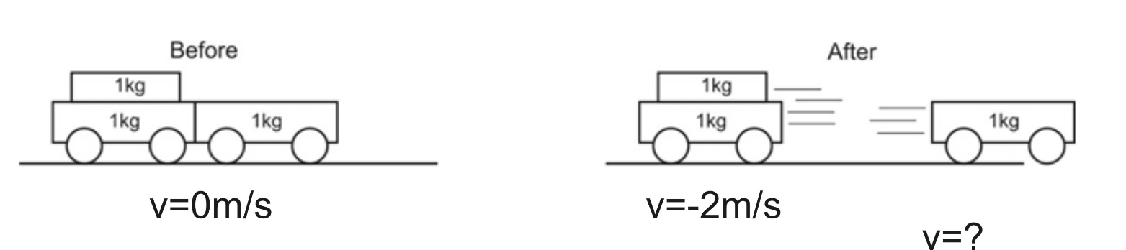

9. 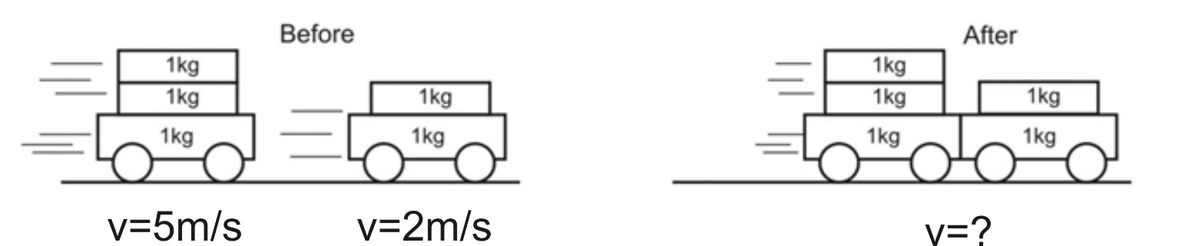

10. A child in a boat throws a 6.40 kg package out of the boat horizontally with a speed of 10.0 m/s. Calculate the velocity of the boat immediately after, assuming that it was initially at rest. The mass of the child is 26.0 kg, and that of the boat is 45.0 kg. Ignore water resistance.

11. A 12,600-kg railroad car travels alone on a level frictionless track with a constant speed of 18.0m/s. A 5350-kg load, initially at rest, is dropped onto the car. What will be the car’s new speed?

12. A 3800 kg open railroad car coasts along level tracks with a constant speed of 8.60 m/s. Snow begins to fall vertically and fills the car at a rate of 3.50 kg/min. Ignoring friction with tracks, what is the speed of the car after 90 min?

Elastic/Inelastic Collision Problems (Conservation of Momentum and, possibly Conservation of KE)
13. Boat A has a mass of 10kg and a velocity of 3m/s. Boat B has a mass of 15kg and a velocity of -1m/s. The two boats collide and bounce away from one another. The collision lasts for 0.1 second, and after the bounce, boat B has a velocity of 1.4m/s.

a. What is the velocity of boat A after the bounce?

b. What impulse is experienced by boat A during the collision?

c. What impact force is felt by boat A?

d. What impulse is experienced by boat B?

e. What impact force is felt by boat B?

f. What is the coefficient of restitution for this collision?

g. Is this collision elastic or inelastic? Explain.

14. A softball of mass 0.220 kg that is moving with a speed of collides head-on and with another ball initially at rest. The collision is perfectly elastic. Afterward the incoming softball bounces backward with a speed of Calculate (a) the velocity of the target ball after the collision, and (b) the mass of the target ball.

15. Two bumper cars in an amusement park ride collide with perfect elasticity as one approaches the other directly from the rear (Fig. 7–34). Car A has a mass of 450 kg and car B 550 kg, owing to differences in passenger mass. If the velocities of car A and Car B before the collision are 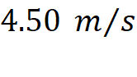 and 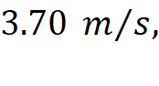 respectively, calculate their velocities after the collision.

Conceptual Questions
16. Use one of Newton’s Laws to prove that momentum must be conserved for ALL collisions, regardless of whether they are elastic or not.

17. A Superball is dropped from a height h onto a hard steel plate (fixed to the Earth), from which it rebounds at very nearly its original speed. (a) If the ball alone is considered to be “the system,” is the momentum of the ball conserved during any part of this process? If so, when is its momentum conserved? (b) If we consider the ball and Earth as our system, during what parts of the process is momentum conserved? Explain.

Ballistic Pendulum – Conservation of Momentum and Conservation of Mechanical Energy
18. A 0.2kg projectile is fired at a 1kg ballistic pendulum. After the projectile embeds in the target, the pendulum and projectile swing upward a height of 0.4m. What was the initial velocity of the projectile (just before it hit the pendulum)?

Answers:
1. 0.235kgm/s 2. 7.69m/s 3. 4,398N 4. 6.0 x 10⁷N 5. 2.025kgm/s, 579N 6. 139,000N, 93m/s²
7. 2m/ 8. 4m/s 9. 3.8m/s 10. -0.901m/s 11. 12.6m/s 12. 7.9m/s
13a. -0.6m/s 13b. -36kgm/s 13c. -360N 13d. 36kgm/s 13e. 360N 13f. 0.5
13g. Inelastic because KE is lost 14. 4.8m/s, 0.56kg 15. 3.62m/s 16. See solutions 17. See solutions 18. 16.8m/s
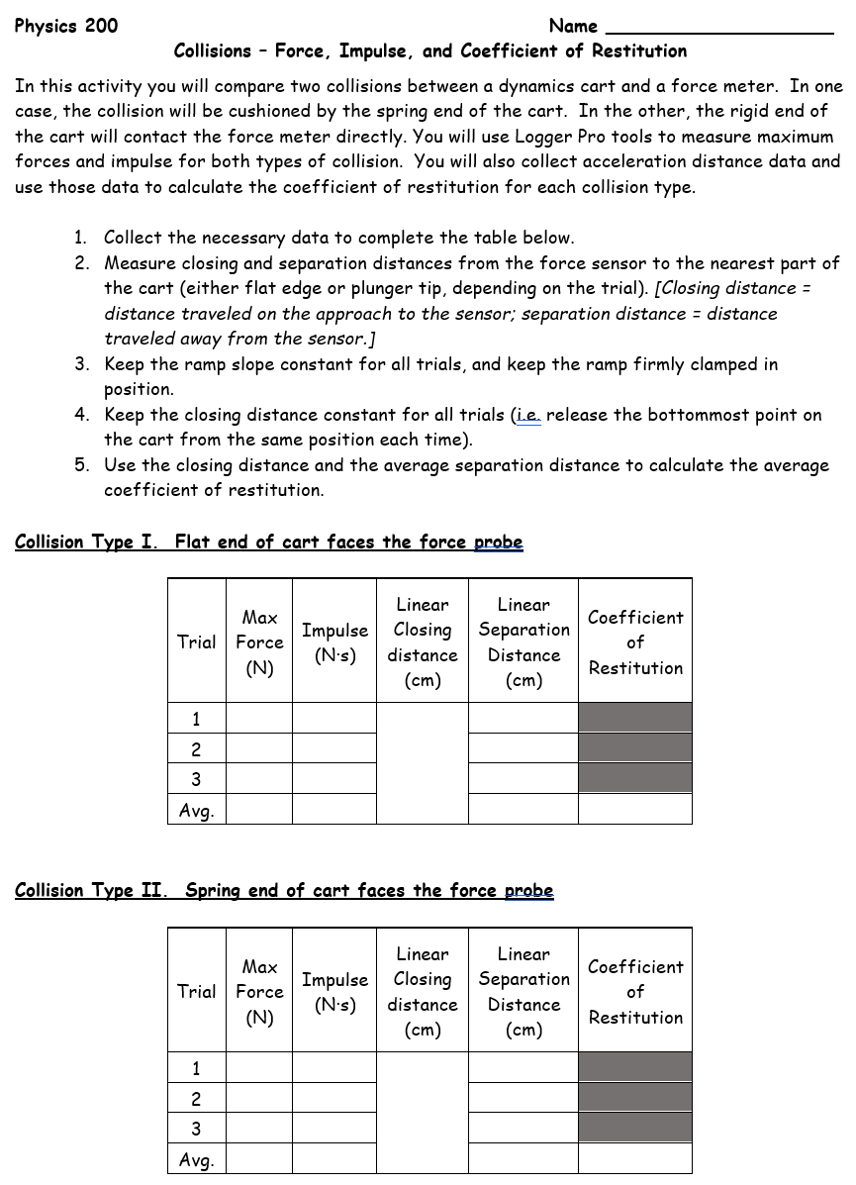 II Questions:
A. How do the maximum forces for each collision type compare? Why? Use the concept of impulse to explain the reason for the difference in maximum force.

B. How do the average impulses for the two collision types compare?

C. Do you think the relationship (from question B) that you observed between impulses in “springy” and “hard” collisions is correct? If so, explain why. If not, explain what the relationship should have been, and explain why.

D. Explain how and why the concepts of coefficient of restitution and impulse are closely related to one another in this activity.

E. If you decreased the slope of the ramp slightly, what effects would you expect to see on maximum force, impulse, and coefficient of restitution?

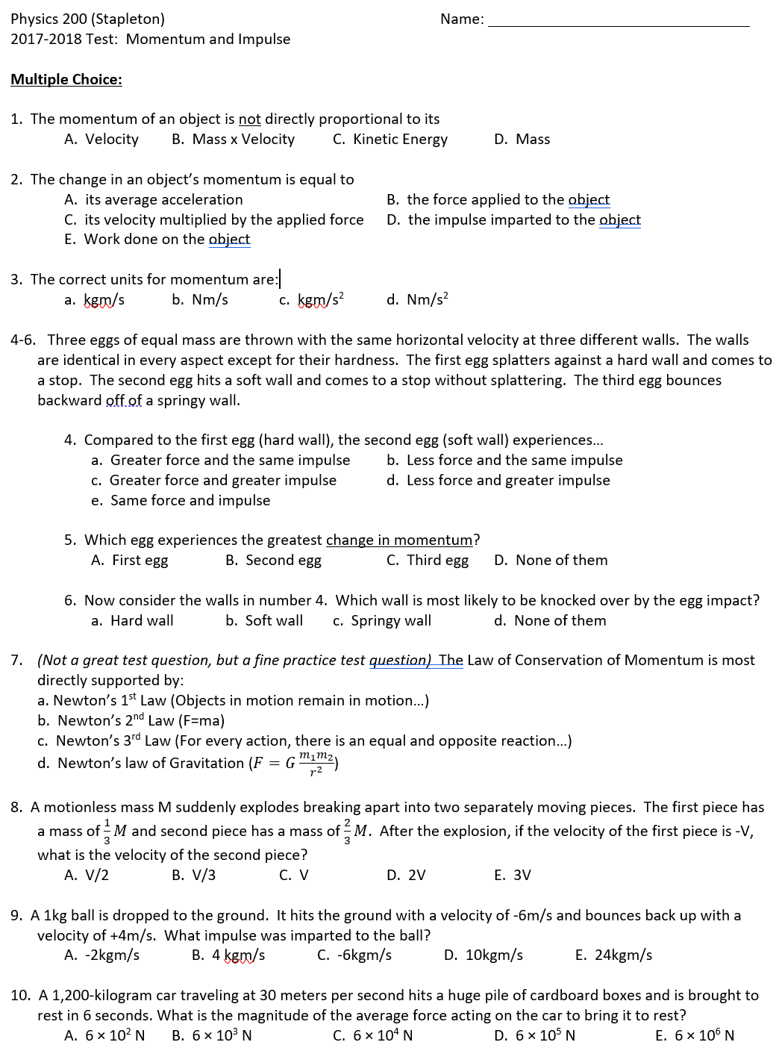
Physics 200 (Stapleton) Name: ________________________________
2020-21 Test Version: Momentum and Impulse

Short Answer:

1. Gigi the stunt cat is dropped from a height to the ground. Gigi can rotate herself, but she still has to deal with the force of impact. What can be done to lessen that force – without changing the height from which she is dropped?

a. (1 point) Suggest a strategy that can be employed to lessen Gigi’s force of impact. This could be something Gigi does, or something someone can do for Gigi.

b. (3 points) How does your strategy work?
- Describe what happens to Gigi’s momentum as she lands.
- Describe the relationship between impulse and momentum.
- Use the impulse formula to explain why your suggested strategy lessens the impact force.

2. a. Define a “system” of one or more objects (in other words, provide an example). Then describe a specific situation in which momentum would not be conserved in that system.

b. Explain why momentum is not conserved in that situation.

c. Explain how you can tell whether or not kinetic energy is conserved during a collision.

3. Two spheres of the same mass and radius are dropped from different heights onto a force plate that measures impact force and impact time. Sphere A is dropped from a height of 4m, and sphere B is dropped from a height of 3m.

a. True or false (circle one): It is possible that the two spheres will experience the same impact force.
b. Provide evidence to support your answer to part A.

c. True or false (circle one): It is possible that the two spheres will experience the same impulse.
d. Provide evidence to support your answer to part c.

Problems:

1. A 0.2kg rubber band car is traveling at a speed of 2m/s. After another 0.4 seconds, the speed of the car is 2.8m/s.

a. (2pts) What was the car’s initial momentum (when its speed was 2m/s)

b. (2pts) What average force caused the car to speed up from 2m/s to 2.8m/s?

2. A soccer player places a 0.4kg ball on the ground and kicks it at a speed of 24m/s. If the average force of the kick was 80N…

a. (2pts) What impulse was applied to the soccer ball?

b. (2pts) What was the duration of the impact?

3. (2pts) An 80kg football player leaps into the air to catch a football. Just before he touches the football, the player’s velocity is -0.8m/s, and the velocity of the 0.5kg football is +30m/s. Instead of being caught, the football bounces off of the player’s helmet with a velocity of -15m/s. What is the velocity of the football player after the collision?

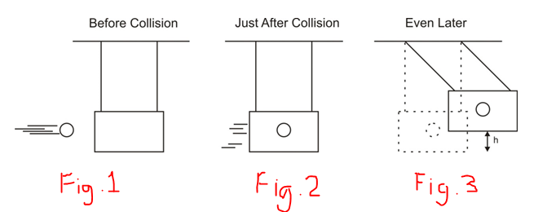4. (4points) A 0.15 kg projectile is fired into a 6kg ballistic pendulum. The projectile embeds in the pendulum and then the pendulum + projectile swing upward to a height (h) of 0.4m before stopping.

a. What is the shared velocity of the pendulum + the projectile just after impact, as they begin the swing (as in figure 2)?

b. What was the velocity of the projectile before it hit the pendulum (as in figure 1)?

5. (4pts) Sphere A is traveling with a velocity of 3m/s when it collides with sphere B, which is traveling with a velocity of -1m/s. After the collision, sphere A has a velocity of 1m/s. If sphere B has a mass of 2kg, and the collision has a coefficient of restitution of 0.5, what is the mass of sphere A, and what is the final velocity of sphere B?

Sphere A mass = _________ Sphere B final velocity = _________

