Physics 200 (Stapleton) Name: ________________________________
2017-2018 Test: Momentum and Impulse

Multiple Choice:

1. The momentum of an object is not directly proportional to its
A. Velocity B. Mass x Velocity C. Kinetic Energy D. Mass

2. The change in an object’s momentum is equal to
A. its average acceleration B. the force applied to the object
C. its velocity multiplied by the applied force D. the impulse imparted to the object
E. Work done on the object

3. The correct units for momentum are:
a. kgm/s b. Nm/s c. kgm/s² d. Nm/s²

4-6. Three eggs of equal mass are thrown with the same horizontal velocity at three different walls. The walls are identical in every aspect except for their hardness. The first egg splatters against a hard wall and comes to a stop. The second egg hits a soft wall and comes to a stop without splattering. The third egg bounces backward off of a springy wall.

4. Compared to the first egg (hard wall), the second egg (soft wall) experiences…
a. Greater force and the same impulse b. Less force and the same impulse
c. Greater force and greater impulse d. Less force and greater impulse
e. Same force and impulse

5. Which egg experiences the greatest change in momentum?
A. First egg B. Second egg C. Third egg D. None of them

6. Now consider the walls in number 4. Which wall is most likely to be knocked over by the egg impact?
a. Hard wall b. Soft wall c. Springy wall d. None of them

7. (Not a great test question, but a fine practice test question) The Law of Conservation of Momentum is most directly supported by:
a. Newton’s 1st Law (Objects in motion remain in motion…)
b. Newton’s 2nd Law (F=ma)
c. Newton’s 3rd Law (For every action, there is an equal and opposite reaction…)
d. Newton’s law of Gravitation ($F=G\frac{m_{1}m_{2}}{r^{2}}$)

8. A motionless mass M suddenly explodes breaking apart into two separately moving pieces. The first piece has a mass of $\frac{1}{3}M$ and second piece has a mass of $\frac{2}{3}M$. After the explosion, if the velocity of the first piece is -V, what is the velocity of the second piece?
A. V/2 B. V/3 C. V D. 2V E. 3V

9. A 1kg ball is dropped to the ground. It hits the ground with a velocity of -6m/s and bounces back up with a velocity of +4m/s. What impulse was imparted to the ball?
A. -2kgm/s B. 4 kgm/s C. -6kgm/s D. 10kgm/s E. 24kgm/s

10. A 1,200-kilogram car traveling at 30 meters per second hits a huge pile of cardboard boxes and is brought to rest in 6 seconds. What is the magnitude of the average force acting on the car to bring it to rest?
A. 6 × 10² N B. 6 × 10³ N C. 6 × 10⁴ N D. 6 × 10⁵ N E. 6 × 10⁶ N
Formulas:

$p=mv$ $F∆t=∆p$ $P_{i}=P_{f}$ $m_{1}v_{1}+m_{2}v_{2}= m_{1}v_{1}^{'}+m_{2}v_{2}^{'}$

$e=\frac{v_{B}^{'}-v_{A}^{'}}{v_{A}-v_{B}}$ $PE=mgh$ $KE=\frac{1}{2}mv^{2}$ ${PE}_{0}+{KE}_{0}={PE}_{f}+{KE}_{f}$

Problems:

1. A 1,000kg car is traveling at a speed of 25m/s. When the brakes are applied the car is brought to a stop by a constant 800N force.

a. What is the momentum of the car before the brakes are applied?

b. How many seconds does it take for the brakes to stop the car?

2. A golf ball of mass 0.045 kg is hit off the tee at a speed of 45 m/s. The golf club was in contact with the ball for 3.5×10⁻³ s.

a. What is the impulse imparted to the golf ball?

b. What is the average force exerted on the ball by the golf club?

3. A piece of putty with a mass of 0.24kg velocity of 15m/s collides with a second piece of putty that is moving with a velocity of -28m/s. After the collision, the two pieces of putty stick together and travel with a shared velocity of -4m/s. What is the mass of the second piece of putty?

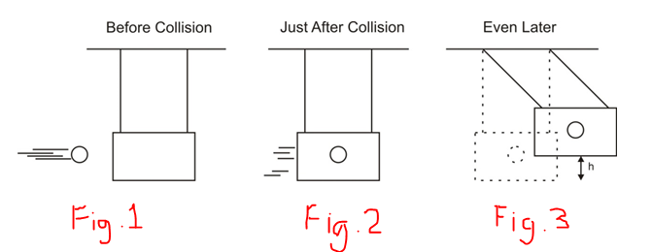
4. A 0.15kg projectile is fired into a 2.0kg ballistic pendulum. The projectile embeds in the pendulum and then the pendulum + projectile swing upward to a height (h) of 0.3m before stopping.

a. What is the shared velocity of the pendulum + the projectile just after impact, as they begin the swing (as in figure 2)?

b. What is the velocity of the projectile before it hits the pendulum (as in figure 1)?

5. In a game of bocce, large spheres (3.0 kg) are thrown at a small, motionless target called the pallino (1.0 kg). Suppose a large ball has a speed of 2.0 m/s and collides, head-on, with the pallino. If the collision has a coefficient of restitution of e = 0.7, find the speed of the pallino and the speed of the large ball after the collision.

