Physics 200 (Stapleton) Name: ____________________________
Conservation of Momentum Notes and Ballistic Pendulums

Notes - 8.3 Conservation of Momentum

1. Write the conservation of momentum principle for 2 objects in an isolated (closed) system.

2. An isolated system is defined to be one in which the net external force = _________.

3. Note that from F_{net} = Δp/Δt, when F_{net} = 0 then Δp_{Tot} = __________ (i.e. the total momentum is constant).

Notes - 8.4 & 8.5 Elastic and Inelastic Collisions

1. All collisions conserve momentum. An elastic collision is one that also conserves

_________________________.

2. How is an inelastic collision different from an elastic collision?

3. When a collision is inelastic (not elastic), where does the “lost” kinetic energy go?

4. Give some examples of nearly elastic collisions between macroscopic objects.

Ballistic Pendulums
Formulas: $KE=\frac{1}{2}mv^{2}$ $p=mv$ $PE=mgh$ $m_{i}v_{i}= m_{i}v_{i}$

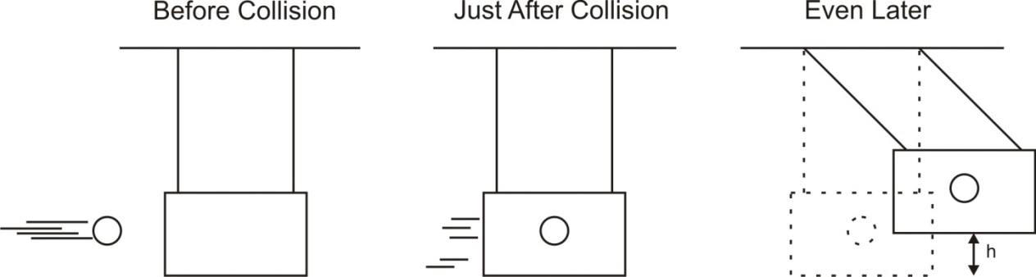

 | Example Launch 1 | Example Launch 2 | Your Launch
Projectile Mass (kg) | 0.01 | 0.5
Pendulum Mass (kg) | 1 | 0.02
Swing Height, “h” (m) | 0.5 | 0.4

Answer the following questions using “launch 1” data. Complete the rest on your own.
1. What is the total potential energy of the ball and pendulum in the “even later” picture?

2. What was the total kinetic energy of the ball and pendulum in the “just after” picture?

3. What was the shared velocity of the ball and pendulum in the “just after” picture?

4. What was the net momentum of the ball and pendulum in the “just after” picture?

5. What was the momentum of the ball before the collision?

6. What was the velocity of the ball before the collision?

7. Prove that the collision was inelastic.

