Physics 200 (Stapleton) Name: _________________________________

Coefficient of Restitution, Plus Various Momentum Problems

**Coefficient of Restitution:** a number from zero to one that tells how elastic a collision is; a ratio of the separation speed of objects after a collision to their approach (or “closing”) speed before the collision.

**Coefficient of Restitution** = $\frac{Separation Speed}{Closing speed}$

When e =1…

* objects separate as fast as they came together
* collision is **perfectly elastic.**
* No kinetic energy is lost.
* Example: A perfectly bouncy ball approaches the ground at 2m/s (closing speed) and then bounces back up with a speed of 2m/s (separation speed). e = 2/2 = 1

When e=0…

* objects do not separate
* the collision is **perfectly inelastic.**
* Kinetic energy is lost to friction.
* Example: a bullet approaches a ballistic pendulum at 500m/s (closing speed) and the bullet and pendulum then swing upward together (separation speed = 0; no separation). e =0/2

When 1>e>0, objects separate, but not as fast as they came together. Some energy is lost to friction.

**Coefficient of Restitution Formula** = $e= \frac{{V_{b}}^{'}-{V_{a}}^{'} }{V_{a}-V_{b}}$…where Va = initial velocity of object A, Vb = initial velocity of object B, and Va’ and Vb’ = their final velocities.

When e=1, ${V_{b}}^{'}-{V_{a}}^{'}= V_{a}-V_{b}$

**Example Problem:**

Cart A has a mass of 4kg and an initial velocity of -2m/s. Cart B has a mass of 3kg and an initial velocity of 0m/s. If the carts collide with perfect elasticity (e=1), what are the carts’ velocities after the collision?

**Momentum and Impulse problems**

1. What is the magnitude of the momentum of a 28-g sparrow flying with a speed of 8.4 m/s?

2. A constant friction force of 25 N acts on a 65-kg skier for 20s. What is the skier’s change in velocity?

3. A 0.145-kg baseball pitched at 39.0 m/s is hit in a horizontal line drive straight back toward the pitcher at 52.0 m/s. If the contact time between bat and ball is 3.00x10-3s, calculate the average force between the ball and bat during contact.

4. Calculate the force of a rocket’s thrust, given that the propelling gases are expelled at a rate of 1500 kg/s with a speed of 4.00x104m/s (at the moment of takeoff). The force on the gas can be found from its change in momentum.

5. A golf ball of mass 0.045 kg is hit off of a tee at a speed of  The golf club was in contact with the ball for  Find (*a*) the impulse imparted to the golf ball, and (*b*) the average force exerted on the ball by the golf club.

6. You are the design engineer in charge of the crashworthiness of new automobile models. Cars are tested by smashing them into fixed, massive barriers at  (30 mph). A new model of mass 1500 kg takes 0.15 s from the time of impact until it is brought to rest. (*a*) Calculate the average force exerted on the car by the barrier. (*b*) Calculate the average deceleration of the car.

**Conservation of Momentum – Basic Problems**

7.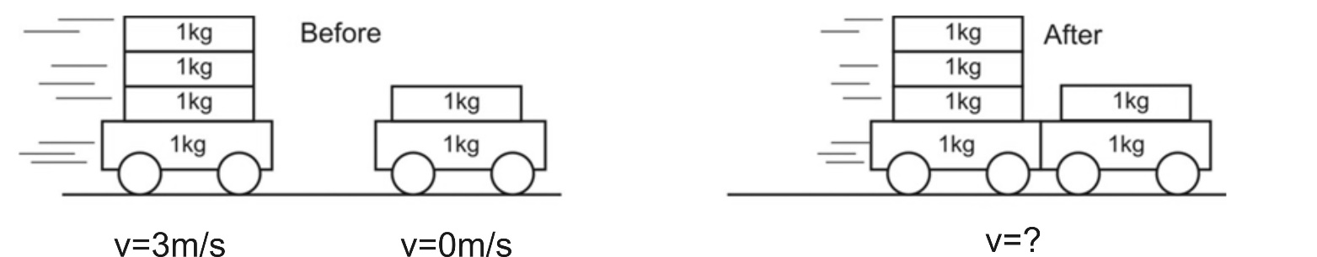

8.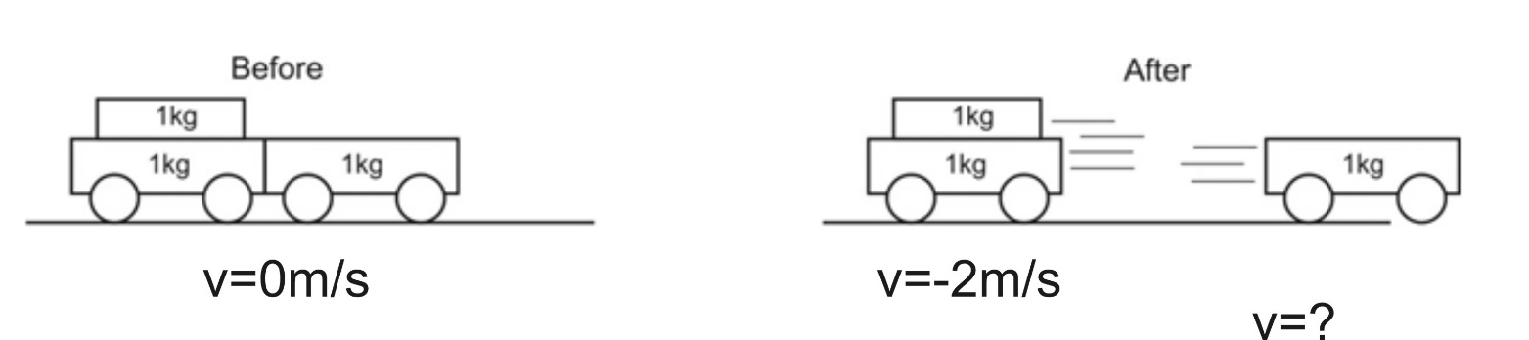

9. 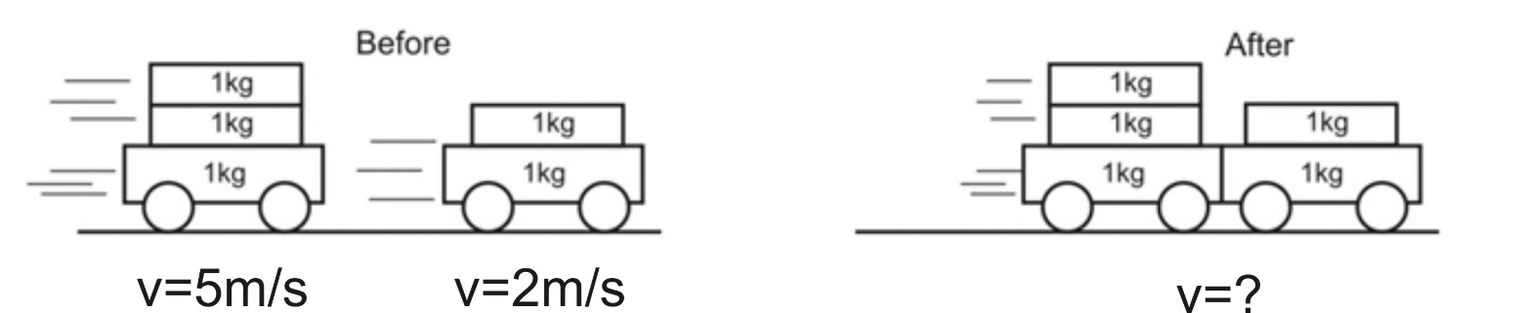

10. A child in a boat throws a 6.40 kg package out of the boat horizontally with a speed of 10.0 m/s. Calculate the velocity of the boat immediately after, assuming that it was initially at rest. The mass of the child is 26.0 kg, and that of the boat is 45.0 kg. Ignore water resistance.

11. A 12,600-kg railroad car travels alone on a level frictionless track with a constant speed of 18.0m/s. A 5350-kg load, initially at rest, is dropped onto the car. What will be the car’s new speed?

12. A 3800 kg open railroad car coasts along level tracks with a constant speed of 8.60 m/s. Snow begins to fall vertically and fills the car at a rate of 3.50 kg/min. Ignoring friction with tracks, what is the speed of the car after 90 min?

**Conservation of Momentum Problems Requiring The Coefficient of Restitution Formula**

13. Boat A has a mass of 10kg and a velocity of 3m/s. Boat B has a mass of 15kg and a velocity of -1m/s. The two boats collide and bounce away from one another. The collision lasts for 0.1 second, and after the bounce, boat B has a velocity of 1.4m/s.

a. What is the velocity of boat A after the bounce?

b. What impulse is experienced by boat A during the collision?

c. What impact force is felt by boat A?

d. What impulse is experienced by boat B?

e. What impact force is felt by boat B?

f. What is the coefficient of restitution for this collision?

g. Is the collision elastic or inelastic? How do you know?

14. A softball of mass 0.220 kg that is moving with a speed of  collides head-on and elastically with another ball initially at rest. Afterward the incoming softball bounces backward with a speed of  Calculate (*a*) the velocity of the target ball after the collision, and (*b*) the mass of the target ball.

15. Two bumper cars in an amusement park ride collide elastically as one approaches the other directly from the rear (Fig. 7–34). Car A has a mass of 450 kg and car B 550 kg, owing to differences in passenger mass. If car A approaches at  and car B is moving at  calculate (*a*) their velocities after the collision.

**Conceptual Questions**

16. Why is momentum conserved for ALL collisions, regardless of whether they are elastic or not? You have not already been told the answer to this question. Skip it if you are totally stuck.

17. A Superball is dropped from a height h onto a hard steel plate (fixed to the Earth), from which it rebounds at very nearly its original speed. (a) If the ball alone is considered to be “the system,” is the momentum of the ball conserved during any part of this process? (b) If we consider the ball and Earth as our system, during what parts of the process is momentum conserved? Explain.

**Ballistic Pendulum – Conservation of Momentum and Conservation of Mechanical Energy**

18. A 0.2kg projectile is fired at a 1kg ballistic pendulum. After the projectile embeds in the target, the pendulum and projectile swing upward a height of 0.4m. What was the initial velocity of the projectile (just before it hit the pendulum)?

**Answers:**

1. 0.235kgm/s 2. 7.69m/s 3. 4,398N 4. 6.0 x 107N 5. 2.025kgm/s, 579N

6. 139,000N, 93m/s2 7. 2m/s 8. 4m/s 9. 3.8m/s 10. -0.901m/s

11. 12.6m/s 12. 7.9m/s 13a. -0.6m/s 13b. -36kgm/s 13c. -360N

13d. 36kgm/s 13e. 360N 13f. 0.5 13g. Inelastic because e<1

14. 4.8m/s, 0.56kg 15. 3.62m/s 16. See solutions 17. See solutions 18. 16.8m/s