Physics 200 (Stapleton) Name: _________________________________
Electricity and Magnetism
Quiz Review

1. What is the symbol for magnetic field?

2. The rightmost magnet is twice as strong as the leftmost magnet. Draw the magnetic field lines surrounding the two magnets.

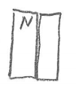
3. Sketch a diagram of the Earth’s magnetic field.

4. Label the remaining poles of the two magnets and draw their magnetic fields.

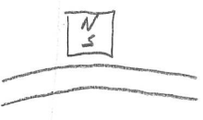
5. Show the poles of the magnetized section of the steel string adjacent to the magnet.

6. When the right hand rule is applied with curled fingers, what part of the right hand indicates…
a. Direction of the magnetic field b. Direction of Current

7. When the right hand rule is applied with straight fingers, what indicates the direction of the force applied to a moving charge?

8. What symbol represents a direction pointing into the paper? What symbol represents “out of the paper?”
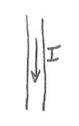

9. Use the symbols from number 8 to show the direction of the magnetic field around the wire.

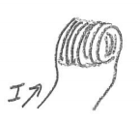

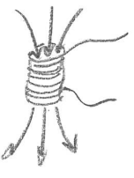
11. Show the direction of the solenoid’s magnetic field.

12. Show the direction of the solenoid’s current.

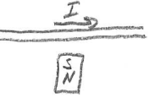
13. Show the direction of the force acting on the wire.

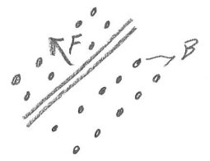
14. Show the direction of the current traveling through the wire.

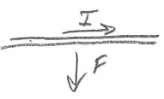
15. Show the direction of the magnetic field.

16. In which direction will the motor rotate when viewed along the axle in the indicated direction?
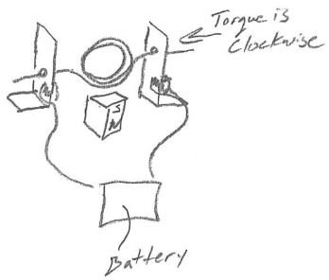
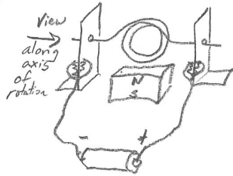
17. In which direction is current flowing through the motor coil? Torque is clockwise when viewed along the axle in the indicated direction.

18. In which direction will the voice coil and speaker move?
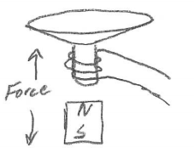
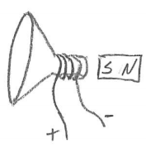

19. In which direction is current flowing through the voice coil?

20. Define magnetic flux.

21. According to Lenz’s law, what is the relationship between magnetic flux and the current induced in a coil?

22. Each of these drawings shows a “coil” (metal ring) and a permanent magnet. The drawing is a perspective drawing; the thicker section of the ring is closer to the viewer. Either the magnet or the coil is moving, and its direction of movement is indicated. For each drawing…
a. describe the general direction of the permanent magnet’s at the coil (choose up, down, left, or right)
b. describe the change in magnetic flux through the coil (increasing or decreasing)
c. describe the direction of the magnetic field that is produced by the induced current in the coil
d. Show (using an arrow) the direction of the induced current along the near side of the coil.
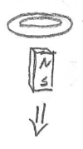

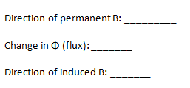
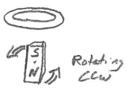

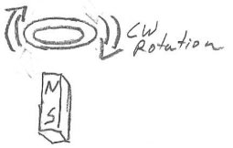
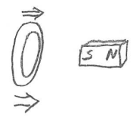

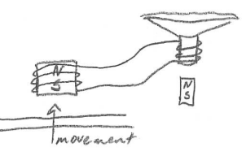
23. In what direction must the magnet be shifted (left or right) in order to produce a current in the indicated direction?
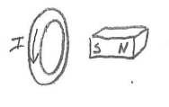

24. Show the direction of current leaving the magnetic pickup when the steel string moves as indicated. Then show the direction of the speaker cone’s movement (Note that the movement will be minimal without the signal being amplified).

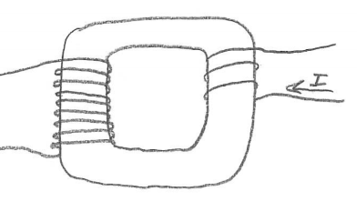
25. The source current entering a transformer is shown on the right. If we assume that current is increasing…
a. Is this transformer increasing voltage or decreasing voltage?
b. By what factor is voltage changing?
c. Show the direction of the current that is induced in the other coil of the transformer.

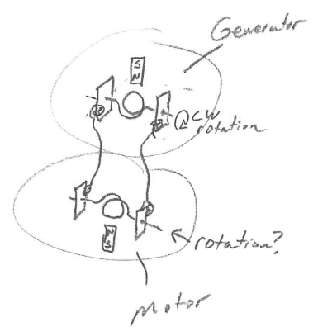
26. In which direction will the “motor” rotate around the indicated axis (from the indicated perspective) when the “generator” magnet is moved as shown?

27. True or false: When a magnet moves near a conducting coil, a force is always produced that opposes the magnet’s movement.

28. Sketch a solenoid buzzer, with correct wiring, connected to a battery, in the on position.

29. Describe an easy way to generate significant electricity without building a generator.

30. Briefly describe how an electric motor works.

31. Briefly describe how a generator works.

