Physics 200 Name: __________________________
Electricity and Magnetism

Magnetism: a class of phenomena resulting in attractive and repulsive forces between objects and relating to motions of electric charge.
Magnetic field lines: arrows flowing away from a magnet’s north pole and toward a magnet’s south pole.

Symbol for Magnetic Field = ________

Standard SI Unit for Magnetic Field = ____________________ = (1N•s/C•m)

North Pole: the pole of a magnet that tends to point itself toward the Earth’s (current) North Pole. This is because, if you think of the Earth as a magnet, the North Pole is really its magnetic south pole. We call it the North Pole because magnets’ north poles point toward it.

South Pole: the pole of a magnet that points toward the Earth’s south pole.

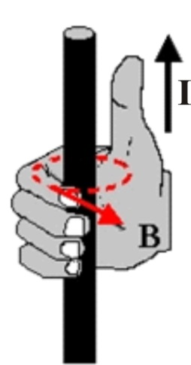
Moving Charges Create Magnetic Fields:

Hyperphysics link

Current (I) in a wire creates a magnetic field (B), according to the right hand rule.

Right hand rule: If you point your right thumb in the direction of current flow, and you curl your fingers on that hand, your fingers point in the direction of the magnetic field lines. [Image on the right from http://physicsed.buffalostate.edu/SeatExpts/resource/rhr/CNB.JPG]

Electrons in atoms create magnetic fields:
- Most atoms have paired electrons. Electrons in pairs have opposite spin, so they cancel one another’s magnetic fields.
- Iron, however, has unpaired spinning electrons that create magnetic fields. In groups of iron atoms, called domains, the unpaired electrons align with one another’s magnetic fields. However, throughout the iron, the aligned domains are randomly oriented, so the iron has no overall magnetic field. When a strong magnet is brought near a piece of iron, the iron’s domains align with the magnet’s magnetic field. The iron becomes “magnetized,” and it sticks to the other magnet. When the magnet is taken away, the iron’s domains usually return to their normal orientations, so the iron does not become a permanent magnet.
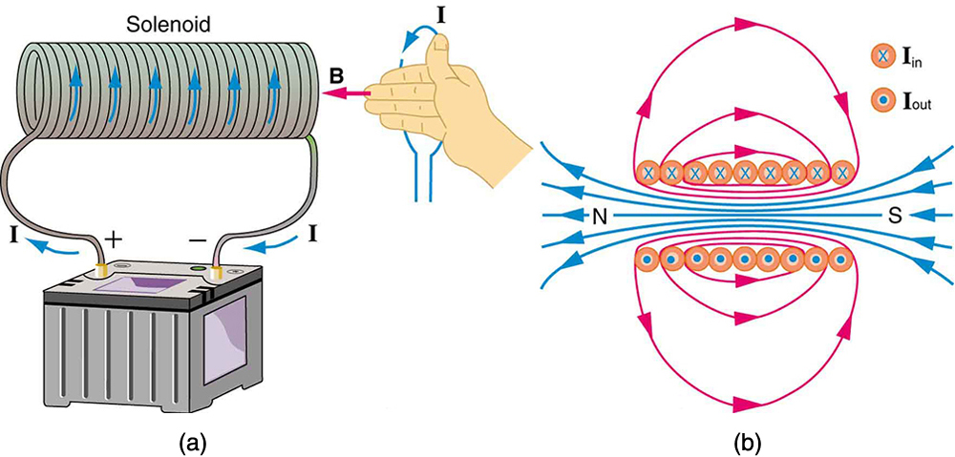
Solenoid (electromagnet):

A solenoid is a coil of wire through which current is flowing. The right hand rule can be used to understand the direction of the magnetic field, B. In the diagram on the far right, X represents current flowing into the page. A dot represents current flowing out of the page.
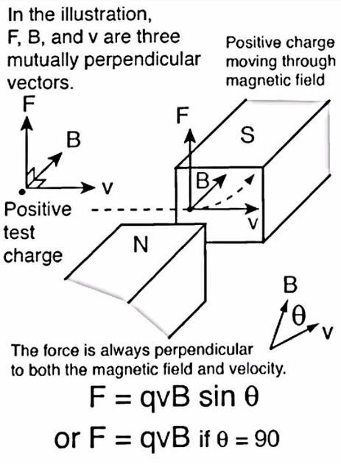
(another?) Right Hand Rule: concerning the direction and magnitude of the Magnetic force exerted on charge moving in a magnetic field (e.g. through a wire, near a magnet)

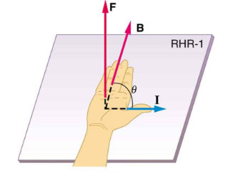

Lorentz Force Law (in terms of charge or current):
F_{magnetic} = F_{magnetic} =ILBsinθ

Example Problem:

We are at the south pole, observing a proton traveling to our right at a speed of 3x10⁷m/s (1/10 speed of light). Assume that the Earth’s magnetic field strength is 5 x 10⁻⁶T at this location.
a. What is the direction of the Earth’s magnetic field, relative to an observer at the South Pole?

b. What is the magnitude of the magnetic force exerted on the proton?

c. What is the direction of this magnetic force, relative to the observer?

d. What would be the direction of the magnetic force if this particle were an electron?

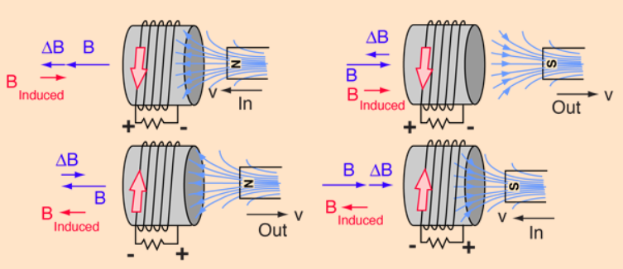
Lenz’ Law: A change in magnetic flux through a conductive coil induces a current in the coil, such that the induced current’s magnetic field opposes the first change in magnetic flux.

Magnetic Flux is a measure of the magnitude and direction of magnetic field passing through a given area.

