Unit 10 Handout – Electricity and Magnetism Name: ______________________
Physics 200
Notes:

Magnetism: a class of phenomena resulting in attractive and repulsive forces between objects and relating to motions of electric charge.
Magnetic field lines: arrows flowing away from a magnet’s north pole and toward a magnet’s south pole.

Symbol for Magnetic Field = ________

Standard SI Unit for Magnetic Field = ____________________ = (1N•s/C•m) or (kg/s²A)

North Pole: the pole of a magnet that tends to point itself toward the Earth’s (current) North Pole. This is because, if you think of the Earth as a magnet, the North Pole is really its magnetic south pole. We call it the North Pole because magnets’ north poles point toward it.

South Pole: the pole of a magnet that points toward the Earth’s south pole.

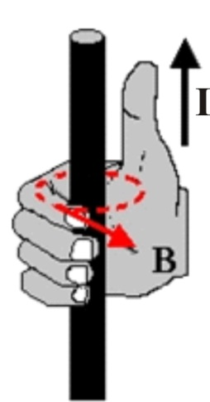
Moving Charges Create Magnetic Fields:

Current (I) in a wire creates a magnetic field (B), according to the right hand rule.

Right hand rule: If you point your right thumb in the direction of current flow, and you curl your fingers on that hand, your fingers point in the direction of the magnetic field lines. [Image on the right from http://physicsed.buffalostate.edu/SeatExpts/resource/rhr/CNB.JPG]

Electrons in atoms create magnetic fields:
- Most atoms have paired electrons. Electrons in pairs have opposite spin, so they cancel one another’s magnetic fields.
- Iron, however, has unpaired spinning electrons that create magnetic fields. In groups of iron atoms, called domains, the unpaired electrons align with one another’s magnetic fields. However, throughout the iron, the aligned domains are randomly oriented, so the iron has no overall magnetic field. When a strong magnet is brought near a piece of iron, the iron’s domains align with the magnet’s magnetic field. The iron becomes “magnetized,” and it sticks to the other magnet. When the magnet is taken away, the iron’s domains usually return to their normal orientations, so the iron does not become a permanent magnet.
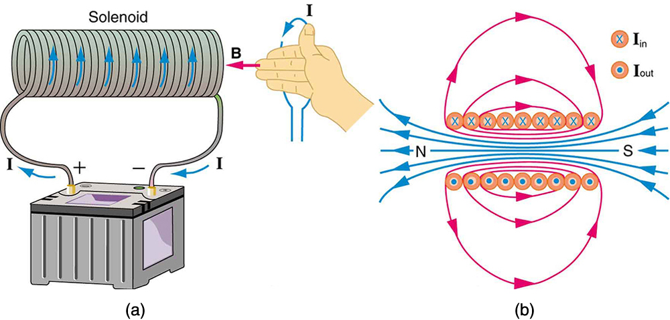
Solenoid (electromagnet):

A solenoid is a coil of wire through which current is flowing. The right hand rule can be used to understand the direction of the magnetic field, B. In the diagram on the far right, X represents current flowing into the page. A dot represents current flowing out of the page.

(another) Right Hand Rule: concerning the direction and magnitude of the Magnetic force exerted on charge moving in a magnetic field (e.g. through a wire, near a magnet)

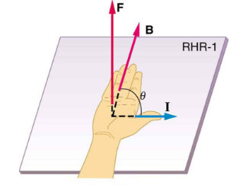

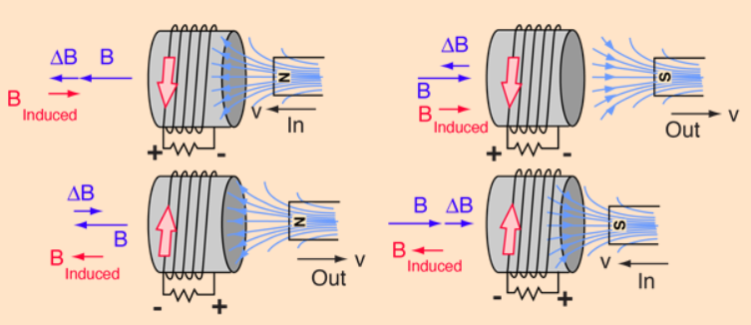
Lenz’ Law: A change in magnetic flux through a conductive coil induces a current in the coil, such that the induced current’s magnetic field opposes the first change in magnetic flux.

Magnetic Flux is a measure of the magnitude and direction of magnetic field passing through a given area.

Practice: Right hand Rules and Lenz’s Law Practice

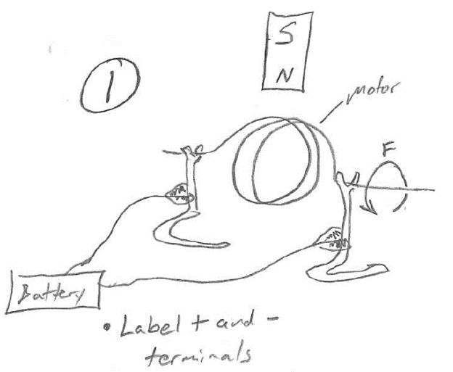
Given the battery terminal connections, infer the forces exerted on the magnet and coil.
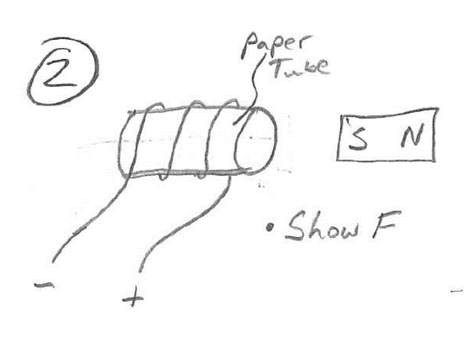

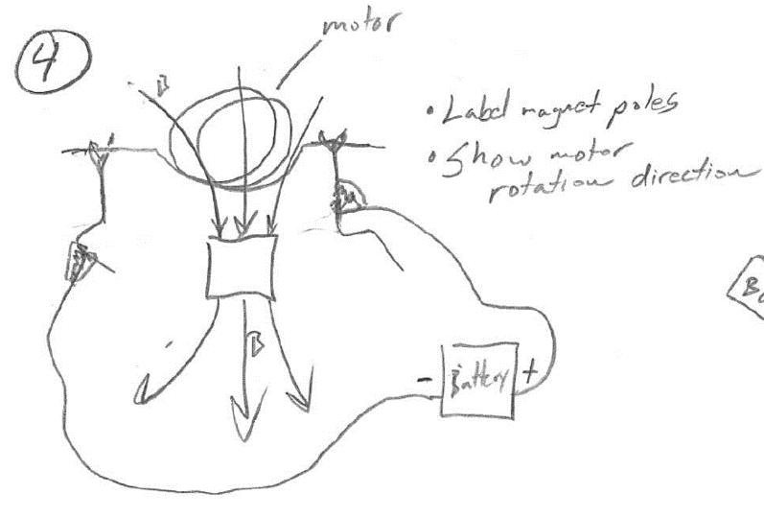
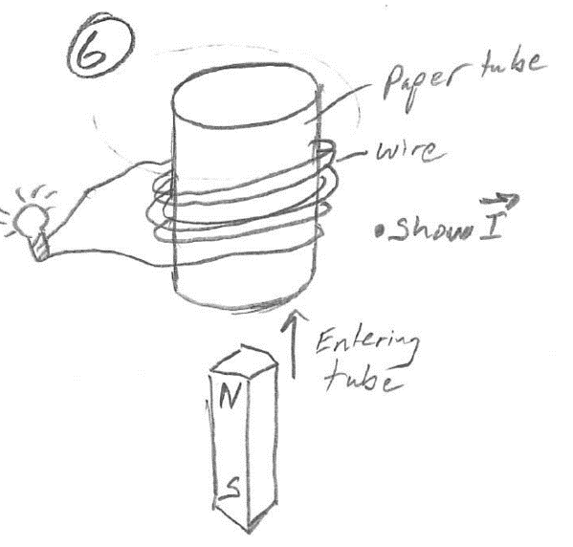
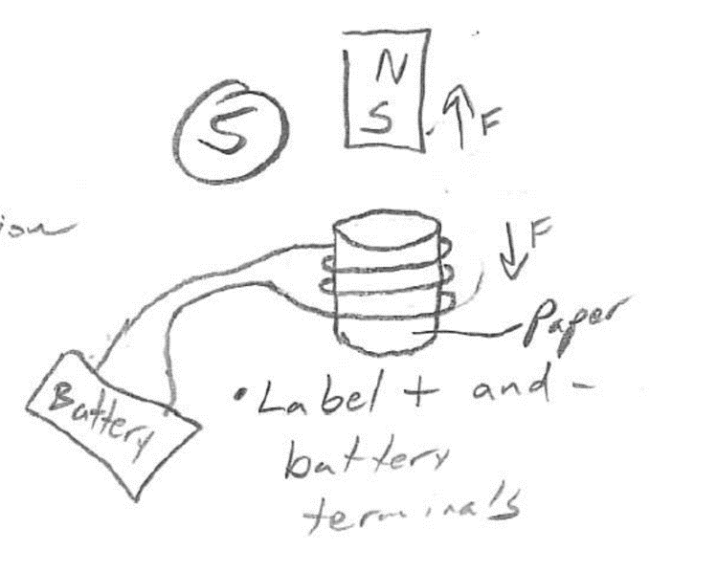
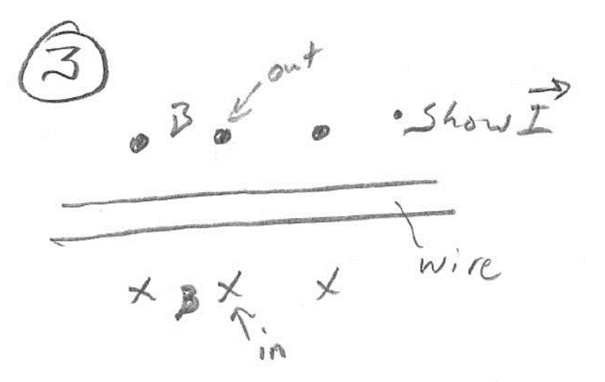
Given that the magnet and coil are repelling, infer the battery terminals.
Given that the magnet is moving into the tube, infer the current direction.
Given the magnetic field and battery terminals, infer the direction of motor rotation.
Use the magnetic field direction to infer current direction.
Given the force exerted by the motor, infer the direction of current.
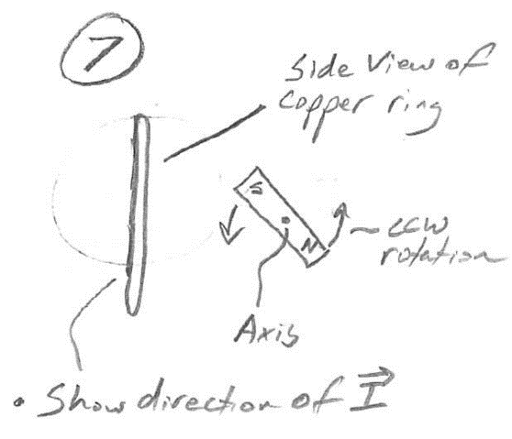
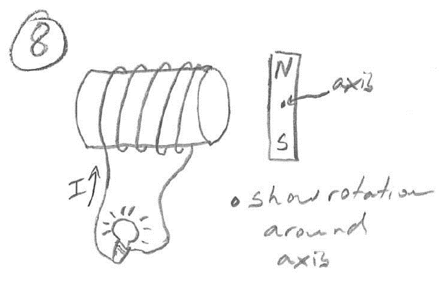
Rotation of the magnet has induced current in the coil, as shown. Infer the magnet’s rotation direction (CW or CCW).

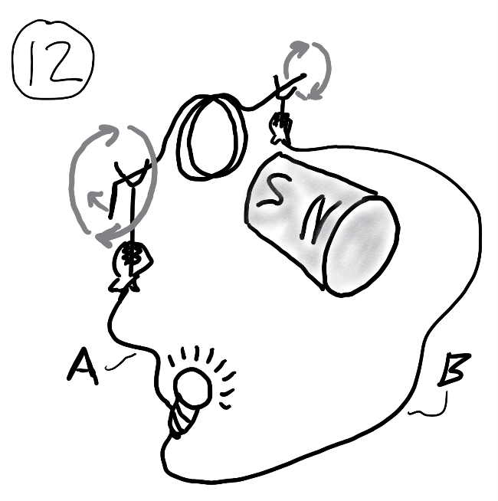
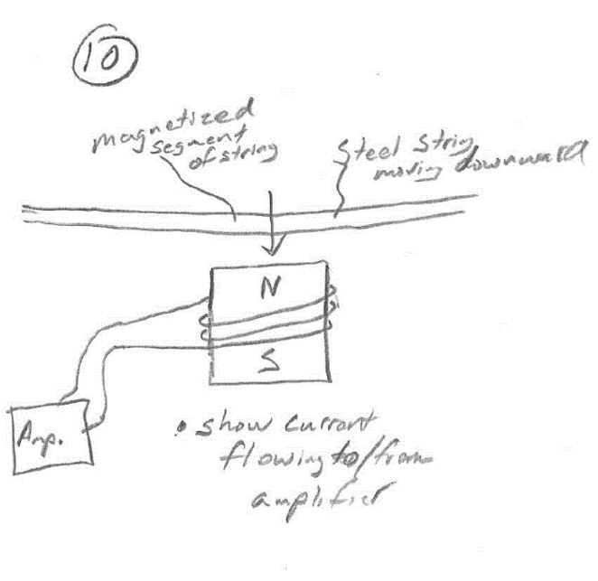
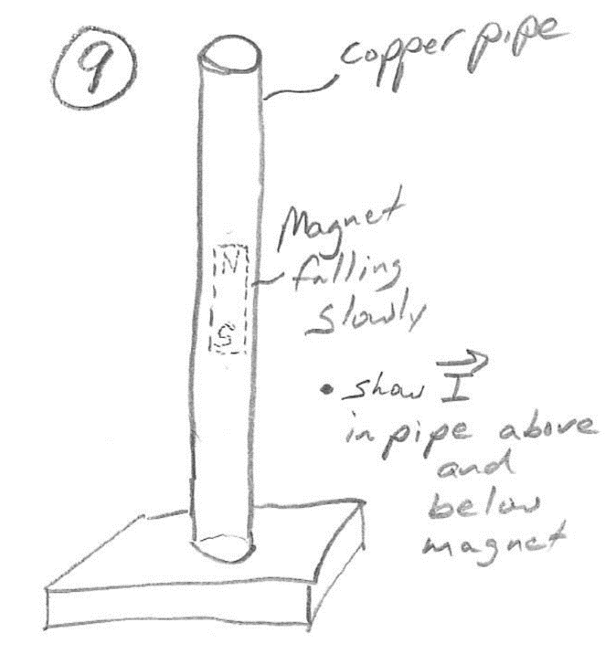
An outside force is rotating the motor coil as shown. Through which wire will the induced current enter the bulb?
Infer the direction of string movement based on the current direction.
The movement of the magnetized steel string induces a current in the coil. Show current direction.
Show the direction of current induced in the copper pipe by the falling magnet. Show current above and below the magnet.

Show the direction of the current induced in the ring by the rotation of the permanent magnet.
Physics 200 (Stapleton) Name: _________________________________
Electricity and Magnetism
2018-2019 Quiz Review

1. What is the symbol for magnetic field?

2. The rightmost magnet is twice as strong as the leftmost magnet. Draw the magnetic field lines surrounding the two magnets.

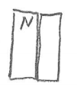
3. Sketch a diagram of the Earth’s magnetic field.

4. Label the remaining poles of the two magnets and draw their magnetic fields.

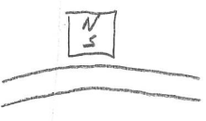
5. Show the poles of the magnetized section of the steel string adjacent to the magnet.

6. When the right hand rule is applied with curled fingers, what part of the right hand indicates…
a. Direction of the magnetic field b. Direction of Current

7. When the right hand rule is applied with straight fingers, what indicates the direction of the force applied to a moving charge?

8. What symbol represents a direction pointing into the paper? What symbol represents “out of the paper?”
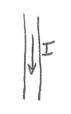

9. Use the symbols from number 8 to show the direction of the magnetic field around the wire.

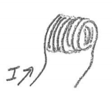

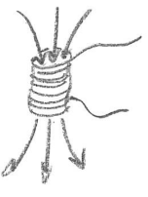
11. Show the direction of the solenoid’s magnetic field.

12. Show the direction of the solenoid’s current.

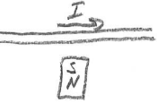
13. Show the direction of the force acting on the wire.

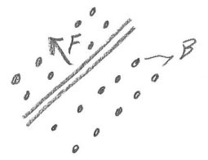
14. Show the direction of the current traveling through the wire.

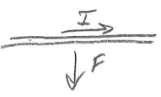
15. Show the direction of the magnetic field.

16. In which direction will the motor rotate when viewed along the axle in the indicated direction?
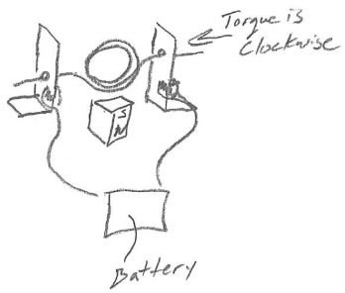
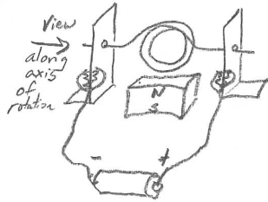
17. In which direction is current flowing through the motor coil? Torque is clockwise when viewed along the axle in the indicated direction.

18. In which direction will the voice coil and speaker move?
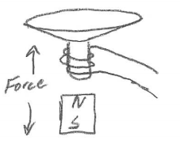
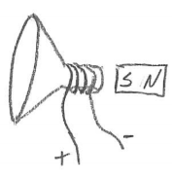

19. In which direction is current flowing through the voice coil?

20. Define magnetic flux.

21. According to Lenz’s law, what is the relationship between magnetic flux and the current induced in a coil?

22. Each of these drawings shows a “coil” (metal ring) and a permanent magnet. The drawing is a perspective drawing; the thicker section of the ring is closer to the viewer. Either the magnet or the coil is moving, and its direction of movement is indicated. For each drawing…
a. describe the general direction of the permanent magnet’s at the coil (choose up, down, left, or right)
b. describe the change in magnetic flux through the coil (increasing or decreasing)
c. describe the direction of the magnetic field that is produced by the induced current in the coil
d. Show (using an arrow) the direction of the induced current along the near side of the coil.

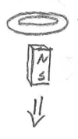
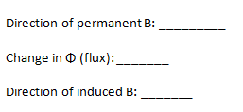
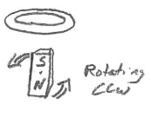
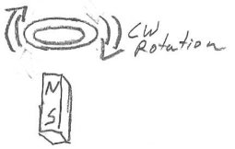

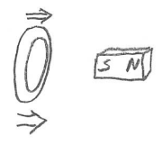

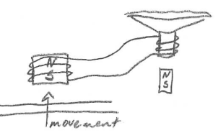
23. In what direction must the magnet be shifted (left or right) in order to produce a current in the indicated direction?
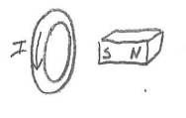

24. Show the direction of current leaving the magnetic pickup when the steel string moves as indicated. Then show the direction of the speaker cone’s movement (Note that the movement will be minimal without the signal being amplified).

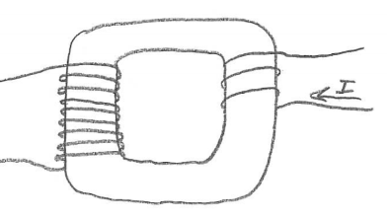
25. The source current entering a transformer is shown on the right. If we assume that current is increasing…
a. Is this transformer increasing voltage or decreasing voltage?
b. By what factor is voltage changing?
c. Show the direction of the current that is induced in the other coil of the transformer.

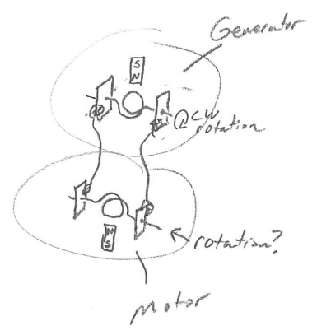
26. In which direction will the “motor” rotate around the indicated axis (from the indicated perspective) when the “generator” magnet is moved as shown?

27. True or false: When a magnet moves near a conducting coil, a force is always produced that opposes the magnet’s movement.

28. Sketch a solenoid buzzer, with correct wiring, connected to a battery, in the on position.

29. Describe an easy way to generate significant electricity without building a generator.

30. Briefly describe how an electric motor works.

31. Briefly describe how a generator works.

Physics 200 (Stapleton) Name: _________________________________
Electricity and Magnetism
2018-2019 Quiz

*Note: except for the steel guitar strings (which are magnetizable), all other wires and coils are made of copper (which is not magnetic).

1. What is the symbol for magnetic field?
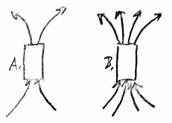
a. M b. B c. I d. F e. E

2. Compared to magnet A, magnet B is _____
a. The same strength b. 2x stronger c. ½ as strong d. 4x stronger e. ¼ as strong

3. A compass needle is a small magnet. Which of the compass’ poles points in the general direction of the Earth’s North Geographic Pole?
a. The needle’s north pole b. The needle’s south pole

4. The diagram on the right shows three magnets sticking together. What magnetic pole is in the position of the question mark?
a. South b. North c. Not enough information
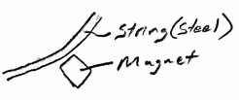
5. Which pole of the magnet is closest to the steel guitar string?
a. North b. South c. Not enough information

6. When the right hand rule is applied with curled fingers, what indicates the direction of current?
a. Palm b. Thumb c. Fingers

7. When the right hand rule is applied with curled fingers, what indicates the direction of the magnetic field?
a. Palm b. Thumb c. Fingers

8. When the right hand rule is applied with straight fingers, what indicates the direction of the force applied to a moving charge?
a. Palm b. Thumb c. Fingers

9. What direction does the letter “X” represent?
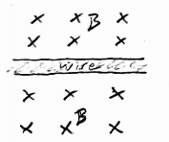
a. Up b. down c. into the paper d. out of the paper e. NE, SE, NW, and SW

10. Given the magnetic field, B, what is the direction of the current in the wire on the right?
a. Leftward b. rightward

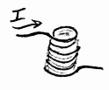
11. What is the direction of the magnetic field inside the solenoid? A. upward
B. Downward

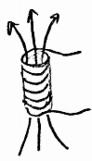
12. Relative to an observer looking downward through the solenoid, which way is current traveling?
a. Clockwise b. Counter-Clockwise

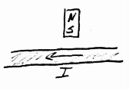
13. What is the direction of the force acting on the wire?
a. Upward (Toward the top margin of this paper)
b. Downward (toward the bottom margin of this paper)
c. Into the paper
d. Out of the paper
e. Leftward

14. What is the direction of the current traveling through the wire?
A. Leftward B. Rightward C. Into the Paper d. Out of the paper

15. What is the direction of the magnetic field.?
A. Leftward B. Rightward C. Into the Paper d. Out of the paper

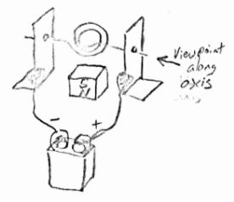
16. In which direction will the motor rotate when viewed along the axle in the indicated direction?
A. Clockwise B. Counter-Clockwise

17. As the generator coil is rotated clockwise (when viewed as shown), through which wire does current flow into the battery?
A. Wire A B. Wire B

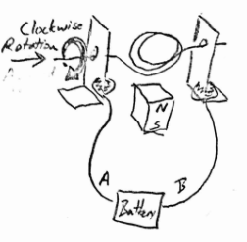

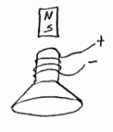
18. In which direction will the voice coil and speaker be pushed by the permanent magnet?
A. Upward B. Downward C. Leftward
D. Rightward E. Clockwise

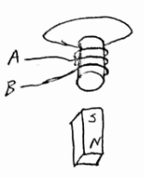
19. Through which wire is current flowing leftward?
A. Wire A B. Wire B

20. Magnetic Flux through a coil is:
a. The direction of a magnetic field near the coil
b. The change in a magnetic field near the coil
c. The number of turns in a solenoid that is moving near a magnet
d. The number of magnetic field lines passing through the coil
e. The strength of a permanent magnet that is used in a generator or motor

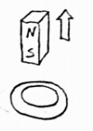
21-24. This drawing shows a “coil” (metal ring) and a permanent magnet. The drawing is a perspective drawing; the thicker section of the ring is closer to the viewer. The arrow shows movement of the permanent magnet.

21. What is the direction of the permanent magnet’s field?
A. up B. Down C. Left D. right
22. What is happening to the absolute magnitude of the magnetic flux through the coil?
a. Increasing b. Decreasing c. No change
23. What is the direction of the magnetic field that is created in the coil?
A. up B. Down C. Left D. right
24. What is the direction of the induced current along the near side of the coil?
A. up B. Down C. Left D. right

25-28. This drawing shows a “coil” (metal ring) and a permanent magnet. The drawing is a perspective drawing; the thicker section of the ring is closer to the viewer. The arrow shows movement.
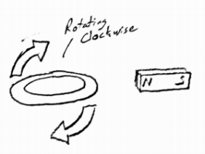
25. What is the direction of the permanent magnet’s field?
A. up B. Down C. Left D. right
26. What is happening to the absolute magnitude of the magnetic flux through the coil?
a. Increasing b. Decreasing c. No change
27. What is the direction of the magnetic field that is created in the coil?
A. up B. Down C. Left D. right
28. What is the direction of the induced current along the near side of the coil?
A. up B. Down C. Left D. right

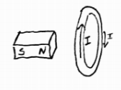
29. In what direction must the magnet be shifted in order to produce a current in the indicated direction? A. Rightward, upward, or downward b. Leftward, upward, or downward
c. Rightward only d. Leftward only e. upward or downward

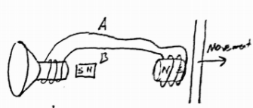
30. In the diagram on the right, through which wire will the current travel leftward, from the speaker voice coil to the pickup? A. Wire A B. Wire B

31. In the same diagram, which way will the voice coil and speaker cone be pushed by the nearby permanent magnet?
A. leftward B. rightward

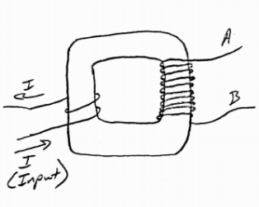
32-34. The source current entering a transformer is shown on the right. If we assume that current is decreasing…

32. Is this transformer increasing voltage or decreasing voltage? A. Increasing b. Decreasing

33. In terms of voltage, how much stronger is the high voltage coil, compared to the lower voltage coil?
A. 2x B. 3X C. 4X D. 5X E. 6X

34. Through which of the wires in the output coil is current traveling leftward?
A. Wire A B. Wire B

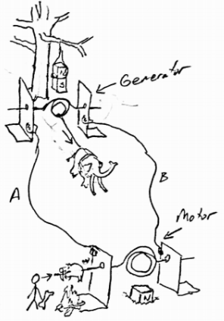
35-36. In their first attempt at creating a rotisserie for roasting pigs and whatnot, the cave people have set up a mammoth-powered generator to drive a motor that will rotate a saber-toothed pig as it cooks over a fire. Notice that they have hung the generator magnet from a tree limb and half-buried the motor magnet in the ground. As you can see, the mammoth is harnessed to the bottom of the generator coil, so the beast will only be able to cause ¼ of a rotation before it must stop (remember, this is the first attempt). Nonetheless, that ¼ rotation will produce current that will travel to the motor and rotate the pig.

35. When the mammoth pulls the coil, as shown, through which wire will current flow from the generator to the motor?
A. Wire A B. Wire B

36. From the perspective of the cave person, in which direction will the saber-toothed pig rotate as the mammoth pulls the rope.
A. Clockwise B. Counter-Clockwise

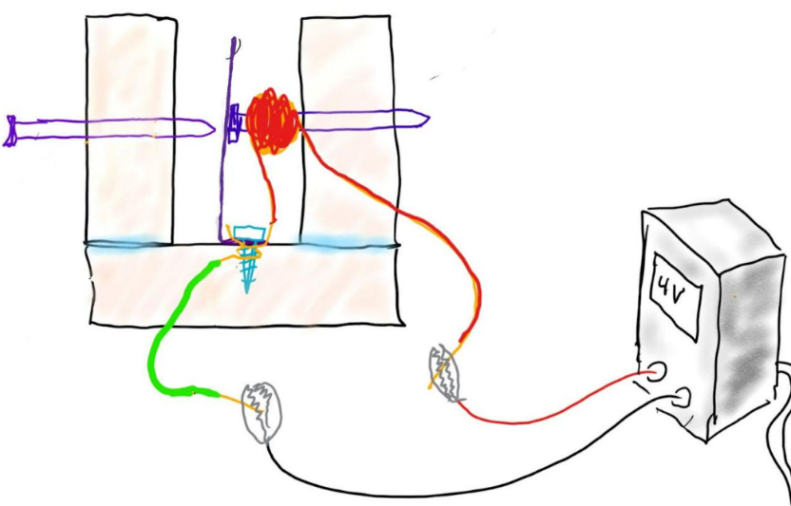
37. Assuming that all of the connections are well-sanded, this solenoid buzzer? Select all that apply.
A. Will not work
B. Has its solenoid turned off
C. Has its solenoid turned on
D. Has the battery connected in reverse

38. If you pass electricity through a coil of wire, in the presence of a permanent magnet, you have made a simple _________.
a. Generator b. Motor

39. If you move a magnet in the presence of a coil of wire, you have made a simple _______.
a. Generator b. Motor

