Magnetism Practice Quiz:
- True or false: all magnetism involves motions of electric charge.
- Magnet A has a magnetic field that is twice as strong as Magnet B. Draw field lines surrounding the two magnets.

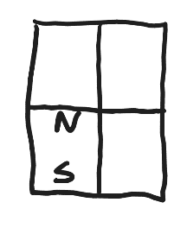
- One of the four magnets on the right has its poles labeled. Label the poles of the other magnets. Assume that they are all sticking together in equilibrium.
- A compass needle is a magnet with a north and a south pole. Often the north pole of the needle is painted red. Why is the north pole of a compass needle attracted to the North pole of the Earth?

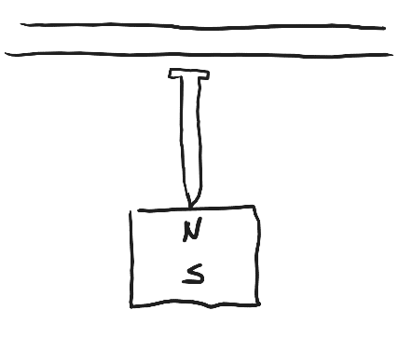

- Label the temporary magnetic poles, created by the permanent magnet, in the nail and steel string, on the right.
- What’s the symbol for magnetic field?

- Right Hand Rules
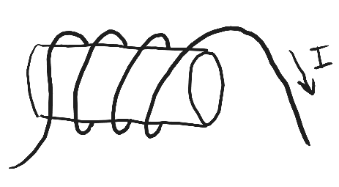
  - If you curl the fingers of your right hand, and stick out your thumb…
    - The direction that your thumb is pointing indicates _______.
    - Your curling fingers point in the direction of _______.
    - The solenoid on the right was made by wrapping current-carrying wire around a hollow tube. What is the direction of the solenoid’s magnetic field? A. up b. down c. left d. right

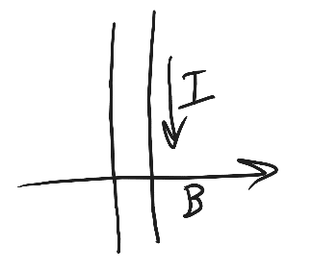
  - If you stick your fingers out straight, with your thumb making a right angle to them (mitten-like)…
    - Your thumb points in the direction of _________.
    - Your fingers point in the direction of _________.
    - Your palm points in the direction of _________.
    - Current is flowing through a wire in the direction shown on the right. This is happening in the presence of the indicated magnetic field. What is the direction of the force that is exerted on the wire? A. into the paper B. Out of the paper

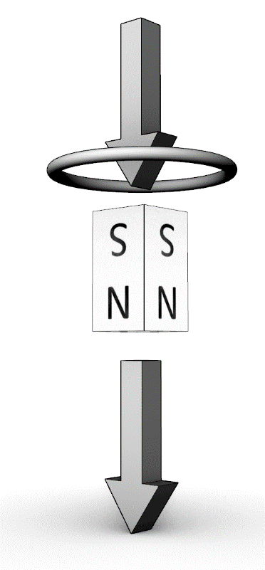
- Lenz' Law:
  - Be able to describe Lenz' Law.(won’t be on the quiz)

  - The diagram on the right shows a magnet moving near a conducting ring (coil). The arrows show the magnet’s path. It has passed through the ring and is now moving downward and away from the ring.
    - Describe the direction of the magnet's field.
    - Is the flux of that field through the coil increasing or decreasing.
    - Identify the direction of the new magnetic field that will form in response to this change in flux (from part ii).
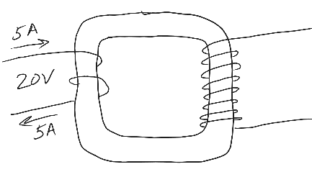
    - Identify the direction of the current that produces this new magnetic field. Will the current on the near side of the ring move to our left or to our right?
- 5A of current enter the transformer on the right, driven by a voltage of 20V. What is the output voltage?
Short Answer: Expect 2 or 3 of these on the quiz.
- This solenoid buzzer doesn’t work. Explain how to fix it.
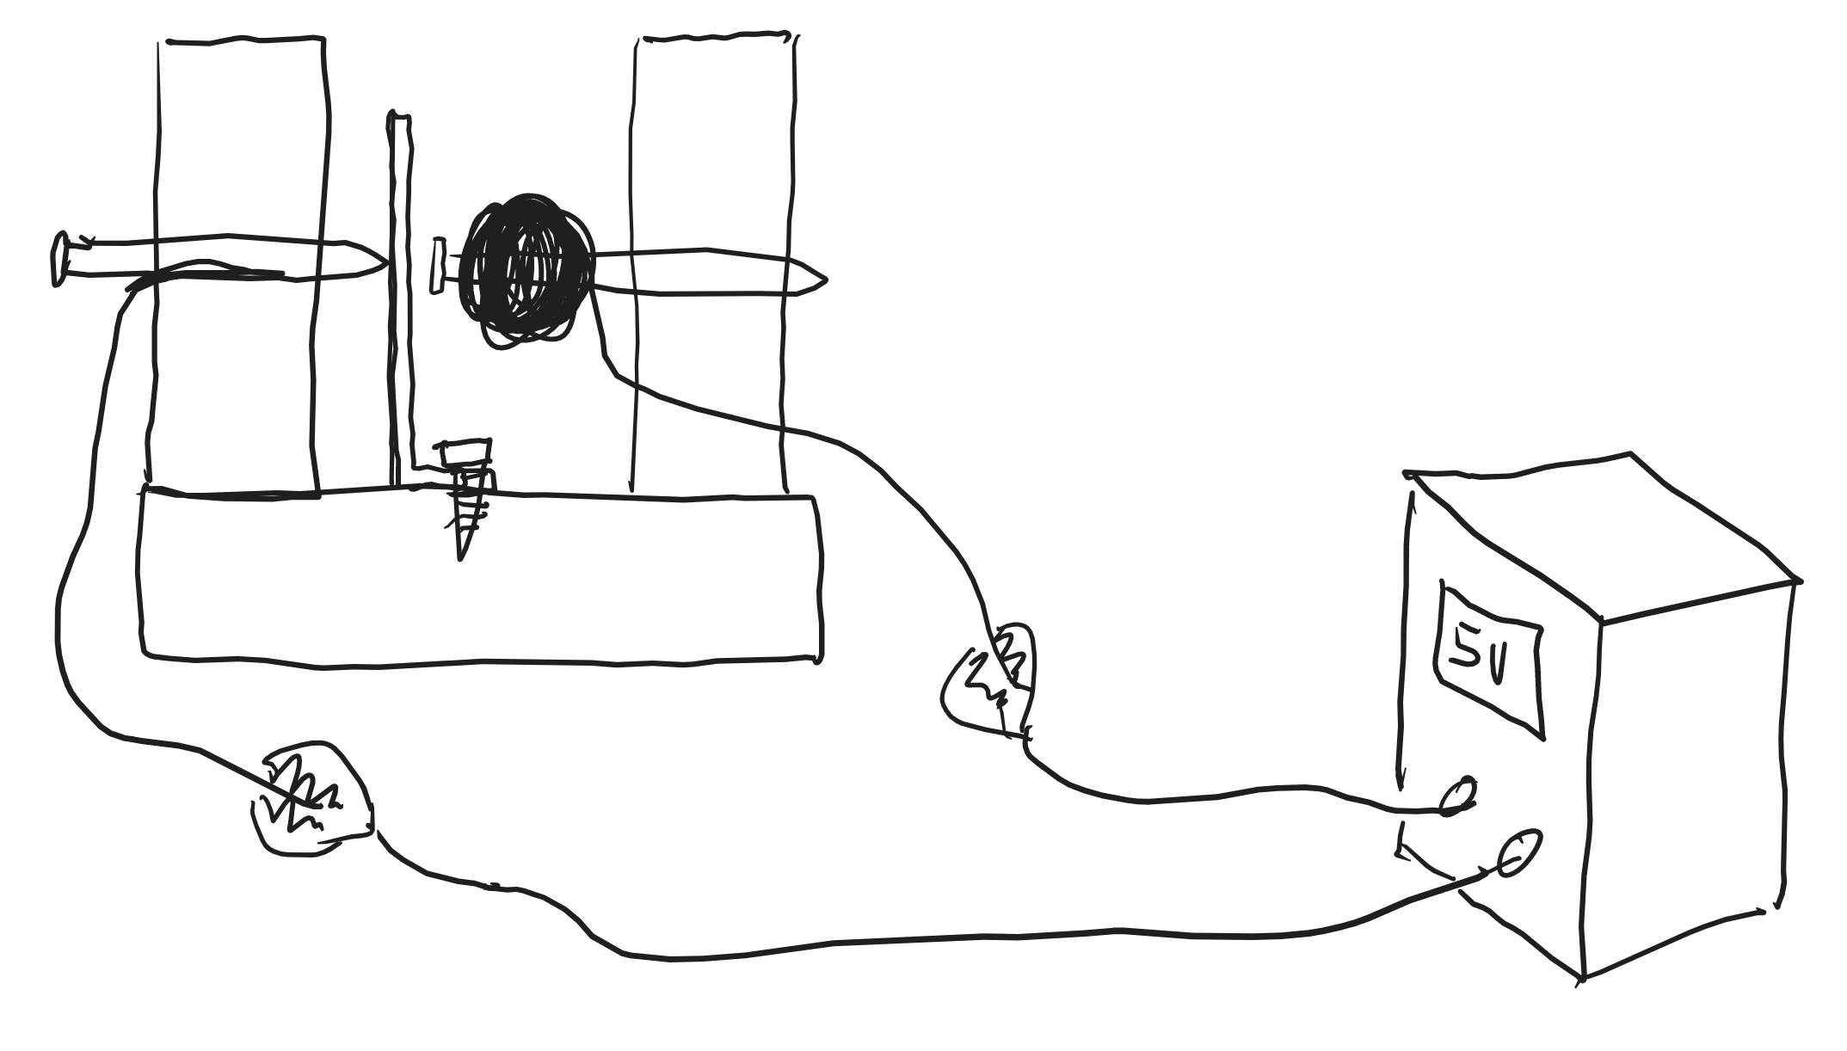
- What does an electric motor do, and how does it work? Keep it simple. Boil it down to its essence.

- What does an electrical generator do, and how does it work. Again, keep it simple.

- Explain briefly how a speaker works as a motor.

- Explain briefly how a pickup works as a generator.

