Physics 200 Name: _____________________________

Right hand Rules and Lenz’s Law Practice #2

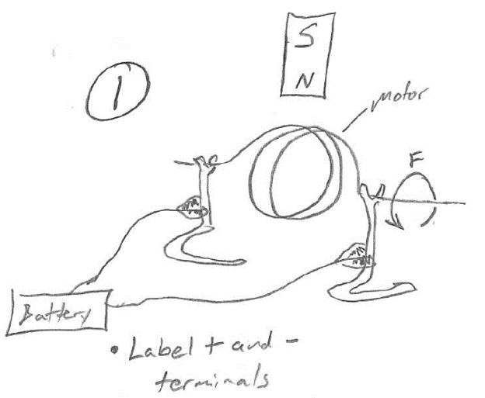

Given the battery terminal connections, infer the forces exerted on the magnet and coil.

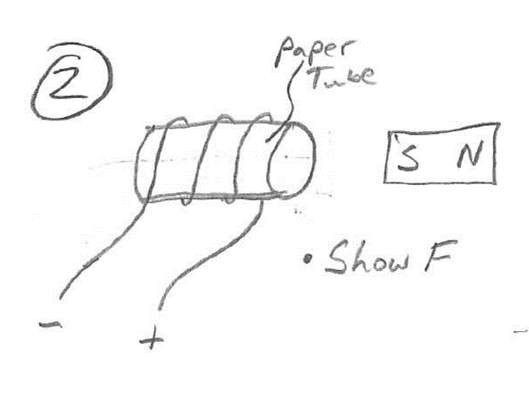

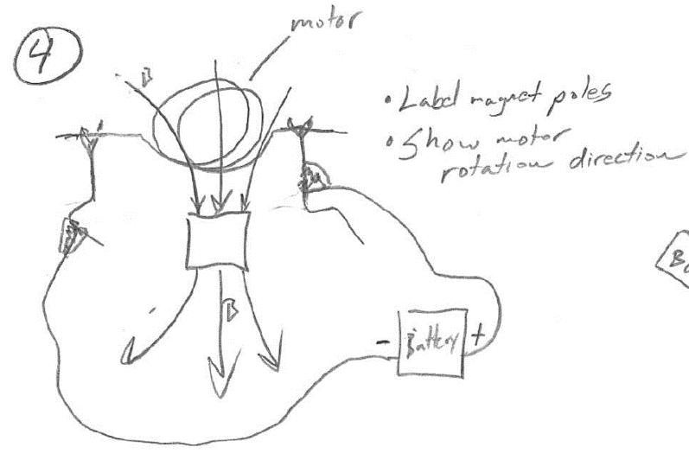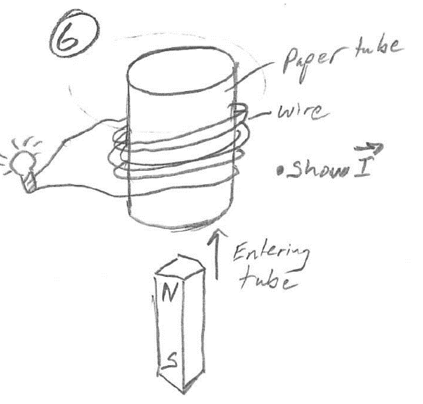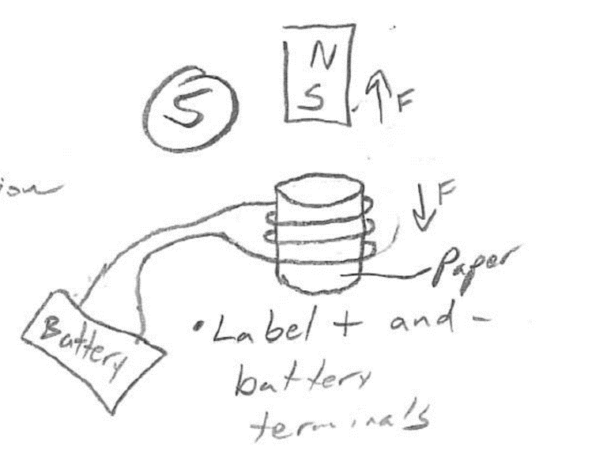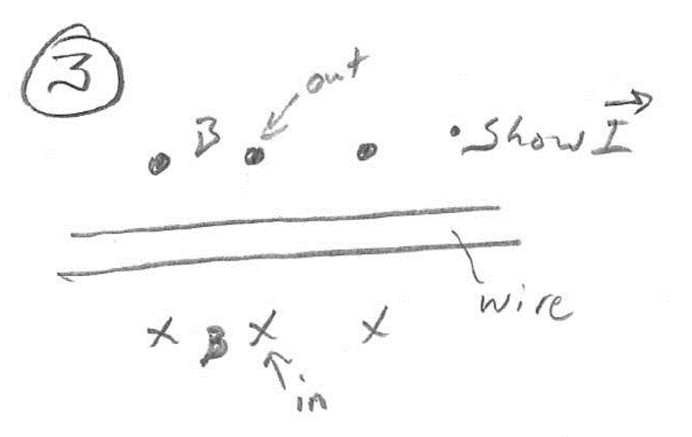

Given that the magnet and coil are repelling, infer the battery terminals.

Given that the magnet is moving into the tube, infer the current direction.

Given the magnetic field and battery terminals, infer the direction of motor rotation.

Use the magnetic field direction to infer current direction.

Given the force exerted by the motor, infer the direction of current.

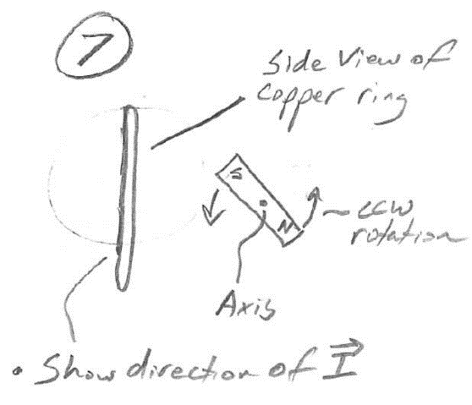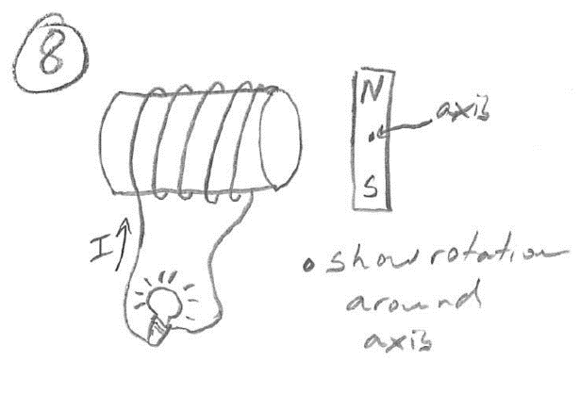

Rotation of the magnet has induced current in the coil, as shown. Infer the magnet’s rotation direction (CW or CCW).

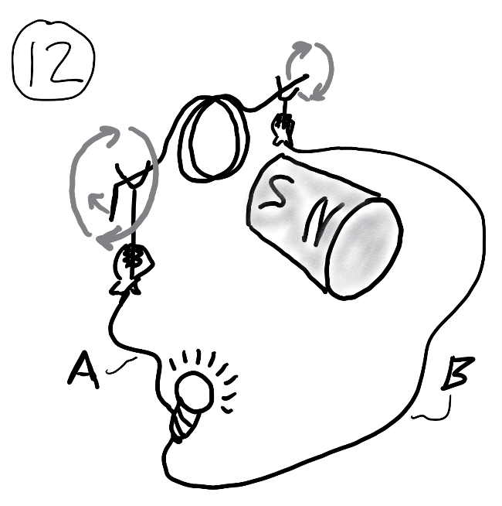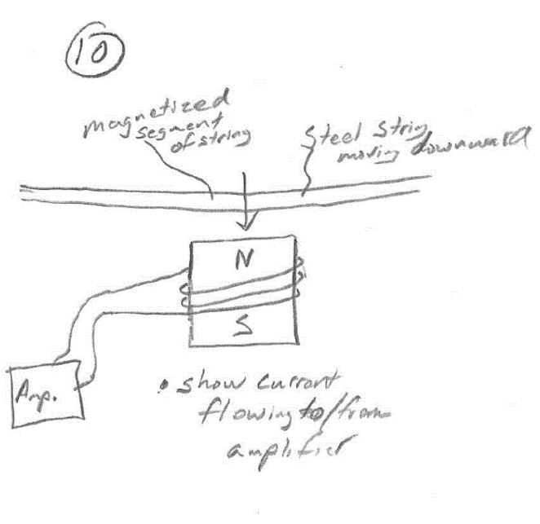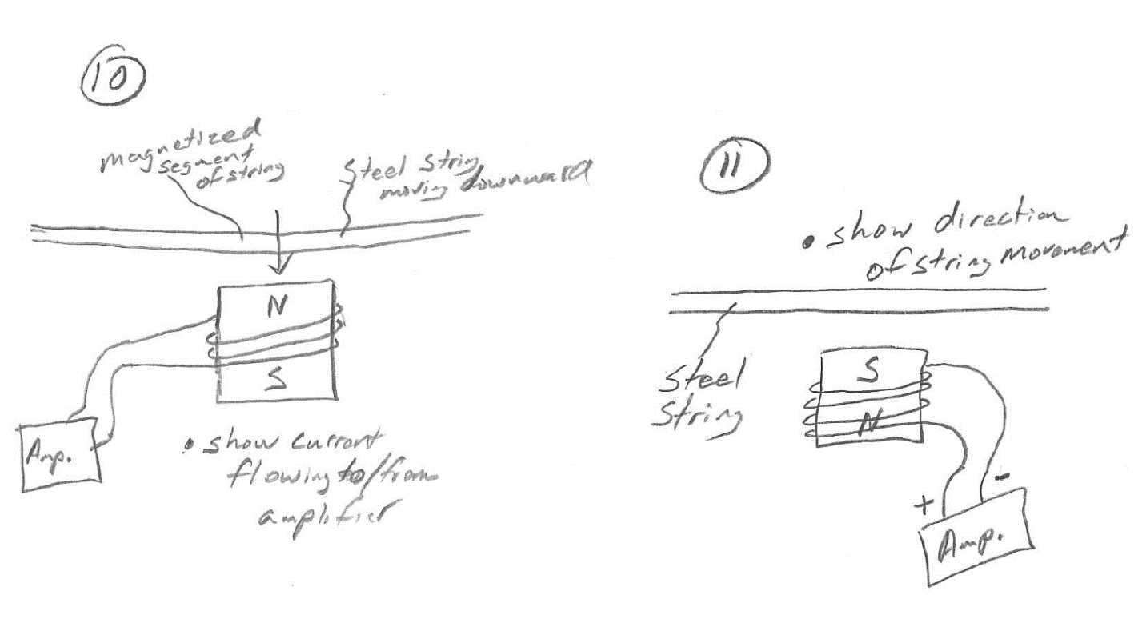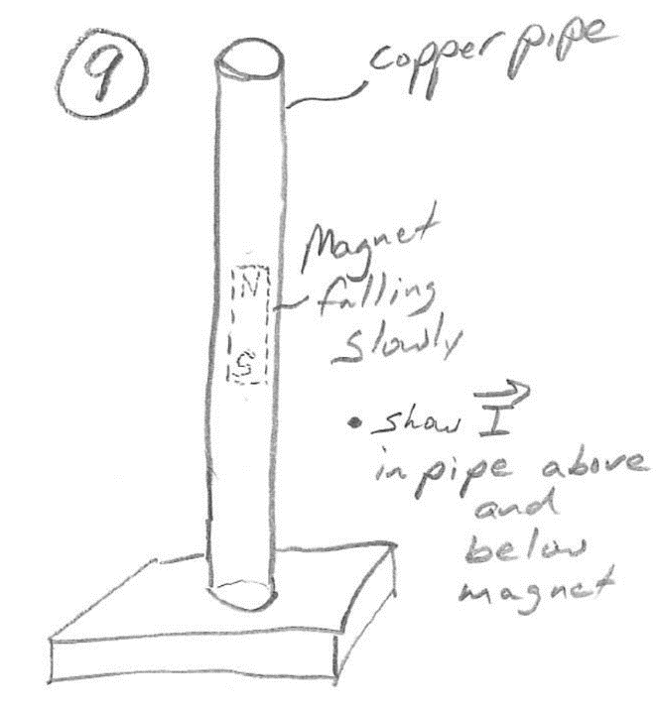

An outside force is rotating the motor coil as shown. Through which wire will the induced current enter the bulb?

Infer the direction of string movement based on the current direction.

The movement of the magnetized steel string induces a current in the coil. Show current direction.

Show the direction of current induced in the copper pipe by the falling magnet. Show current above and below the magnet.

Given that the magnet and coil are repelling, infer the battery terminals.