Physics 200 (Stapleton) Name: _______________________________________
Electricity and Magnetism Practice

Magnetic Fields

1. What is the symbol for magnetic field?
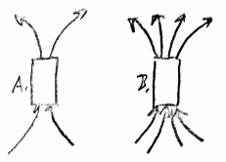
a. M b. B c. I d. F e. E

2. Compared to magnet A, magnet B is _____
a. The same strength b. 2x stronger c. ½ as strong d. 4x stronger e. ¼ as strong

3. A compass needle is a small magnet. Which of the compass’ poles points in the general direction of the Earth’s North Geographic Pole?
a. The needle’s north pole b. The needle’s south pole

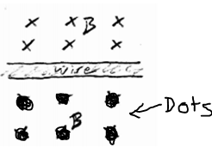
Right Hand Rules

4. Given the magnetic field, B, what is the direction of the current in the wire on the right?
a. Leftward b. rightward

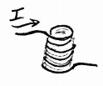
5. What is the direction of the magnetic field inside this solenoid?
A. upward B. Downward
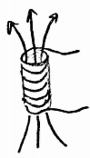

6. Relative to an observer looking downward through the solenoid on the right, which way is current traveling?
a. Clockwise b. Counter-Clockwise

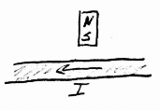
7. What is the direction of the force acting on the wire?
a. Upward (Toward the top margin of this paper)
b. Downward (toward the bottom margin of this paper)
c. Into the paper
d. Out of the paper
e. Leftward

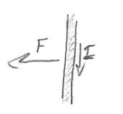
8. Given the directions of the force vector and current, what is the direction of the magnetic field?
A. Leftward B. Rightward C. Into the Paper d. Out of the paper

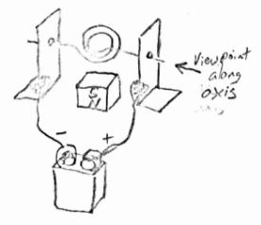
9. In which direction will the motor rotate when viewed along the axle in the indicated direction?
A. Clockwise B. Counter-Clockwise

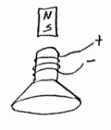
10. In which direction will the voice coil and speaker be pushed by the permanent magnet?
A. Upward B. Downward C. Leftward
D. Rightward E. Clockwise

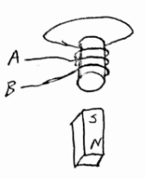
11. If the magnet in the diagram is moving upward, at which letter is charge entering the wire?
A. B.

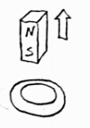
12-15. This drawing shows a “coil” (metal ring) and a permanent magnet. The drawing is a perspective drawing; the thicker section of the ring is closer to the viewer. The arrow shows movement of the permanent magnet, relative to the ring.

12. What is the direction of the permanent magnet’s field?
A. up B. Down C. Left D. right
13. What is happening to the absolute magnitude of the magnetic flux through the coil?
a. Increasing b. Decreasing c. No change
14. What is the direction of the magnetic field that is created in the coil?
A. up B. Down C. Left D. right
15. What is the direction of the induced current along the near side of the coil?
A. up B. Down C. Left D. right

16-19. This drawing shows a “coil” (metal ring) and a permanent magnet. The drawing is a perspective drawing; the thicker section of the ring is closer to the viewer. The arrow shows movement.
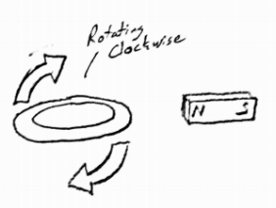
16. What is the direction of the permanent magnet’s field?
A. up B. Down C. Left D. right
17. What is happening to the absolute magnitude of the magnetic flux through the coil?
a. Increasing b. Decreasing c. No change
18. What is the direction of the magnetic field that is created in the coil?
A. up B. Down C. Left D. right
19. What is the direction of the induced current along the near side of the coil?
A. up B. Down C. Left D. right
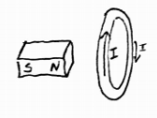
20. In what direction must the magnet be shifted in order to produce a current in the indicated direction? A. Rightward, upward, or downward b. Leftward, upward, or downward
c. Rightward only d. Leftward only e. upward or downward

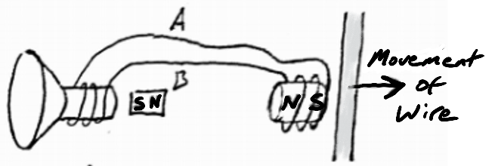
21. In the diagram on the right, through which wire will the current travel leftward, from the speaker voice coil to the pickup? A. Wire A B. Wire B

22. In the same diagram, which way will the voice coil and speaker cone be pushed by the nearby permanent magnet?
A. leftward B. rightward
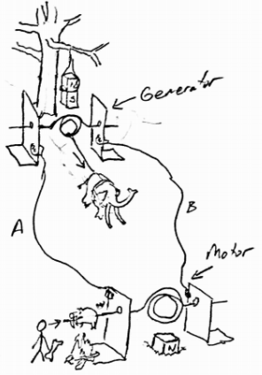
23-24. In their first attempt at creating a rotisserie for roasting pigs and whatnot, the cave people have set up a mammoth-powered generator to drive a motor that will rotate a saber-toothed pig as it cooks over a fire. Notice that they have hung the generator magnet from a tree limb and half-buried the motor magnet in the ground. As you can see, the mammoth is harnessed to the bottom of the generator coil, so the beast will only be able to cause ¼ of a rotation before it must stop (remember, this is the first attempt). Nonetheless, that ¼ rotation will produce current that will travel to the motor and rotate the pig. In the picture, the generator coil is in a vertical plane.

23. When the mammoth pulls the coil, as shown, through which wire will current flow from the generator to the motor?
A. Wire A B. Wire B

24. From the perspective of the cave person, in which direction will the saber-toothed pig rotate as the mammoth pulls the rope.
A. Clockwise B. Counter-Clockwise

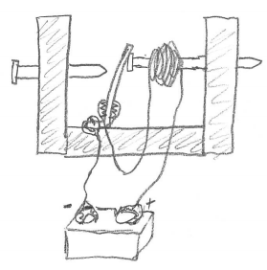
25. Assuming that all of the connections are well-sanded, select all of the following statements that are true about the solenoid buzzer on the right.
A. It will not buzz.
B. Its solenoid is currently turned off
C. Its solenoid is currently turned on
D. Its battery is connected in reverse

26. If you pass electricity through a coil of wire, in the presence of a permanent magnet, you have made a simple _________.
a. Generator b. Motor

27. If you move a magnet in the presence of a coil of wire, you have made a simple _______.
a. Generator b. Motor

