Kinematics Loose Ends and Review Questions Name____________________ Answers
Physics 200

Part 1 Answers: Unit Conversions Practice
Convert the following speeds to miles per hour.
1. 90 km/hr =
2. 20,000 feet/hr = 3.8 mph
3. 5,400 m/hr = 3.3 mph
4. 3.5 m/s = 7.8 mph
Convert the following speeds to meters/second
- 0.034 km/s = 34 m/s
- 650 m/hr = 0.181 m/s
- 65 miles/hr =
- 48 ft/sec = 15 m/s

Part 2 Answers:

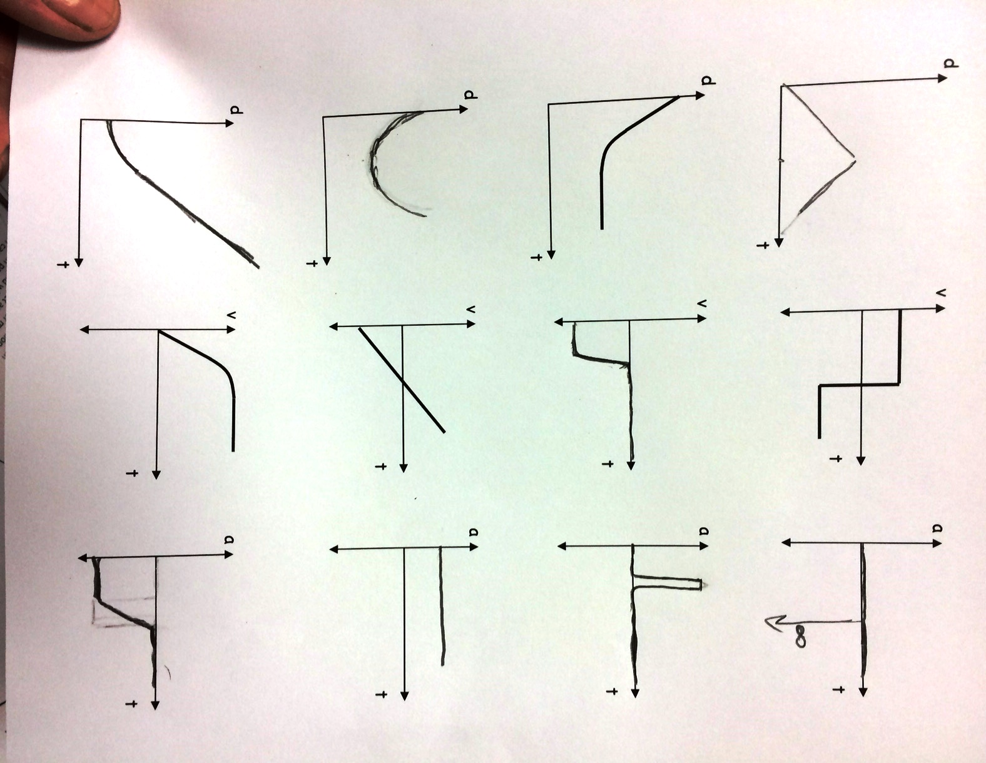
This answer is wrong! Flip it vertically for the correct solution.
Part 3 Answers:

17. The elevator moving from the second floor to the fifth floor is NOT an example of constant acceleration. The elevator accelerates upward each time it starts to move, and it accelerates downward each time it stops.

Ignoring air resistance, a rock falling from a cliff would have a constant acceleration. (If air resistance is included, then the acceleration will be decreasing as the rock falls.) A dish resting on a table has an acceleration of 0, so the acceleration is constant.

18. As an object rises WITH air resistance, the acceleration is larger in magnitude than g, because both gravity and air resistance will be causing a downward acceleration. As the object FALLS with air resistance, the acceleration will be smaller in magnitude than g, because gravity and resistance will be opposing each other. Because of the smaller acceleration being applied over the same distance, the return speed will be slower than the launch speed.

19. Describe an event in which an object would have each of the following characteristics:
 | Velocity | Acceleration | Event Description
a. | Positive | Positive | Moving to the right (or upward) and speeding up.
b. | Positive | Negative | Moving to the right (or upward) and slowing down.
c. | Positive | Zero | Moving to the right (or upward) at a constant speed.
d. | Negative | Positive | Moving to the left (or downward) and slowing down.
e. | Negative | Negative | Moving to the left (or downward) and speeding up.
f. | Negative | Zero | Moving to the at a constant speed.
g. | Zero | Positive | A bouncing ball (or a bungee jumper, or a yo-yo) has reached its lowest point. It is between falling and rising back up.
h. | Zero | Negative | A vertically launched object is at its highest point.
i. | Zero | Zero | An object is motionless.

57. (a) For the free-falling part of the motion, choose downward to be the positive direction, and
to be the height from which the person jumped. The initial velocity is , acceleration is , and the location of the net is . Find the speed upon reaching the net from Eq. (2-11c) with x replaced by y.
The positive root is selected since the person is moving downward.
For the net-stretching part of the motion, choose downward to be the positive direction, and to be the height at which the person first contacts the net. The initial velocity is , the final velocity is , and the location at the stretched position is . Find the acceleration from Eq. (2-11c) with x replaced by y.
(b) For the acceleration to be smaller, in the above equation we see that the displacement would
have to be larger. This means that the net should be .

58. Choose the upward direction to be positive, and to be the level from which the object was thrown. The initial velocity is and the velocity at the top of the path is . The height at the top of the path can be found from Eq. (2-11c) with x replaced by y.
.
From this we see that the displacement is inversely proportional to the acceleration, and so if the acceleration is reduced by a factor of 6 by going to the Moon, and the initial velocity is unchanged, the .

59. The initial velocity of the car is . Choose to be location at which the deceleration begins. We have and . Find the displacement from Eq. (2-11c).

60. Choose downward to be the positive direction, and to be at the height of the bridge. Agent Bond has an initial velocity of , an acceleration of , and will have a displacement of . Find the time of fall from Eq. 2-11b with x replaced by y.
If the truck is approaching with , then he needs to jump when the truck is a distance away given by . Convert this distance into "poles".
So he should jump when the truck is about away from the bridge.

