Physics 200 (Stapleton) Name: _______________________________
Work and Energy, Part 1

Work is the application of a force over a distance. W=Fd. The “distance” is the distance through which the force acts. Technically, the “force” in the equation is only the component of force in the direction of movement. The dot product notation is a reminder of this.

Work units = N•m = Joules (J). [J is also the primary unit we use for energy.]

1. A child pulls a wagon 4m to the right, applying a constant rightward force of 10N. How much work is done?

2. Another child pulls a wagon using a rope. The tension in the rope is 20N, and the rope makes a 45° angle with horizontal. If the child applies this force constantly as the wagon travels 6m, how much work is done?

Power is the rate of work. $P=\frac{W}{t}$ . The units for power that we will use are Watts. 1 Watt = 1J/s. 1horsepower = 746W

3. A 60kg student climbs 12m up a vertical rock wall in 50 seconds. The student’s speed is constant.

a. Approximately how much work did the student do?

b. What was the student’s average power output, in Watts?

c. How long would the climb have taken if the student’s power output had been 1 horsepower?

Energy: Work can be thought of as equivalent to energy. When work is done on an object, the object gains energy. When work is done by an object, the object loses energy.

The Work-Energy Theorem states that W_{net} = ΔKE. [Note that if you are lifted at a constant rate, no net work is done on you; constant rate means no net force.]

The abbreviation KE stands for Kinetic Energy, which is energy of motion. The formula for Kinetic Energy is… $KE=\frac{1}{2 }mv^{2}$, where m = mass and v = velocity.
Energy units are the same as Work units. 1 Joule is derived from the amount of energy required to raise 1kg of water by 1°C. 1calorie = 4.184 Joules. 1 “food calorie” = 1kcal = 1,000 calories = 4,184 Joules. The “calories” used to describe nutrition values are actually kilocalories.

4. When a 0.5kg water rocket is launching, it experiences an average net force of 400N for a distance of 1m. By how much does the rocket’s KE change during this time period?

5. Assuming that the rocket started from rest, use the KE formula to find the rocket’s velocity after accelerating for that one meter.

6. A 2kg package is sliding across a surface with a velocity of 3m/s. The force of friction acting on the package is 1N. How far will the package slide before it stops?

Potential Energy: Potential energy is stored energy. PE can have many forms, including gravitational energy, spring energy, and chemical energy.
PE_{gravitational} : Work done against gravity results in a change in an object’s gravitational potential energy. The minimal possible** work done in the process of lifting an object to a certain height equals the force of gravity multiplied by that height. For objects that are being lifted, this means ΔPE = mgh, where h is the height through which something is lifted. Any object which is already situated at some height can be thought of as having stored gravitational potential energy equal to mgh.

PE_{gravitational} = mgh

Energy Conservation: Unless there is friction, or an external input of energy, the total amount of mechanical energy in a closed system remains constant. KE_{initial} +PE_{initial} = KE_{final} + PE_{final}. The total mechanical energy remains constant, so energy is said to be conserved. This is one form of the Law of Conservation of Energy. [PE_{grav} and KE are mechanical energy; heat is not.]

7. A 3kg watermelon is dropped from a height of 100m. What is its potential energy at its release point (100m)?

8. What is the watermelon’s potential energy when it has fallen to an altitude of 25m?

9. What is the watermelon’s KE when its altitude is 25m?

10. What is the watermelon’s velocity when its altitude is 25m?

Addition or Subtraction of Energy to/from a system: Sometimes work is done on a system. When this happens, energy is either added or removed. Sometimes work takes away energy. In either case, this work is said to be done by “non-conservative forces,” and is labeled W_{nc}. Friction is an example of something that does work to remove energy from a system. In this case, KE_{initial} +PE_{initial} + W_{nc} = KE_{final} + PE_{final}. When there is friction, W_{nc} is a negative number, because friction opposes motion. When something adds energy, W_{nc} is a positive number. In the case of friction, the energy is not really lost, but rather it gets turned into thermal energy. Still, the equation above apples to mechanical energy, not thermal energy.

11. A 20kg child sits at rest at the top of a slide which is 5m long and 3m high. As the child slides down the slide, the child experiences a constant 5N force of friction.

a. What is the child’s total energy at the top of the slide? What form of energy does the child have?

b. How much work is done by friction?

c. How much PE and KE does the child have at the bottom of the slide?

d. What is the child’s speed upon reaching the bottom of the slide?

Work and Energy Practice Problems:

1. A stick pushes a 170g hockey puck with a constant force of 100N over a distance of 0.4m and a time of 0.1 seconds.
a. How much work is done on the puck?
b. How much power does the stick use while it is pushing the puck?
c. Assuming that the puck starts from rest, what is its speed after being pushed by the stick?

2. A dad pulls his daughter in a sled. He drags the sled using a long rope, which is essentially horizontal, maintaining a constant tension of 100N.
a. How much work does the dad do if he pulls his daughter for one mile?
b. A Snickers Bar contains about 260,000 calories of energy. Assuming that the dad’s body is 30% efficient (makes use of only 30% of its energy intake), how many Snickers bars must he eat to replace the energy lost by dragging his daughter around?

3. A 5kg bowling ball is hanging by a cable from the ceiling of a train. The cable makes a 70° angle with the ceiling. During a certain time interval, the train travels 30m.
a. What is the horizontal component of the tension in the cable?
b. How much net work is done on the ball during this time interval?
c. If the velocity of the train and ball were both 10m/s at the beginning of this time interval, what are their velocities at the end of the time interval?

4. Suppose it takes 100J of energy to smash an apple. What horsepower is required to smash 5 apples in 1 seconds?

5. According to Wikipedia, a Ferrari 458 has a mass of 1,565kg, and the car’s maximum acceleration takes it from 0-100km/h (≈27.8m/s) in 3.0 seconds. The tires, which are racing slicks, have a µ_{s} = 0.9 and µ_{k} = 0.6.

a. How much work does the car’s motor do as the car accelerates from 0-100km/h?
b. How much power, in Watts, is required in order to achieve this acceleration?
c. Convert that power to horsepower.
d. If, after reaching 100km/h, the driver stops accelerating and applies the maximum braking force without skidding, how far will the car travel before coming to a stop?
f. How far will the car travel before stopping if the driver brakes too hard, the tires lock, and the car skids to stop?

6. The diagram below shows the path followed by a 200kg car on a roller coaster. Between points A and B, the car is pulled up a slope in the absence of friction. Starting from rest at point A, the car is pulled up the incline by an average force of 1,120N force along 70m of track. By the time it reaches point B, the car’s speed has slowed to 0m/s. At point B, the car begins to accelerate frictionlessly down the slope to C and across a horizontal section to point D. Between points D and E, a constant 500N braking force is applied, but this is not enough to keep the cart from flying off the precipice at point E. Complete the table, below.

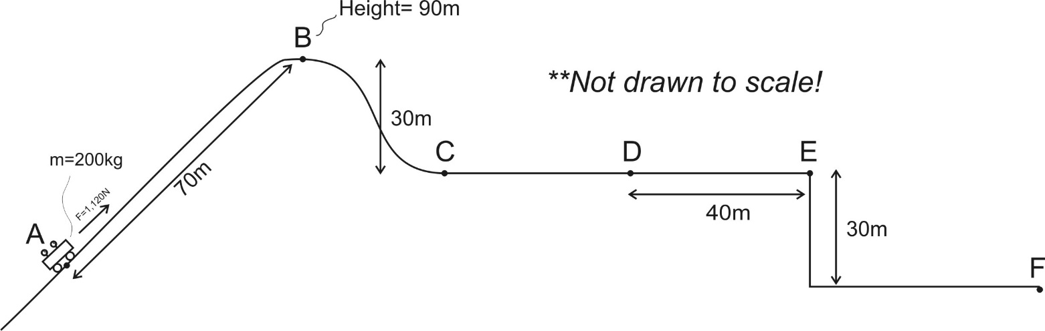

Location | Height (m) | Velocity (m/s) | Potential Energy (J) | Kinetic Energy (J) | Total Energy (J)
A |  | 0
B | 90m | 0
C
D
E
F

