Physics 200 Name: ________________________________
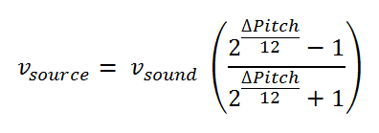
Last Practice Quiz (Instruments, reflection, refraction)

Formulas:
v_{medium} = c = 3.00 x 10⁸ m/s
_{incidence} = _{reflection} n₁ sin _{incidence} = n₂ sin _{refraction}

Part 1: Instruments/Sound:

1. Assuming that each fret on a string instrument represents a change in pitch of one half-step, calculate the distance of the 7th fret from the nut for an instrument with a string length (bridge to nut) of 40cm. [Hint: The frequency of the fundamental does not matter. You can assume any frequency you like.]

2. You are standing next to a highway on a day when the speed of sound is 340m/s. As car approaches you and then speeds past, you pay close attention to its pitch drop. Then you whip out your ukulele and match that pitch drop by plucking a string and playing two different notes. For the first note, you hold the string down at the the 6th fret. For the second note, you hold the string down at the 1st fret. What was the car’s speed? [Note: in the formula at the top of the page, “Δpitch” is the absolute value of the number of half-steps.]

Don’t forget part 2, on the back ↓

Part 2: Reflection and Refraction

Index of Refraction Table
Vacuum | Air | Water | Glass | Diamond
1.000000 | 1.000293 | 1.33 | 1.52 | 2.42

1. The speed of light will be the smallest in

A. a vacuum B. water C. diamond D. air E. glass
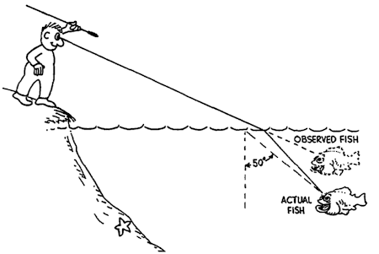
A.
B.
C.

3. Where would the actual fish be in the diagram on the right?

4. In which situation can total internal reflection not occur?

A. water into air B. air into glass

C. glass into water D. glass into air

5. If the speed of light in a transparent material is 1.50 x 10⁸ m/s, what is the index of refraction of this material?

A. 0.33 B. 0.50 C. 2.00

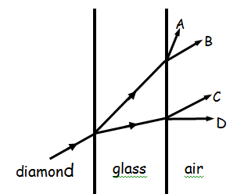
D. 3.00 E. 4.00

10. What path does the light come out? Assume all incident angles are less than the critical angle.

Optics Problems:

1. Find the speed of light in diamond.

2. What is the incident angle for a light beam passing from glass into water if the refracted angle is 35.0º?

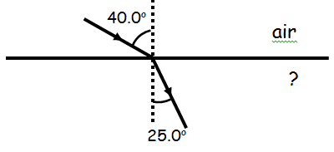

4. Find the index of the unknown material on the right.

B. What material is this?

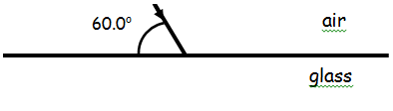

6. Find the angle of refraction.

