Final Exam Review – Physics 200 (2025-2026) Name: __________________________

Helpful Information:
G = 6.67 x 10⁻¹¹ Nm²/kg² M_{Earth} = 5.97 × 10²⁴ kg M_{Moon} = 7.35 x 10²² kg Earth Radius = 6.378 x 10⁶ m Earth Orbital Radius = 1.50 x 10¹¹ m Moon Radius = 1.74 x 10⁶m
q_{electron} = -1.6x10⁻¹⁹C q_{proton} = 1.6x10⁻¹⁹C k = 8.99x10⁹Nm²/C²
Metric Prefixes: n=10⁻⁹ µ = 10⁻⁶ m = 10⁻³

Unit 1 Test: Motion in 1 Dimension

[1-2: be able to do this for any of the 9 combinations of a and v.]
1. Describe an example of motion that has positive acceleration and negative velocity.
2. Describe an example of motion that has negative velocity and negative acceleration.

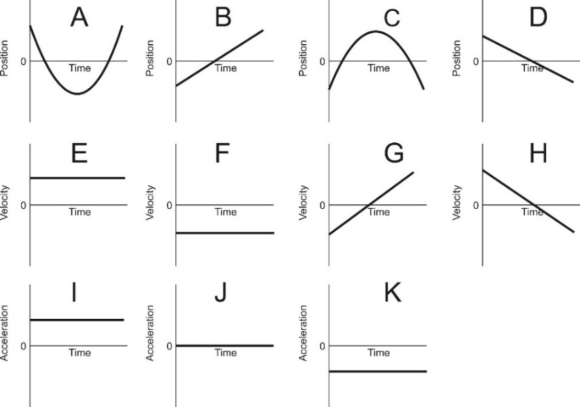
[Be able to match all of the position graphs (A-D) to their corresponding velocity and acceleration graphs.]
6. Which velocity graph represents the same motion as position graph B?
E F G H

7. Which acceleration graph represents the same motion as position graph C?
I J K

8. Which velocity graph represents the same motion as acceleration graph I?
E F G H

9. Which position graph represents the same motion as acceleration graph I?
A B C D

12. [Be able to draw an acceleration graph for some event.] A typical elevator waits for a passenger on the 4th floor of a hotel. The elevator then travels from the 4th floor to the 1st floor. During a portion of this travel time, the elevator’s speed is constant. The elevator stops on the first floor and remains there. Use the timetable to graph the changes in the elevator’s acceleration over this 30 second period. **Assume that upward = positive**

Time | Event
0s | Elevator is waiting motionless on 4th Floor.
5s | Elevator begins traveling toward the 1st floor.
10-20s | Elevator travels at a constant speed toward the first floor
25s | Elevator comes to rest (stops) at the 1st floor.
25-30s | Elevator remains at rest on 1st floor.
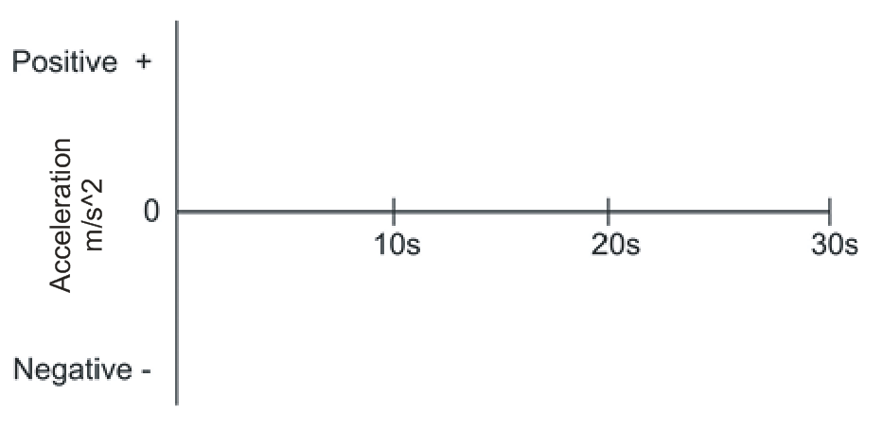

2. A car traveling at a rate of 20m/s begins to accelerate at a rate of 3m/s² in order to pass another car. If this acceleration lasts for 4 seconds, what is the velocity of the passing car at the end of those 4 seconds?

3. How long does it take a racehorse to travel a distance of 300m if it is running at a constant speed of 22m/s?

4. A falling circus performer is stopped by a net. The performer’s velocity is -20m/s when he first touches the net. The net then causes the performer to accelerate at a constant rate of +90 m/s² until he comes to a stop. How far does the performer travel after first touching the net?

5. A grape is shot directly upward in the absence of air resistance. After 15 seconds, the grape returns to the same elevation from which it was launched. How high above the launch point did the grape travel?

Unit 2 Test: Motion in 2 Dimension

The diagram on the right shows a projectile that is launched from left to right in the absence of air resistance. The projectile’s velocity vector (v) at position A is shown on the diagram.

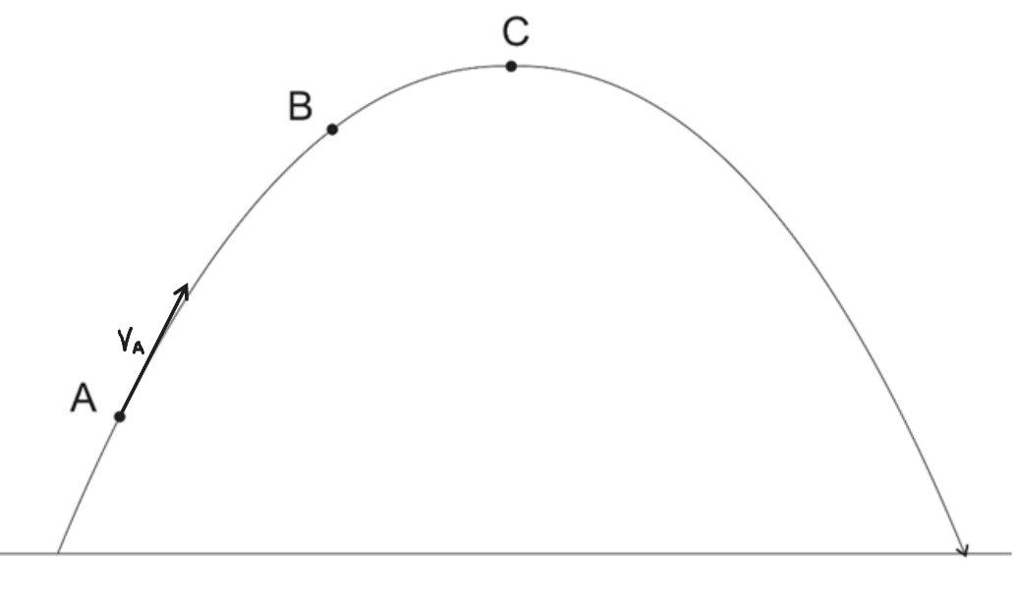
** For these questions, if any vector has a value of zero, don’t try to draw it; just write its name, followed by “= 0.
”
1. Draw and label the x and y components (v_{x} and v_{y}) of the projectile’s velocity at point A. [Make sure that your arrow lengths are correct in comparison to the length of v.]

2. Draw and label all of the projectile’s velocity vectors (v, v_{x}, and v_{y}) at point B. [Make sure that all of your arrow lengths are correct in comparison to one another.]

3. Draw and label all of the projectile’s velocity vectors (v, v_{x}, and v_{y}) at point C. [Make sure that all of your arrow lengths are correct in comparison to one another.]
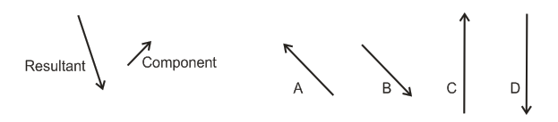
5. Which of the lettered vectors can be added to the component vector to give the resultant vector?

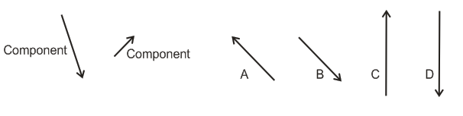
6. Which of the lettered vectors is produced when the two component vectors are added together?

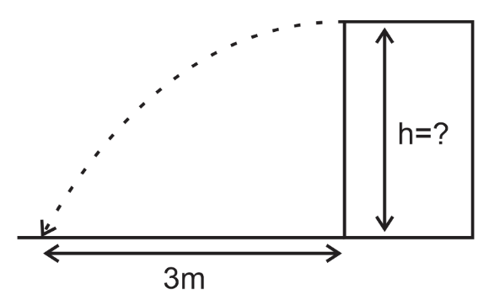
3. You shoot a projectile horizontally from a tabletop. The projectile flies 3m horizontally before it hits the floor. The projectile hits the floor 1 second after its launch.

a. What is the height of the tabletop?

b. What is the projectile’s initial speed as it leaves the tabletop?

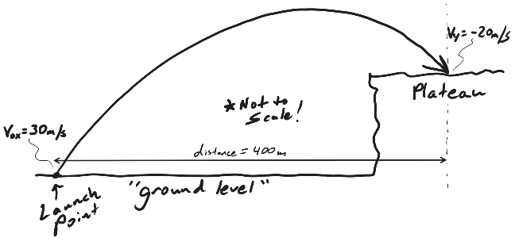
5. A projectile was launched from ground level with an initial x velocity (v_{0x}) of 30m/s. The projectile traveled a horizontal distance of 400m before landing on a plateau, as shown in the diagram. At the moment of impact, the projectile’s y velocity (v_{y}) was -20m/s.

- How much time elapsed during the projectile’s flight?

b. What was the projectile’s initial y velocity (V_{0y})?

c. What was the projectile’s launch angle, relative to the ground?

d. What was the height of the plateau?

Unit 3 Test: Forces / Newton’s Laws

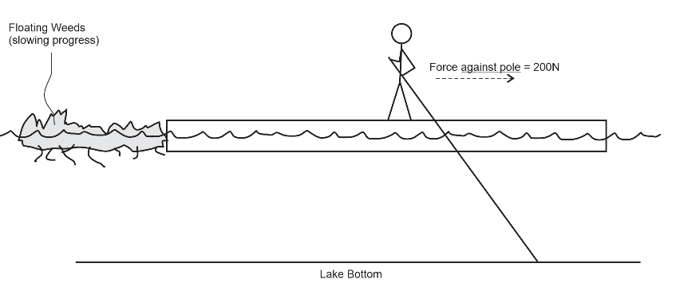
1. A 50kg human is standing on a leftward-moving raft, using a pole to propel the raft leftward (as shown). Despite her efforts, the human and her raft are slowing down due to some floating weeds that are slowing their progress. The accelerations of both the human and her raft are currently 0.5m/s² to our right, and the human is exerting a 200N rightward force on the pole. It is important to note that the human’s feet are not slipping on the raft surface.

Ignoring air resistance, draw all of the forces ACTING ON THE HUMAN. Draw (using arrows), calculate, and label (with a reasonable name) all of the individual forces acting on the human. Also do this for the NET FORCE acting on the human. Make sure that you include correct units with the forces. **Do not draw any forces that are not acting directly on the human.

3. Describe the action and reaction forces that explain how someone begins to walk to the left.

Action:

Reaction:

4. A parachuter steps out of a stationary helicopter and experiences stages A-E, shown below. For each lettered stage, below, use labeled arrows to show the individual forces and net force acting on the rocket. If net force = zero, you do not need an arrow; just use zero. Use the correct names (or at least sensible names) for the forces. Arrow lengths should be proportional to force magnitudes. Assume that there is air resistance.
Stages A-E.  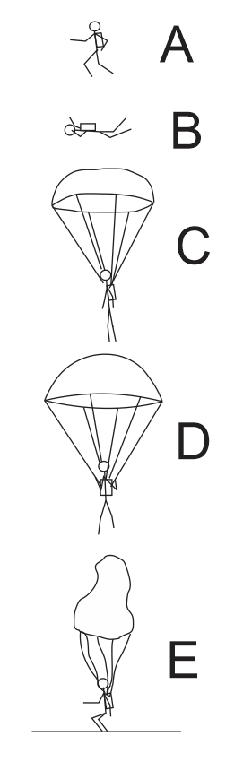 | A. Time = 0; the parachuter has stepped out of the helicopter but has not gained any speed; parachuter speed = 0mph.
B. Between 0s and 5s. Parachuter is falling, and his/her falling speed is increasing. | C. Between 5s and 6s. Chute has deployed, causing the parachuter to slow down.
D. After 6 seconds, the parachuter falls at a constant speed of 8mph. | E. The parachuter has just touched the ground and is in the process of slowing down (before coming to a full stop).

1. A student weighs 800N on Earth. What is their mass?
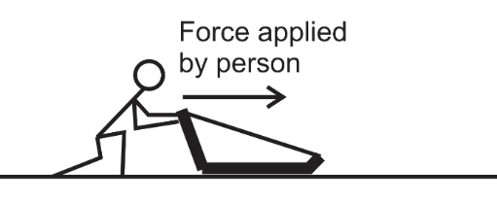
2. A 15kg sled is being pushed horizontally by a person.

a. In a frictionless environment, how much force must the person apply in order accelerate the sled horizontally at a rate of 3m/s²?

b. If the coefficient of friction between the sled and the ground is µ_{k} =0.4, calculate the force of friction while the sled is sliding horizontally to the right.

c. If µ_{k} =0.4, what force does the person need to apply in order to move the sled, horizontally, at a constant velocity?

3. Consider the same 15kg sled, with µ_{k} =0.4. The person applies a constant force that accelerates the sled from an initial velocity of 2m/s to a final velocity of 5m/s, over a distance of 12m.

a. Calculate the sled’s acceleration over this distance.

b. What force does the person apply to the sled in order to cause that acceleration?

Unit 5 Test: Circular Motion and Gravity

1. *[The actual test only asked for tension at one position.] A 0.2kg ball on a string is swinging in vertical circles with a radius of 0.3m. The ball’s speed is constant at 4m/s.

- What is the string tension at the top of the ball’s path?

- What is the string tension at the bottom of the ball’s path?

3. What is the force of gravitational attraction between the Earth and a 65kg astronaut orbiting the Earth at an orbital radius of 35,000km (3.5x10⁷m)? [I mistakenly wrote this as 35,000m on the test, but that doesn’t make sense, because it’s inside the Earth.]

Unit 6 Test: Energy and Work

1. How much work is done on a box that is pushed 6m to the right by a constant rightward net force of 10N?

3. Suppose a 450kg racehorse is initially at rest. For exactly 6 seconds, the horse generates a constant power of 15,000W (about 20.1 horsepower, surprisingly) and uses all of that power to accelerate horizontally. The horse travels across level ground.

a. How much work does the racehorse do during this 6 second period?

b. Assuming that none of this work is lost to “other energy,” what is the kinetic energy of the horse after 6 seconds?

c. What is the horse’s speed at the end of the 6 second interval?

6. Starting from rest, a 600kg roller coaster car leaves point A and travels frictionlessly down a ramp to point B. At point B, the coaster travels horizontally while its brakes apply a -2,500 N force of friction to slow it down. As friction continues to slow the coaster, the coaster contacts a huge spring (k=10,000N/m), finally coming to stop at point C, after compressing the spring a distance of 3m. When the coaster comes to a stop, the spring pushes it back again.
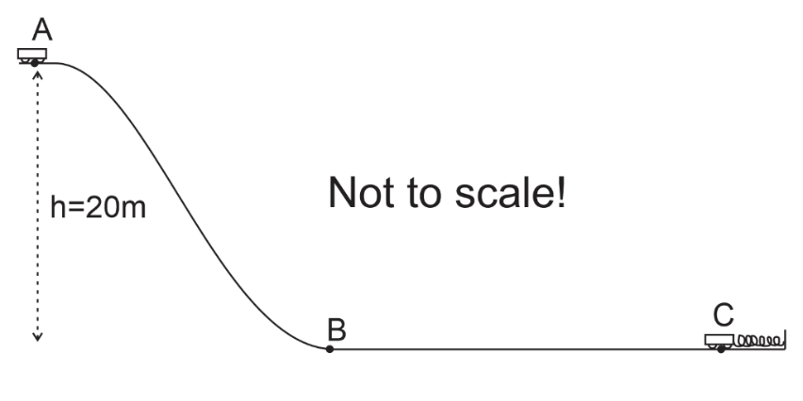

A. Find the coaster’s PE at point A.

B. Find the coaster’s KE at point B.

C. Find the PE stored in the spring, at the moment the coaster comes to rest at point C.

D. Between points B and C the coaster experienced a constant 2,500N force of friction from its brakes. What is the distance from B to C?

E. How much force does the spring exert on the coaster at the moment that the coaster comes to rest (before bouncing back again) at point C?

Unit 7 Test: Momentum and Impulse

2. Ned kicked a 0.4kg rock, exerting an average force of 30N. The rock was stationary before Ned kicked it, and Ned’s applied force lasted for 0.12seconds.

a. What impulse was applied to the rock?

b. (2pts) what was the speed of the rock when it left Ned’s foot?

3. A 15kg child riding a 3kg longboard is moving with a velocity of 4m/s (and so is the longboard). When the child jumps off of the longboard, the board continues in moving in the same direction, but it travels at a new velocity of 8m/s. What is the child’s velocity just after she jumps off?

Unit 8 Test: Rotational Motion
[These problems are from the 2023-2024 rotational motion test.]
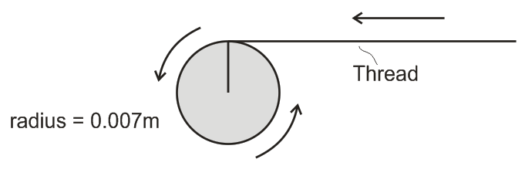
1. A sewing machine bobbin is winding thread. Starting from rest, the bobbin (disk on the right) rotates counter-clockwise, pulling thread leftward and causing the thread to wrap around the bobbin. The bobbin accelerates from rest to 10 revolutions per second over a time of 1.4 seconds. Assume that the bobbin radius remains constant at 0.007m.

a. The bobbin’s final angular speed is 10 revolutions per second. Convert that angular speed to radians per second.

b. What is the final linear (tangential) speed of a point on the edge of the bobbin, in m/s? [Note that this is also the final speed of the thread.]?

c. What is the bobbin’s angular acceleration in rad/s²?
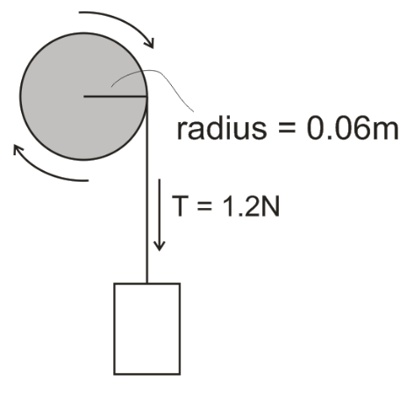
2. A weight is attached to a string that is wrapped around a pulley. When the weight is released, the weight falls and the string tension applies a constant 1.2N force tangent to the edge of the pulley (as shown). Starting from rest, the weight descends over a time of 3 seconds, causing the pulley to turn through 90 radians during that time. The pulley is frictionless, and it has a radius of 0.06m.

a. What is the angular acceleration of the pulley while the weight is falling?

b. What torque is exerted on the pulley by the string?

c. What is the pulley’s moment of inertia (I)? [Note: this should be a small value, far less than 1]

Unit 9 Test: Electric Charges and Electric Field

1. Like charges (such as a negative and a negative) will
A. attract one another B. repel one another
C. both attract and repel one another D. neither attract nor repel one another

3. When a metal conductor is placed in a strong, upward-pointing electric field,
A. electrons in the conductor will move downward, and protons will move upward
B. electrons in the conductor will move upward, and protons will move downward
C. only electrons will move, and they will move downward.
D. only protons will move, and they will move upward.

6. Charge moves most rapidly through which of the following?
A. conductor B. insulator

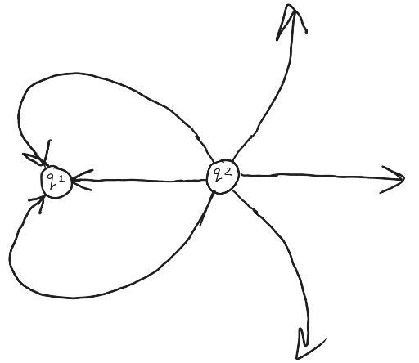
15. Which of these statements is true according to the electric field diagram on the right?
a. q₁ is negative b. q₁ is positive
c. both q₁ and q₂ are positive c. both q₁ and q₂ are negative

16. Which of these statements is true according to the diagram?
a. $\left|q_{1}\right|=2\left|q_{2}\right|$ b. $\left|q_{1}\right|=3\left|q_{2}\right|$
c. $\left|q_{2}\right|=2\left|q_{1}\right|$ d. $\left|q_{2}\right|=3\left|q_{1}\right|$

1. Two objects with equal charge are separated by 0.01m. The attractive force between them is 0.02N. What is the magnitude of one of the charges?

3. A pie pan sitting on top of a negatively charged Van de Graaff generator is repelled upward by the VDG’s electric field. The upward force exerted on the pan is 0.05N, and the electric field magnitude at the pan’s location is 17N/C. position. Find the pan’s charge and the direction of the electric field in the pan’s location.

Pan’s charge: _______________ Electric Field Direction (at the pan’s position): ______________

Unit 10 Test:
I. Matching: Some choices are used more than once.

A. Resistance C. Energy D. Current E. Charge F. Potential Difference G. Power

1. _____ Coulombs per second
2. _____ volt
3. _____ Joules per second
4. _____ watt
6. _____ Coulomb
7. _____ ohm
8. _____ kilowatt-hour
9. _____ Joules per Coulomb
10. _____ ampere

II. More matching! A circuit can be understood as an energy distribution network, and an analogy can be made to a commercial distribution network, like the one orchestrated by Amazon.com. Match the circuit terms to their Amazon distribution analogs. One term won’t be used. No terms will be used twice.

A. Power B. Voltage C. Current D. Resistance E. Charge F. Energy

11. _____ Number of packages on each truck

12. _____ # of packages delivered per day

13. _____ Packages

14. _____ # of trucks making deliveries per day

15. _____ Delivery Truck

16. Find everything for this circuit.

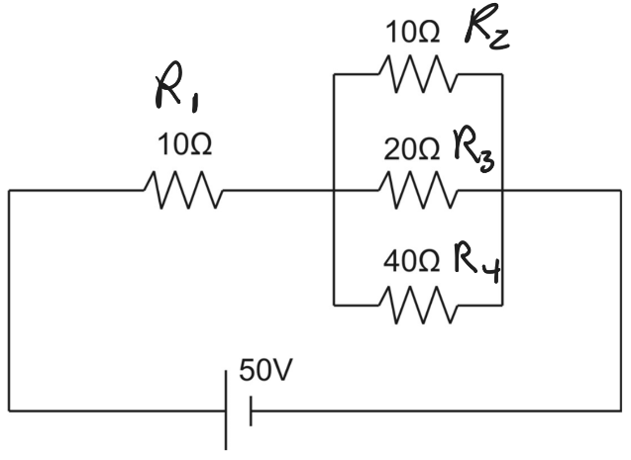

Part 11: Magnetism
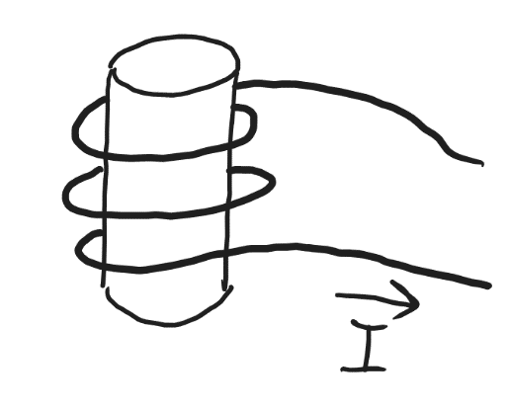
8. The solenoid on the right was made by wrapping current-carrying wire around a hollow tube. What is the direction of the solenoid’s magnetic field?
a. up b. down c. left d. right

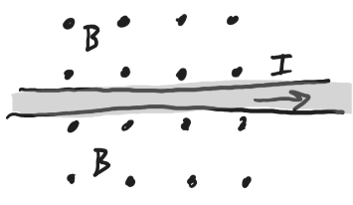
10. The picture below shows the direction of current flowing through a wire. The dots show that the magnetic field direction is into the paper. What is the direction of the force that is exerted on the wire?
a. toward the left side of this paper → b. toward the left side of this paper ←
c. toward the top of this paper ↑ d. toward the bottom of this paper ↓

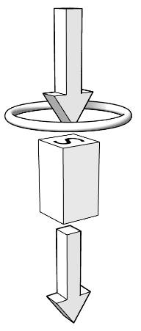
The diagram on the right shows a magnet moving near a conducting ring (coil). The arrows show the magnet’s path. The ring is motionless.

13. Describe the direction of the magnet's field.
a. upward b. downward c. leftward d. rightward
14. At the moment illustrated in the figure, what is happening to the flux of the magnet’s field through the coil?
a. increasing b. decreasing c. no change
15. What is the direction of the magnetic field that will be created by the ring in response to this change in flux?
a. upward b. downward c. leftward d. rightward
16. What is the direction of the induced current in the ring? Specifically, does the current on the near side of the ring move to our left or to our right?
a. leftward b. rightward

