Physics 200 (Stapleton) Name: __________________________
Notes: Circular Motion, Gravity, and Kepler’s Laws

Circular Motion Formulas: *** These formulas only apply to objects undergoing circular motion at a constant speed.
a_{centripetal} = v²/r F_{net centripetal} = ma_{centripetal} = mv²/r

a_{centripetal} is directed toward the center of the circle.

Circular Motion Example Problems:

1. (horizontal circle) A 500kg car drives in a circle with a radius of 20m. If the car maintains a constant speed of 20m/s, what centripetal force acts on the car? If the driving surface is flat and horizontal, what provides the centripetal force?

2. (vertical circle) A 60kg teenager is at the county fair. Currently she is on a circular ride that revolves its passengers in a vertical circle (with horizontal axis of rotation) with a 4m radius. Her speed is kept constant at 7m/s. As she revolves, the teenager is supported by a cushioned pad. Inside the pad is scale that records the normal force exerted on the girl.
a. What is the normal force when she is at the top of the circle?
b. What is the normal force when she is at the bottom of the circle?

Circular Motion Problems:

1. [Horizontal circles – vertical axis] A 0.4kg ball on a string is swinging in circles (in a horizontal plane) at a constant speed of 3m/s. The radius of the orbit (i.e. the string length) is 0.5m and the string is horizontal (because this is happening in the absence of gravity). What is the tension in the string?

2. [Vertical Circles – horizontal axis] A car is approaching a “loop-the-loop” with a radius of 15m. What speed does the car need to maintain in order to maintain contact with the road, even when upside-down?

3. [Vertical Circles] A 20kg child is standing on a bathroom scale inside a Ferris Wheel that is rotating at a constant rate . The speed of the child is a constant 3m/s. If the radius (distance from child/scale to center) of the wheel is 10m, what does the scale read, in Newtons, when the child is at the top of the circle? What does it read when the child is at the bottom?

Newton’s Law of Universal Gravitation:

$F_{gravity}=G\left(\frac{M_{1}m_{1}}{r^{2}}\right)$ , where G is the gravitational constant (an empirically measured quantity), m₁ and m₂ are two different masses, and r is the distance between their centers of mass.

$$G=6.67x{10}^{-11}\frac{{Nm}^{2}}{{kg}^{2}}$$

4. Calculate the force of gravity between a 100kg student and a 60kg student whose centers of mass are 1.7m apart.

5. Derive a formula for g, in terms of the earth’s radius and mass.

6. Find the acceleration of gravity, g, using the Earth’s mass (5.972x10²⁴kg) and average radius (6.731x10⁶m).

7. Derive a formula for the velocity of an object orbiting the Earth in a stable, circular orbit.

8. What is the velocity of a space station that is orbiting the Earth with an orbital radius of 30,000km?

Kepler’s Laws:

Necessary Conditions: a) Orbiting mass is much smaller than the orbited mass (so the orbited mass is essentially stationary); b) The system is isolated from other masses.
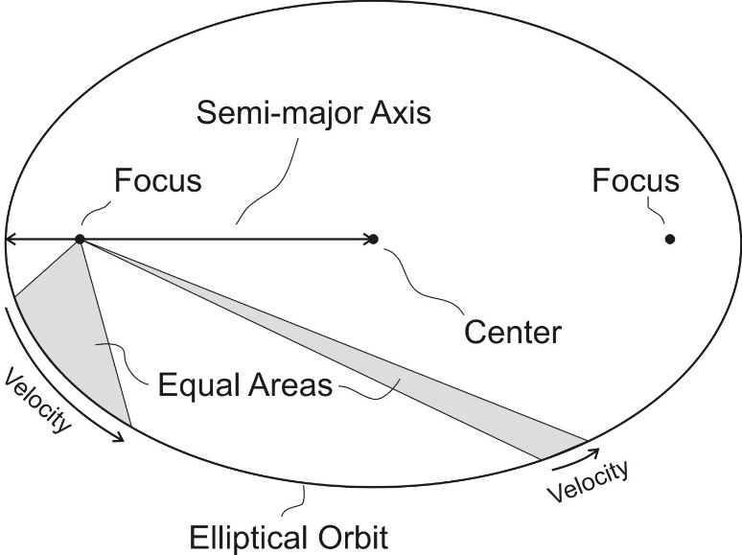
1st Law -- Law of Orbits: All planets move in elliptical orbits with the sun at one focus.

2nd Law -- Law of Areas: A line that connects a planet to the sun sweeps out equal areas in equal times.

3rd Law -- Law of Periods: The ratio of the squares of the periods of any two planets about the Sun is equal to the ratio of the cubes of their average distances from the Sun. For planets A and B with periods T_{A} and T_{B} and average distances r_{A} and r_{B}, orbiting around the same large mass, $\frac{T_{A}^{2}}{T_{B}^{2 }}=\frac{r_{A}^{3}}{r_{B}^{3 }}$.

9. Given that the Moon orbits Earth each 27.3 days and that it is an average distance of 3.84×10⁸m from the center of Earth. Use Kepler’s 3rd Law to calculate the period of an artificial satellite orbiting at an average altitude of 1500 km above Earth’s surface.

1 Astronomical Unit (AU) = Average distance from the center of the Earth to the center of the sun.

9.5. Neptune’s period of revolution is 165 Earth years. What is its distance to the sun, in AU?

Various Problems:

Circular motion:
10. [Vertical Circles] A 50kg adult is standing on a bathroom scale inside a Ferris Wheel that is rotating at a constant rate of 3rpm. If the scale reads 600N when the adult is at the bottom of the Ferris wheel’s circle, what is the wheel’s radius?

11. [Horizontal Circles in 2 Dimensions] A child in her seat are tethered to a rotating carnival ride by a cable that makes a 60° angle with horizontal. The child is 8m from the ride’s axis of rotation. If the total mass of the seat + child equals 60kg and the cable has negligible mass, what is the speed of the child?

Gravity:
12. Calculate the acceleration due to gravity on the surface of the sun, given the sun’s mass (1.99x10³⁰kg) and radius (6.96x10⁸m).

13. A satellite orbits the Earth in a stable orbit at a constant speed of 7,800m/s. What is the satellite’s distance from the center of the Earth?

Kepler’s 3rd Law:
14. Jupiter’s distance from the sun is 5.2 AU (5.2 x farther than the Earth-Sun Distance). How long is a year on Jupiter, in Earth years?

15. Europa orbits the planet Jupiter once every 85.2 hours, at an average radius of 6.7x10⁸m. Ganymede orbits Jupiter once every 172 hours. What is Ganymede’s average orbital radius?

