Physics 200 (Stapleton) Name: _________________________
Circular Motion, Gravity, Kepler
More Conceptual Practice, etc.

Provided Formulas: a_{centripetal} = v²/r F_{centripetal} = mv²/r G = 6.67x10⁻¹¹Nm²/kg²

$F_{gravity}=G\left(\frac{M_{1}m_{1}}{r^{2}}\right)$ $\frac{T_{A}^{2}}{T_{B}^{2 }}=\frac{r_{A}^{3}}{r_{B}^{3 }}$

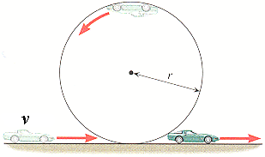
1. A car’s speed is kept constant on a loop-the-loop. If this is true, when does the net force acting on the car equal __________?
[For each of the following values of net force, describe a location (or locations) where that net force is acting on the car. One answer will be “everywhere,” and one will be “nowhere.”]
a. The centripetal force.
b. The weight of the car.
c. The normal force
d. The weight plus the normal force
e. The weight minus the centripetal force

2. If you move twice as far from the Earth’s center, your weight…
a. Doubles b. Quadruples c. Is divided by 2 d. Is divided by 4

3. Planet A is twice as far away from the Sun as Planet B. This means planet A’s orbital period takes ____ as many Earth years.
a. 4x b. 8x c. $√8x$ d. 16x

4. What is the difference between a satellite’s altitude and its orbital radius?

5. A tetherball is rapidly orbiting a central pole. No outside force is being applied to the system. What is pulling the ball away from the pole?

6. Starting with the Universal Law of Gravitation and centripetal force, derive a formula for the speed of a stable orbit around Earth. Show your steps.

7. Provide a formula for g on a planet of Mass M and radius r.

8. A geostationary satellite orbits the Earth in a circular orbit while remaining over one fixed point on the equator. Can such a satellite orbit at a variety of altitudes or at just one altitude? Use one of Kepler’s laws to explain your answer.

9. What does Kepler’s 1st law tell us about planetary orbits?

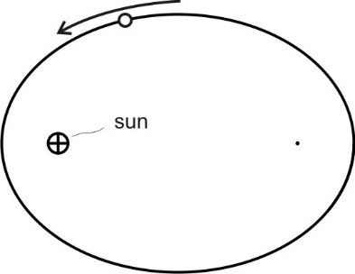

10. On the diagram to the right, label the areas where the planet is speeding up and slowing down.

11 Explain why the planet is speeding up and slowing down in those areas of the diagram.

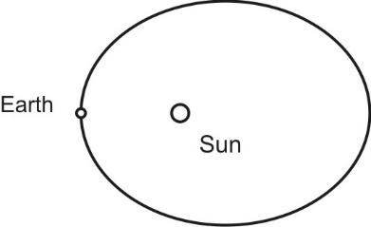
12. In 2017, the Earth was at Perihelion (closest to the sun) on January 4th. We will be at aphelion on July 3rd. In the Northern Hemisphere, are our winters longer than our summers, or are our Summers longer than our winters? Which of Kepler’s Laws gives us the answer to this question? Explain your reasoning.

13. A 1,200kg car follows a semicircular curve at a constant speed. The static coefficient of friction of the car’s tires against the track is µ_{s}=0.7. If the radius of the turn is 50m, and the surface of the track is horizontal, what is the maximum speed at which the car can round the corner without skidding?

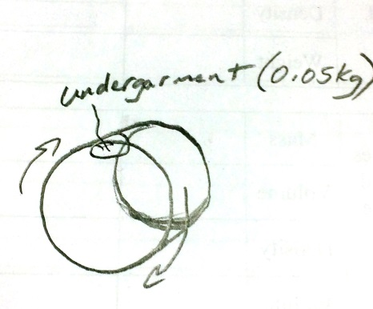

14. A side loading washing machine rotates around a horizontal axis. A 0.05kg undergarment at the top of its orbit during the spin cycle experiences a 4N normal force. The normal force is exerted by the inner wall of the washer drum. If the inner radius of the washing machine drum is 0.3m…
a. How many g’s are being felt by the undergarment?
b. What is the velocity of the undergarment in m/s?

16.1. Two 5kg spheres, each having a radius of 0.68m, are in contact with one another. What is the force of gravitational attraction between them?

16.2. Knowing that the centripetal force on a planet is the gravitational force, derive the exact version of Kepler’s 3rd Law (which could only be done after Newton developed his Universal Law of Gravitation). Show your work.
16.3. Calculate g on Pluto, which has a mass of 1.3x10²²kg and a radius of 1,187km.

17. The Earth’s mass is 5.972x10²⁴kg and its average radius is 6.371x10⁶m. Use these numbers to calculate the velocity of a satellite in a stable, circular orbit at a constant altitude of 28,000km above Earth’s surface.
a. What is the satellite’s orbital radius?
b. What is the satellite’s velocity?

18. a. What is the orbital period of the satellite in the previous question?
b. Use your previous answers to find the orbital radius of a geostationary satellite.

