Name_____________________ Essex High School
Physics 200
Circular Motion, Part 1

Notes:
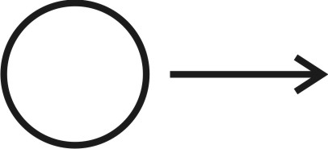
- A sphere is moving to our right. Describe three fundamentally different ways that it can accelerate.

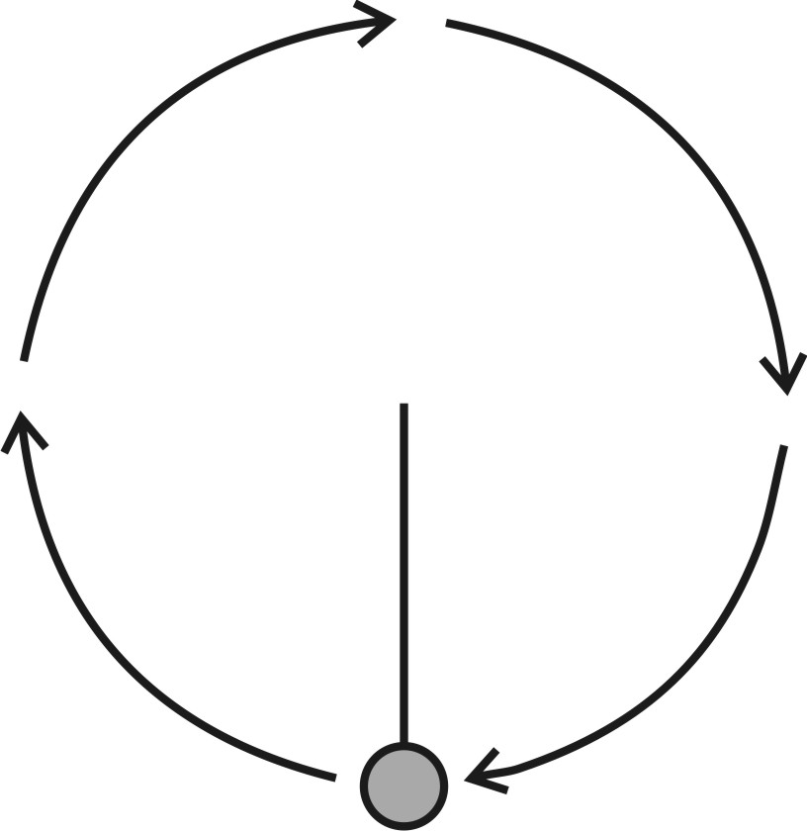

- The ball on the right is attached to a string. The string is held by a student who is swinging the ball in a circle at a constant speed. This is happening in space, in the absence of friction and gravity.
  - Show where the ball would go if the string were released.
  - Explain why the ball would travel in that direction if it were released.

  - Is there a net force acting on the ball, or are the forces balanced? Explain.

  - Is a there a centrifugal force pulling the ball outward, away from the center of the circle? Explain.

  - Is there a centripetal force pulling the ball inward toward the center of the circle?

- Formulas:
  - $centripetal acceleration=\frac{v^{2}}{r}$
  - $centripetal force=\frac{{mv}^{2}}{r}$

- A 500kg motorcycle is traveling at a constant speed of 30m/s in a circle with a radius of 60m.

  - What is the direction of the motorcycle’s acceleration

  - What is the magnitude of the motorcycle’s acceleration?

  - What is the magnitude of the motorcycle’s acceleration, in g’s?

  - What is the magnitude of the net force that is acting on the motorcycle?

  - What source is providing that force?

Circular Motion Mini-Lab
Purpose
The purpose of this lab is to investigate the cause of circular motion and the variables associated with it. Circular motion will be represented by a rubber stopper on the end of a string. We can control the amount of force used to keep the stopper moving in a circle by hooking a mass to the other end of the string and using a smooth tube that allows the stopper and the hanging mass find equilibrium.
m
r
Proper technique in this lab results in the rubber stopper rotating horizontally.

Hold the tube in one hand and the mass in the other. Swing the stopper using your wrist so that it begins to lift the mass from your hand. Then let go of the mass and the circular motion of the stopper will be enough to hold the mass in place. Measure the time for 10 revolutions and the radius of the revolutions.

Time for 10 rev. = ______ s Radius = _______ m
Hanging mass = ______ kg Stopper = _______ kg

The key variables in this activity are:

- Centripetal Force is provided by mass of hanging weight = m × g
- Radius of the Circle
- Period is the time required to make one revolution ( T = seconds ÷ revolutions )
- Frequency is the number of revolutions made per second ( f = 1 ÷ T )
- Rotational Speed in RPMs. Determine the rotational speed of the stopper in RPMs (RPMs = frequency × 60 ).
- Speed is circumference of the motion divided by the period for one revolution (v = 2πr ÷ T).

Continued on the back↓

Circular Motion Lab, continued. Calculate the following,,.

1) The period of the stopper’s motion.

2) The linear velocity of the stopper.

3) The rotational velocity of the stopper in RPMs.

4) The centripetal acceleration of the stopper (m/s² and g’s).

5) The centripetal force (theoretical force needed) needed to keep the stopper moving in a circle.

6) The weight of the hanging mass (actual force needed).

7) The % error between the 2 forces.

