Physics 200 (Stapleton) Name: __________________________
Unit 5 Handout:
Circular Motion and The Law of Gravitation

Circular Motion Formulas: *** These formulas only apply to objects undergoing “uniform circular motion” (i.e. circular motion at a constant speed
a_{centripetal} = v²/r F_{net centripital} = ma_{centripetal} = mv²/r

a_{centripetal} is directed toward the center of the circle.

Circular Motion Example Problems:

1. (horizontal circle) A 500kg car drives in a circle with a radius of 20m. If the car maintains a constant speed of 20m/s, what centripetal force acts on the car? If the driving surface is flat and horizontal, what provides the centripetal force?

2. (vertical circle) A 60kg teenager is riding a roller coaster that is going through several circular “loop-the-loops.” She is currently traveling in a uniform circular path with a radius of 4m, and her speed is constant at 7m/s. A bathroom scale “beneath” her measures the normal force that she experiences.
a. What is the scale reading when she is at the top of the circle (upside-down)?
b. What is the scale reading when she is at the bottom of the circle (right-side-up)?

Circular Motion Practice Problems:

3. [Horizontal circles] A 0.4kg ball on a string is swinging in circles (in a horizontal plane) at a constant speed of 3m/s. The radius of the orbit (i.e. the string length) is 0.5m and the string is horizontal (because this is happening in the absence of gravity). What is the tension in the string?

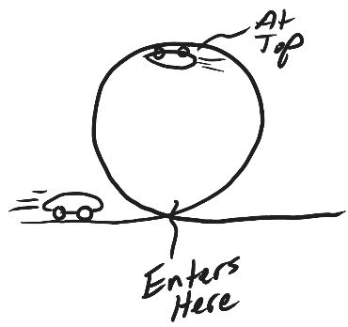

4. [Vertical Circles] A 1,000kg car is approaching a “loop-the-loop” with a radius of 15m. What speed does the car need to maintain in order to experience a normal force at the top of the loop that is equal to the weight of the car? At this speed, what normal force does the car experience when it is at the bottom of the loop?

5. [Vertical Circles] A child weighing 200N is standing on a bathroom scale inside a Ferris Wheel that is rotating at a constant rate. If the radius of the circles made by the child is 10m, and the scale reads 100N at the top, what is the child’s speed? What does the scale read when the child is at the bottom?

Newton’s Law of Universal Gravitation:

$F_{gravity}=G\left(\frac{m_{1}m_{2}}{r^{2}}\right)$ –or-- $G\left(\frac{Mm}{r^{2}}\right)$, where G is the gravitational constant (an empirically measured quantity), m₁ and m₂ are two different masses, and r is the distance between their centers of mass. When one mass orbits the other, r is also referred to as the “orbital radius.” [Often, M is used for a planetary mass, and m is used for its satellite.]

$$G=6.67x{10}^{-11}\frac{{Nm}^{2}}{{kg}^{2}}$$

4. Calculate the force of gravity between a 100kg student and a 60kg student whose centers of mass are 1.7m apart.

Combining Circular Motion and The Law of Gravitation:

5. Find the value of g at Earth’s surface. Earth’s mass is (5.972x10²⁴kg) and its average radius (6.371x10⁶m).

6. Derive a general formula for the value of g at a distance r from the center of a planet with mass M (assuming that this location is at or above the planet’s surface).

8. What is the velocity of a space station that is orbiting the Earth with an orbital radius of 30,000km?

7. Derive a general formula for the speed v of a satellite in a circular orbit – in terms of the orbited planet’s mass M and the satellite’s orbital radius r.

8. Period (T) is the amount of time it takes for a satellite to complete a full orbit. Write equations for: T in terms of v and r; and v in terms of T and r.

9. Find the necessary orbital radius for a geostationary satellite (a satellite that is always over the same point on the equator. You’ll need the Earth’s mass -- 5.972x10²⁴kg.

10. Derive a formula for T in terms of r, G, and the mass of the orbited body (M). Assume that the orbit is uniform and circular. [This is the general form of Kepler’s 3rd Law.]

Physics 200 (Stapleton) Name: ___________________________
Practice Test #1: Circular Motion, Gravitation, Kepler

Conceptual Questions

1. The gravitational force between two masses separated by a distance r is 400 N. If the distance between the two masses (measured from center to the center) is now doubled, the gravitational forces becomes
A. 1600 N B. 800 N C. 400 N D. 200 N E. 100 N

2. A ball of mass m attached to a string is moving in a horizontal circle of radius r with a uniform speed of v. The tension in the string (i.e. the force needed to keep the ball moving in a circle) is F_{T}. If the velocity of the ball decreases to v/3 (i.e. 1/3 its original velocity), what is the new tension in the string?
A. F_{T}/9 B. F_{T}/3 C. F_{T} D. 3F_{T} E. 9F_{T}

3. The acceleration of a free-falling object on some planet, does not depend on which of the following? A. The planet’s mass
B. The object’s mass
C. The distance of the object from the planet’s center
D. The Gravitational Constant

5. When an object experiences uniform circular motion, the direction of the acceleration is
A. in the same direction as the velocity vector.
B. in the opposite direction of the velocity vector.
C. directed toward the center of the circular path.
D. directed away from the center of the circular path.
E. straight down towards the ground.

6. The orbital speed of a planet in our solar system does not depend upon
A. Newton’s gravitational constant G.
B. the Sun's mass.
C. the planet's mass.
D. the planet’s orbital radius

8. Explain or show the difference between a satellite’s orbital radius and its altitude.

Problems:
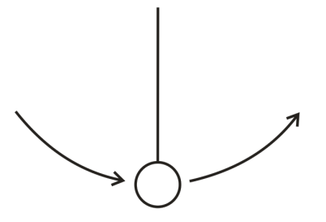
1. [Warning: This is a “trick question.” Read the entire question and pay close attention to the bold words.] A playful lunar explorer swings a ball on a string. The 1kg ball is traveling in 0.5m radius vertical circles at a constant speed of 5m/s. The value of g on the moon is 1.63m/s². Give the magnitude and direction of the net force that is acting on the ball at the top of its swing.

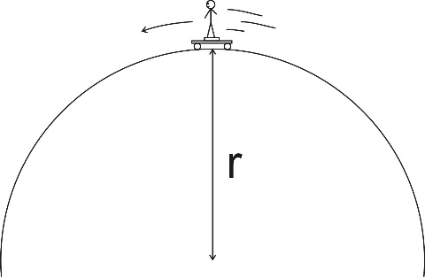
2. A skateboarder stands on a bathroom scale on top of a skateboard as she travels over the top of a circular skate park feature. Her mass is 55kg, and you may assume that her speed is momentarily constant at 8m/s. If the scale reads 400N at the top of the hill, what is the radius of the hill’s curve?

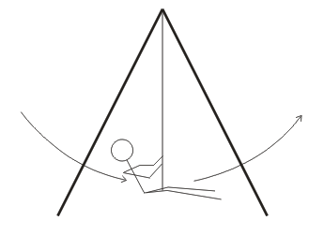
3. A 40kg child is swinging on a massless swing in a vacuum. The child is swinging in arcs with a radius of 3m. At the lowest point in her swing, her speed is 3m/s. Assuming that her speed is constant in this part of her swing, what is the tension in the rope when she is at this lowest point?

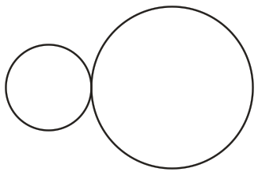
4. One sphere has a radius of 0.1m, and the other sphere has a radius of 0.2m. They both have a mass of 0.7kg, and they are touching. Calculate the gravitational force between them.

5. Use the data at the back of this quiz to find the orbital period of Mars.

6. A satellite orbits the Earth at an altitude (distance above the planet’s surface) of 2x10⁶m. Use the data on the back of this test to solve the following problems related to the satellite.

a. What is the satellite’s orbital radius?

b. What value of “g” is experienced by the satellite?

7. Extraterrestrial explorers insert a satellite into a circular orbit around a newly discovered planet in a distant solar system. The satellite has a period of 1.20x10⁵seconds and an orbital radius of 5.60x10⁷m.

a. What is the speed of the satellite?

b. What is the mass of the planet around which the satellite orbits?

Planetary Data

Name | Planetary Radius (meters) | Mass (kg) | Orbital Radius (meters)
Sun | 696 x 10⁶ | 1.991 x 10³⁰ | -
Mercury | 2.43 x 10⁶ | 3.2 x 10²³ | 5.8 x 10¹⁰
Venus | 6.073 x 10⁶ | 4.88 x 10²⁴ | 1.081 x 10¹¹
Earth | 6.3713 x 10⁶ | 5.979 x 10²⁴ | 1.4957 x 10¹¹
Mars | 3.38 x 10⁶ | 6.42 x 10²³ | 2.278 x 10¹¹

Physics 200 Name: _____________________________

Practice Test #2 (2019-2020 Test): Circular Motion, Gravity, and Kepler’s Laws

I. Multiple Choice (1pt each)

1. A tennis ball is swung in a vertical circle (horizontal axis) at a constant velocity. Where in the swing is the tension in the string the weakest?
A. At the bottom of the swing
B. At the top of the swing
C. Half-way between the top and the bottom, on the way up
D. Half-way between the top and the bottom, on the way down

2. If car goes around a curve of radius r at a constant speed v, the car’s acceleration is…
A. directed towards the curve's center.
B. directed away from the curve's center.
C. directed toward the back of the car.
D. directed toward the front of the car.
E. zero.

3. A ball of mass m attached to a string is moving in a horizontal circle of radius r with a uniform speed of v. The tension in the string (i.e. the force needed to keep the ball moving in a circle) is F_{T}. If the velocity of the ball triples to 3v (i.e. 3 times its original velocity), what is the new tension in the string?
A. F_{T}/9 B. F_{T}/3 C. F_{T} D. 3F_{T} E. 9F_{T}

4. A ball of mass M attached to a string is moving in a horizontal circle of radius r with a uniform speed of v. The tension in the string (i.e. the force needed to keep the ball moving in a circle) is F_{T}. If the mass of the ball increases to 5M(i.e. 5 times its original mass), what is the new tension in the string?
A. F_{T}/25 B. F_{T}/5 C. F_{T} D. 5F_{T} E. 25F_{T}

6. A satellite orbits the Earth with a period of 2 hours. If the mass of the satellite were suddenly doubled, its orbital period would be …
A. 30 minutes b. 1 hour c. $\sqrt{2}$ hours d. 2 hours e. 4 hours

7. The speed of a comet, while traveling in its elliptical orbit around the Sun,
A. is constant.
B. slows to zero at its furthest distance from the Sun.
C. increases as it nears the Sun.
D. decreases as it nears the Sun.

8. The gravitational force between two masses separated by a distance r is 400 N. If the distance between the two masses (measured from center to the center) is now cut in half, the gravitational forces becomes
A. 1600 N B. 800 N C. 400 N D. 200 N E. 100 N

9. The table below presents four planets whose masses and radii are expressed in terms of Earth’s mass (M_{E}) and Earth’s radius (R_{E}). On each planet, a ball of a different mass is dropped from a height of 10m. Neglecting air resistance, in which case will the ball fall fastest?
 | Mass of Planet (Earth masses) | Radius of Planet (Earth radii) | Ball Mass (kg)
A. | 1 M_{E} | 1 R_{E} | 1kg
B. | 4 M_{E} | 2 R_{E} | 6kg
C. | 5 M_{E} | 1 R_{E} | 8kg
D. | 2 M_{E} | 0.5 R_{E} | 2kg

10. A car of mass m is traveling at a constant speed through a circular loop-the-loop of radius r. What normal force does the car experience at the top of the loop? [assume down = negative]
a. mv²/r b. mg c. mv²/r -mg d. 0 e. -mg – F_{N}

11. In order to properly simulate Earth’s gravity, approximately how fast must the outer edge of a cylindrical space station rotate, if the radius of the space station is 5 m?
a. 1m/s b. 3m/s c. 5m/s d. 7m/s e. 9m/s

II. Problems (4pts each): For at least one of the problems, you will need at least one bit of this information. For partial credit, show your work. Box your starting formula(s) and your final answer. All answers must include correct units.

1.00 AU = 1.50 x 10¹¹ m 1.00 y = 3.16 x 10⁷ s
M_{Sun} = 1.99 × 10³⁰ kg M_{Earth} = 5.97 × 10²⁴ kg
M_{Moon} = 7.35 x 10²² kg R_{Earth} = 6.378 x 10⁶ m

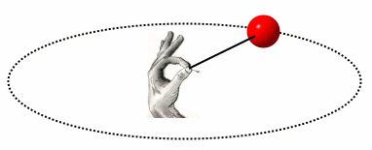
1. A 0.058kg tennis ball on a string travels in a horizontal circle at a constant speed of 6.30 m/s. If the string is 1.15 m long, what is the tension in the string? [Assume that this happens in a gravity-free environment.]

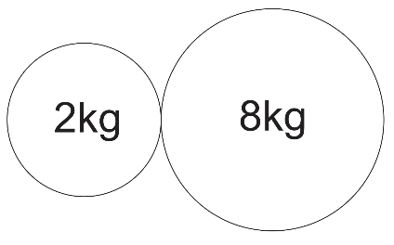
2. The radii of the spheres on the right are 0.1m and 0.15m, respectively. What is the force of gravitational attraction between the two spheres?

3. A 1,500kg car traverses a loop-the-loop with a radius of 5m, maintaining a constant speed the whole time. If, at the top of the loop, the car is being pushed downward by a normal force of 5,000N, what is the car’s speed?

4. A 60kg student is on a ride called the Ring of Fire, which travels in vertical circles. At the bottom of one of the circles, the student is traveling at a speed of 11 m/s. Furthermore, the bathroom scale that is supporting her suggests that her weight is three times its normal value. Assuming that her speed is constant, what is the radius of the circle in which the student is traveling?

5. An asteroid traveling in a circular orbit circles the Sun once every 4.20 Earth years.
a. What is the radius of the asteroid’s orbit?

b. What is the asteroid’s speed?

6. A satellite is launched into a circular orbit that is 4.22 x 10⁷ m from the center of Earth. What is its speed once it is in this stable orbit?

7. To what altitude would you have to shoot a cannonball so that, at its highest point, it would begin to free-fall back to Earth with an acceleration of -5m/s²? [In other words, so that g would equal 5m/s at that point]

