Physics 200 (Stapleton) Name: __________________________
Unit 7 Packet:
Circular Motion, Gravity, and Kepler’s Laws

Notes, Part 1:

Circular Motion Formulas: *** These formulas only apply to objects undergoing circular motion at a constant speed.
a_{centripetal} = v²/r F_{net centripital} = ma_{centripetal} = mv²/r

a_{centripetal} is directed toward the center of the circle.

Circular Motion Example Problems:

1. (horizontal circle) A 500kg car drives in a circle with a radius of 20m. If the car maintains a constant speed of 20m/s, what centripetal force acts on the car? If the driving surface is flat and horizontal, what provides the centripetal force?

2. (vertical circle) A 60kg teenager is at the county fair. Currently she is on a circular ride that revolves its passengers in a vertical circle with a 4m radius. Her speed is kept constant at 7m/s. As she revolves, the teenager is supported by a cushioned pad. Inside the pad is scale that records the normal force exerted on the girl.
a. What is the normal force when she is at the top of the circle?
b. What is the normal force when she is at the bottom of the circle?

Circular Motion Problems:

1. [Horizontal circles] A 0.4kg ball on a string is swinging in circles (in a horizontal plane) at a constant speed of 3m/s. The radius of the orbit (i.e. the string length) is 0.5m and the string is horizontal (because this is happening in the absence of gravity). What is the tension in the string?

2. [Vertical Circles] A car is approaching a “loop-the-loop” with a radius of 15m. What speed does the car need to maintain in order to maintain contact with the road, even when upside-down?

3. [Vertical Circles] A 20kg child is standing on a bathroom scale inside a Ferris Wheel that is rotating at a constant rate . The speed of the child is a constant 3m/s. If the radius (distance from child/scale to center) of the wheel is 10m, what does the scale read, in Newtons, when the child is at the top of the circle? What does it read when the child is at the bottom?

Newton’s Law of Universal Gravitation:

$F_{gravity}=G\left(\frac{m_{1}m_{2}}{r^{2}}\right)$ –or-- $G\left(\frac{Mm}{r^{2}}\right)$, where G is the gravitational constant (an empirically measured quantity), m₁ and m₂ are two different masses, and r is the distance between their centers of mass. [Often, M is used for a planetary mass, and m is used for its satellite.]

$$G=6.67x{10}^{-11}\frac{{Nm}^{2}}{{kg}^{2}}$$

4. Calculate the force of gravity between a 100kg student and a 60kg student whose centers of mass are 1.7m apart.

5. Derive a formula for g, in terms of the earth’s radius and mass.

6. Find the acceleration of gravity, g, using the Earth’s mass (5.972x10²⁴kg) and average radius (6.371x10⁶m).

7. Derive a formula for the velocity of an object orbiting the Earth in a stable, circular orbit.

8. What is the velocity of a space station that is orbiting the Earth with an orbital radius of 30,000km?

Kepler’s Laws:

Necessary Conditions: a) Orbiting mass is much smaller than the orbited mass (so the orbited mass is essentially stationary); b) The system is isolated from other masses.
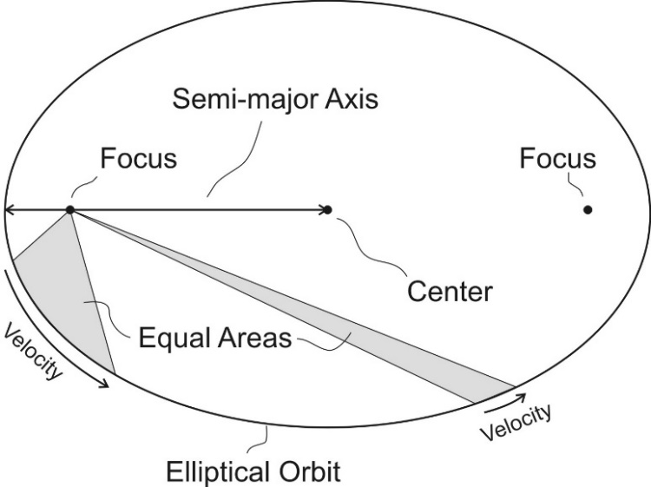
1st Law -- Law of Orbits: All planets move in elliptical orbits with the sun at one focus.

2nd Law -- Law of Areas: A segment that connects a planet to the sun sweeps out equal areas in equal times.

3rd Law -- Law of Periods: The ratio of the squares of the periods of any two planets about the Sun is equal to the ratio of the cubes of their average orbital radii around the Sun. For planets A and B with periods T_{A} and T_{B} and average distances r_{A} and r_{B}, orbiting around the same large mass, $\frac{T_{A}^{2}}{T_{B}^{2 }}=\frac{r_{A}^{3}}{r_{B}^{3 }}$.
[$And therefore\frac{r_{B}^{3}}{T_{B}^{2 }}=\frac{r_{A}^{3}}{T_{A}^{2,}}, or \frac{T^{2}}{r^{3}}is constant for all planets in a solar system.]$
[T = “period” = time to revolve once]

9. Given that the Moon orbits Earth each 27.3 days and that it is an average distance of 3.84×10⁸m from the center of Earth. Use Kepler’s 3rd Law to calculate the period of an artificial satellite with an orbital radius of 7.87X10⁶m.

1 Astronomical Unit (AU) = Average distance from the center of the Earth to the center of the sun.

9.5. Neptune’s period of revolution is 165 Earth years. What is its distance to the sun, in AU?

Various Practice Problems:

Circular motion:
10. [Vertical Circles] A 50kg adult is standing on a bathroom scale inside a Ferris Wheel that is rotating at a constant rate of 4m/s. If the scale reads 600N when the adult is at the bottom of the Ferris wheel’s circle, what is the wheel’s radius?

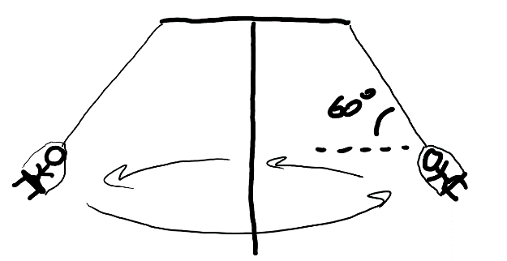
11. [Horizontal Circles in 2 Dimensions] A child in her seat are tethered to a rotating carnival ride by a cable that makes a 60° angle with horizontal. The child is 8m from the ride’s axis of rotation. If the total mass of the seat + child equals 60kg and the cable has negligible mass, what is the speed of the child?

Gravity:
12. Calculate the acceleration due to gravity on the surface of the sun, given the sun’s mass (1.99x10³⁰kg) and radius (6.96x10⁸m).

13. A satellite orbits the Earth in a stable orbit at a constant speed of 7,800m/s. What is the satellite’s distance from the center of the Earth?

Kepler’s 3rd Law:
14. Jupiter’s distance from the sun is 5.2 AU (5.2 x farther than the Earth-Sun Distance). How long is a year on Jupiter, in Earth years?

15. Europa orbits the planet Jupiter once every 85.2 hours, at an average radius of 6.7x10⁸m. Ganymede orbits Jupiter once every 172 hours. What is Ganymede’s average orbital radius?

Elliptical Orbits
Preparation: Make a loop of string with a circumference about 1.5-2 inches longer than the distance between the Sun and the dot on the graph below. Place tacks at the sun and the dot.

1. Place your loop around the tacks and use the tacks and string to draw a nice ellipse. Label these points on the ellipse: point 1 (perihelion – closest to the Sun), 2 (top center of orbit – 12:00 if it’s a clock), and 3 (aphelion – furthest from the Sun).

2. Draw a straight segments from Point 1 to the Sun and from Point 2 to the sun. Then estimate the number of squares in the region enclosed by these two segments. Imagine this is the area “swept out” by a planet in one week, as it travels from point 1 to point 2. Kepler’s Law of Equal Areas says that the planet sweeps out equal areas in equal times. Use that area to predict where the planet will be one week after position 3 (when it has again swept out the same area as it did between 1 and 2 – hint: use triangles). Label that new point 4. Draw straight segments from the Sun to 3 and the Sun to 4.

Approximately how many squares were swept out between… 1&2: ________ 3&4: ________

3. Draw force vectors at each point (1,2,3, and 4) representing the gravitational force acting on the planet. Make sure that your vectors’ lengths are reasonable and that their directions are correct.

4. Draw velocity vectors tangential to the elliptical path at points 1, 2, 3, and 4. Make sure that your vectors’ lengths are reasonable and that their directions are correct.

Fill in the chart below.

Point | Angle between force and velocity? (circle the best answer) | What is happening to its speed? (circle one) | Changing direction? (circle one) | Overall speed (circle one)
1  Perihelion  (closest to the Sun) | 180˚  obtuse  90˚  acute  0˚ | Speeding up  Staying the same  Slowing down  Undefined | Yes  No | Slowest  Slower  Faster  Fastest
2 | 180˚  obtuse  90˚  acute  0˚ | Speeding up  Staying the same  Slowing down  Undefined | Yes  No | Slowest  Slower  Faster  Fastest
3  Aphelion  (farthest from the Sun) | 180˚  obtuse  90˚  acute  0˚ | Speeding up  Staying the same  Slowing down  Undefined | Yes  No | Slowest  Slower  Faster  Fastest
4 | 180˚  obtuse  90˚  acute  0˚ | Speeding up  Staying the same  Slowing down  Undefined | Yes  No | Slowest  Slower  Faster  Fastest
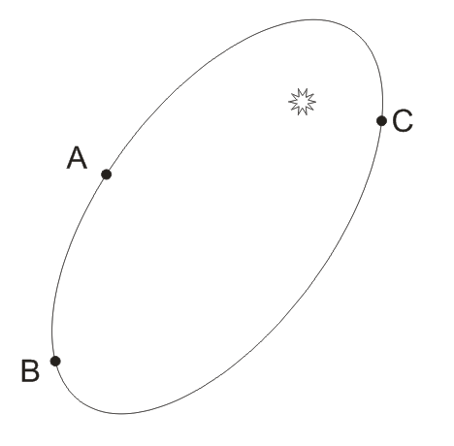

5. If an asteroid traveled from A to B in one Earth Year. At what approximate location would it end up one Earth year after leaving point C? Label this point D.

6. If an asteroid traveled from C to A in one Earth Year. At what approximate location would it end up one Earth year after leaving point B? Label this point E.

Physics 200 (Stapleton) Name: ___________________________
Practice Test #1: Circular Motion, Gravitation, Kepler

Conceptual Questions

1. The gravitational force between two masses separated by a distance r is 400 N. If the distance between the two masses (measured from center to the center) is now doubled, the gravitational forces becomes
A. 1600 N B. 800 N C. 400 N D. 200 N E. 100 N

2. A ball of mass m attached to a string is moving in a horizontal circle of radius r with a uniform speed of v. The tension in the string (i.e. the force needed to keep the ball moving in a circle) is F_{T}. If the velocity of the ball decreases to v/3 (i.e. 1/3 its original velocity), what is the new tension in the string?
A. F_{T}/9 B. F_{T}/3 C. F_{T} D. 3F_{T} E. 9F_{T}

3. The acceleration of a free-falling object on some planet, does not depend on which of the following? A. The planet’s mass B. The object’s mass
C. The distance of the object from the planet’s center D. The Gravitational Constant

4. The term “astronomic unit” is defined as
A. the average distance between the Earth and the Moon.
B. the average diameter of the Moon’s orbit about the Earth.
C. the average distance between the Earth and the Sun.
D. the average diameter of Earth’s orbit about the Sun.
E. the orbital period of Earth.

5. When an object experiences uniform circular motion, the direction of the acceleration is
A. in the same direction as the velocity vector.
B. in the opposite direction of the velocity vector.
C. directed toward the center of the circular path.
D. directed away from the center of the circular path.
E. straight down towards the ground.

6. The orbital speed of a planet in our solar system does not depend upon
A. Newton’s gravitational constant G.
B. the Sun's mass.
C. the planet's mass.
D. the planet’s orbital radius

7. a. Which planets in our solar system have the longest orbital periods (the incomplete table on the last page of this test may be helpful)?

b. Choose one of Kepler’s Laws and explain how it supports your answer to part A.

8. Explain or show the difference between a satellite’s orbital radius and its altitude.

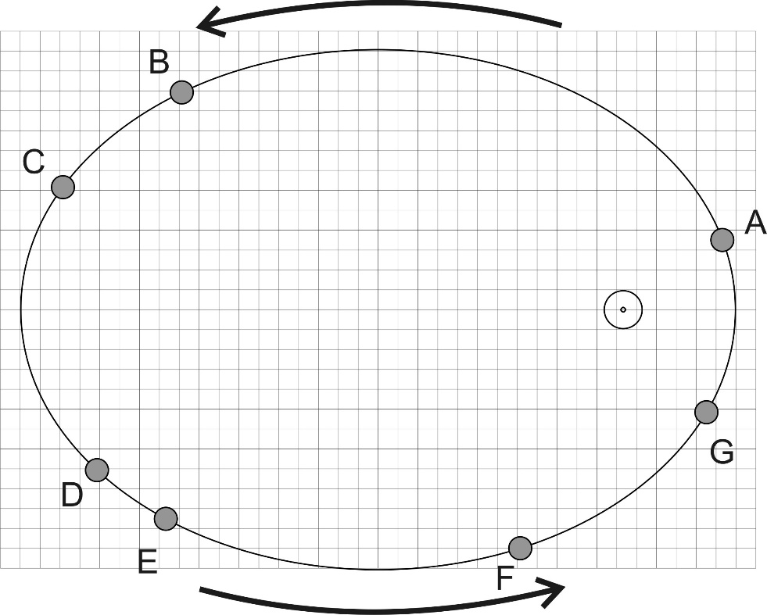
9. The diagram on the right shows the orbit of a planet around the sun. Consider the time it takes the planet to travel from point C to D, from point D to E, from point E to F, etc., until you have considered each of the intervals listed below. Then circle the two distance intervals that the planet would traverse in equal travel times. Just to be clear, you are circling two intervals from the five choices below.

C to D D to E
E to F F to G
G to A

10. Rank the all of the lettered locations in order of the speed of the satellite at each location. List them from fastest to slowest.

Fastest: _____,______,______,______,______,______,______

11. At points B and F on the diagram, draw and label vectors for velocity and gravitational force. Lengths must be proportional to magnitude.

Problems:
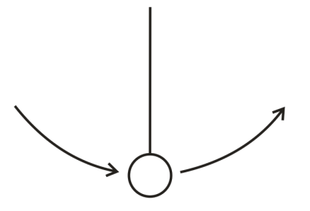
1. [Warning: This is a “trick question.” Read the entire question and pay close attention to the bold words.] A playful lunar explorer swings a ball on a string. The 1kg ball is traveling in 0.5m radius vertical circles at a constant speed of 5m/s. The value of g on the moon is 1.63m/s². Give the magnitude and direction of the net force that is acting on the ball at the top of its swing.

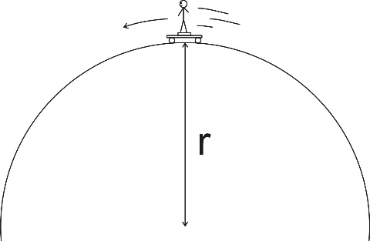
2. A skateboarder stands on a bathroom scale on top of a skateboard as she travels over the top of a circular skate park feature. Her mass is 55kg, and you may assume that her speed is momentarily constant at 8m/s. If the scale reads 400N at the top of the hill, what is the radius of the hill’s curve?

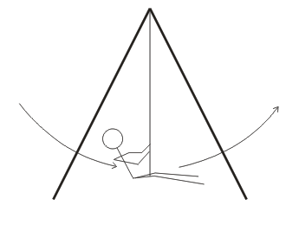
3. A 40kg child is swinging on a massless swing in a vacuum. The child is swinging in arcs with a radius of 3m. At the lowest point in her swing, her speed is 3m/s. Assuming that her speed is constant in this part of her swing, what is the tension in the rope when she is at this lowest point?

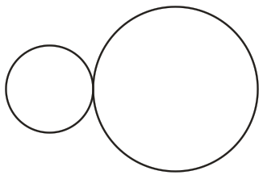
4. One sphere has a radius of 0.1m, and the other sphere has a radius of 0.2m. They both have a mass of 0.7kg, and they are touching. Calculate the gravitational force between them.

5. Use your knowledge of the Earth’s orbit and the data at the back of this quiz to find the orbital period of Mars, in Earth years.

6. A satellite orbits the Earth at an altitude of 2x10⁶m. Use the data on the back of this test to solve the following problems related to the satellite.

a. What is the satellite’s orbital radius?

b. What value of “g” is experienced by the satellite?

7. Extraterrestrial explorers insert a satellite into a circular orbit around a newly discovered planet in a distant solar system. The satellite has a period of 1.20x10⁵seconds and an orbital radius of 5.60x10⁷m.

a. What is the speed of the satellite?

b. What is the mass of the planet around which the satellite orbits?

Planetary Data

Name | Planetary Radius (meters) | Mass (kg) | Orbital Radius (meters)
Sun | 696 x 10⁶ | 1.991 x 10³⁰ | -
Mercury | 2.43 x 10⁶ | 3.2 x 10²³ | 5.8 x 10¹⁰
Venus | 6.073 x 10⁶ | 4.88 x 10²⁴ | 1.081 x 10¹¹
Earth | 6.3713 x 10⁶ | 5.979 x 10²⁴ | 1.4957 x 10¹¹
Mars | 3.38 x 10⁶ | 6.42 x 10²³ | 2.278 x 10¹¹

Physics 200 Name: _____________________________

Practice Test #2 (2019-2020 Test): Circular Motion, Gravity, and Kepler’s Laws

I. Multiple Choice (1pt each)

1. A tennis ball is swung in a vertical circle (horizontal axis) at a constant velocity. Where in the swing is the tension in the string the weakest?
A. At the bottom of the swing
B. At the top of the swing
C. Half-way between the top and the bottom, on the way up
D. Half-way between the top and the bottom, on the way down

2. If car goes around a curve of radius r at a constant speed v, the car’s acceleration is…
A. directed towards the curve's center.
B. directed away from the curve's center.
C. directed toward the back of the car.
D. directed toward the front of the car.
E. zero.

3. A ball of mass m attached to a string is moving in a horizontal circle of radius r with a uniform speed of v. The tension in the string (i.e. the force needed to keep the ball moving in a circle) is F_{T}. If the velocity of the ball triples to 3v (i.e. 3 times its original velocity), what is the new tension in the string?
A. F_{T}/9 B. F_{T}/3 C. F_{T} D. 3F_{T} E. 9F_{T}

4. A ball of mass M attached to a string is moving in a horizontal circle of radius r with a uniform speed of v. The tension in the string (i.e. the force needed to keep the ball moving in a circle) is F_{T}. If the mass of the ball increases to 5M(i.e. 5 times its original mass), what is the new tension in the string?
A. F_{T}/25 B. F_{T}/5 C. F_{T} D. 5F_{T} E. 25F_{T}

5. Which is not one of Kepler’s 3 Laws?
A. Planets orbit the Sun in ellipses
B. An imaginary segment drawn between the Sun and the planet sweeps out equal areas in equal times
C. A planet’s centripetal acceleration is proportional to its velocity squared.
D. The square of a planet’s period is proportional to the cube of its orbital radius

6. A satellite orbits the Earth with a period of 2 hours. If the mass of the satellite were suddenly doubled, its orbital period would be …
A. 30 minutes b. 1 hour c. $\sqrt{2}$ hours d. 2 hours e. 4 hours

7. The speed of a comet, while traveling in its elliptical orbit around the Sun,
A. is constant.
B. slows to zero at its furthest distance from the Sun.
C. increases as it nears the Sun.
D. decreases as it nears the Sun.
8. The gravitational force between two masses separated by a distance r is 400 N. If the distance between the two masses (measured from center to the center) is now cut in half, the gravitational forces becomes
A. 1600 N B. 800 N C. 400 N D. 200 N E. 100 N

9. The table below presents four planets whose masses and radii are expressed in terms of Earth’s mass (M_{E}) and Earth’s radius (R_{E}). On each planet, a ball of a different mass is dropped from a height of 10m. Neglecting air resistance, in which case will the ball fall fastest?
 | Mass of Planet (Earth masses) | Radius of Planet (Earth radii) | Ball Mass (kg)
A. | 1 M_{E} | 1 R_{E} | 1kg
B. | 4 M_{E} | 2 R_{E} | 6kg
C. | 5 M_{E} | 1 R_{E} | 8kg
D. | 2 M_{E} | 0.5 R_{E} | 2kg

10. A car of mass m is traveling at a constant speed through a circular loop-the-loop of radius r. What normal force does the car experience at the top of the loop? [assume down = negative]
a. mv²/r b. mg c. mv²/r -mg d. 0 e. -mg – F_{N}

11. In order to properly simulate Earth’s gravity, approximately how fast must the outer edge of a cylindrical space station rotate, if the radius of the space station is 5 m?
a. 1m/s b. 3m/s c. 5m/s d. 7m/s e. 9m/s

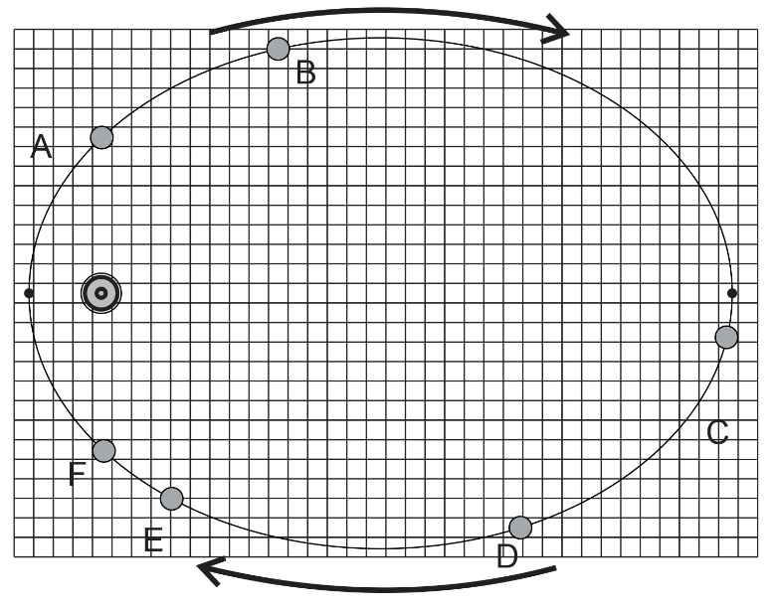
12-13. The ellipse on the right represents the path of an orbiting planet. The small black dots represent perihelion (closest to the Sun) and aphelion (farthest).

12. The planet spends the same amount of time traveling from point A to point B as it does traveling from __________
B to C C to D D to E
E to F F to A

13. At which point in the planet’s orbit do the vector representing the planet’s velocity and the vector representing the Sun’s gravitational pull make the largest acute angle with one another?
A B C D E F
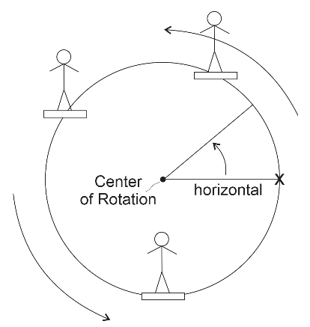

Bonus: The Slipperiest Place. Instead of sitting in a normal Ferris Wheel compartment, the rider on the right is standing on a flat, level surface with a static coefficient of friction µ = 0.4. For unknown reasons, the Ferris Wheel operator gradually speeds up the wheel until the rider begins to slide across the platform. Assuming that the speeding up process is gradual enough, we can predict where on the circle this slippage will first occur. There are two equally likely locations.
Identify either of these locations in terms of degrees counter-clockwise from the X. For more credit, identify the location by describing the angle in terms of µ.
II. Problems (4pts each): For at least one of the problems, you will need at least one bit of this information. For partial credit, show your work. Box your starting formula(s) and your final answer. All answers must include correct units.

1.00 AU = 1.50 x 10¹¹ m 1.00 y = 3.16 x 10⁷ s
M_{Sun} = 1.99 × 10³⁰ kg M_{Earth} = 5.97 × 10²⁴ kg
M_{Moon} = 7.35 x 10²² kg R_{Earth} = 6.378 x 10⁶ m

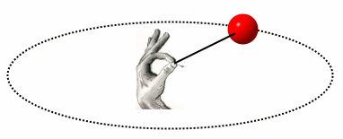
1. A 0.058kg tennis ball on a string travels in a horizontal circle at a constant speed of 6.30 m/s. If the string is 1.15 m long, what is the tension in the string? [Assume that this happens in a gravity-free environment.]

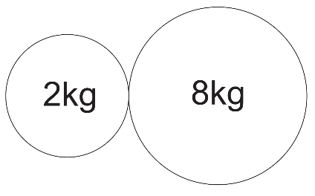
2. The radii of the spheres on the right are 0.1m and 0.15m, respectively. What is the force of gravitational attraction between the two spheres?

3. A 1,500kg car traverses a loop-the-loop with a radius of 5m, maintaining a constant speed the whole time. If, at the top of the loop, the car is being pushed downward by a normal force of 5,000N, what is the car’s speed?

4. A 60kg student is on a ride called the Ring of Fire, which travels in vertical circles. At the bottom of one of the circles, the student is traveling at a speed of 11 m/s. Furthermore, the bathroom scale that is supporting her suggests that her weight is three times its normal value. Assuming that her speed is constant, what is the radius of the circle in which the student is traveling?

5. An asteroid traveling in a circular orbit circles the Sun once every 4.20 Earth years.
a. What is the radius of the asteroid’s orbit in AU (1AU = 1 astronomical unit = Earth’s orbital radius)?

b. What is the asteroid’s speed, in AU per year (much easier than m/s, in this case)?

6. A satellite is launched into a circular orbit that is 4.22 x 10⁷ m from the center of Earth. What is its speed?

7. To what altitude would you have to shoot a cannonball so that, at its highest point, it would begin to free-fall back to Earth with an acceleration of -5m/s²? [In other words, so that g would equal 5m/s at that point]

Physics 200 (Stapleton) Name: ____________________
Circular Motion, Gravity, Kepler
A Last Bit of Conceptual Practice, etc.

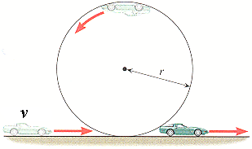
1. Assuming that a car’s speed is kept constant on a loop-the-loop, at what location(s) [if ever] in the loop does the net force on the car equal…

a. The centripetal force?

b. The weight of the car?

c. The normal force?

d. The weight plus the normal force?

e. The weight minus the centripetal force?

2. Draw a diagram to show the difference between a satellite’s altitude and its orbital radius.

3. A tetherball is rapidly orbiting a central pole. No outside force is being applied to the system. What is pulling the ball away from the pole?

4. Starting with the Universal Law of Gravitation and centripetal force, derive a formula for the speed of a stable orbit around Earth. Show your steps.

5. Provide a formula for g on a planet of Mass M and radius r.

6. On the diagram to the right, label the areas where the planet is speeding up and slowing down.
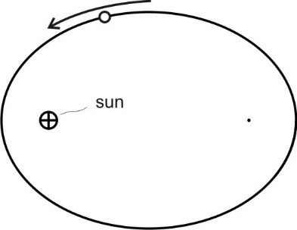

7. Explain why the planet is speeding up and slowing down in those areas of the diagram.

8. Knowing that the centripetal force on a planet is the gravitational force, derive the exact version of Kepler’s 3rd Law (which could only be done after Newton developed his Universal Law of Gravitation). Show your work.

Chapter 6 4-Minute Drill
Centripetal force in terms of r and v

Centripetal acceleration in terms of r and v

Tension in a string keeping mass m moving in horizontal circles of radius r

Tension in a string keeping mass m moving in vertical circles of radius r (top of circle)

Tension in a string keeping mass m moving in vertical circles of radius r (bottom of circle)

Gravitational force between two bodies m₁ and m₂

Acceleration due to gravity g in terms of a planet’s mass M and radius R

Velocity of an object in a circular orbit with radius R around a planet of mass M.

Kepler’s Law relating the periods and average orbital radii axis of two bodies orbiting a common larger body.

