Elliptical Orbits
Preparation: Make a loop of string with a circumference about 1.5-2 inches longer than the distance between the Sun and the dot on the graph below. Place tacks at the sun and the dot.

1. Place your loop around the tacks and use the tacks and string to draw a nice ellipse. Label these points on the ellipse: point 1 (perihelion – closest to the Sun), 2 (top center of orbit – 12:00 if it’s a clock), and 3 (aphelion – furthest from the Sun).
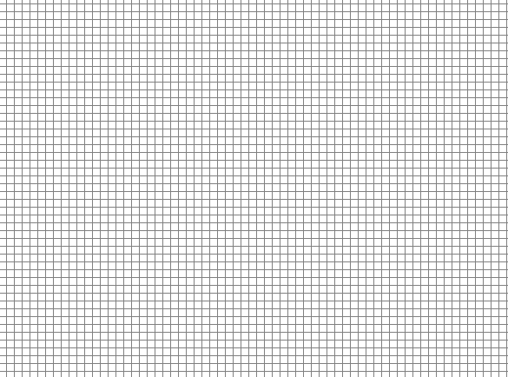



2. Draw a straight segments from Point 1 to the Sun and from Point 2 to the sun. Then estimate the number of squares in the region enclosed by these two segments. Imagine this is the area “swept out” by a planet in one week, as it travels from point 1 to point 2. Kepler’s Law of Equal Areas says that the planet sweeps out equal areas in equal times. Use that area to predict where the planet will be one week after position 3 (when it has again swept out the same area as it did between 1 and 2 – hint: use triangles). Label that new point 4. Draw straight segments from the Sun to 3 and the Sun to 4.

Approximately how many squares were swept out between… 1&2: ________ 3&4: ________

3. Draw force vectors at each point (1,2,3, and 4) representing the gravitational force acting on the planet. Make sure that your vectors’ lengths are reasonable and that their directions are correct.

4. Draw velocity vectors tangential to the elliptical path at points 1, 2, 3, and 4. Make sure that your vectors’ lengths are reasonable and that their directions are correct.

Fill in the chart below.

Point | Angle between force and velocity? (circle the best answer) | What is happening to its speed? (circle one) | Changing direction? (circle one) | Overall speed (circle one)
1  Perihelion  (closest to the Sun) | 180˚  obtuse  90˚  acute  0˚ | Speeding up  Staying the same  Slowing down  Undefined | Yes  No | Slowest  Slower  Faster  Fastest
2 | 180˚  obtuse  90˚  acute  0˚ | Speeding up  Staying the same  Slowing down  Undefined | Yes  No | Slowest  Slower  Faster  Fastest
3  Aphelion  (farthest from the Sun) | 180˚  obtuse  90˚  acute  0˚ | Speeding up  Staying the same  Slowing down  Undefined | Yes  No | Slowest  Slower  Faster  Fastest
4 | 180˚  obtuse  90˚  acute  0˚ | Speeding up  Staying the same  Slowing down  Undefined | Yes  No | Slowest  Slower  Faster  Fastest
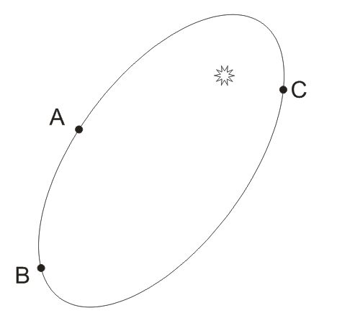

5. If an asteroid traveled from A to B in one Earth Year. At what approximate location would it end up one Earth year after leaving point C? Label this point D.

6. If an asteroid traveled from C to A in one Earth Year. At what approximate location would it end up one Earth year after leaving point B? Label this point E.

