Physics 200 (Stapleton) Name: __________________________________
Big Quiz (Little Test): Circular Motion, Gravitation, Kepler

Conceptual Questions

1. The gravitational force between two masses separated by a distance r is 400 N. If the distance between the two masses (measured from center to the center) is now doubled, the gravitational forces becomes
A. 1600 N B. 800 N C. 400 N D. 200 N E. 100 N

2. A ball of mass m attached to a string is moving in a horizontal circle of radius r with a uniform speed of v. The tension in the string (i.e. the force needed to keep the ball moving in a circle) is F_{T}. If the velocity of the ball decreases to v/3 (i.e. 1/3 its original velocity), what is the new tension in the string?
A. F_{T}/9 B. F_{T}/3 C. F_{T} D. 3F_{T} E. 9F_{T}

3. The acceleration of a free-falling object on some planet, does not depend on which of the following? A. The planet’s mass B. The object’s mass
C. The distance of the object from the planet’s center D. The Gravitational Constant

4. The term “astronomic unit” is defined as
A. the average distance between the Earth and the Moon.
B. the average diameter of the Moon’s orbit about the Earth.
C. the average distance between the Earth and the Sun.
D. the average diameter of Earth’s orbit about the Sun.
E. the orbital period of Earth.

5. When an object experiences uniform circular motion, the direction of the acceleration is
A. in the same direction as the velocity vector.
B. in the opposite direction of the velocity vector.
C. directed toward the center of the circular path.
D. directed away from the center of the circular path.
E. straight down towards the ground.

6. The orbital speed of a planet in our solar system does not depend upon
A. Newton’s gravitational constant G.
B. the Sun's mass.
C. the planet's mass.
D. the planet’s orbital radius

7. a. Which planets in our solar system have the longest orbital periods (the incomplete table on the last page of this test may be helpful)?

b. Choose one of Kepler’s Laws and explain how it supports your answer to part A.

8. Explain or show the difference between a satellite’s orbital radius and its altitude.

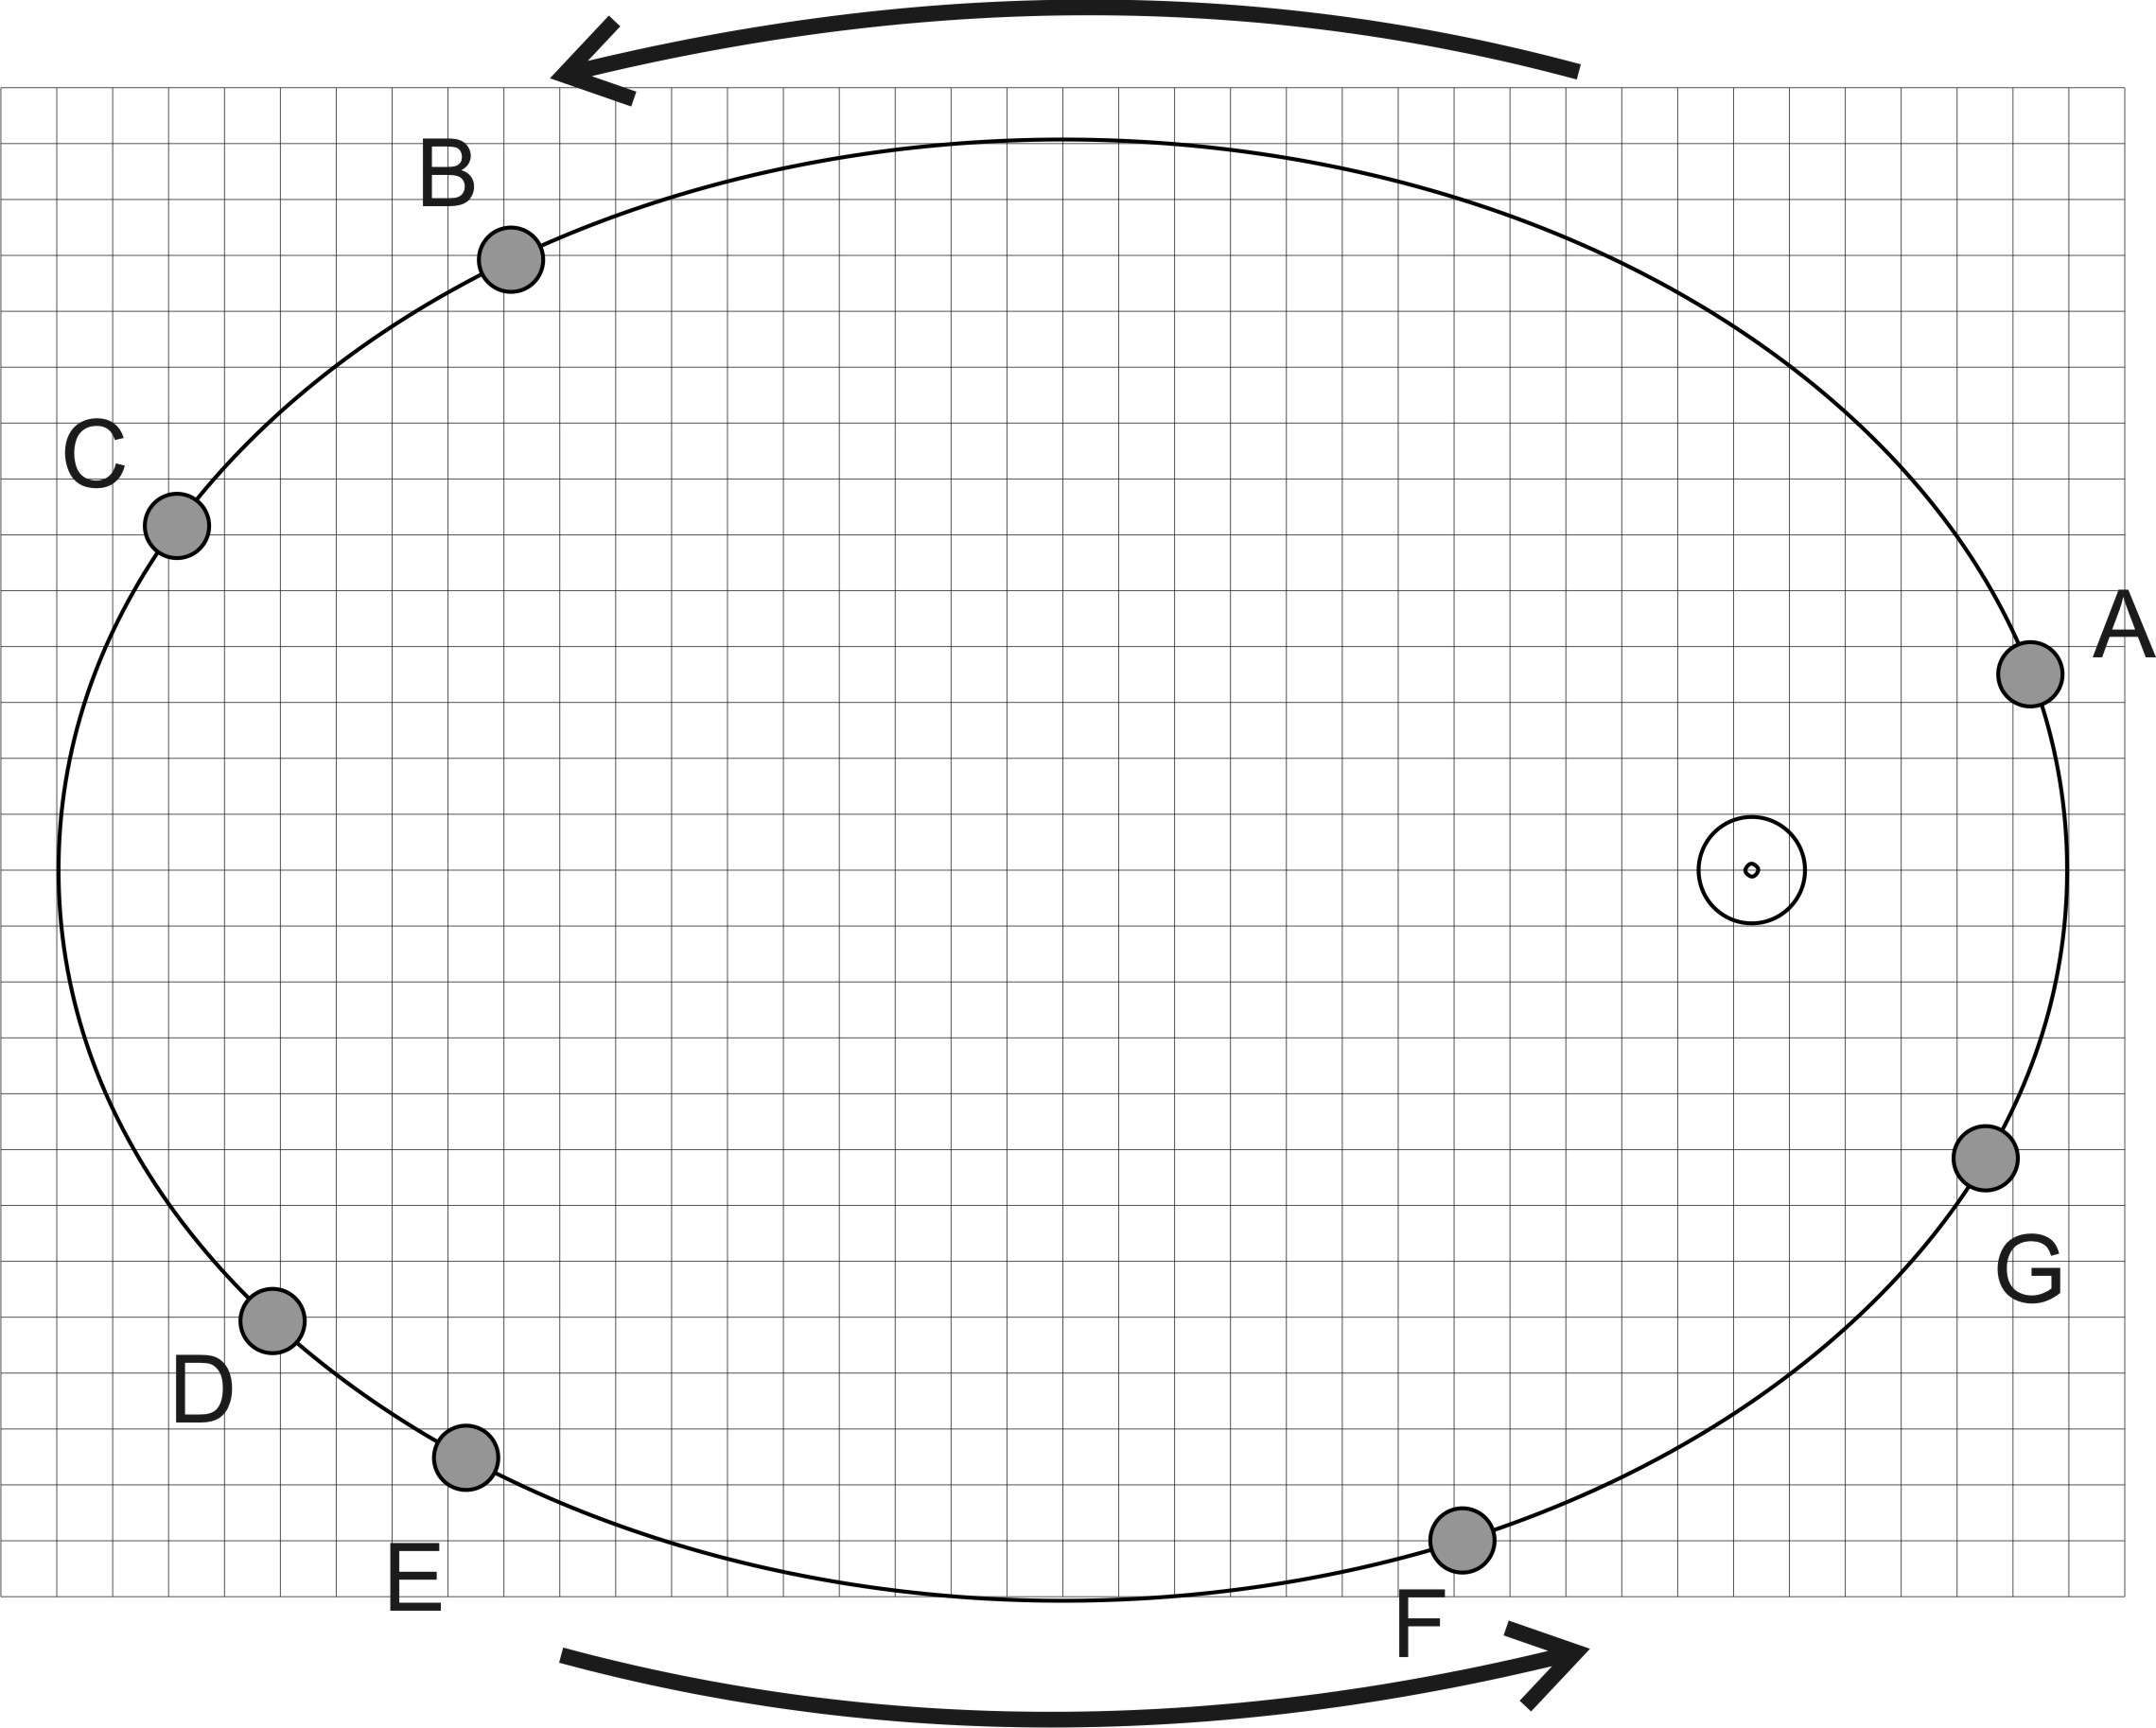
9. The diagram on the right shows the orbit of a planet around the sun. Consider the time it takes the planet to travel from point C to D, from point D to E, from point E to F, etc., until you have considered each of the intervals listed below. Then circle the two distance intervals that the planet would traverse in equal travel times. Just to be clear, you are circling two intervals from the five choices below.

C to D D to E
E to F F to G
G to A

10. Rank the all of the lettered locations in order of the speed of the satellite at each location. List them from fastest to slowest.

Fastest: _____,______,______,______,______,______,______

11. At points B and F on the diagram, draw and label vectors for velocity and gravitational force. Lengths must be proportional to magnitude.

Problems:
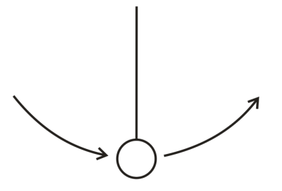
1. [Hint: Read the entire question and pay close attention to the bold words.] A playful lunar explorer swings a ball on a string. The 1kg ball is traveling in 0.5m radius vertical circles at a constant speed of 5m/s. The value of g on the moon is 1.63m/s². Give the magnitude and direction of the net force that is acting on the ball at the top of its swing.

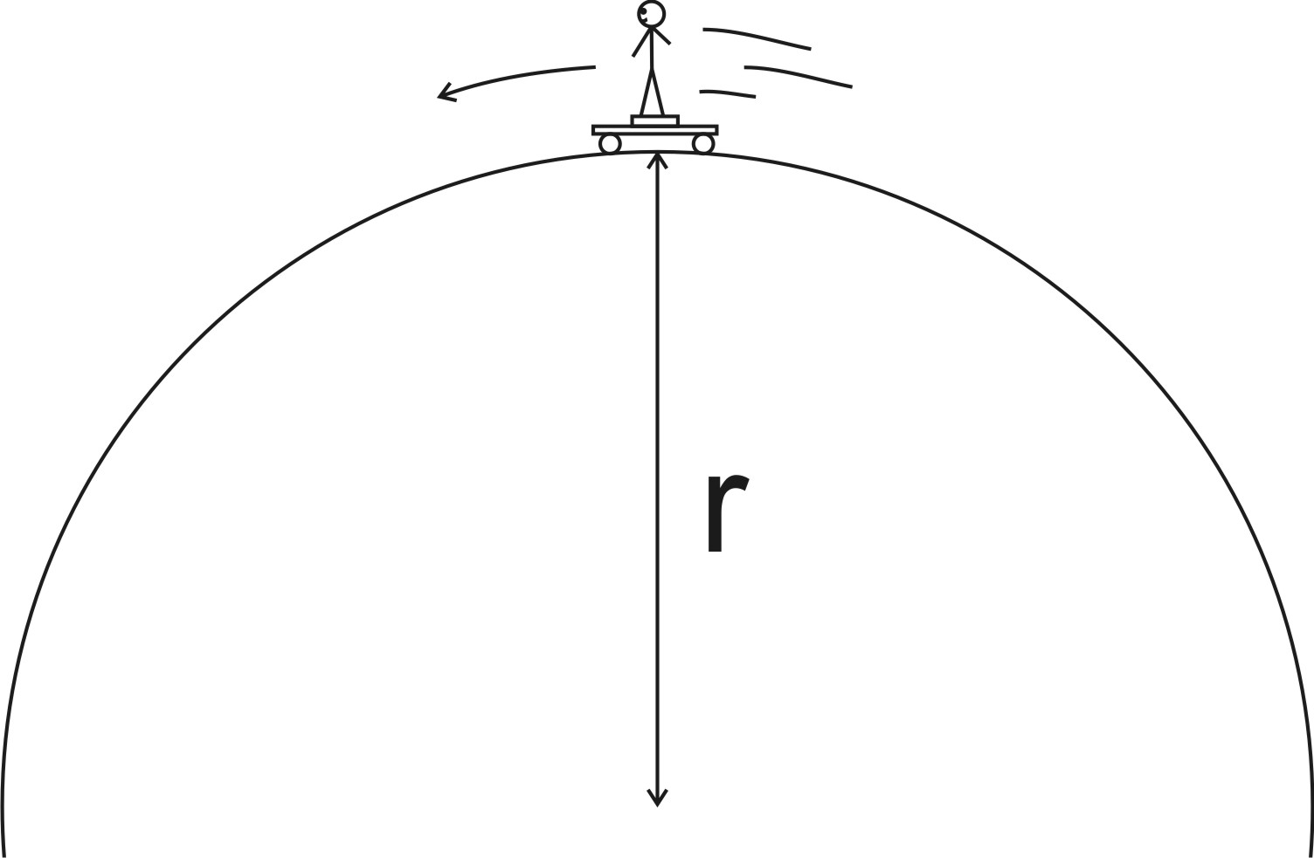
2. A skateboarder stands on a bathroom scale on top of a skateboard as she travels over the top of a circular skate park feature. Her mass is 55kg, and you may assume that her speed is momentarily constant at 8m/s. If the scale reads 400N at the top of the hill, what is the radius of the hill’s curve?

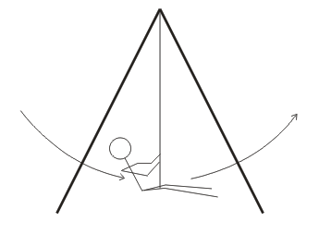
3. A 40kg child is swinging on a massless swing in a vacuum. The child is swinging in arcs with a radius of 3m. At the lowest point in her swing, her speed is 3m/s. Assuming that her speed is constant in this part of her swing, what is the tension in the rope when she is at this lowest point?

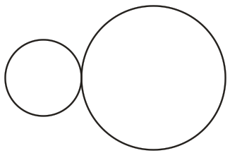
4. One sphere has a radius of 0.1m, and the other sphere has a radius of 0.2m. They both have a mass of 0.7kg, and they are touching. Calculate the gravitational force between them.

5. Use your knowledge of the Earth’s orbit and the data at the back of this quiz to find the orbital period of Mars, in Earth years.

6. A satellite orbits the Earth at an altitude of 2x10⁶m. Use the data on the back of this test to solve the following problems related to the satellite.

a. What is the satellite’s orbital radius?

b. What value of “g” is experienced by the satellite?

7. Extraterrestrial explorers insert a satellite into a circular orbit around a newly discovered planet in a distant solar system. The satellite has a period of 1.20x10⁵seconds and an orbital radius of 5.60x10⁷m.

a. What is the speed of the satellite?

b. What is the mass of the planet around which the satellite orbits?

Planetary Data
Name | Planetary Radius (meters) | Mass (kg) | Orbital Radius (meters)
Sun | 696 x 10⁶ | 1.991 x 10³⁰ | -
Mercury | 2.43 x 10⁶ | 3.2 x 10²³ | 5.8 x 10¹⁰
Venus | 6.073 x 10⁶ | 4.88 x 10²⁴ | 1.081 x 10¹¹
Earth | 6.3713 x 10⁶ | 5.979 x 10²⁴ | 1.4957 x 10¹¹
Mars | 3.38 x 10⁶ | 6.42 x 10²³ | 2.278 x 10¹¹
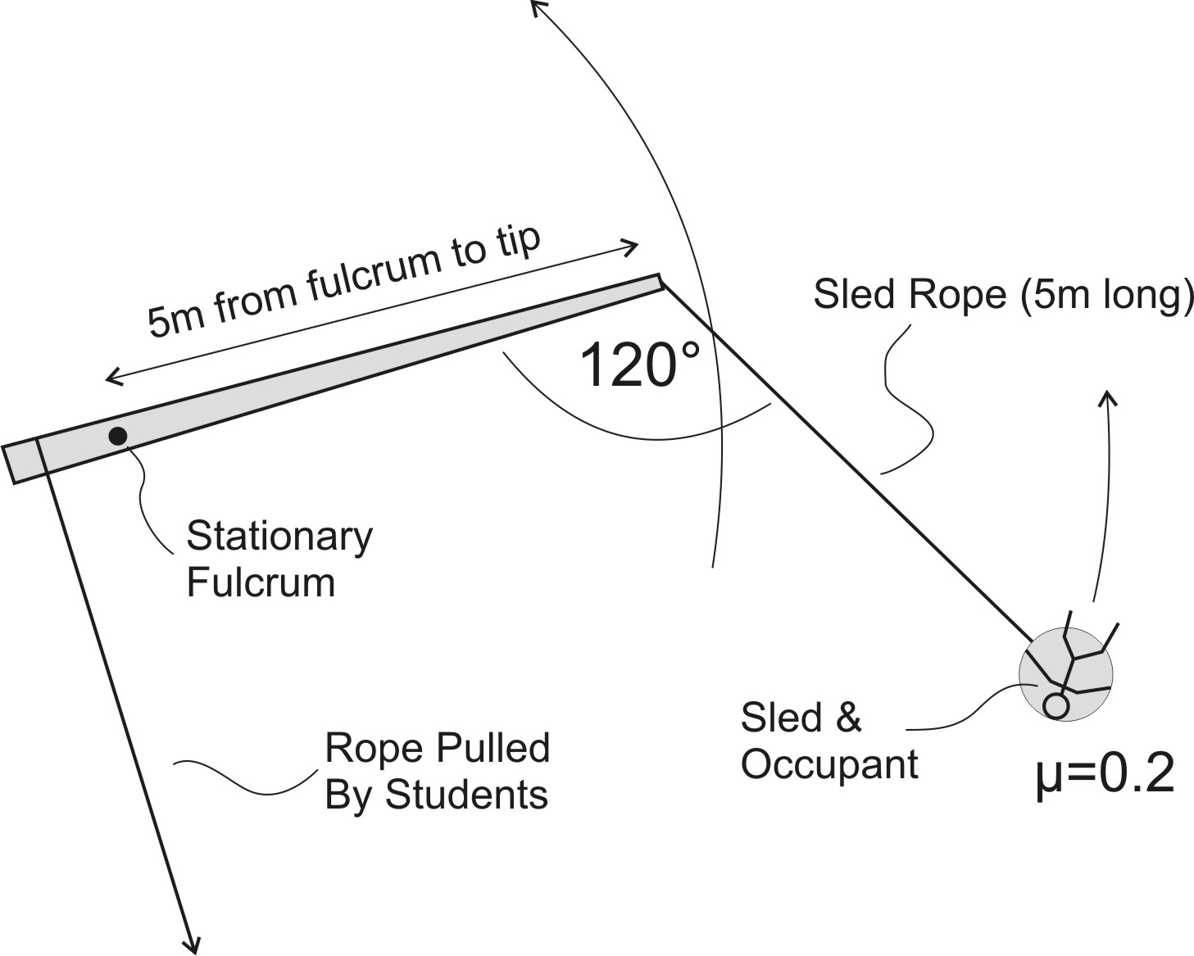
Bonus: The diagram on the right is a top view of a snow lever that operates in the horizontal plane, rotating around a stationary steel pole (fulcrum) that has been driven into a snowy surface. Students pull a rope, thus rotating the lever and propelling the sled (5kg) and occupant(60kg). If the 5m lever arm makes a constant 120° angle with the 5m sled rope (as shown), and the sled’s µ_{k} on snow is 0.2, what is the speed of the sled occupant?

