Physics 200 Name: _____________________________

Practice -- Mr. Pennington’s Chapter 6 Test 2014-2015

I. Multiple Choice

3. When an object experiences uniform circular motion, the direction of the acceleration is
A. in the same direction as the velocity vector.
B. in the opposite direction of the velocity vector.
C. directed toward the center of the circular path.
D. directed away from the center of the circular path.
E. straight down towards the ground.

4. The fundamental force which holds the planets in their orbits around the sun is
A. the electric force, the same force that holds atoms together in a solid material.
B. the gravitational force, the same force that pulls the gas and dust of a nebula together to form a star.
C. the strong nuclear force, the same force that holds the neutrons and protons in a nucleus together.
D. dark energy, the same force that is causing the galaxies to move at an ever increasing rate away from each other.
E. the weak nuclear force, the same force the governs radioactive decay.

5. Which scientist developed the first complete mathematical description of gravity that allows us to calculate the gravitational forces between objects and explain such things as the tides, objects falling at the Earth’s surface and the Moon’s orbit around the Earth?
A. Ptolemy B. Brahe C. Kepler D. Plato E. Newton

6. A car goes around a curve of radius r at a constant speed v. What is the direction of the net force on the car?
A. towards the curve's center.
B. away from the curve's center.
C. toward the back of the car.
D. toward the front of the car.
E. straight down towards the ground from each tire

7. A ball of mass m attached to a string is moving in a horizontal circle of radius r with a uniform speed of v. The tension in the string (i.e. the force needed to keep the ball moving in a circle) is F_{T}. If the velocity of the ball triples to 3v (i.e. 3 times its original velocity), what is the new tension in the string?
A. F_{T}/9 B. F_{T}/3 C. F_{T} D. 3F_{T} E. 9F_{T}

8. A ball of mass m attached to a string is moving in a horizontal circle of radius r with a uniform speed of v. The tension in the string (i.e. the force needed to keep the ball moving in a circle) is F_{T}. If the mass of the ball increases to 5m (i.e. 5 times its original mass), what is the new tension in the string?
A. F_{T}/25 B. F_{T}/5 C. F_{T} D. 5F_{T} E. 25F_{T}

9. The orbital speed of a planet in a circular orbit around the sun does not depend on
A. Newton’s gravitational constant G.
B. the Sun's mass.
C. the planet's mass.
D. the planet’s orbital radius

10. The speed of a comet, while traveling in its elliptical orbit around the Sun,
A. is constant.
B. slows to zero at its furthest distance from the Sun.
C. increases as it nears the Sun.
D. decreases as it nears the Sun.

11. The gravitational force between two masses separated by a distance r is 400 N. If the distance between the two masses (measured from center to the center) is now cut in half, the gravitational forces becomes
A. 1600 N B. 800 N C. 400 N D. 200 N E. 100 N

12. For a ball in free fall near the surface of a planet (e.g. in our classroom), neglecting air resistance, the value of the acceleration due to gravity, g, does not depend upon
A. the planet's mass.
B. the ball's mass.
C. the planet's radius.
D. Newton’s gravitational constant G.

13. ** We haven’t covered this, but you may know it, and you can look it up***
The term “astronomic unit” is defined as
A. the average distance between the Earth and the Moon.
B. the average diameter of the Moon’s orbit about the Earth.
C. the average distance between the Earth and the Sun.
D. the average diameter of Earth’s orbit about the Sun.
E. the orbital period of Earth.

14. Which of these non-Earth planets would have the greatest acceleration due to gravity g at its surface? M = mass of the planet, M_{E} = mass of Earth, r = radius of the planet and R_{E} = radius of Earth
 | Mass of Planet | Radius of Planet
A. | 1 M_{E} | 1 R_{E}
B. | 4 M_{E} | 2 R_{E}
C. | 5 M_{E} | 1 R_{E}
D. | 2 M_{E} | 0.5 R_{E}

16. A tennis ball is swung in a vertical circle (horizontal axis) at a constant velocity. Where in the swing is the tension in the string the greatest?
A. At the bottom of the swing
B. At the top of the swing
C. Half way between the top and the bottom on the way up
D. Half way between the top and the bottom on the way down
19. Which is not one of Kepler’s 3 Laws?
A. Planets orbit the Sun in ellipses
B. An imaginary segment drawn between the Sun and the planet sweeps out equal areas in equal times
C. The square of a planet’s period is proportional to the cube of its orbital radius
D. A planet’s centripetal acceleration is proportional to its velocity squared.

II. Problems g = 9.80 m/s² G = 6.67 x 10⁻¹¹ N m²/kg²
1.00 AU = 1.50 x 10¹¹ m 1.00 y = 3.16 x 10⁷ s
M_{Sun} = 1.99 × 10³⁰ kg M_{Earth} = 5.97 × 10²⁴ kg
M_{Moon} = 7.35 x 10²² kg R_{Earth} = 6378 km

Show your starting equations and your work clearly. All work and answers must be shown on a separate sheet of paper. Please circle all of your answers.

1. Calculate the force between these two unequal spheres that are touching as shown. Each sphere has a radius of 0.180 m, but one has a mass of 3.00 x 10² kg and the other has a weight of 9.00 x 10² N.

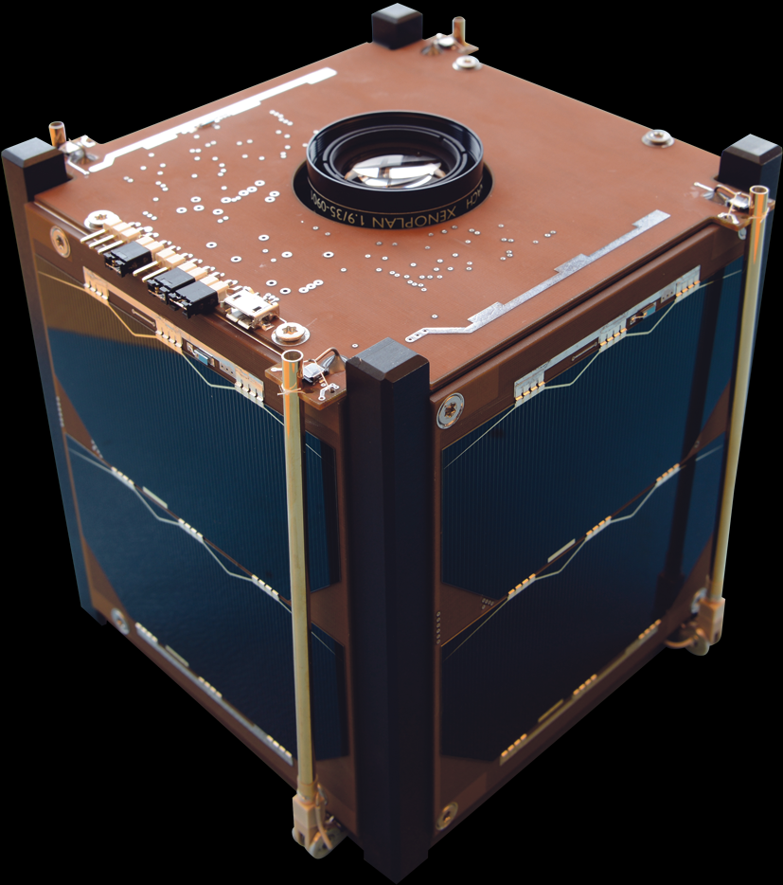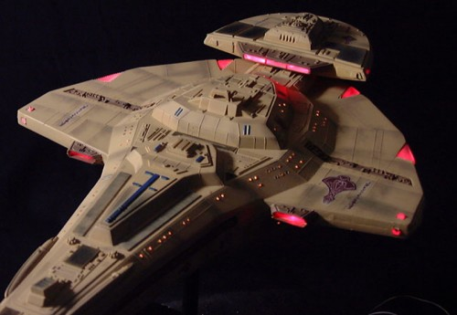2. A Cardassian warship has kidnapped you from Earth and begins to leave the Solar System. A Federation starship approaches firing photon torpedoes. The Cardassians, not wishing to start an intergalactic incident, eject you in a space pod and leave the Solar System at warp speed. The bad news is that you are marooned in the space pod. The really bad news is the Federation ship does not see you. The good news is you are orbiting the Sun in a circular orbit. The really good news is that there is plenty of food and water. You make one full orbit around the Sun in 4.20 Earth years. What is the radius of your orbit in AU (1AU = 1 astronomical unit)?

3. A CubeSat is a type of miniaturized satellite for space research. This particular CubeSat has the maximum allowed mass of 1.33 kg. If the CubeSat is launched into a circular orbit that is 4.22 x 10⁷ m from the center of Earth, what is its orbital speed?

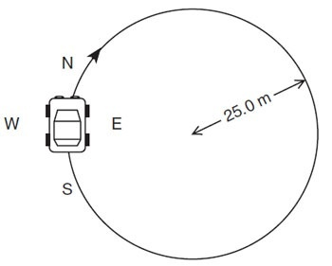4. A 1250-kg car drives in a circle at a constant speed in an empty flat parking lot. The circle is 50.0 m in diameter. If the car’s maximum speed without sliding is 11.4 m/s, what is the coefficient of friction μ between the pavement and the tires?
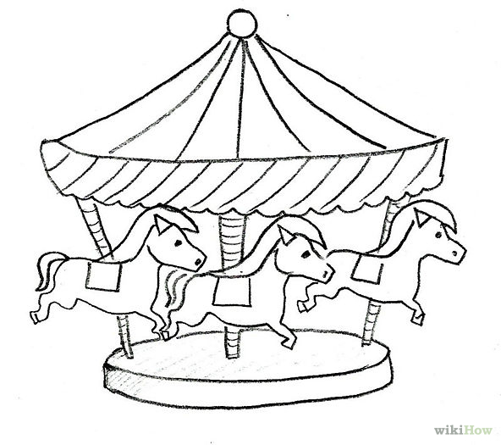

5. A merry-go-round 18.0 m in diameter makes 1.00 revolution every 6.00 seconds. What is the velocity (in meters per second) of a rider on a horse out at the very edge of the merry-go-round?

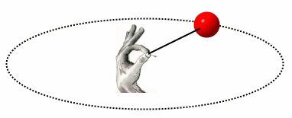
6. A 58.0-g tennis ball on a string travels in a horizontal circle at a constant speed of 6.30 m/s. If the string is 1.15 m long,

A. Find the centripetal acceleration.

B. Find the tension in the string

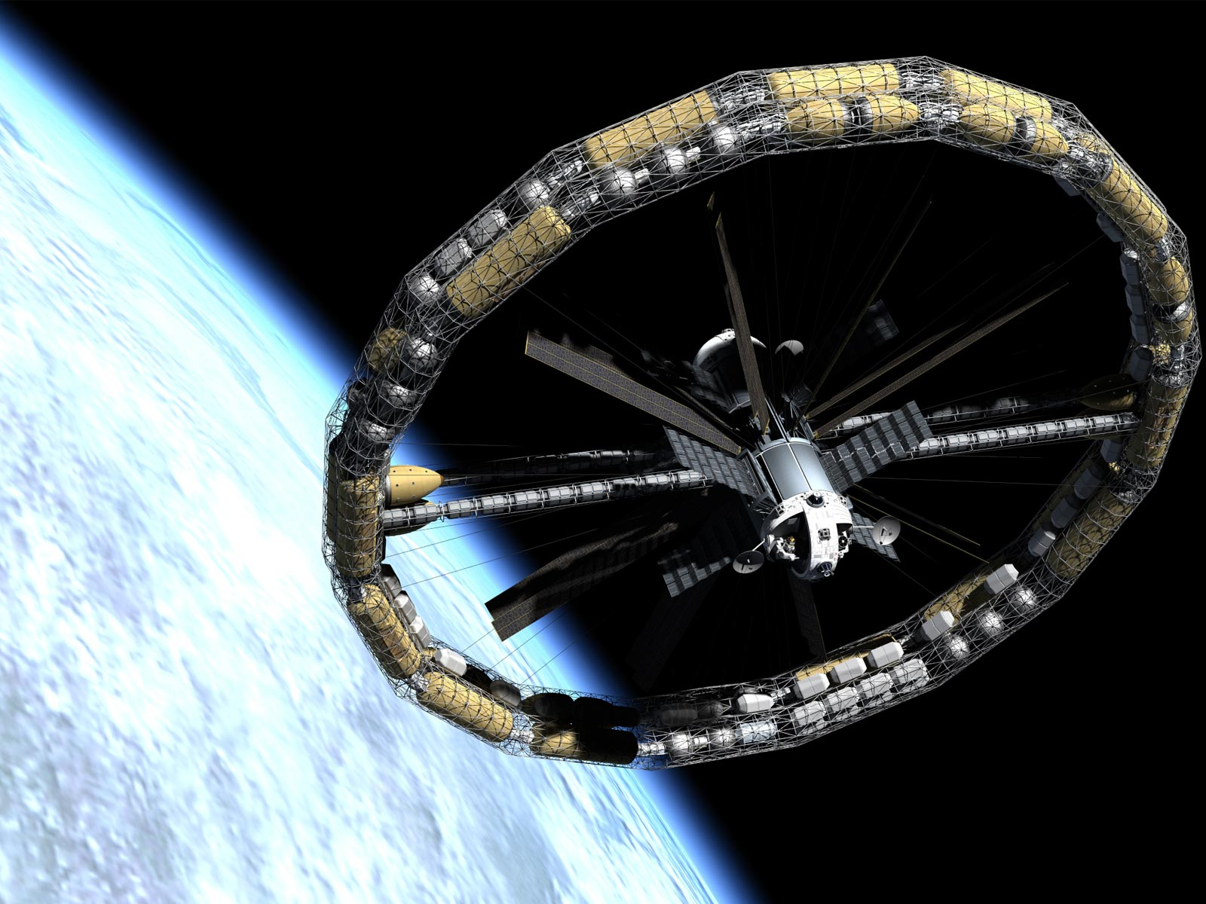7. A rotating space station is said to create “artificial gravity”, which is a loosely-defined term used for an acceleration that would somewhat mimic gravity. The outer wall of the rotating space station would become a floor for the astronauts, and centripetal acceleration supplied by the floor would allow astronauts to exercise and maintain muscle and bone strength more naturally than in non-rotating space environments. If the space station has a radius of 1.50 x 10² m, what velocity (at the rim) would produce an “artificial gravity” of 9.80 m/s² at the rim? (**In the answer key, the solution is provided in terms of radians. To convert the answer, multiply the rad/s velocity by the radius of the station)

