Name: ___________________________

Notes – 20.2 Ohm’s Law: Resistance and Simple Circuits

1. What drives current? We can think of various devices—such as batteries, generators, wall outlets, and so on—which are necessary to maintain a current. All such devices create a __________________ difference and are loosely referred to as voltage sources. When a voltage source is connected to a conductor, it applies a potential difference V that creates an _______________________, which in turn exerts an ___________________________ on the charges, causing a _______________ to flow.

1.1. Voltage and electric potential are the same thing. Voltage is not electric potential energy. Voltage is electric potential energy per coulomb of charge. The units for voltage are therefore _______. Joules are a _________ (vector or scalar) quantity and so are volts.

1.2. If a motionless 3C charge in an electric field has a potential of 4V, it has _____J of electric potential energy. If the field accelerates the charge until its potential drops to 3V, its PE_{E} becomes ______, and the lost PE_{E} is turned to ______ or _______.

2. The current that flows through most substances is directly proportional to the __________________ applied to it and inversely proportional to the substance’s _________________. This is known as ___________ Law.

I
V

3. Write the equation for Ohm’s Law:

4. The units for resistance are _______________.

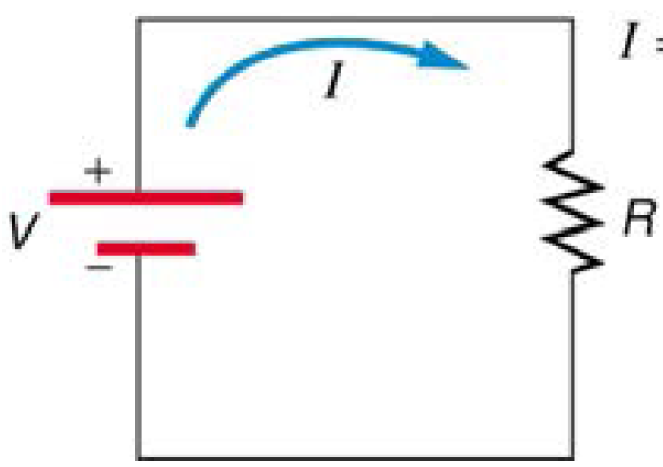
5.

6. What is the resistance of an automobile headlight through which 2.50 A flows when 12.0 V is applied to it?

7. Resistances range over many orders of magnitude. Some ceramic insulators, such as those used to support power lines, have resistances of 10¹² Ω or more. A dry person may have a hand-to-foot resistance of 10⁵ Ω, whereas the resistance of the human heart is about 10³ Ω. A meter-long piece of large-diameter copper wire may have a resistance of _____________ , and superconductors have _______ resistance at all.

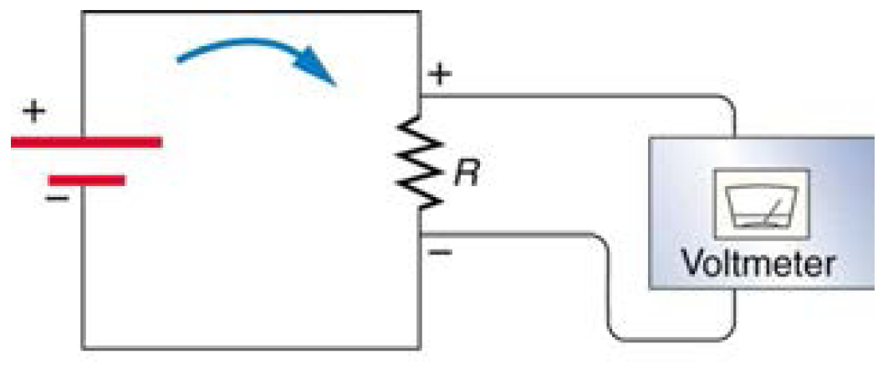
8.

