Name: ______________________
Physics 200 (Stapleton) Chapter 21 Equivalent Resistance Challenge

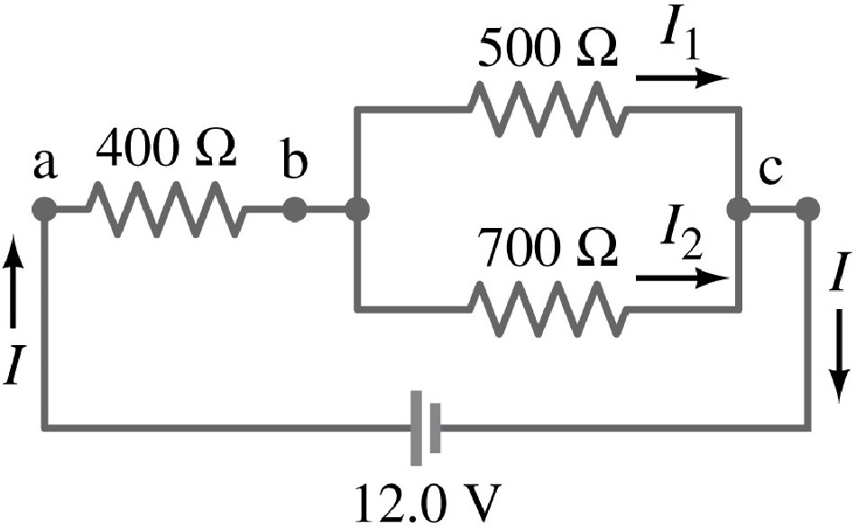
Problem 1
A. Find the equivalent resistance of this circuit.

B. Find the current passing through the battery.

C. 400 Ω Resistor
i. Find V

ii. Find I

iii. Find P

D. 500 Ω Resistor
i. Find V

ii. Find I

iii. Find P

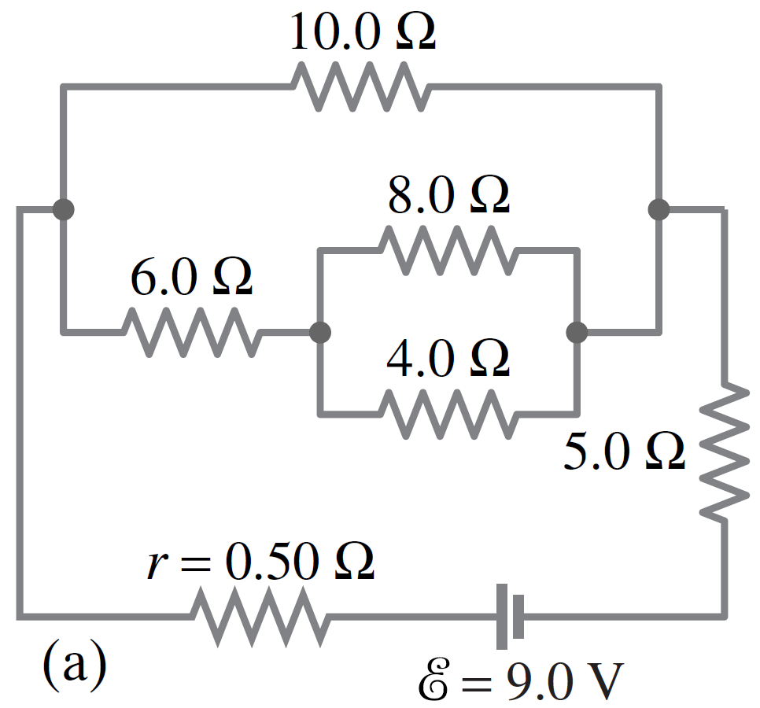
Problem 2
A. Find the equivalent resistance of this circuit.

B. Find the current passing through the battery.

C. 10.0 Ω Resistor
i. Find V

ii. Find I

iii. Find P

D. 4.0 Ω Resistor
i. Find V

ii. Find I

iii. Find P

Solutions:
Prob 1: A. 692 Ω B. 0.0173 A C.i. 6.94 V ii. 0.0173 A iii. 0.120 W D.i. 5.06 V ii. 0.0101 A iii. 0.0512 W
Prob 2: A. 10.1 Ω B. 0.887 A C.i. 4.12 V ii. 0.412 A iii. 1.70 W D.i. 1.27 V ii. 0.317A iii. 0.402 W

