Physics 200 **Unit 9 Packet** Name: __________________

Notes – 19.1 Electric Potential Energy: Potential Difference

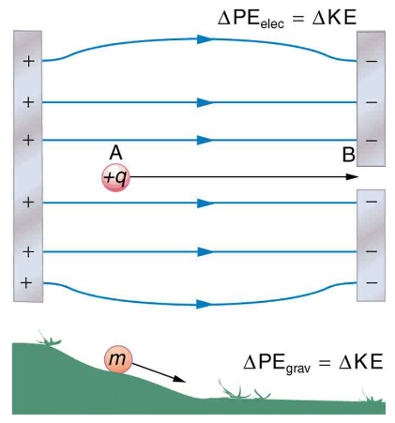The diagram on the right presents an analogy comparing electric potential energy to gravitational potential energy. Gravitational and Electrostatic forces are both conservative, so the law of conservation of energy applies.

1. Where in the diagram would the positive charge have the greatest potential energy?

2. If the charge (+q) were released to travel from A to B, what would happen to its potential and kinetic energy?

PE: ___________ KE: _____________

3. *Electric Potential* is electric potential energy per unit of charge. This is not the same as electric potential energy. It is a ratio that applies to a specific point in an electric field, and it allows us to determine the potential energy of any charge at that point.

4. *Voltage* = *Electrical Potential Difference*. This is the difference between the electrical potentials at two different points.

5. Units and symbols:

|  |  |  |  |
| --- | --- | --- | --- |
| Quantity | Symbol | Formula | Units |
| Electrical Potential Energy |  |  |  |
| Electrical Potential |  |  |  |
| Voltage (Electrical Potential Difference) |  |  |  |

6. In practice, you can use these formulas and units:

ΔPEe =

V (voltage) =

7. Example Problem:

Suppose you have a 12.0 V motorcycle battery that can move 5000 C of charge, and a 12.0 V car battery that can move 60,000 C of charge. How much energy does each deliver? (Assume that the numerical value of each charge is accurate to three significant figures.)

8. Electron Volts: It is useful to have an energy unit related to submicroscopic effects. An energy unit called the electron volt (eV), which is the energy given to a fundamental charge accelerated through a potential difference of ____________.

1eV = _______________ J

Practice – 19.1 Electric Potential Energy: Potential Difference

qelectron  = -1.6x10-19C KE = ½ mv2

1. A. What is the speed of an electron starting from rest accelerated through a potential difference of 100 V? me = 9.11 x 10-31 kg

B. What is the speed of a proton starting from rest accelerated through a potential difference of 100 V? mp = 1.67 x 10-27 kg

2. An evacuated tube uses an accelerating voltage of 40.0 kV to accelerate electrons to hit a copper plate and produce x rays. What is the speed of these electrons?

3. A bare helium nucleus has two positive charges (protons) and a mass of 6.64 x 10–27 kg.

A. Calculate its kinetic energy in joules at 2.00% of the speed of light. c = 3.00 x 108 m/s.

B. What is this in electron volts?

C. What voltage would be needed to obtain this energy?

**Answers**:

1. A. 5.93 x 106 m/s B. 1.38 x 105 m/s 2. 1.19 x 108 m/s

3. A. 1.20 x 10-13 J B. 7.47 x 105 eV C. 3.74 x 105 V

Notes – 20.1 Current

1. Electric current is defined to be the rate at which ___________ flows.

2. Write the equation for electric current.

3. The unit for electric current is _____________.

4. 1 ampere = 1 _______________ /second.

5. Example:

A. What is the current involved when a truck battery sets in motion 720 C of charge in 4.00 s while starting an engine? Show your work.

B. How long does it take 1.00 C of charge to flow through a handheld calculator if a 0.300-mA current is flowing? Show your work.

6. Label the terms and components in this circuit.

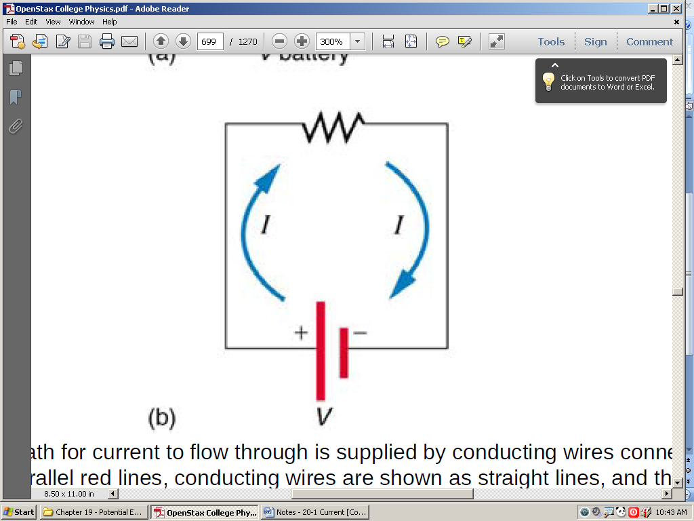

7. By convention, the direction of current flow is from _____________ to _____________. The direction of conventional current is the direction that _____________ charge *would* flow.

8. In metal wires, current is carried by _____________. So it is _____________ charges that are moving, and they are moving oppositely to conventional current.

9. The fact that conventional current is taken to be in the direction that positive charge would flow can be traced back to American politician and scientist ______________________. He named the type of charge associated with electrons negative, long before they were known to carry current in so many situations. Franklin, in fact, was totally unaware of the small-scale structure of electricity.

10. It is important to realize that there is an __________________in conductors that is responsible for producing the current, unlike static electricity situations, where a conductor in equilibrium cannot have an electric field in it. Conductors carrying a current have an electric field and are not in static equilibrium. An electric field is needed to supply energy to move the charges.

11. If the 0.300-mA current through a wire is carried by electrons, how many electrons per second pass through it? Show your work.

12. Electrical signals are known to move very rapidly. Most electrical signals carried by currents travel at speeds on the order of ______ m/s, a significant fraction of the speed of light. However, the actual electrons move much more slowly on average, typically drifting at speeds on the order of _______ m/s. Another example of sending messages quickly through a slowly-moving medium is provided by __________

________________________________________________________________

13. Show the direction of the drift velocity vd, electric field E and the current I.

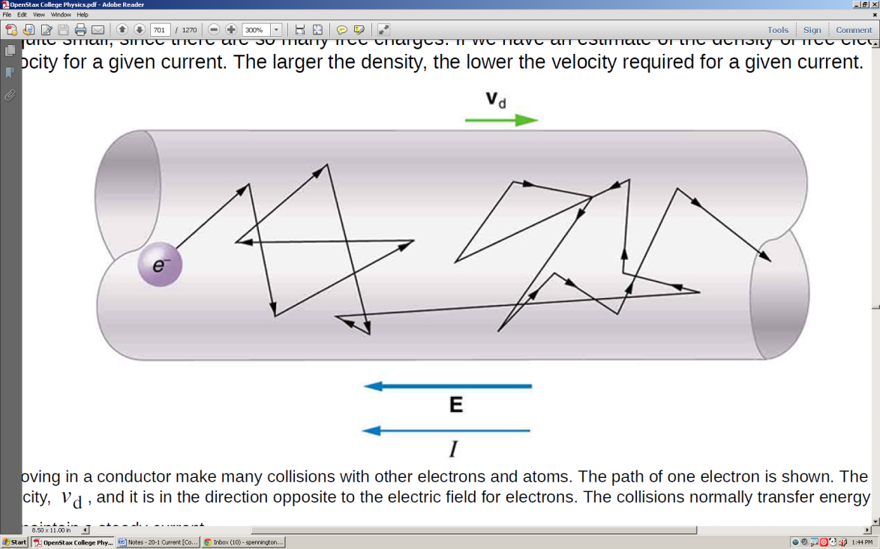

Practice – 20.1 Current

1. Car batteries are rated in ampere-hours (A ⋅ h). To what physical quantity do ampere-hours correspond (voltage? Charge? Energy? . . .)?

5. What is the current in milliamperes produced by the solar cells of a pocket calculator through which 4.00 C of charge passes in 4.00 h?

6. What is the current when a typical static charge of 0.250 μC moves from your finger to a metal doorknob in 1.00 μs?

7. A large lightning bolt had a 20,000-A current and moved 30.0 C of charge. What was its duration?

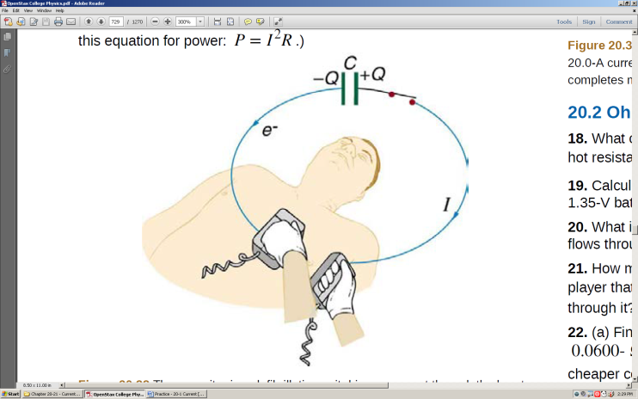

8. A defibrillator passes 12.0 A of current through the torso of a person for 0.0100 s. How much charge moves?

9. A clock battery wears out after moving 10,000 C of charge through the clock at a rate of 0.500 mA.

A. How long did the clock run?

B. How many electrons per second flowed?

**Solutions**:

1. charge 5. 0.278 mA 6. 0.250 A 7. 1.50 x 10-3 s 8. 0.120 C

9. A. 2.00 x 107 s B. 3.13 x 1015 e-/s

Name: _______________________

Name: ___________________________

Notes – 20.2 Ohm’s Law: Resistance and Simple Circuits

1. What drives current? We can think of various devices—such as batteries, generators, wall outlets, and so on—which are necessary to maintain a current. All such devices create a __________________ difference and are loosely referred to as voltage sources. When a voltage source is connected to a conductor, it applies a potential difference V that creates an _______________________, which in turn exerts an ___________________________ on the charges, causing a _______________ to flow.

2. The current that flows through most substances is directly proportional to the __________________ applied to it. This is known as ___________ Law.

I

V

3. Write the equation for Ohm’s Law:

4. The units for resistance are _______________.

5.

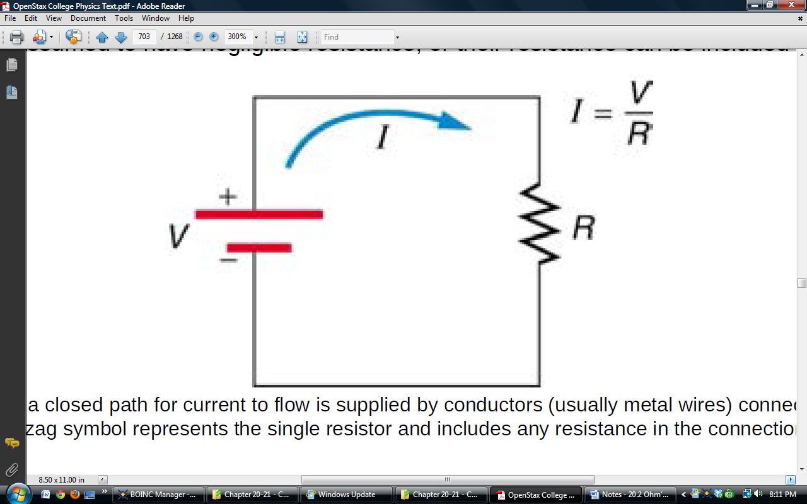

6. What is the resistance of an automobile headlight through which 2.50 A flows when 12.0 V is applied to it?

7. Resistances range over many orders of magnitude. Some ceramic insulators, such as those used to support power lines, have resistances of 1012  or more. A dry person may have a hand-to-foot resistance of 105 , whereas the resistance of the human heart is about 103 . A meter-long piece of large-diameter copper wire may have a resistance of _____________ , and superconductors have _______ resistance at all.

**Practice – 20.2 Ohm’s Law: Resistance and Simple Circuits**

2. What current flows through the bulb of a 3.00-V flashlight when its hot resistance is 3.60 ?

3. Calculate the effective resistance of a pocket calculator that has a 1.35-V battery and through which 0.200 mA flows.

4. What is the effective resistance of a car’s starter motor when 150 A flows through it as the car battery applies 11.0 V to the motor?

5. How many volts are supplied to operate an indicator light on a DVD player that has a resistance of 140 , given that 25.0 mA passes through it?

7. A power transmission line is hung from metal towers with glass insulators having a resistance of 1.00×109 . What current flows through the insulator if the voltage is 200 kV? (Some high-voltage lines are DC.)

**Solutions**:

2. 0.833 A 3. 6.75 x 103  4. 7.33 x 10-2  5. 3.50 V 7. 2.00 x 10-4 A

**Physics 200** Name: ___________________________

**Notes: Chapter Sections 20.3, 20.4, and 21.1**

**Notes – 20.3 Resistance and Resistivity**

1. The resistance of an object depends on its _________________________ and the _______________ of which it is composed.

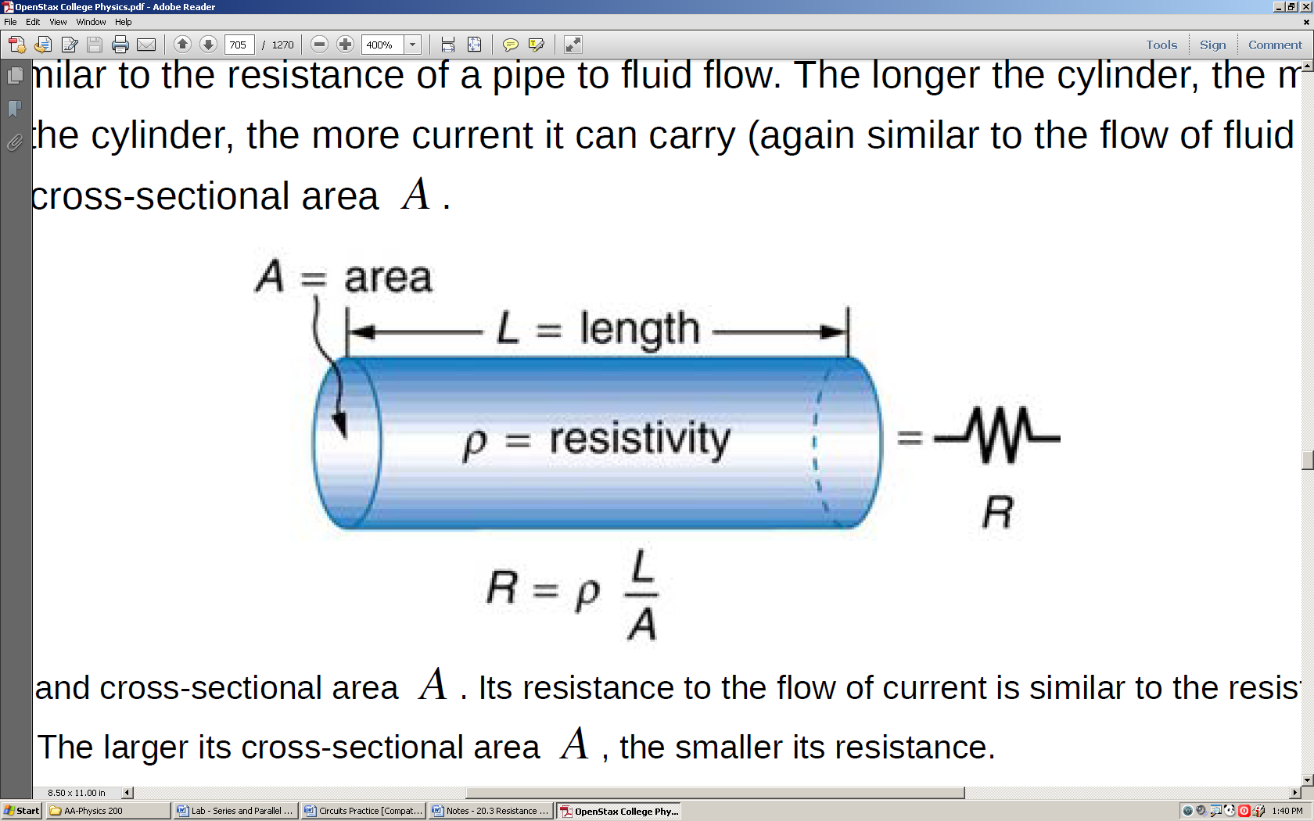

2. R =

3. Resistivity ρ is an ________________ _________________ of the material, independent of its shape or size.

4. In home wiring, currents are limited and minimum wire thicknesses are specified because, as current and resistance increase, more _______________ is produced in the wires,

4.5 Example Problem: What is the resistance of a 20.0-m-long piece of 12-gauge copper wire having a 2.053-mm diameter? (Cu = 1.72 x 10-8 .m)

**Notes – 20.4 Electric Power and Energy**

5. Power (P) is the ______________ of energy use or energy conversion.

6. Voltage (electric potential) can be expressed as J/C, and Current (Amperes) can be

expressed as C/s. Therefore, P= _______

7. The unit for power is _________________.

8. 1 W = 1 ______________

9. Given that V = IR, alternate expressions for power include:

P =

10. Power companies do not charge for power, they charge for _____________, which is sold to you in units called kilowatt-hours. 1kWh = ___________J.

**Notes – 21.1 Resistors in Series and Parallel**

11. Most circuits have more than one component, called a resistor that limits the flow of charge in the circuit. A measure of this limit on charge flow is called ____________.

12. Label which resistors are in series and which are in parallel.

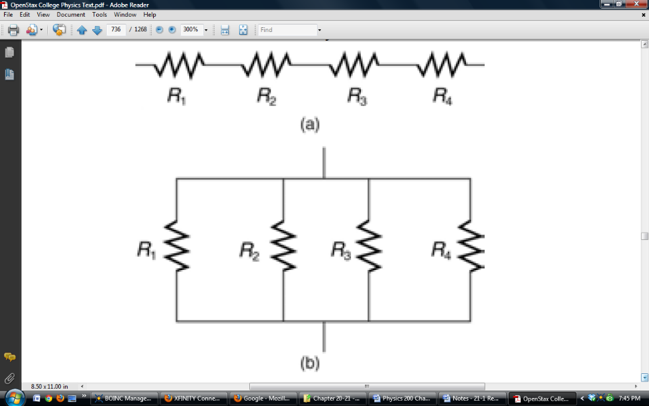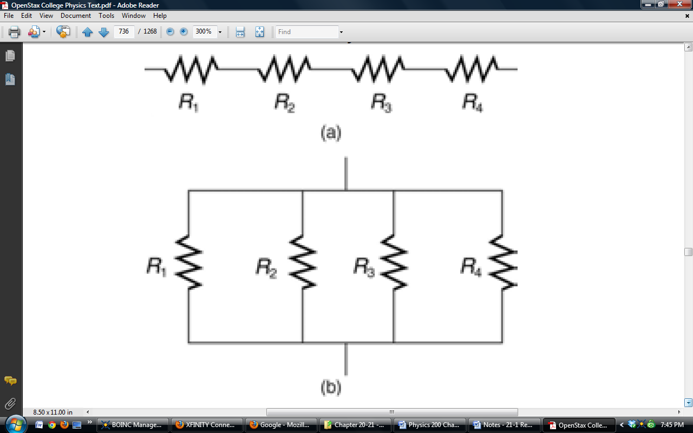

_______________ _______________

13. **Resistors in Series**:

A. Series resistances add. Rseries = ____________________________

B. The current flowing through resistors in series is

_________________________

C. Individual resistors ____________ the overall voltage drop.

14. **Resistors in Parallel**:

A. Individual resistors’ voltages _______________________________________

B. Resistors in parallel ________________ the overall source current.

C. Parallel resistances are found from ___________________________________

15. Suppose the voltage output of a battery is 12.0 V, and the resistances for 3 resistors connected in **series** with the battery are R1 = 1.00 , R2 = 6.00  and R3 = 13.0 .

A. Draw a diagram of the circuit.

B. What is the total resistance?

C. Find the current.

D. Calculate the voltage drop in each resistor, and show these add to equal the voltage output of the source.

E. Calculate the power dissipated by each resistor.

F. Find the power output of the source, and show that it equals the total power dissipated by the resistors.

16. Suppose the voltage output of a battery is 12.0 V, and the resistances for 3 resistors connected in **parallel** with the battery are R1 = 1.00 , R2 = 6.00  and R3 = 13.0 .

A. Draw a diagram of the circuit.

B. What is the total resistance?

C. Find the total current.

D. Calculate the currents in each resistor, and show these add to equal the total current output of the source.

E. Calculate the power dissipated by each resistor.

F. Find the power output of the source, and show that it equals the total power dissipated by the resistors.

Circuit Reduction – The Nine Companions

Assume each resistor has a value of 10 Ohms. Find the equivalent resistance of each circuit. Use the space provided to do circuit reductions as necessary.

1.

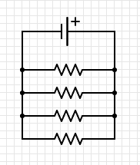 2.

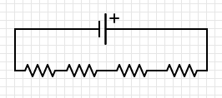

4.

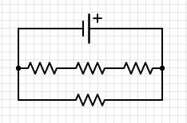3.

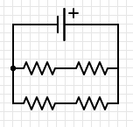

5. 6.

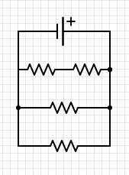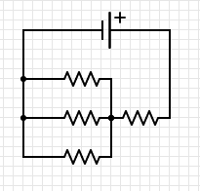

7. 8.

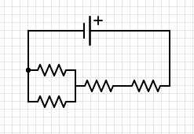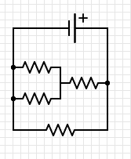

9.

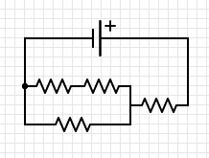

Answers:

1. 2.5 Ω 2. 40 Ω 3. 10 Ω 4. 7.5 Ω

5. 13.3 Ω 6. 4 Ω 7. 6 Ω 8. 25 Ω

9. 16.7Ω

Name: ______________________

Physics 200 (Stapleton) Chapter 21 Equivalent Resistance Challenge

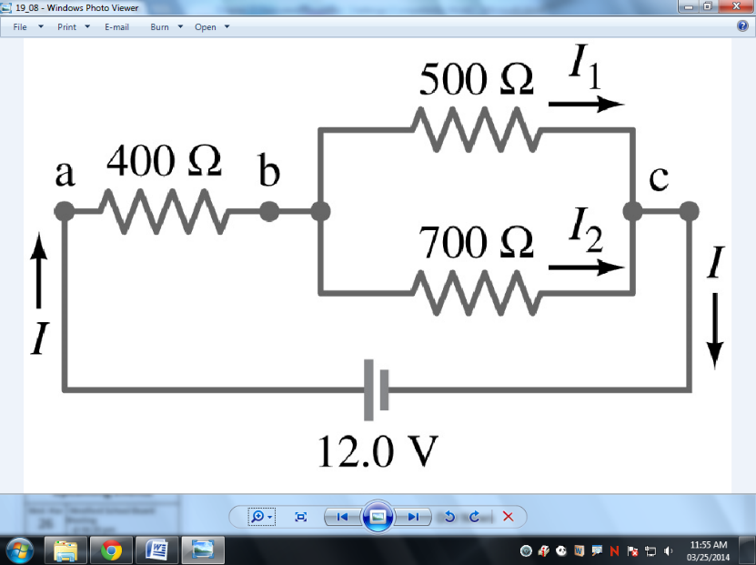Problem 1

A. Find the equivalent resistance of this circuit.

B. Find the current passing through the battery.

C. 400  Resistor

i. Find V

ii. Find I

iii. Find P

D. 500  Resistor

i. Find V

ii. Find I

iii. Find P

Problem 2

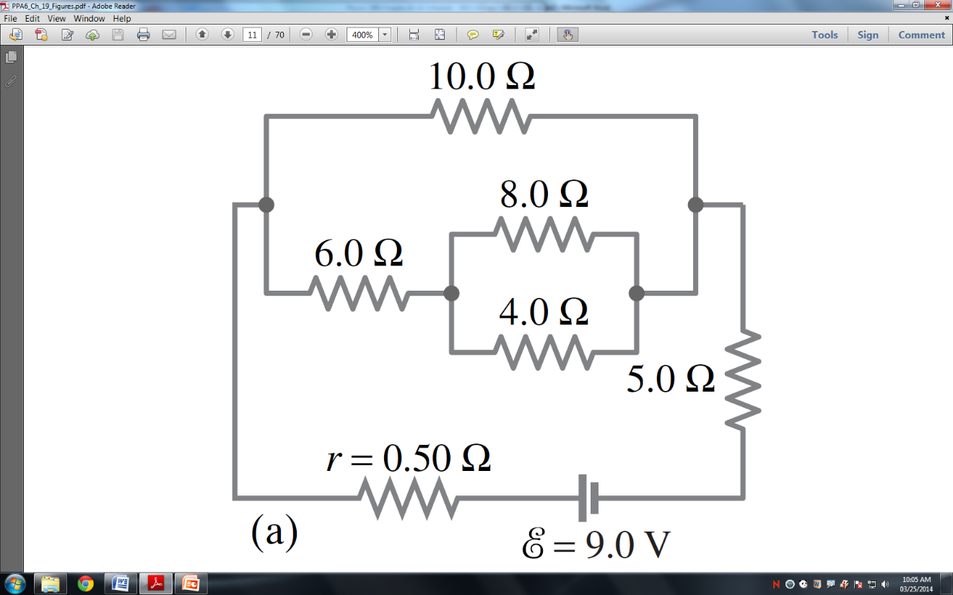

A. Find the equivalent resistance of this circuit.

B. Find the current passing through the battery.

C. 10.0  Resistor

i. Find V

ii. Find I

iii. Find P

D. 4.0  Resistor

i. Find V

ii. Find I

iii. Find P

**Solutions**:

Prob 1: A. 692  B. 0.0173 A C.i. 6.94 V ii. 0.0173 A iii. 0.120 W D.i. 5.06 V ii. 0.0101 A iii. 0.0512 W

Prob 2: A. 10.1  B. 0.887 A C.i. 4.12 V ii. 0.412 A iii. 1.70 W D.i. 1.27 V ii. 0.317A iii. 0.402 W

**Physics 200 Chapter 21.3 Notes and Practice – Kirchoff’s Rules**

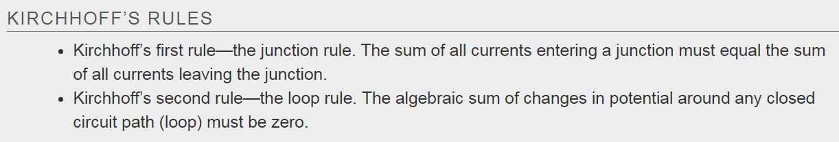

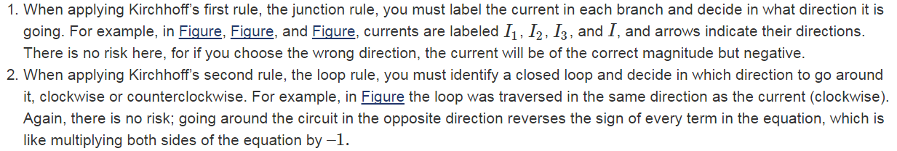

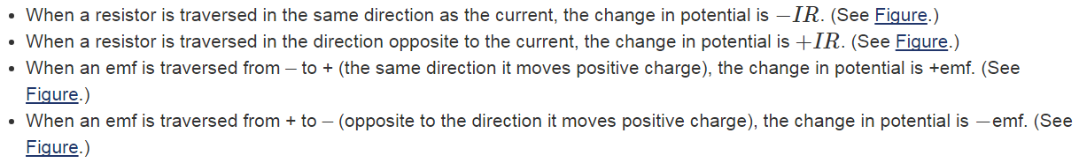

**Kirchoff’s Laws #1. Find the correct current in each branch of each circuit.**

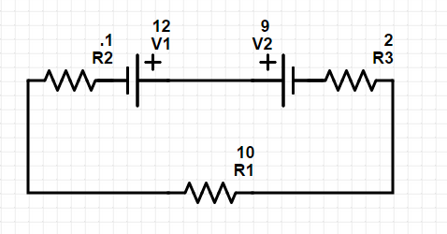

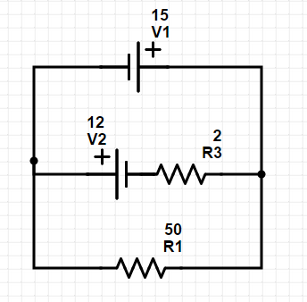

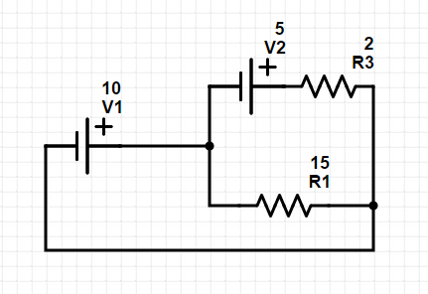

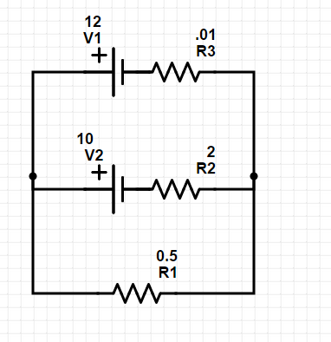

**Name: ___________________________**

**Chapters 20-21 Practice Test 2016-2017**

**(*** The actual test will also have at least one problem requiring Kirchoff’s Rules.)**

**I. Matching:**

A. Match each SI unit with the correct electrical parameter.

A. current

B. potential difference

C. power

D. resistance

E. energy

1. kilowatt-hour

2. volt

3. ohm

4. watt

B. Match each SI unit with the correct electrical parameter.

A. resistivity

B. drift velocity

C. resistance

D. current

E. charge

5. ampere

6. coulomb

7. ohm-meter

8. meters per second

**II. Multiple Choice:** Select the one best answer for each question.

9. In a circuit, the indicated direction of the current is in the

A. same direction as the net electron flow.

B. direction from the negative battery terminal to the positive battery terminal.

C. opposite direction as the net electron flow.

D. is in the same direction that protons are moving through the wire.

10. If the potential difference across a resistor is doubled,

A. only the current is doubled.

B. only the current is halved.

C. only the resistance is doubled.

D. only the resistance is halved.

E. both the current and resistance are doubled.

11. Three identical light bulbs are connected to a battery. What will happen if the top bulb burns out?



V

A. All the bulbs will go out.

B. The light intensity of the other two bulbs will decrease

(but they won't go out).

C. The light intensity of the other two bulbs will increase.

D. The light intensity of the other two bulbs will remain

the same.

E. More current will be drawn from the battery.

12. Which of the following appliances consumes the most power when operating?

A. Appliance #1: 120 V 1.0 A

B. Appliance #2: 240 V 0.5 A

C. Appliance #3: 240 V 2.0 A

D. Appliance #4: 120 V 3.0 A

13. To measure the potential difference across a resistor, a voltmeter is connected in ______________ because it has the _________________.

A. series, same current flowing through it as the resistor

B. series, same potential difference across it as the resistor

C. parallel, same current flowing through it as the resistor

D. parallel, same potential difference across it as the resistor

14. Which of these equations is Ohm’s Law?

A. V = IR B. I = VR C. R = IV D. P = IV

15. Which graph represents the current through a resistor that obeys Ohm’s Law?

V

I

V

I

V

I

V

I

V

I

A. B. C. D. E.

16. The resistivity of a conductor depends upon:

A. the length of the conductor.

B. only on the specific material of the conductor.

C. the cross-sectional area of the conductor.

D. the current flowing through the conductor.

17. Current is a measure of:

A. force that moves a charge past a point

B. resistance to the movement of a charge past a point

C. energy used to move a charge past a point

D. amount of charge that moves past a point per unit time

E. speed with which a charge moves past a point

18. In a simple circuit consisting of a battery and a resistor, if the resistance of the resistor increases, the current through the resistor will:

A. increase B. decrease C. stay the same

19. If a circuit consists of a battery and two resistors connected in parallel with the battery and a third identical resistor is added in parallel, the current in the two initial resistors will:

A. increase B. decrease C. stay the same

20. If a circuit consists of a battery and two resistors connected in series to each other and a third identical resistor is added in series, the current in the circuit will:

A. increase B. decrease C. stay the same

21. In a string of holiday lights, when one bulb burns out the rest of the bulbs stay lit, the bulbs must be connected in

A. series B. parallel

**III. Problems:** Answers all of these problems on a separate sheet of paper. Your answers should flow from top to bottom. Do not skip around or place answers horizontally next to previous work. Show your work. Circle or box your answer. Answers must have the correct number of significant figures and the correct units. **5 points each:**

**Starting equation: 1 point**

**Work and correct answer: 3.5 points**

**Boxed answer: 0.5 points**

1. You have a 15.0-m-long piece of 14-gauge copper wire having a radius of 0.814 mm? (Cu = 1.67 x 10-8 .m)

A. What is the resistance of this wire?

B. How much current will flow through the wire if there is a 12.0 V potential difference between the ends (i.e. if it is hooked up to a 12.0 V battery)?

2. A clock battery wears out after moving 2.40 x 104 C of charge through the clock with an average current of 0.330 mA.

A. How long did the clock run?

B. How many electrons per second on average flowed through the clock?

3. A. Calculate the total equivalent resistance of this circuit.

18.0 V

6.00 

9.00 

4.50 

B. Calculate the current flowing through this circuit.

4. How much does it cost to run a 200.0 watt floodlight 13.00 hours a day for 30.00 days if the local electric company charges 14.00 cents per kilowatt-hour?

5. A. Calculate the total equivalent resistance of this circuit.

36.0 V

9.00 

12.50 

7.40 

B. Calculate the total current flowing through this circuit.

C. Calculate the current flowing through the 7.40- resistor.

D. Calculate the power dissipated as heat through the 7.40- resistor.

6. A. Calculate the total equivalent resistance of this circuit.

12.0 

24.0 

5.30 

18.0 V

B. Calculate the total current flowing through this circuit.

C. Calculate the potential difference across the 5.30- resistor.

D. Calculate the current flowing through the 24.0- resistor.

E. Calculate the total power dissipated as heat in this circuit.