Physics 200 (Stapleton) Unit 2 Handouts Name: _______________

Notes - 3.1. Kinematics in Two Dimensions: An Introduction

1. Give two examples of 2-dimensional motion.
A. __________________________ (e.g. a “river problem”)

B. __________________________ (e.g. a “projectile motion” problem)

2. Given a right triangle of sides a and b and a hypotenuse of c, write the equation to find the length of c.

3. What is used to represent the magnitude and direction of a vector?

4. The length of the vector is directly proportional to the __________________ of the vector.

5. HUGE IDEA: The horizontal and vertical components of two-dimensional motion are

____________________ of each other. Any motion in the horizontal direction does not affect motion in the vertical direction, and vice versa.

6. One baseball is dropped from rest. At the same instant, another is thrown horizontally from the same height and follows a curved path. Which baseball hits the ground first?

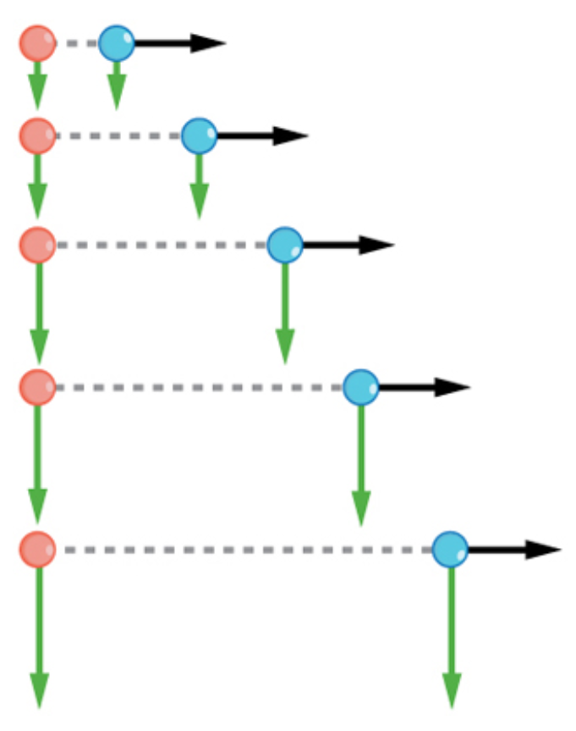
7. The figure on the right shows a dropped ball, and a ball that is thrown rightward. For the thrown ball…
A. Is there acceleration in the y-direction?

B. Is there acceleration in the x-direction?

8. The key to analyzing such motion is to resolve (separate) the motion into separate X an Y vectors, which can be numerically added and subtracted with other vectors of the same dimension.

When a problem has zero acceleration in both the X and Y

dimensions, we call it a ________________________ problem. When a problem has zero acceleration in the X dimension, but an acceleration of -9.8m/s² in the Y dimension,

we call it a _____________________ problem.
Vector Addition Practice:
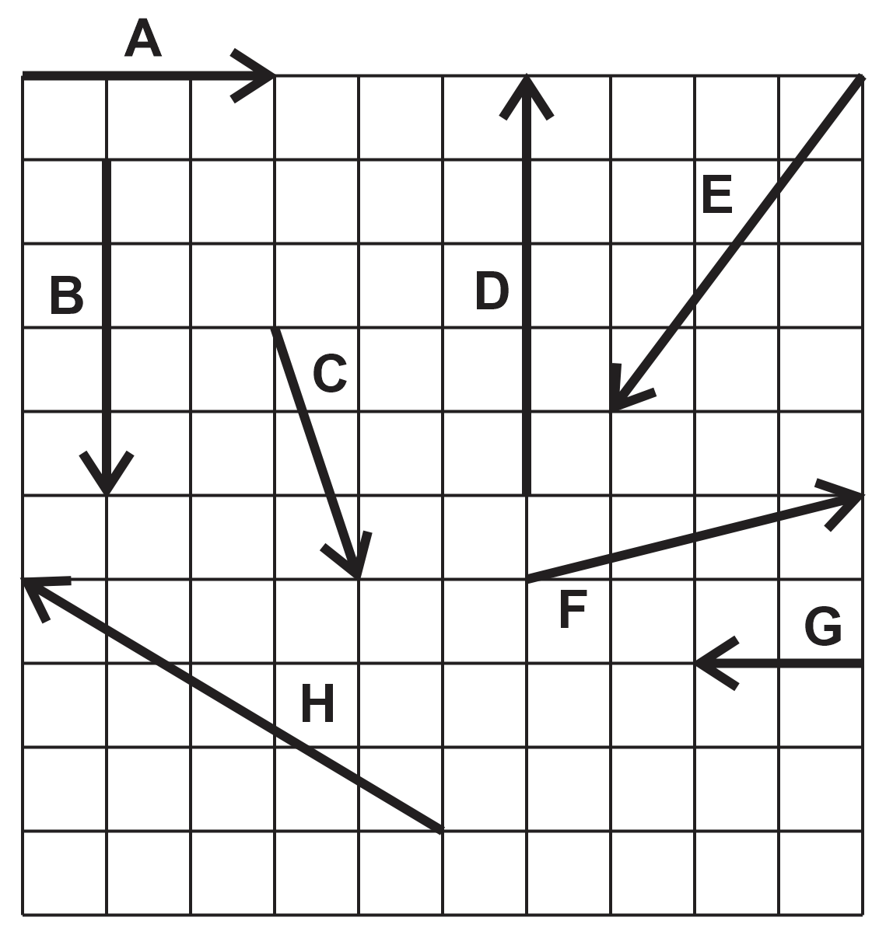

1. Find the resultant vector that is produced by adding vectors A and B.

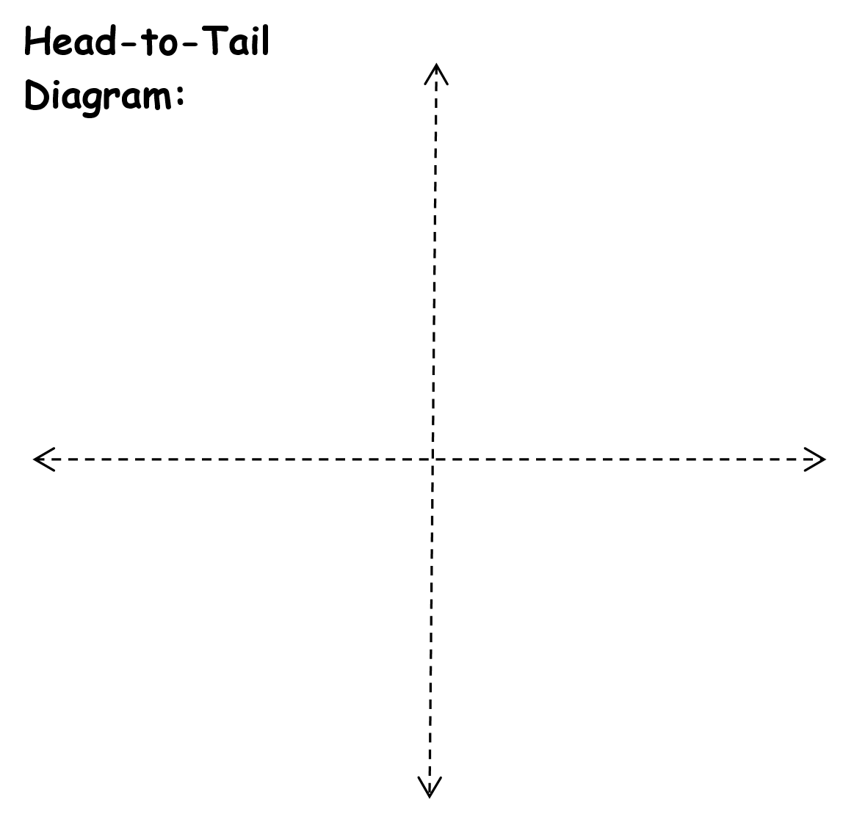
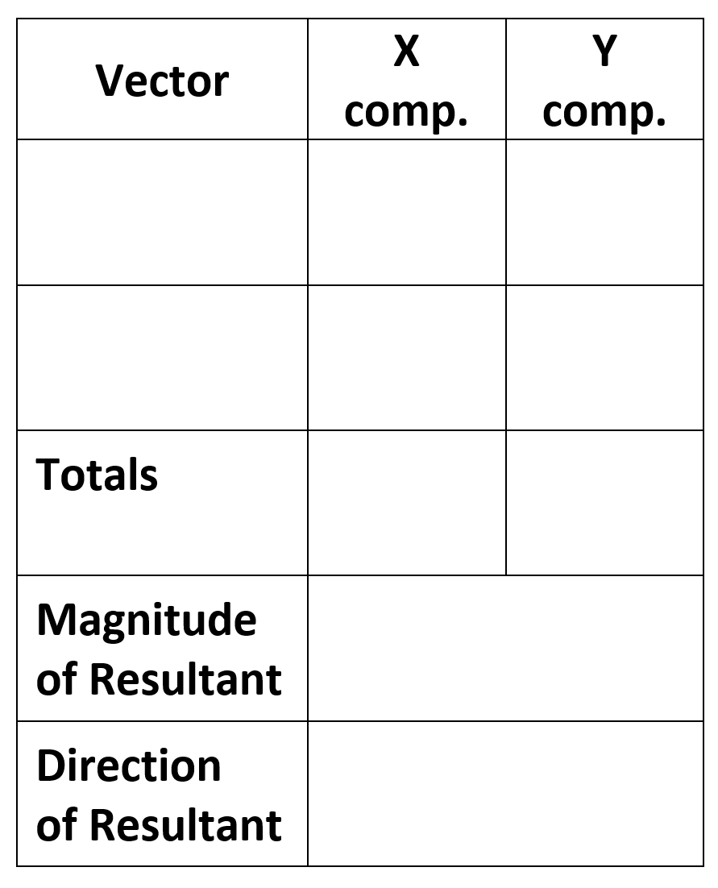

2. Add vectors E and C.

3. What is are the magnitude and direction of the resultant vector that is produced by adding vectors D, C, and A?

Find the resultant vectors from the additions of…
4. E + H
5. C + F
6. E + H + G

Answers: 1. 5, 53.1° below positive x axis 2. 7.3, 74° below negative x axis
3. 4.5, 26.5°above +x axis 4. 8.1, 7.1° below -x
5. 5.4, 21.8° below +x 6. 10.05, 84.2° left of -y axis
The Classic River Problem

Bob and Jane went camping. They put their canoe into a 80.0 meter wide river directly across from the perfect campsite. Avid hikers and paddlers, they are able to walk with a speed of 4.0 m/s and paddle their canoe with a speed of 3.0 m/s. The river flows South with a speed of 2.0 m/s.

Jane suggests that they angle the nose of their canoe into the current so that they travel in a line perpendicular to the current and make a landing at the campsite. She also offers to calculate (she never leaves home without her calculator) the correct angle that the compass should read as they paddle.

Bob declares that the fastest way to get across the river is to point the canoe directly across the river. Of course they will get washed downstream, but no matter says Bob, they can simply walk back to the campsite along the river.

1. Sketch both methods of travel. Label the component velocity vectors and the resultant velocity vectors with their correct magnitude. Proportions of vector magnitudes do not have to be perfect.

2. How long does Jane’s method take?

3. How long does Bob’s method take?

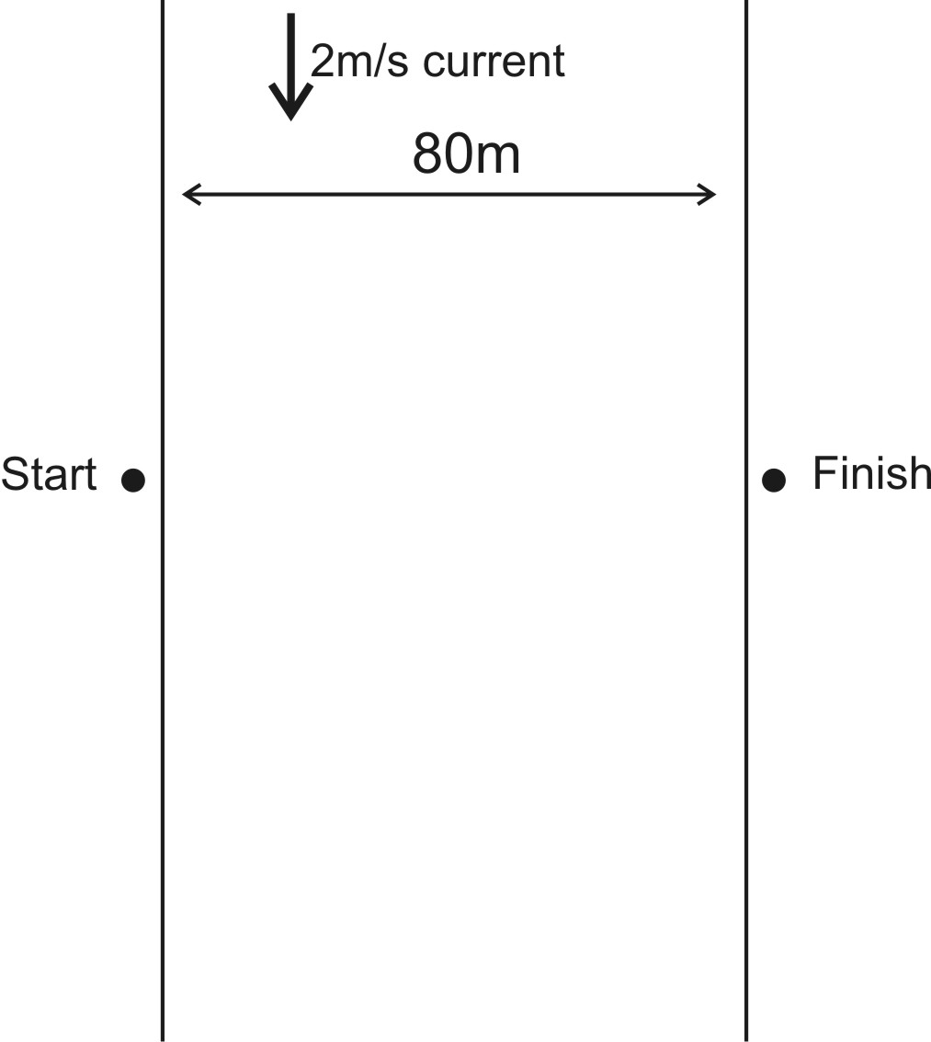
Still More River Problems

For each of the orthogonal problems below, create a head-to-tail diagram and use that diagram to answer the questions. For each non-orthogonal problem (a problem with at least one component vector that is not “vertical” or “horizontal”), create a table of x and y components, and use that table to answer the questions.

2. A motorboat is crossing a river that runs directly northward. The boat captain points the bow eastward and travels with a speed, relative to the water, of 4 m/s. The river is flowing at a rate of 7.0 m/s north. (from the Physics Classroom)
- What is the resultant velocity of the motorboat?
- If the width of the river is 100 meters wide, then how much time does it take the boat to travel shore to shore?
- At what distance downstream does the boat reach the opposite shore?

3. A ferryboat (speed in still water =5 m/s) needs to arrive at a point directly South across a 100 meter wide river. The river has a current of 02.50 m/s toward the east. Find the ferry’s time to cross. (from ChasePhysics)

4. A helicopter, flying where the average wind velocity is 38 km/h [25° N of E], needs to travel a displacement of 182 km [17° W of N] relative to the ground on a schedule of 2.0 h. Determine the required airspeed (speed through still air) and direction the helicopter must maintain. (from Northwestern University)

5. A boat travels westward at a rate of 3m/s. The boat is heading directly to the Northeast, and its speed in still water is 8m/s. What is the velocity of the water in which the paddler is paddling?
6. A quadcopter has a velocity of 20m/s in a direction 80 degrees west of North. The wind is blowing southward at a rate of 7 m/s. What are the quadcopter's airspeed and heading?
7. The driver of a golf cart on an aircraft carrier uses a compass to head northward. The cart's speedometer reads 6 mph. The aircraft carrier's heading is 28 degrees south of East, and its speed in still water is 8 mph. The ocean current is northwestward at a rate of 5mph. What is the actual velocity (relative to the Earth) of the golf cart?

Notes and Practice – Currents and Projectiles

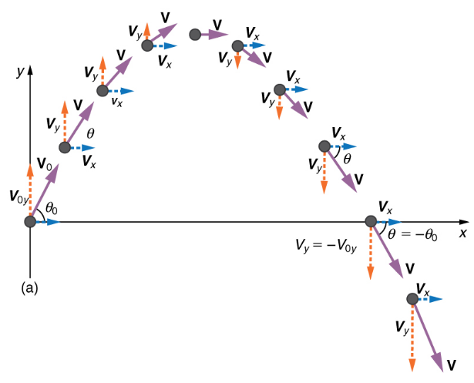
Projectiles:

1. The velocity of a launched projectile can be resolved into vertical (y) and horizontal (x) components. What happens to each of these components during the flight of the projectile? Why? Assume that there is no air resistance.

2. A projectile is launched horizontally and to the left from the top of a tall building in the absence of air resistance. Sketch the path of the projectile as it falls to the ground. Use arrows to represent the object’s speed, Vx, and Vy at the topmost point and at some other points during the fall.

3. Suppose a boat travels across a river, maintaining a heading that is due north. The boat’s speed, relative to the water, is a steady 4m/s. The river’s current has a westward velocity of 2m/s. What happens to the x and y components of the boat’s velocity as it crosses the river? Sketch a diagram showing the boat’s path. For at least three points, sketch vectors representing the x and y components of the boat’s velocity (Vx and Vy).

4. What is the main difference between “river problems” and “projectile problems?”
5-9. A projectile is launched from ground level with an initial speed of V at an angle of θ above horizontal to the right. The projectile flies in the absence of air resistance until it returns to ground level. Remember Mr. Pennington’s Huge Idea.

5. Create a sketch showing the initial conditions in this problem. Show the initial velocity vector. Also resolve the initial velocity vector into X and Y components and sketch those components.

6. Use trig identities to express the values of Vox and Voy.

Vox =

Voy =

7. Which component vector determines the time that the projectile remains in flight? Derive an equation for time aloft.

8. Derive an equation for the x displacement of a projectile with the same starting and ending height. This is known as the range formula.

9. Memorize this conversion: 1m/s ≈ 2.24mph

Projectile Practice Problems: Assume for all problems that there is no air resistance.

1. A car traveling at 60mph drives horizontally off of a cliff and falls to the ground 100m below.

a. Convert 60mph to m/s.

b. How long does it take the car to reach the ground?

c. How far, horizontally, does the car fly through the air?

2. You throw a ball at a 70° angle with an initial speed of 30mph. The ball flies in an arc and lands on a shelf at the same height from which you released it.

a. Convert 30mph to m/s.

b. Find the ball’s v_{0x} and v_{0y} .

c. How long will the ball remain aloft before hitting the shelf?

d. What is the distance between the point of release and the point of impact on the shelf?

e. What maximum height was reached by the ball?

3. You are trying to throw a ball through an open window that is 20m above the point at which you will release the ball and 5m in front of that release point. To minimize possible damage, you want the ball to enter the window at its apogee (max height). At what angle and with what initial speed should you release the ball?

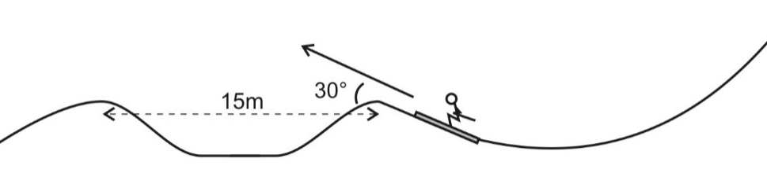
4. A skier builds a jump and a landing area as shown on the diagram to the right. The takeoff point and the landing point are 15m apart and at equal elevations. The jump is inclined to horizontal at a 30 degree angle.

a. What speed does the skier need to attain in order to travel exactly 15 meters?

b. Given the initial speed from part a, what is the skier’s maximum height, relative to the takeoff point?

c. Given the same initial speed, what is the skier’s time aloft?

Mr. Pennington’s Chapter 3 Test 2015-2016

I. Multiple Choice: Select the one best answer for each question. Where g is used, assume it equals 10 m/s² and neglect air resistance for falling/moving objects.

1. For a symmetric projectile with an initial velocity of v₀, what other angle gives the same range as 60º?
A) 5º B) 30º C) 45º D) 60º E) 75º

2. For a symmetric projectile with an initial velocity of v₀, what angle gives the greatest range?
A) 5º B) 30º C) 45º D) 60º E) 75º

3. A projectile is shot vertically upward with a given initial velocity. It reaches a maximum height of 50.0 m. If, on a second shot, the initial velocity is tripled (i.e. 3X), then the projectile will reach a maximum height of:
A) 75 m B) 100 m C) 150 m D) 200 m E) 450 m

4. The vectors $\vec{A}$, $\vec{B}$ and $\vec{C}$ are related by $\vec{C} = \vec{A} + \vec{B}$. Which diagram below illustrates this relationship?
A) B) C) D)
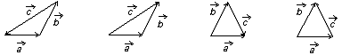

5. A bird flies at a speed of 15 meters per second with respect to the ground and the wind is blowing at a speed of 5 m/s second with respect to the ground. [Note: The wind could be blowing with the bird, in the opposite direction of the bird or all other possible directions.] Which one of the speeds listed below is a possible net speed (i.e. vector sum) of the bird with respect to the ground?
A) 3 m/s B) 5 m/s C) 9 m/s D) 18 m/s E) 25 m/s

For #6-11, the answers will be <, = or >, but you will mark A, B or C on your Scantron sheet. Assume no air friction for these projectiles and consider only the speed of the projectile (i.e. disregard the + and – signs).

A) < B) = C) >
x
y
Diagram for #1-3

6. v_{B} ____ v_{yA}

7. a_{a} ____ a_{B}

8. v_{yB} ____ v_{yC}

y
x
Diagram for #4-6

9. v_{xC} ____ v_{xD}

10. v_{A} ____ v_{E}

11. v_{yD} ____ v_{yB}

12. A vector has a component of 5 m in the +x direction and a component of 12 m in the +y direction. The magnitude of this vector is:
A) 13 m B) 15 m C) 17 m D) 60 m E) 169 m

13. A vector in the xy plane has an x-component of 14.0 and a y-component of 9.4. The angle it makes with the positive x axis is:
A) 26º B) 34º C) 45º D) 59º E) 66º

14. Which of the following cannot be a vector quantity?
A) velocity B) acceleration C) force D) temperature

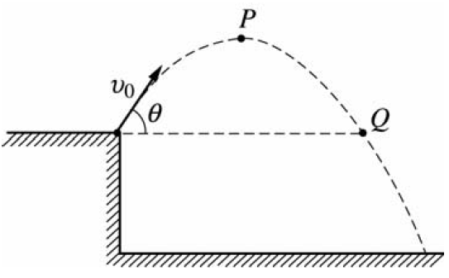
Diagram for
Questions 15 & 16

A rock is thrown from the edge of a cliff with an initial velocity v₀ at an angle θ with the horizontal as shown above. Point P is the highest point in the rock’s trajectory and point Q is level with the starting point. Assume air resistance is negligible.

15. Which of the following correctly describes the horizontal and vertical speeds and the acceleration of the point at Point P?

Horizontal Speed Vertical Speed Acceleration
A) v₀ cos θ 0 g
B) 0 0 g
C) v₀ cos θ v₀ sin θ g
D) 0 v₀ cos θ g
E) v₀ cos θ 0 0

16. Which of the following correctly describes the horizontal and vertical speeds and the acceleration of the point at Point Q?

Horizontal Speed Vertical Speed Acceleration
A) v₀ cos θ 0 g
B) 0 0 g
C) v₀ cos θ v₀ sin θ g
D) 0 v₀ cos θ g
E) v₀ cos θ 0 0

17. A bullet shot horizontally from a gun. At the same instant, another bullet is simply dropped from the same height. Neglecting air resistance, the bullet shot from the gun
A) strikes the ground much later than the dropped bullet.
B) never strikes the ground.
C) strikes the ground at the same time as the dropped bullet
D) travels in a straight line.
E) strikes the ground much sooner than the dropped bullet.

18. If θ is the angle with respect to the +x-axis, the y-component of the vector A is given by
A) A cos θ B) μA cos θ C) A sin θ D) mg – A sin θ E) tan⁻¹θ

v
α
19. Given the diagram to the right, what is the x-component of the vector v?
A) V sin α
B) V cos α
C) V tan α
D) V sin⁻¹α
E)

II. Problems: Clearly show your work. Be neat. Use the correct number of significant figures and circle your answers. All answers must have units. Assume g = 9.8 m/s².

1. A force vector F has a magnitude of 12.0 N and a direction of 290.0º with respect to the +x axis.
A. Find the x-component of the force vector.
B. Find the y-component of the force vector.

2. A position vector $\vec{r}$ has x- and y-components of r_{x} = -6.50 m and r_{y} = 10.25 m.
A. Find the magnitude of the position vector.
B. Find the direction with respect to the +x axis of the position vector.

3. A projectile is launched at ground level with an initial speed of 40.0 m/s at an angle of 58.0º above the horizontal. It strikes a target above the ground 4.60 seconds later. [Note: This is not a symmetric projectile.] Assume the projectile is launched at x₀ = 0.00 m and y₀ = 0.00 m.
A. What is the x-position of the target?
B. What is the y-position of the target?

4. A ball is kicked with an initial velocity of 16.0 m/s in the horizontal direction and 12.0 m/s in the vertical direction. [Note: This is a symmetric projectile.]
A. What maximum height is attained by the ball?
B. For how long does the ball remain in the air?
C. What is the range of the ball (i.e. the horizontal distance traveled)?
D. At what speed does the ball hit the ground?

5. A ball is thrown horizontally from the top of a 60.0-m building and lands 150.0 m from the base of the building. Ignore air resistance.
A. How long is the ball in the air?
B. What must have been the initial velocity?

6. A boat with a calm water speed of 10.0 m/s crosses a river 3.00 x 10² m wide. The boat keeps its bow pointed directly across the river, but drifts downstream because the river current is 3.00 m/s.
A. Find the time needed to cross the river.
B. Find the distance the boat drifts downstream.

Physics 200 (Stapleton) Name: _____________________________
Old Test (22-23): 2-D Kinematics, Version 1

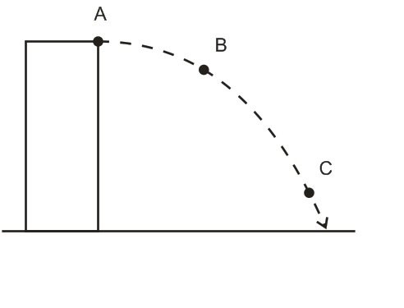
Part 1: Short Answer and Multiple Choice: 1 point each
The diagram on the right shows a projectile that is launched horizontally from the top of a tall building in the absence of air resistance.

1. Use labeled arrows to represent the object’s x velocity (v_{x}) at each lettered point (unless v_{x} happens to be zero).

2. Use labeled arrows to represent the object’s resultant velocity (“v”) at each lettered point (unless v happens to be zero).

3. Use labeled arrows to represent the object’s y velocity (v_{y}) at each lettered point (unless v_{y} happens to be zero).

4. 1m/s =_________ mph

Multiple Choice: Circle the correct answer.
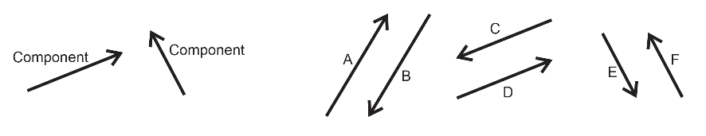
5. Which of the lettered vectors is the resultant that is produced when the two component vectors are added together?
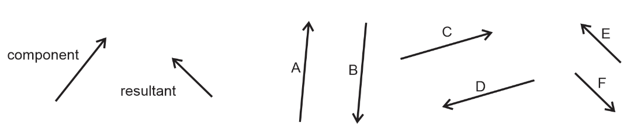
6. Which of the lettered vectors can be added to the component vector to give the resultant vector?

7. A projectile that is shot with a given initial y-velocity reaches a maximum height of 50.0 m. If, on a second shot, the initial y-velocity is doubled, what maximum height will the projectile reach?
A) 75 m B) 100 m C) 150 m D) 200 m E) 450 m

8. If θ is the angle made by vector A and the positive x-axis, then the y-component of the vector A is…
A) A cos θ B) μA cos θ C) A sin θ D) mg – A sin θ E) tan⁻¹θ

9. A vector in the xy plane has an x-component of +5.7 and a y-component of +9.4. The angle it makes with the positive x axis is:
A) 26º B) 34º C) 45º D) 59º E) 66º

10-11. A rock is thrown from the edge of a cliff with an initial velocity v₀ at an angle θ with the horizontal as shown above. Point P is the highest point in the rock’s trajectory and point Q is level with the starting point. Assume air resistance is negligible.

10. Which of the following correctly describes the horizontal and vertical speeds and the acceleration of the point at Point P?

Horizontal Speed Vertical Speed Acceleration
A) 0 v₀ cos θ -g
B) v₀ cos θ 0 0
C) v₀ cos θ v₀ sin θ -g
D) 0 0 -g
E) v₀ cos θ 0 -g

11. Which of the following correctly describes the horizontal and vertical speeds and the acceleration of the point at Point Q?

Horizontal Speed Vertical Speed Acceleration
A) 0 v₀ cos θ -g
B) v₀ cos θ 0 0
C) v₀ cos θ v₀ sin θ -g
D) 0 0 -g
E) v₀ cos θ 0 -g

Part 2: River Problems – In the case of wrong answers, partial credit may be given for correct formulas – in their original form -- and correct units. Enclose your answers and your starting formulas in boxes. For problems with multiple parts, if you do not know the answer to one part, you may make up an answer to use in a subsequent part.
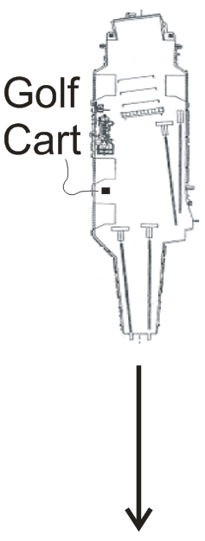
1. (8 Points) An aircraft carrier is traveling at a rate of 10m/s southward. An airman driving a golf cart uses a compass to head eastward across the moving carrier, perpendicular to the carrier’s length. The golf cart’s speedometer reads 6m/s.

a. What is the actual speed of the golf cart, relative to the Earth?

b. What is the golf cart’s direction of travel? Describe the direction in degrees relative to North, South, East, or West.

2. A helicopter is flying in a wind. The helicopter’s heading is due West, and its current air speed (speed in still air) is 50m/s. The helicopter’s actual velocity (relative to the Earth) is 80m/s in a direction 55° West of South. Find the speed and direction of the wind. [Please Note: The following questions refer to x and y components. In reality, these x components are really East-West components, and the y components are really North-South components. But when I work these problems in class, I refer to them as x and y components. It’s easier that way.]

a. (1 pt) What are the x and y components of the helicopter’s heading & air speed (H)?

H_{x} = __________ H_{y} = ___________

b. (1pt) What are the x and y components of the helicopter’s actual velocity (V)?

V_{x} = __________ V_{y} = ___________

c. (3 pts) What are the x and y components of the wind velocity (W)?

W_{x} = __________ W_{y} = ___________

d. (3 pts) Precisely describe the speed and direction of the wind velocity (W).

Wind Speed = ___________

Wind Direction = _______________
2-D Kinematics Test Name: _______________________________
Part 3: Projectile Motion Problems
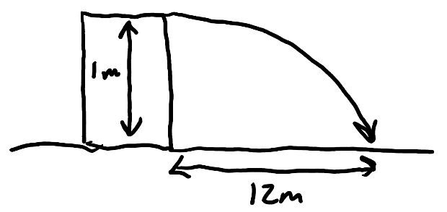
3. (6 pts) You shoot a projectile horizontally from a table top. The projectile flies 12m horizontally before it hits the floor. The point of impact on the floor is 1m lower in elevation than the projectile’s release point.

a. How long is the projectile in the air?

b. What is the projectile’s initial speed as it leaves the launcher?

4. (6 points) An athlete executing a long jump leaves the ground at a 28.0º angle above horizontal and with an initial speed of 8m/s. His landing point is at the same elevation as his take-off point. Determine the following.

a. What is his total time aloft?

c. What horizontal distance does he travel?

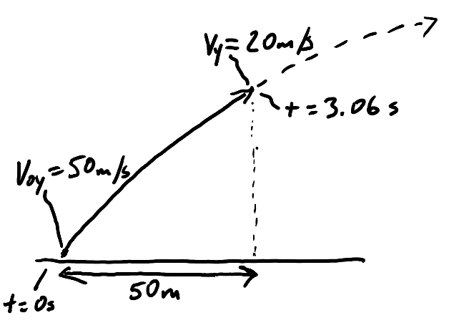
5. (6 pts) A projectile is launched from the ground with an initial y velocity of 50m/s. After 3.06 seconds, the projectile’s y velocity has decreased to 20m/s. During this 3.06 second time period, the projectile has traveled a horizontal distance of 50m.

a. What is the projectile’s height at the moment when its y velocity is 20m/s?

b. What is the projectile’s initial speed?

c. At what angle (relative to horizontal) was the projectile launched?

