Special Pass for Projectile Launcher Testing

On my honor, I agree to minimize disturbances to other classes. Furthermore, I agree that I may use my cell phone to measure launcher angles and to determine impact points, but that I will not use it for any other purpose. I will return my phone to the caddy as soon as I have finished testing my projectile launcher.
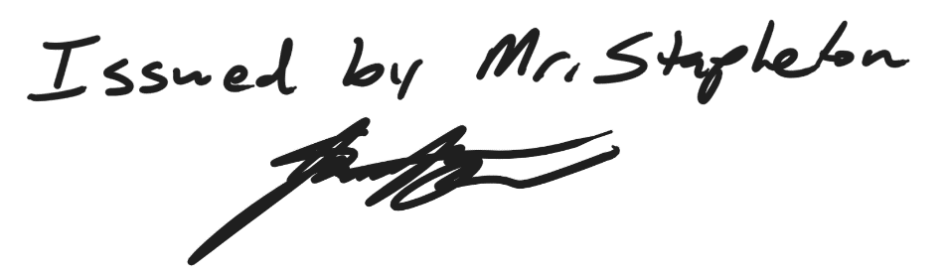
Printed Name: _______________________

Signature: ________________________

Special Pass for Projectile Launcher Testing

On my honor, I agree to minimize disturbances to other classes. Furthermore, I agree that I may use my cell phone to measure launcher angles and to determine impact points, but that I will not use it for any other purpose. I will return my phone to the caddy as soon as I have finished testing my projectile launcher.
Printed Name: _______________________

Signature: ________________________

