Physics 200 (Stapleton) Name: __________________________________
Trajectory Contest Project

Project Overview: Modify, calibrate, and fine-tune a projectile launcher to shoot targets while avoiding obstacles. Use your physics knowledge to create a spreadsheet that will help you determine the best trajectory for each shot, as well as the proper setting for your launcher. Use your ingenuity and problem-solving skills to develop means of aiming and triggering your launcher in order to achieve the greatest accuracy and precision.

Project Requirements:
- Participate in the calibration process, spreadsheet-making, launcher calibration, problem-solving, and all of the contest shots.
- On the contest day, submit of a printed “launcher calibration graph” and corresponding contest solutions. The launch angles, launch heights, and initial velocities provided in your solutions must be “correct” – meaning that a projectile launched in this manner should avoid the obstacles and hit the target.
- Create and turn-in a working trajectory spreadsheet with at least three sheets…
  - Sheet 1: This sheet is named “Trajectory,” and it accomplishes the following:
    - Calculates initial X and Y velocities, based on the following inputs:
      - launch angle
      - launch speed
    - Provides a graph of position vs time meeting the following requirements:
      - The graph is generated based on the following inputs:
        - initial angle
        - initial speed
        - Initial y position
      - The Y axis shows only positive (above the floor) values.
      - The graph also includes the following, each in a color different from the projectile’s path:
        - A point designating the position of the target.
        - At least three points designating the ceiling height
        - At least two points showing the top and bottom of a first vertical obstacle
        - The ability to include two more points showing the top and bottom of a second vertical obstacle.
      - The projectile’s trajectory is shown as a 2nd degree polynomial trendline, with the “point size” set to zero.
      - The calculation time increments are adjustable.
  - Sheet 2: This sheet is named “Launcher Calibration,” and it provides the following:
    - At least two of these initial speed calculators (in working order):
      - Horizontal Launch v₀ Calculator
        - Determines the initial speed of a projectile launched horizontally from a height above the target level.
        - Inputs: launch height, horizontal distance traveled (x distance)
      - Symmetric Launch v₀ calculator
        - Determines the initial speed of a projectile launched upward at an angle, traveling horizontally, and landing at the same height at which it was launched.
        - Inputs: launch angle, range (horizontal distance traveled – x distance)
      - Bonus (worth 5% added to project grade – for the student(s) who figure(s) it out): Asymmetrical Launch v₀ Calculator
        - Determines the initial speed of a projectile launched at an angle, traveling horizontally, and landing at a height that is different from the launch height.
        - Inputs: launch angle, range, y displacement
    - Calibration Graph: A graph of “Initial speed (v₀) vs. Launcher Setting” for your launcher. On this graph, fit a trendline to your data points, but don’t get rid of the dots.
  - Sheet 3: This sheet is named “Launcher Calibration Graph.” Create this sheet by copying and pasting your graph on sheet two, so that you have two identical copies. Then move this one to its own sheet. Adjust the gridlines so that you can read the graph more precisely. You may also find it useful to adjust the axes’ minima and maxima.

Data Collection:

Warnings/Notices:
- Be safe: you really could hurt an eye with these launchers.
- Be respectful of other classes: the sound of people launching little oak logs in the hallway is distracting. Do your best to be quiet, and avoid open classroom doors.
- This is an application of physics, but it is also an engineering challenge. There are many things you can do to improve your performance and your launcher’s performance. I could suggest some things, but I would rather give those of you who are motivated and clever the chance to distinguish yourselves. You will be sharing launchers, but you can modify them as long as you do not hinder the success of a group in the other class. Among other problems, you will need to devise a way to launch at a specific height and angle.

Data Collection Procedure (feel free to go in an order that suits you, but this one makes sense to me):
- Choose a launcher and write down its number.
- Set up your launcher and get a projectile. You may want to measure the mass of your projectile (in case you lose it). It is also a good idea to create a unique label your projectile.
- You might want to think about strategy at this point, but it’s not required.
- Adjust your launcher so that you can launch projectiles with a v₀ up to at least 10m/s. There is no benefit to being able to launch faster.
- Create or adopt a launcher scale. You can draw on the launcher if you wish.
- Choose a method for finding your launcher’s initial velocity (symmetric flight, horizontal launch, or asymmetric flight). There are pros and cons to each method.
- Get a cardboard backstop.
- Find a good place to work (probably a hallway). Then shoot your launcher at a variety of settings on your scale and collect the necessary data to determine your launcher’s v₀ with the calculator that you have chosen. For example, if you are using the horizontal launch, for each launch you will need to record release height, horizontal distance, and launcher setting. Be organized; create and use a data table to record your data. Try to be smart, too. Repeat measurements as many times as you deem efficient and necessary. You want good data, but you don’t want to spend too long on data collection.
- Enter your data on the second sheet of your spreadsheet. Make a graph of v₀ vs launcher setting. Add a trendline. You may have to use a high order polynomial trendline. If you have switched groups, you can make a copy of your previous group’s spreadsheet.
- Copy and paste this calibration graph. Then move the copy to its own sheet. This graph will be bigger, so you can read it with more precision.
- Practice. Set up some practice scenarios and see how close you can come to hitting targets that you set for yourself.
- Perform occasional tests to see if your calibration graph still accurately predicts initial velocity. If it doesn’t, adjust it. An easy way to make adjustments is to print the graph and then draw a new curve by hand

Trajectory Practice Problems:

These are actual contest problems that were used in the past. Use your spreadsheet to determine a successful combination of launch angle and initial speed. Then use the example calibration graph to determine the correct launch setting for the hypothetical launcher. Obstacle positions are described in terms of their horizontal distance from the launch point and their vertical distance above the floor.

1. Release height = 01.63m Horizontal Distance To Target = 5m Target Height = 0.025m
Obstacle 1 Position: 2m from the launch point, 1.18m-2m from the floor
Ceiling Height = 2.57m
Θ = ________ V₀ = ________ Launcher Setting = ________

2. Release height = 0.55m Horizontal Distance To Target = 1m Target Height = 0.025m
Obstacle 1 Position: 0.4m from the launch point, 1.5-1.8m from the floor
Obstacle 2 Position: 0.65m from the launch point, 0-0.86m from the floor
Ceiling Height = 2.57m

Θ = ________ V₀ = ________ Launcher Setting = ________

3. Release height = 0.55m Horizontal Distance To Target = 8m Target Height = 0.025m
Obstacle 1 Position: 2m from the launch point, 0-0.86m from the floor
Obstacle 2 Position: 4m from the launch point, 1.38m-2.2m from the floor
Ceiling Height = 2.57m

Θ = ________ V₀ = ________ Launcher Setting = ________

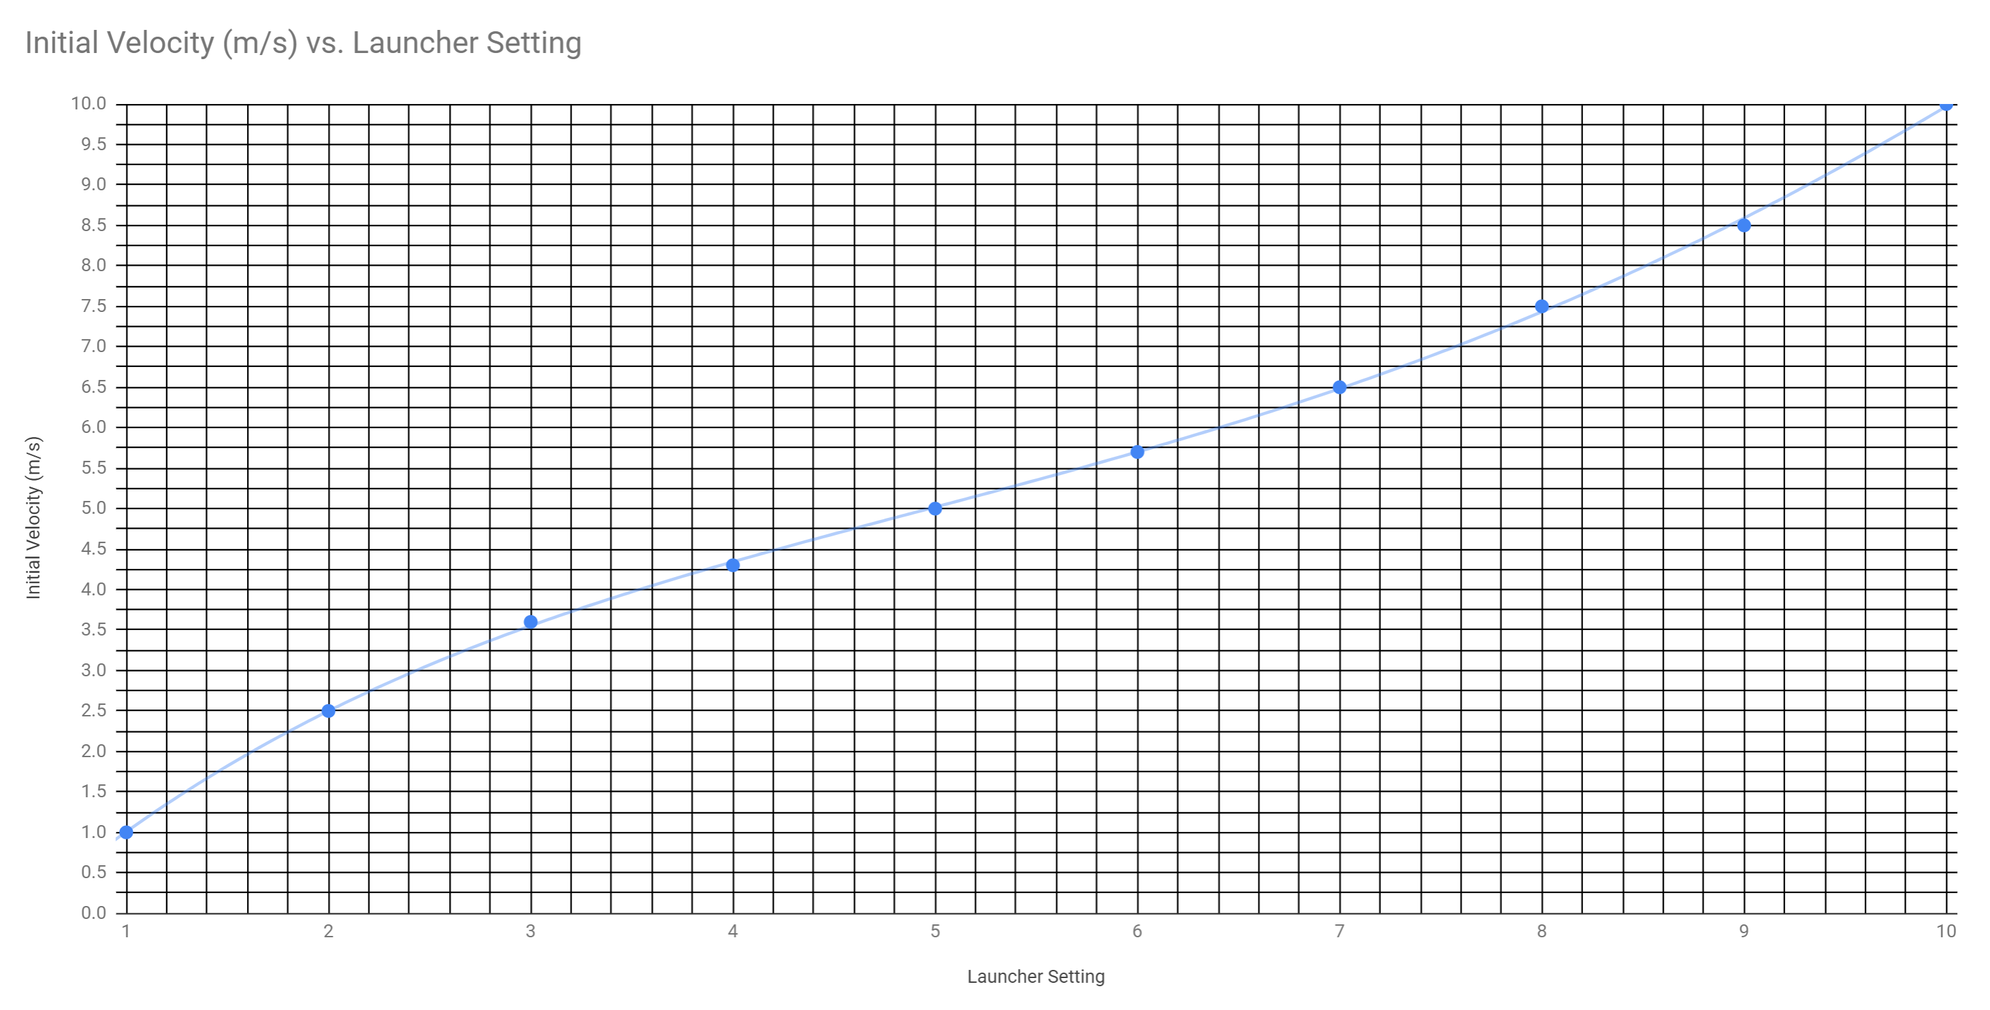

Some Contest Details:
- You will be given the contest problems at the end of class on the day before the contest. This will allow you to strategize before class, so that you can take your best shots and so that the contest will run smoothly.
- ***Instead of a specified launch height, you will be offered a 15” (38cm) vertical (y axis) launch “window” above some horizontal surface. The reason for this is that you may choose from a variety of launch angles, and your choice of launch angle will constrain the starting height of your projectile. For example, if you launch straight upward from a horizontal surface, your launch height must be at least 14” above that surface, since the launcher is 14” long. On the other hand, someone who wants to launch horizontally can have a launch height of about 1” from that surface, since the launcher is not as tall as it is long.

Project Grading: 28 Points Total

- Spreadsheet completion and submission
  - Sheet 1: (8pts) Produces an interactive trajectory graph with “programmable” obstacles and ceiling.
  - Sheet 2: (6pts)
    - Provides at least two correctly-functioning calculators for determining a launcher’s initial velocity (for a horizontal launch above the target and a symmetric launch
    - Provides a graph of v_{o} vs launcher setting, based on data you collect by shooting your launcher at different settings.
    - (Optional -- 1.5 bonus points for a working, asymmetric calculator – awarded only to the creator of the calculator.)
  - Sheet 3: (1pt) Provides a larger, more precise version of the graph on a separate sheet
- Contest Problem Solutions: (3pts)
  - Before trying your competition shots, you will turn in the solutions to three trajectory problems. You will receive these problems on the day before the contest. For each problem, you will provide an initial height, an initial velocity, and an initial angle.
  - I will check your solutions with my spreadsheet (simulation). For full credit, your solutions must not predict a collision with an obstacle, and your solutions’ X axis error must be less than or equal to 5%. For error over 5%, a deduction equal to approximately twice the error will be applied to the problem in question (e.g. 20% error means you lose 40% of the points).
- Practical Application (Contest Shot #1): (10pts)
  - The first contest shot will have one simple obstacle, requiring an angle of more than 20 degrees. Grading of this first shot will be the same as the grading of the contest solutions, described above.
  - If your shot is blocked by the obstacle, the obstacle will be considered your impact point, and your % error will be the distance between the obstacle and the target divided by the overall distance to the target.
  - You will have two chances for this shot (and the others), and your best shot is the one that will be scored. [If you don’t like your score, you can try again some time during Flex. The distance will change each time you try this.]

Prizes: Donuts (or the equivalent) and glory for the top group. 3%, 2%, and 1% bonuses, respectively, for the top three groups.

