Chapter 3 Practice Test #2 – Kinematics in 2D
Concepts
1. Suppose a projectile is launched at some non-vertical angle in the absence of air resistance. The projectile remains in freefall for several seconds before hitting the ground.

a. Choose any non-vertical launch angle and sketch the flight path of the projectile.

b. Describe what happens to the projectile’s Vx over time and explain why.

c. Describe what happens to the projectile’s Vy over time and explain why.

2. Can a projectile’s Y velocity affect the projectile’s X displacement? Why or why not?

3. The velocity of an object moving in 2 dimensions has been resolved into two velocity components: Vx=5m/s and Vy = -5m/s.

a. Describe the object’s direction of travel.

b. Suppose the addition of a -5m/s air current in the y dimension doubles Vy to Vy = -10m/s. How does that change the object’s speed?

c. How does this this air current (from part b) affect the object’s X velocity?

4. Which of the following determine(s) the amount of time it takes for a boat to cross a river that runs in the positive X direction?
a. The river’s current
b. The boat’s Y velocity Component
c. The boat’s X Velocity Component
d. All of these
e. None of these
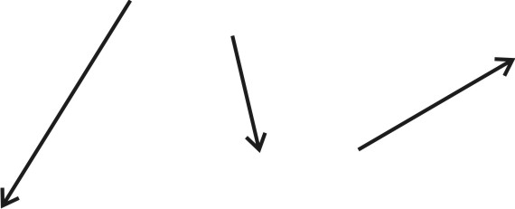
5. The figure on the right shows three vectors. Two of the vectors are component vectors that add up to the resultant vector. Which vector is the resultant vector? How can you tell?

Problems

1. A motorboat with a water speed of 10 m/s and a Northward heading encounters a 3m/s westward current.
- What is the resultant velocity (not just speed) of the motorboat?

- How long does it take the boat to travel to point that is 50m further north?

- In the time that the boat has traveled 50m northward, how far has it traveled to the west? (6 pts)

2. A paddler wants to paddle in an eastward path across a river, ending up at a point directly across the river. The river is 100m wide, and it flows Northward with a current of 1.5m/s. In still water, the paddler’s speed is 3m/s.

a. What compass heading should the paddler follow?

b. Give the paddler’s resultant velocity in terms of two component vectors, V_{North} and V_{East.}

V_{North} = V_{East.}=

3. A car drives horizontally off of a cliff. The cliff is 50m above the ocean below and the stunt driver wants the car to travel 60m, horizontally, before hitting the water. How fast should the car be traveling when it launches from the cliff?

4. A projectile is launched from ground level with a speed of 28m/s and a release angle of 72°. The projectile remains aloft until it returns to ground level.

a. How long does the projectile remain aloft?

b. What is the projectile’s maximum height?

c. How far, horizontally, does the projectile travel?

d. What is the projectile’s minimum speed during the flight (after release and before impact)?

