Physics 200 Name: ___________________________

Notes - 3.1. Kinematics in Two Dimensions: An Introduction

1. Give three examples of 2-dimensional motion.
A. __________________________
B. __________________________
C. __________________________

2. Given a right triangle of sides a and b and a hypotenuse of c, write the equation to find the length of c.

3. What is used to represent the magnitude and direction of a vector?

4. The length of the vector is directly proportional to the __________________ of the vector.

5. HUGE IDEA: The horizontal and vertical components of two-dimensional motion are

____________________ of each other. Any motion in the horizontal direction does not affect motion in the vertical direction, and vice versa.

6. One baseball is dropped from rest. At the same instant, another is thrown horizontally from the same height and follows a curved path. Which baseball hits the ground first?

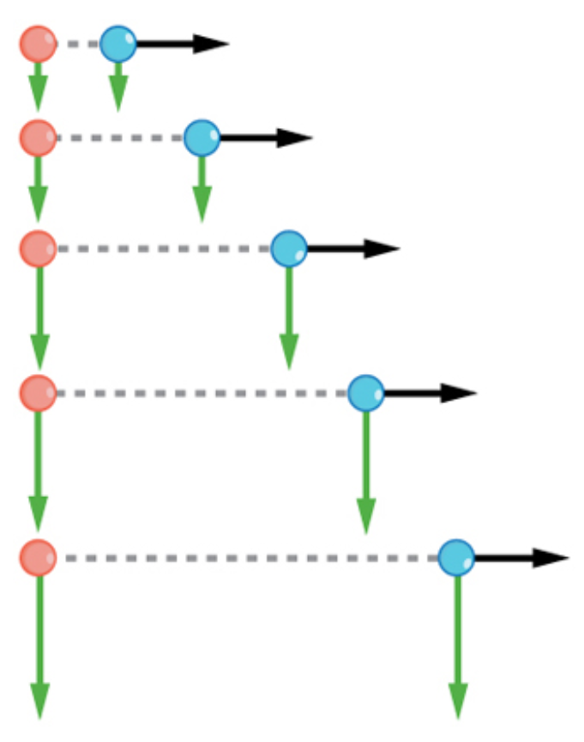
7. For the thrown (blue) ball in Figure 3.6 (on the right),
A. Is there acceleration in the y-direction?

B. Is there acceleration in the x-direction?

8. The key to analyzing such motion, called projectile motion, is to resolve (break) it into motions along perpendicular directions. Resolving two-dimensional motion into

__________________________ components is possible

because the components are __________________________.

Vector Addition Practice:
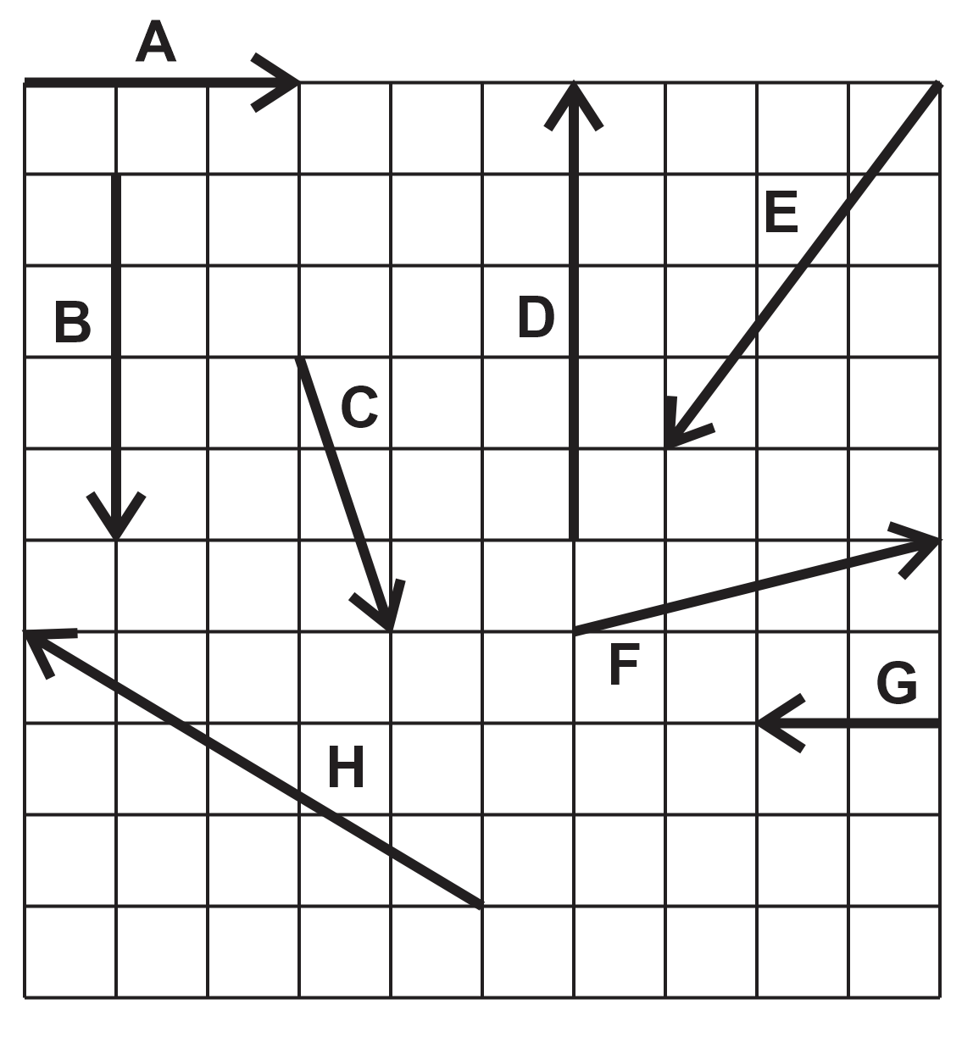

Head-to-Tail Diagram:

1. Find the resultant vector that is produced by adding vectors A and B.

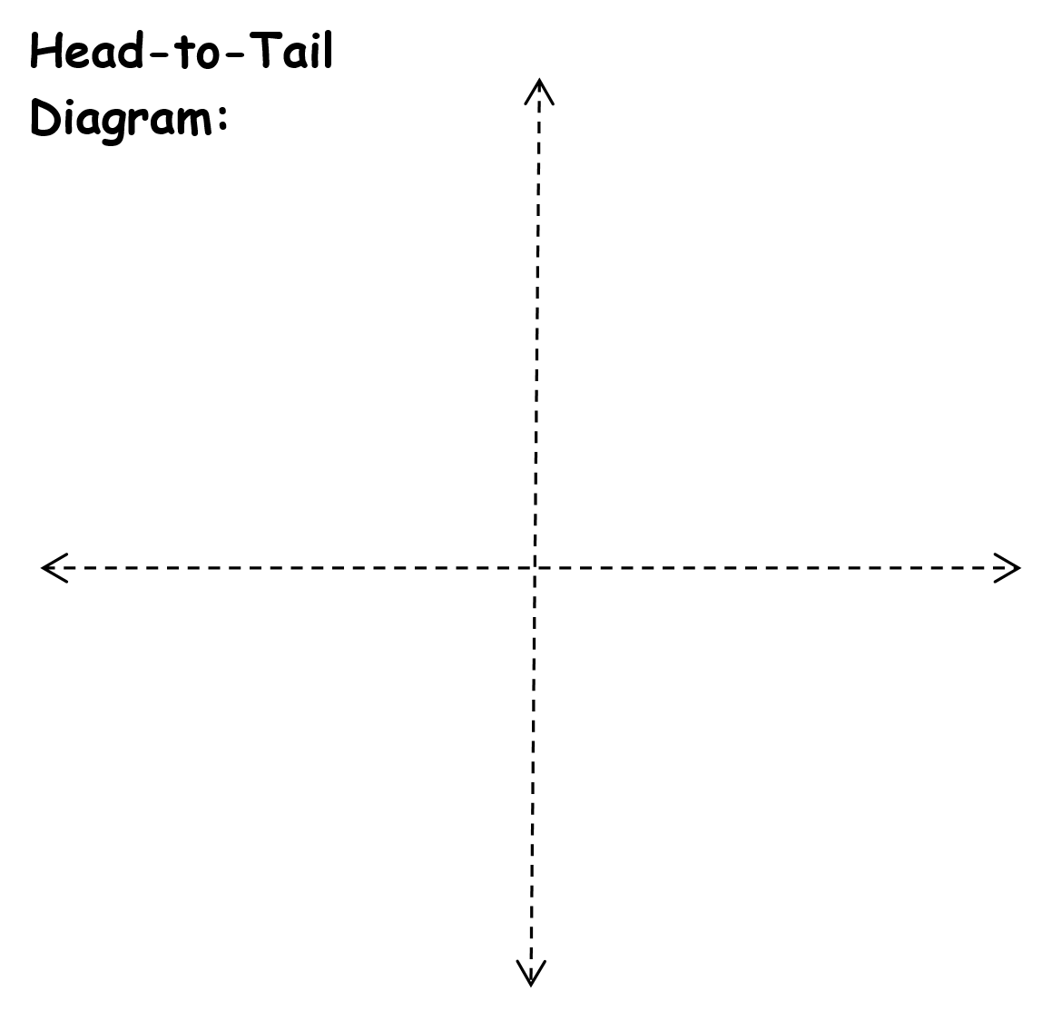
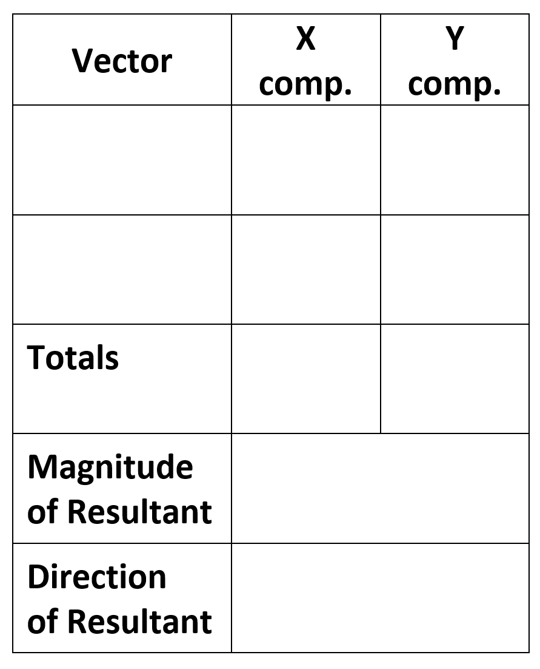

2. Add vectors E and C.

3. What is are the magnitude and direction of the resultant vector that is produced by adding vectors D, C, and A?

Find the resultant vectors from the additions of…
4. E + H
5. C + F
6. E + H + G

Answers: 1. 5, 53.1° below positive x axis 2. 7.3, 74° below negative x axis
3. 4.5, 26.5°above +x axis 4. 8.1, 7.1° above -x
5. 5.4, 21.8° below +x 6. 10.05, 84.2° left of -y axis

Physics 200 Name: _______________________

The Classic River Problem

Bob and Jane went camping. They put their canoe into a 80.0 meter wide river directly across from the perfect campsite. Avid hikers and paddlers, they are able to walk with a speed of 4.0 m/s and paddle their canoe with a speed of 3.0 m/s. The river flows South with a speed of 2.0 m/s.

Jane suggests that they angle the nose of their canoe into the current so that they travel in a line perpendicular to the current and make a landing at the campsite. She also offers to calculate (she never leaves home without her calculator) the correct angle that the compass should read as they paddle.

Bob declares that the fastest way to get across the river is to point the canoe directly across the river. Of course they will get washed downstream, but no matter says Bob, they can simply walk back to the campsite along the river.

1. Sketch both methods of travel. Label the component velocity vectors and the resultant velocity vectors with their correct magnitude. Proportions of vector magnitudes do not have to be perfect.

2. How long does Jane’s method take?

3. How long does Bob’s method take?

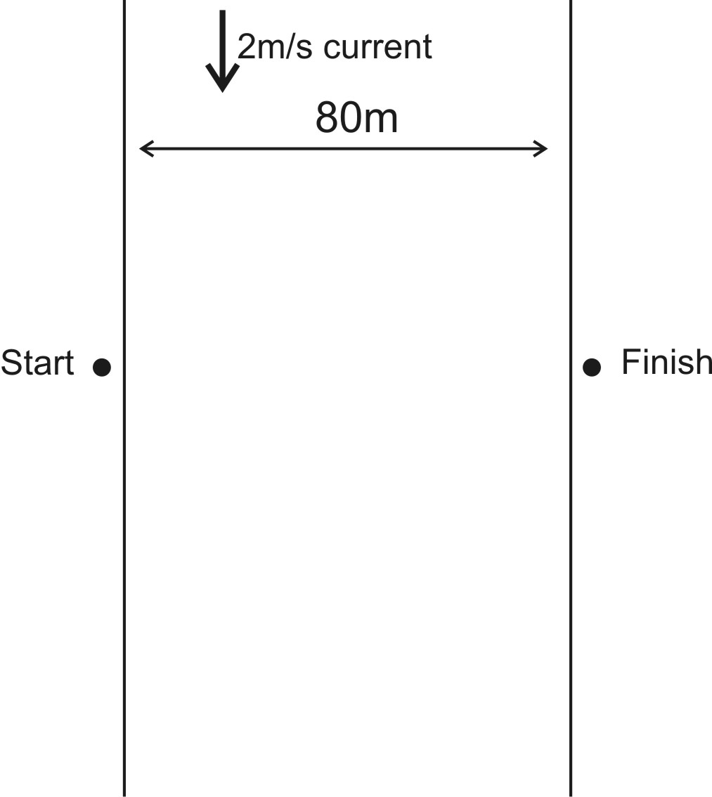
Still More River Problems

2. A motorboat is crossing a river that runs directly northward. The boat captain points the bow eastward and travels with a speed, relative to the water, of 4 m/s. The river is flowing at a rate of 7.0 m/s north. (from the Physics Classroom)
- What is the resultant velocity of the motorboat?
- If the width of the river is 100 meters wide, then how much time does it take the boat to travel shore to shore?
- At what distance downstream does the boat reach the opposite shore?

3. A ferryboat (speed in still water =5 m/s) needs to arrive at a point directly South across a 100 meter wide river. The river has a current of 0.50 m/s toward the east. Find the ferry’s time to cross. (from ChasePhysics)

4. A helicopter, flying where the average wind velocity is 38 km/h [25° N of E], needs to travel a displacement of 182 km [17° W of N] relative to the ground on a schedule of 2.0 h. Determine the required airspeed (speed through still air) and direction the helicopter must maintain. (from Northwestern University)

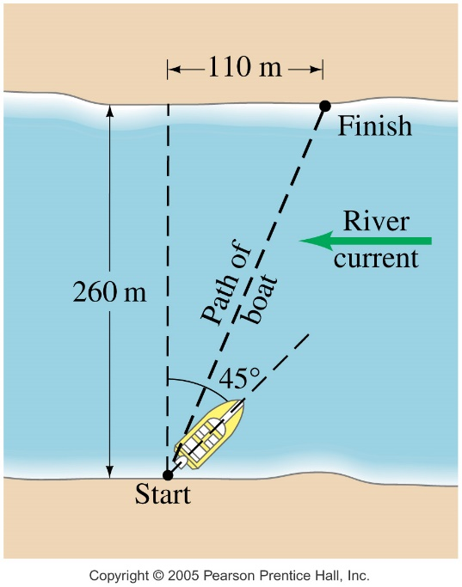
5. A boat, whose speed in still water is 3.4 m/s must cross a 260-m-wide river and arrive at a point 110 m upstream from where it starts. To do so, the pilot must head the boat at a 45º upstream angle. What is the speed of the river’s current? (from last year’s test)

