Physics 200 (Stapleton) NAME: _____________________

Chapter 1 & 2 Test 2015-2016
1-D Kinematics Practice

I. MULTIPLE CHOICE: Select the one best answer for each question. Where g is used, assume it equals 10 m/s² and neglect air resistance for falling/moving objects.

1. Which of the following five position versus time graphs represents the motion of an object moving with an increasingly negative velocity?
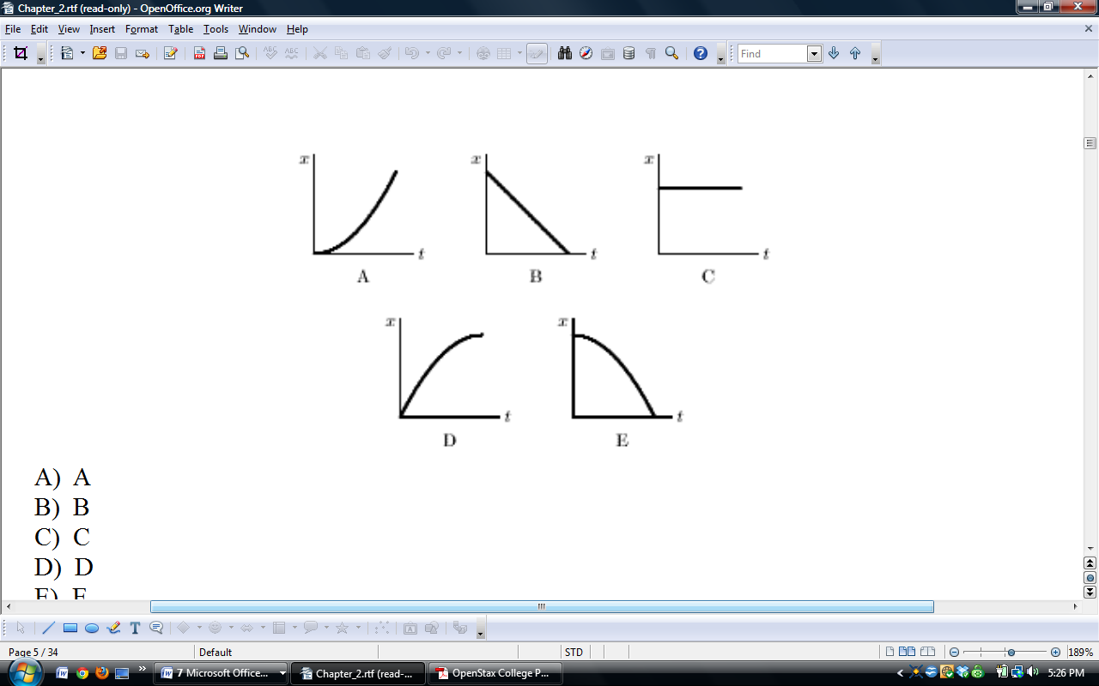
A B C D E

2. The slope of a position versus time graph gives
A) position. B) velocity. C) acceleration. D) displacement.

3. Which one of the following situations is impossible?
A) A body having a positive velocity and a negative acceleration
B) A body having a negative velocity and a negative acceleration
C) A body having zero velocity and positive acceleration
D) A body having constant acceleration and positive velocity
E) A body having constant velocity and positive acceleration

4. A particle moves on the x axis. When its velocity is positive and increasing:
A) its acceleration must be positive
B) its acceleration must be negative
C) its acceleration must be zero
D) it must be slowing down
E) none of the above must be true

5. The slope of a velocity versus time graph gives
A) position. B) velocity. C) acceleration. D) displacement.

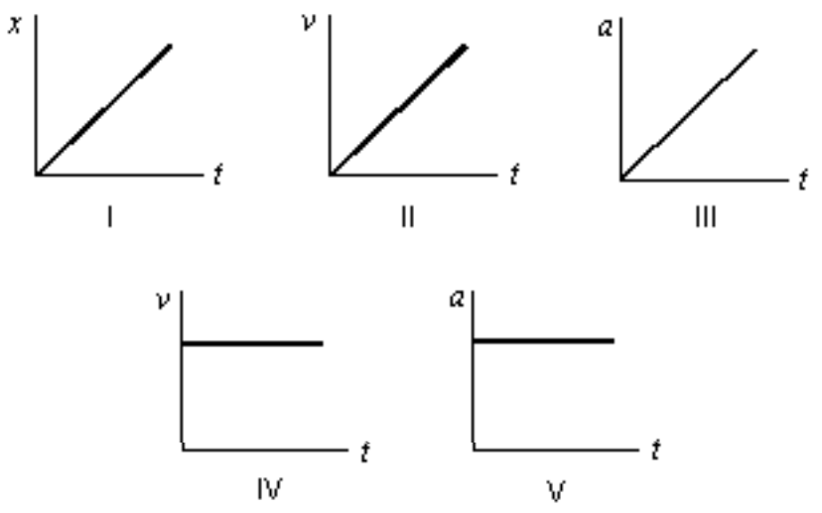
6. Consider the following five graphs (note the axes carefully!). Which of these represent(s) motion at constant velocity?

A) IV only
B) IV and V only
C) I, II, and III only
D) I and II only
E) I and IV only

7. A particle moves along the x axis from x₀ to x. Of the following values of the initial and final coordinates, which results in the displacement with the largest magnitude?
A) x₀= –4 m, x = 2 m
B) x₀ = –4 m, x = 4 m
C) x₀ = 4 m, x = –2 m
D) x₀ = 4 m, x = 6 m
E) x₀ = –4 m, x = –8 m

Questions 8-11
A car starts from Burlington, goes 60 km in a straight line to Montpelier, immediately turns around, and returns to Burlington. The time for this round trip is 2 hours.

8. What is the average speed for this round trip?
A) 0 B) 30 km/hr C) 60 km/hr D) 120 km/hr

9. What is the average velocity for this round trip?
A) 0 B) 30 km/hr C) 60 km/hr D) 120 km/hr

10. What is the distance traveled on this round trip?
A) 0 B) 30 km C) 60 km D) 120 km

11. What is the displacement for this round trip?
A) 0 B) 30 km C) 60 km D) 120 km

12. A car starts from rest and goes down a slope with a constant acceleration of 5 m/s². After 6 seconds the car reaches the bottom of the hill. Its speed at the bottom of the hill is:
A) 5 m/s B) 12 m/s C) 25 m/s D) 30 m/s E) 180 m/s

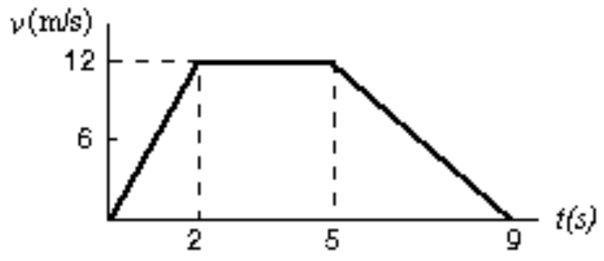
13. The graph represents the straight line motion of a car. How far does the car travel between t = 5 seconds and t = 9 seconds?
A) 4 m
B) 12 m
C) 24 m
D) 36 m
E) 60 m

14. A ball is tossed straight up. Upward is taken to be the positive direction. The acceleration due to gravity of the ball is:
A) positive during both ascent and descent
B) negative during both ascent and descent
C) negative during ascent and positive during descent
D) positive during ascent and negative during descent
E) none of the above

15. The area under a curve in an acceleration versus time graph gives
A) change in acceleration. B) change in velocity. C) displacement. D) position.

16. A freely falling body has a constant acceleration of -10 m/s². This means that:
A) the speed of the body increases by 10 m/s during each second
B) the body falls 10 m during each second
C) the body falls 10 m during the first second
D) the acceleration of the body increases by 10 m/s² during each second
E) the acceleration of the body decreases by 10 m/s² during each second

17. An object is thrown straight up from ground level with a speed of 50 m/s. What is its upward speed above ground level 3.0 seconds later? Assume g = 10 m/s².
A) 0 m/s B) 50 m/s C) 40 m/s D) 30 m/s E) 20 m/s

18. A stone is dropped from a cliff. The graph (carefully note the axes) that best represents its speed while it falls is:
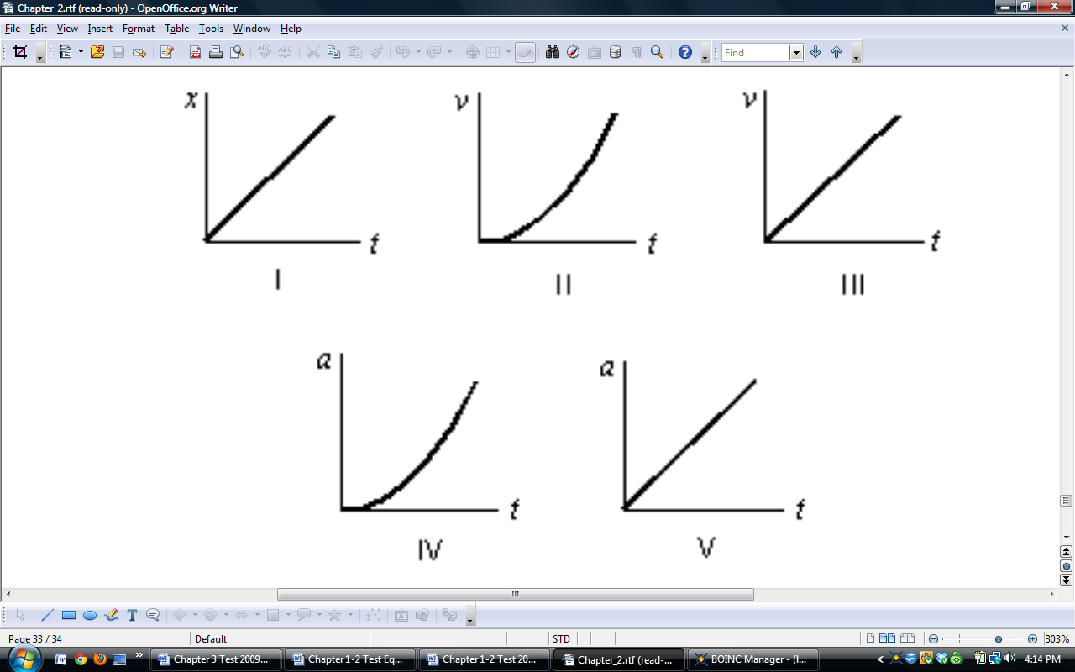
A B C D E

19. Suppose that an object travels from one point in space to another. Make a comparison between the displacement and the distance traveled. (Note: The path is not necessarily a direct straight-line path.)
A) The displacement is either greater than or equal to the distance traveled.
B) The displacement is always equal to the distance traveled.
C) The displacement is either less than or equal to the distance traveled.
D) The displacement can be either greater than, smaller than, or equal to the distance traveled.

20. The area under a curve in a velocity versus time graph gives
A) acceleration. B) velocity. C) position D) displacement..

21. Suppose a ball is thrown straight up. Make a statement about the velocity and the acceleration when the ball reaches the highest point.
A) Both its velocity and its acceleration are zero.
B) Its velocity is zero and its acceleration is not zero.
C) Its velocity is not zero and its acceleration is zero.
D) Neither its velocity nor its acceleration is zero.

II. PROBLEMS: Solve these problems on a separate sheets of white page. Do not solve them here. For full credit, show your starting equation(s), show your work and circle your answer. Where g is used, assume it equals 9.80 m/s² for these problems.

1. A car is traveling at a speed of 95.0 kilometers per hour. What is its speed in meters per second?

2. The average distance between the Mars and the Sun is 2.28 x 10⁸ km and it makes one orbit around the Sun in 687 days. Calculate the average speed of Mars in its orbit in kilometers per hour assuming a circular orbit.

3. The new pitcher for the Boston Red Sox, Hekuva Fastball (the fans call him HF for short), can throw a baseball at 0.800 c (0.800 times the speed of light). The distance between home plate is 60 feet 6 inches (18.4 m). Assuming the ball does not burn up due to friction, how long does it take the ball to reach home plate? [Note: Whenever HF is scheduled to pitch, all of the catchers call in sick.] c = 3.00 x 10⁸ m/s

4. A car travelling at 24.0 m/s slows down to 15.0 m/s in 3.00 s. How many meters will the car travel during this time?

5. A car travelling at 12.0 m/s accelerates at 2.80 m/s2 for 6.00 s. What is the car’s final speed?

6. A potato is launched from a potato gun straight up at 60.0 m/s. How much time will elapse before it smashes back into the potato gun? (Look out below!)

7. Consider a grey squirrel falling out of a tree to the ground. If we ignore air resistance in this case (only for the sake of this problem), determine a squirrel’s velocity just before hitting the ground, assuming it fell from a height of 6.00 m.

