UNIT 1 Packet: Kinematics in 1 Dimension Name: _______________________
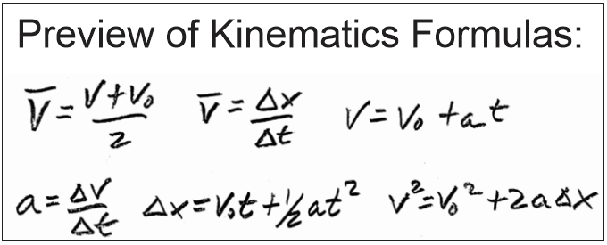Physics 200 (Stapleton)

Kinematics: The study of motion without considering its causes.

Scalar: A quantity with magnitude but no direction.

Vector: A quantity with magnitude and direction. Numerically, may be positive or negative, depending on the chosen reference frame. Usually, signs follow the same conventions as an x/y grid… upward = positive, downward = negative, rightward = positive, leftward = negative.

Δ = Delta = Final - initial = “change in”. If x changes from 3m to 1m, then Δx = 1m - 3m = -2m.

 | Symbol | Meaning (what it’s supposed to mean) | Vector or Scalar? | Common Units | How to estimate or convert
Position | x (or y, depending on axis of motion) | An indicator of distance and direction from some chosen point of origin. |  | Meters (m) | 1 long step  0.305m ≈ 1foot
Displacement (often called “distance.”) | Δx (or Δy)  Sometimes = d | Final position minus original position(e.g. x-x₀); “Change in position” |  | Meters (m) | 1 long step  0.305m ≈ 1foot
Distance | d | How far something has traveled from its original position, disregarding direction. Distance is not negative. |  | Meters (m) | 1 long step  0.305m ≈ 1foot
Distance traveled | d | Sum of all of the distances traveled on a trip. Distance traveled is what is recorded by a car’s odometer -- generally. |  | Meters (m) | 1 long step  0.305m ≈ 1foot
Time | t | ? |  | Seconds (s) | 1s = “one mississippi”
Speed | v (even though v is technically velocity) | How fast something is moving. A ratio of distance traveled to travel time elapsed. |  | Meters per second (m/s) | 1m/s ≈ 2.24mph ≈ 1 long step per second
Velocity | v | Speed in a particular direction. A ratio of displacement to travel time elapsed. |  | Meters per second (m/s) | 1m/s ≈ 2.24 mph  4.5m/s = 6min/mile pace

If I have a velocity of 3 m/s, what does that mean?

One Definition of Velocity:

Average Velocity Formula (Hint: the units provide the formula)

Average Velocity (symbol = ): when we measure velocity, average velocity is what we will actually measure. This is the average speed of an object as it travels through a given distance. The object may speed up or slow down over that distance, but the average velocity that we calculate will not show this.

Instantaneous Velocity: the velocity of an object at a single point in time

“Initial velocity” symbol =

Final velocity symbol =

Terminology Practice: An object leaves its initial position and travels to a new position. What are the object’s…

Initial Position?

Final Position?

Displacement?

Final distance from The Origin (the 0 meter mark)?
Distance traveled?

Average velocity?

Average speed?

Two Ways to Graph The Same Event

Position vs. time graph (below, left) [also called “distance vs. time”]:
- For the first 2 seconds, Chuck walked steadily away from a motion sensor. During that time, he traveled 4m “forward.”
- For the next 4 seconds (from t=2 to t=6), Chuck stood still at the 4m distance mark.
- During the last 4 seconds (t=6 through t=10), Chuck walked steadily back toward the sensor. During those two seconds, Chuck traveled 2m “backward.”

Velocity vs. time graph:
- During the first segment, Chuck traveled 4m forward (+4m) over a time of 2s. His average velocity for that interval is therefore 4m/2s = 2m/s. The velocity vs. time graph shows a constant velocity of 2m/s for the first two seconds.
- During the second segment of data (2s to 6s), Chuck stood still (0m distance) over a time of 4s. His average velocity for that interval was therefore 0m/4s = 0m/s. The velocity vs. time graph shows a constant velocity of 0m/s for the second segment of data.
- During the 3rd segment (6s to 10s), Chuck moves 4m backward (-4m). His average velocity for that interval is therefore -4m/4s = -1m/s. The velocity vs. time graph shows a constant velocity of -1m/s for the second segment of data (6s through 10s).

The small graphs, below, are actually more realistic than the large graphs. Why?

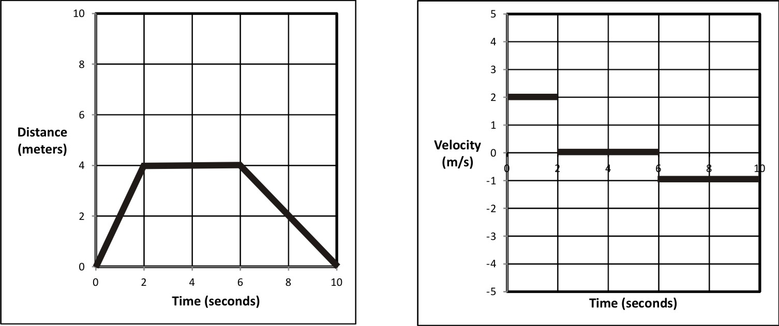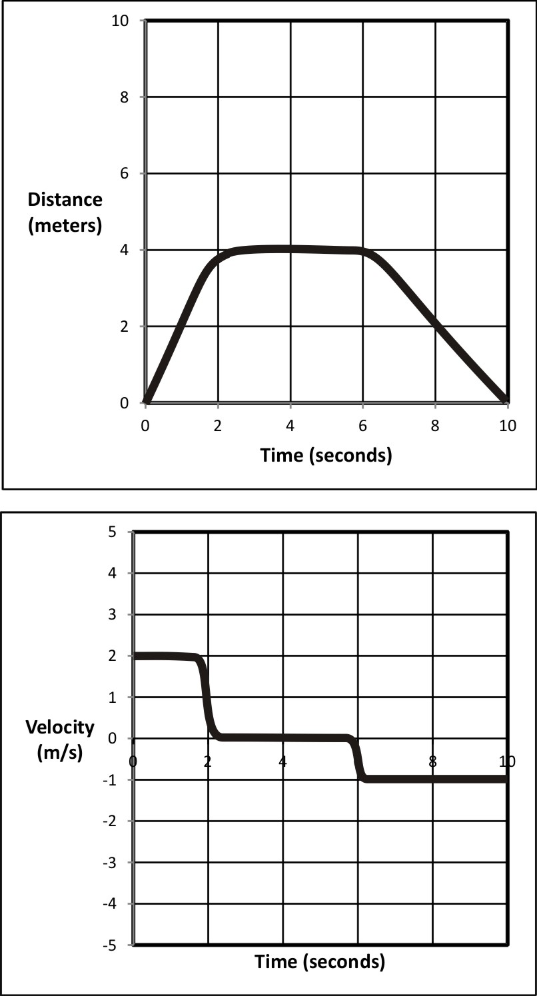

Velocity Practice: The graph on the right shows the movement of an object in front of a motion sensor. Determine the velocity of the moving object for lettered each segment, and use your calculations to fill out a velocity vs. time graph for the object (bottom of page).

1. Fill in the correct information for segment A, in the graph on the right.
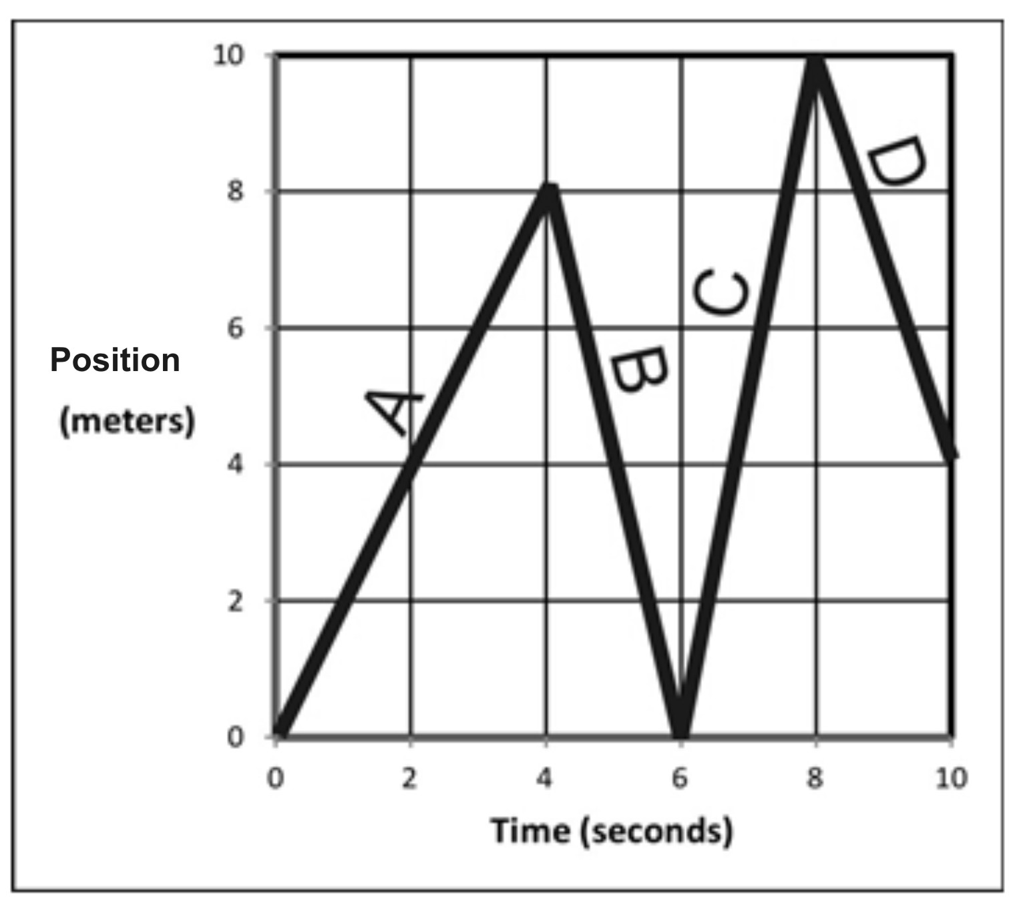
Displacement = _________

Δt = _________

v_{average} = _________

Distance traveled = ___________

Position at end of segment = ____________

2. Fill in the correct information for segment B.

Displacement = _________

Δt = _________

v_{average} = _________

Distance traveled = ___________

Position at end of segment = ____________

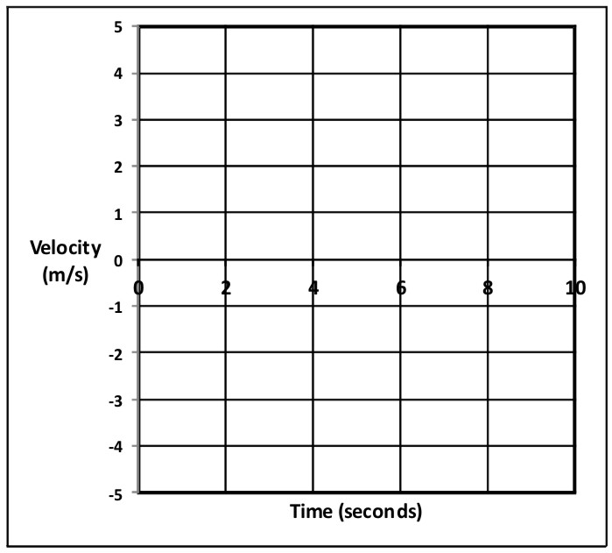3. Fill in the correct information for the entire trip (segments A-D).

Displacement = _________

Δt = _________

v_{average} = _________

Distance traveled = ___________

Position at end of segment = ____________

4. Use the distance vs. time graph above to fill in the velocity vs. time graph on the right.

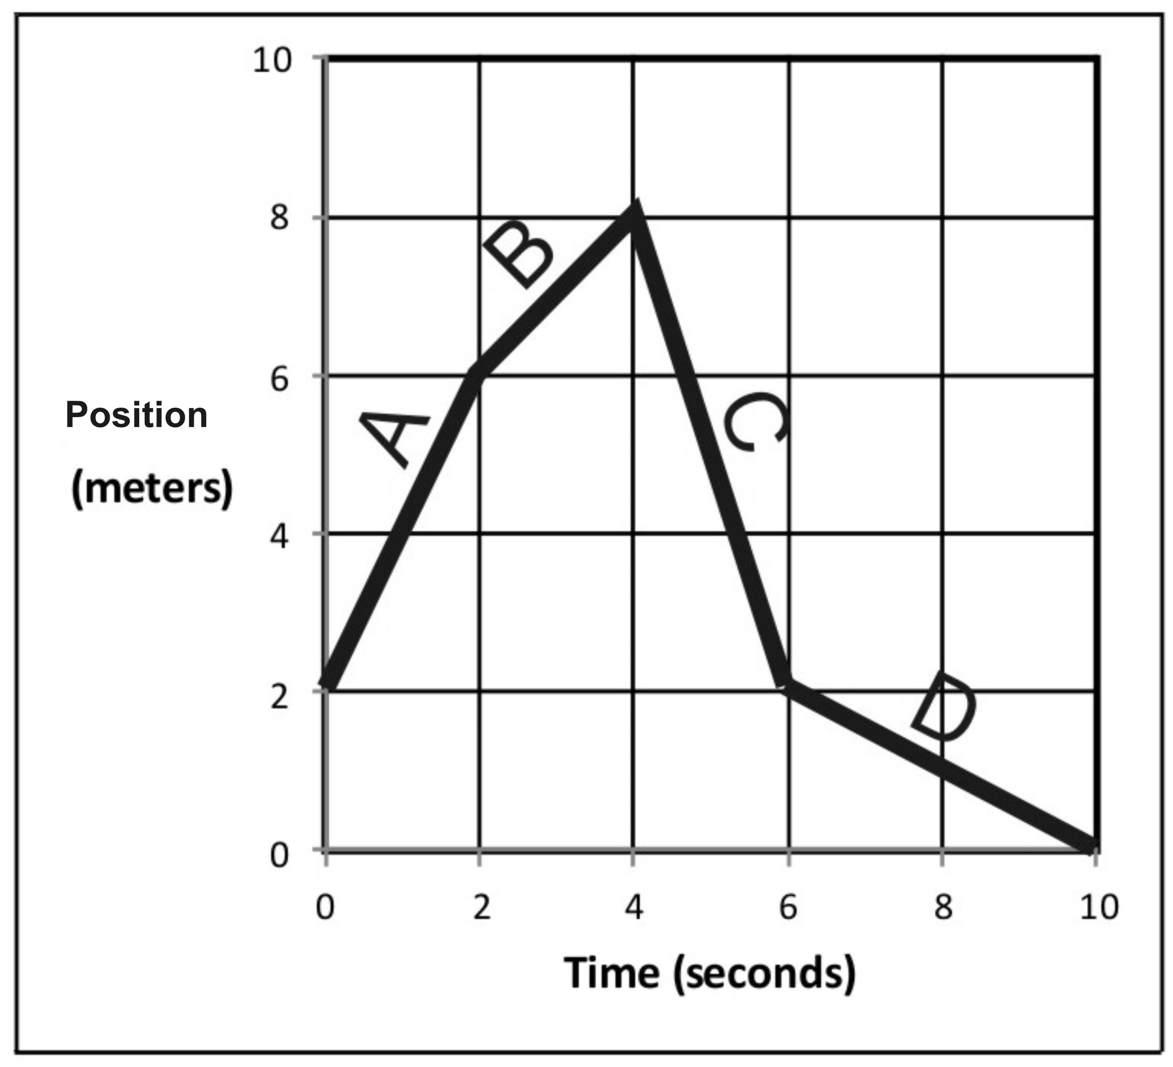
5. Fill in the correct information for segment A, in the graph on the right.

Displacement = _________

Δt = _________

v_{average} = _________

Distance traveled = ___________

Position at end of segment = ____________

6. Fill in the correct information for segment B.

Displacement = _________

Δt = _________

v_{average} = _________

Distance traveled = ___________

Position at end of segment = ____________

7. Fill in the correct information for the entire trip (segments A-D).

Displacement = _________

Δt = _________

v_{average} = _________

Distance traveled = ___________

Position at end of segment = ____________

8. Use previous answers and the distance vs. time graph above to fill in the velocity vs. time graph on the right.
Position vs. Time Motion Matching Activity Questions:

On a motion sensor graph of position vs. time…

1. What does a positive (upward) slope tell you about the object’s motion?

2. What does a negative slope indicate?

3. What does the steepness of a slope tell you about the object’s motion?

4. What does a constant (straight line) slope indicate?

5. What might a smoothly curving line indicate?

6. Sketch a negative slope that is becoming less steep. What does this curve indicate about the motion of an object?

7. Sketch a negative slope that is getting steeper. What does this curve indicate about the motion of an object?

8. Sketch a positive slope that is becoming less steep. What does this curve indicate about the motion of an object?

9. Sketch a positive slope that is getting steeper. What does this curve indicate about the motion of an object?

Acceleration Notes:

______________________ tells you how something’s position changes during one second.

______________________ tells you how something’s velocity changes during one second.

Is acceleration a vector or scalar quantity?

Acceleration can happen in two fundamentally different ways:

1)

2)

Negative acceleration is also called _____________________________

Common metric units for acceleration are:

The Analogous Relationship between Velocity and Acceleration:

If Pam has a velocity of +6m/s, that means she travels 6m for every second that ticks by. Another way to say this is that, for each passing second, Pam adds 6m to her position.

Analogously, if Pam’s acceleration is +6m/s/s, this means…

Velocity adds __________ each second.

Acceleration adds ________________________ each second.

Velocity is the slope of a _________ vs __________ graph.

Acceleration is the slope of a _________ vs __________ graph.

The acceleration formula:

Velocity describes a change in position over a time interval. Acceleration describes a change in velocity over a time interval.

a_{average} =

Acceleration Formula Practice Problems:

1. Suppose your velocity is 2m/s. One second later, your velocity is 6m/s. What is your average acceleration over this time period?

2. When your watch reads 8:01:32 AM, your velocity is 6m/s. At 8:01:40 AM (on the same day), your velocity is 2m/s. What is your average acceleration over this time period?

Motion Graphs:

Each row of graphs below comprises a position vs. time graph, a velocity vs. time graph, and an acceleration vs. time graph. Every graph in a row conveys the same motion. For each row, use the one completed graph to fill in the incomplete graphs with reasonable curves. Some rows will have a wider variety of possible answers. Assume that all acceleration is constant.

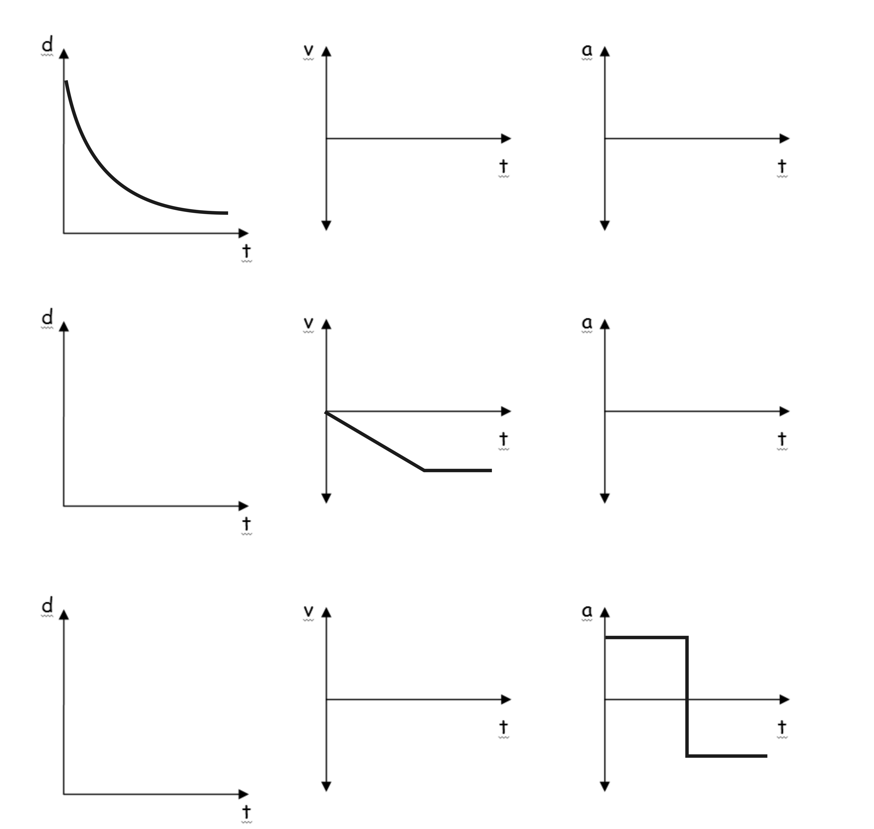
Graph Comparisons: use the information provided in one graph to complete the other two graphs. Be aware that some graphs may be unrealistic.

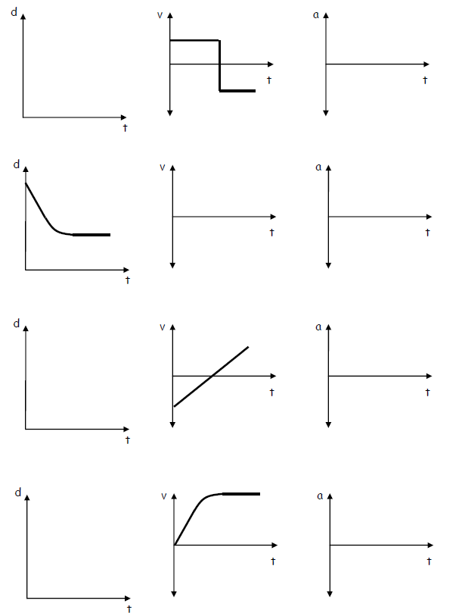
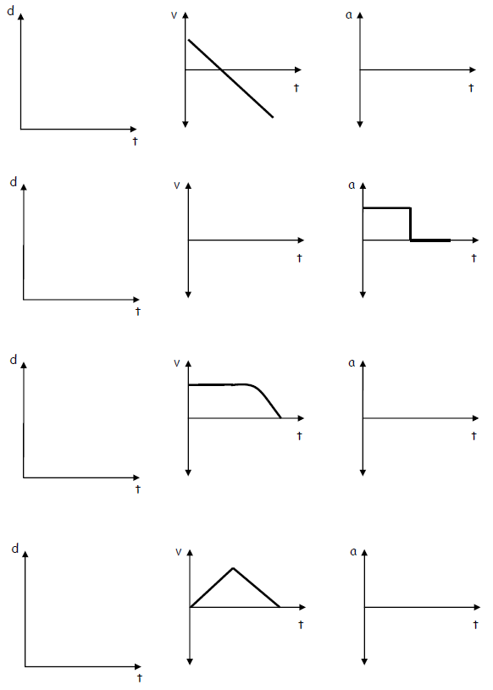
Notes: Intro to Kinematics Formulas

Deriving a formula for constant acceleration of an object starting from rest:

Suppose the car below moves with constant acceleration after starting from rest at the starting line. The car travels from the starting line to the finish line in a time of 8s. The distance from the starting line to the finish line is 32m.

=

v =

Δv =

Δt =

=

Solving for a algebraically, in terms of ∆x and t, we get…

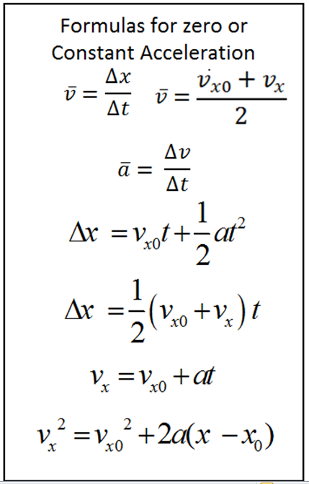
The formula we just derived for acceleration can be rearranged to give a version of the first displacement formula, on the right. What is the difference between the formula we derived and the formula on the right?

The box on the right contains a more complete set of kinematics formulas for zero or constant acceleration. If you’re curious about their derivations, many of the derivations can be found in the online textbook.

Those formulas will not always look like the ones on the right. Some symbols may be different, and some may be left out. For example:

By convention, rightward and upward directions are _______________________, and

leftward and downward directions are ___________________________.

Practice With Motion Equations:

The G.U.E.S.S. method…
- Steps: Identify what is Given. Identify the Unknown(s). Find an *Equation that incorporates the givens and the unknown. **Substitute givens into the equation. Solve.
- *Sometimes you will need more than one equation
- **It will sometimes save time and confusion if you solve for the unknown algebraically before substituting givens into the equation.

Example 1. What is the displacement of a car that starts from rest and accelerates at 6m/s² for 7 seconds?

Example 2. A nut is falling at a rate of -5m/s. If gravity accelerates the nut at a rate of -9.8m/s² for 6 additional seconds, what will be the velocity of the nut after those 6 seconds?

1. A grouse takes off from the 8 yard line of a football field and travels to the 40 yard line over a time of 8 seconds. What is its average velocity?

2. A car accelerates from 30mph to 50mph over a time of 4 seconds. What is the car’s average velocity during this time period? (Assume constant acceleration)

3. You drop a rock off of a very high bridge. Starting from rest, the rock accelerates at a rate of
-9.8m/s². You see a splash 8 seconds after you release the rock. What is the rock’s velocity when it hits the water?

4. Starting from rest, a car accelerates at 7m/s² for 10 seconds. What is the car’s displacement during this time?

5. A runner’s velocity at 12:34:33 PM is 4m/s. At time 12:34:38 PM, the runner’s velocity is 2m/s. What is the runner’s average acceleration over this time period?

6*. A child traveling at a rate of 15m/s along a zip line. After slowing down at a constant rate over a distance of 40m, the child comes to a stop.

a. What is the child’s average acceleration over this 40m?

b. How many seconds does it take for the child to travel this 40m distance?

7**. (requires multiple formulas) A driver sees a turtle in the road and hits the brakes. After slowing down for a time of 3 seconds and a distance of 20m, the driver has reduced his speed to 4m/s. What was the driver’s rate of acceleration during this three second time period?

Notes: Free-Fall, Helpful Hints, and Areas Under Curves

Free-fall: The state of being acted upon by only the force of gravity [Note that an upward-moving object may be in free-fall.]

g: the absolute value of free-fall acceleration near the Earth’s surface.

Free-fall acceleration: -9.8m/s² or -g

The diagram below is intended to represent an object that is launched vertically upward in the absence of air resistance (i.e. in free-fall). The diagram appears to show the ball moving sideways, but it isn’t moving sideways. The apparent sideways motion is unavoidable if we’re going to separate upward-moving objects from the downward-moving objects (as we need to do for clarity).

1. Fill in one of the blanks in the diagram with a made-up value. Based on that value, fill in the rest. Estimate by using g=10m/s²

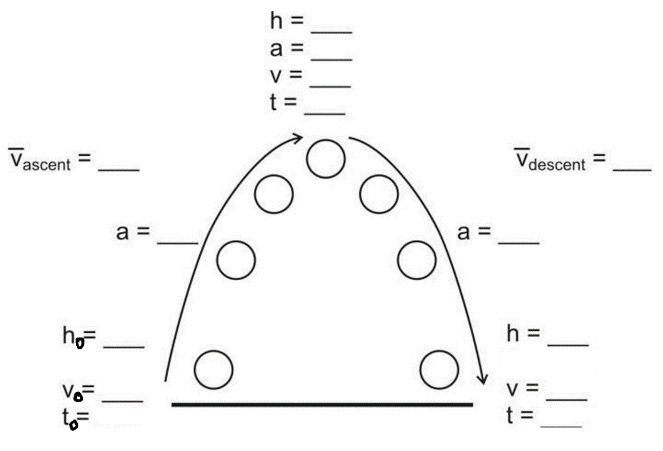

Free-Fall Hint #1: Free-falling objects that go up and then come down have symmetric flights. The trip up is the same as the trip down, only backward. It is often easier to analyze the fall rather than the ascent, because we know the initial velocity of the fall is _____.
Example 1: A ball is launched directly upward from ground level (in the absence of air resistance). It stays in the air for 10 seconds. What height did it reach at its highest point?

Helpful Hint #2: Draw a diagram.
Helpful Hint #3: If you’re having trouble getting started, list all of the usual variables and fill in the ones you know.
Example 2: A ball is released, from rest, above a couch. After free-falling for 4 seconds, the ball contacts the couch cushion and then travels another 0.2m downward before coming to a stop. What is the ball’s acceleration while it was being stopped by the couch cushion?

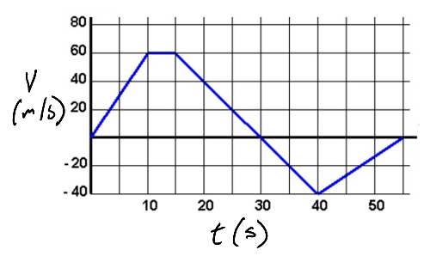Areas “Under” curves:
1. What kinematic information can we get by calculating the area "under" the curve of a velocity vs. time graph?

2. Why did I put quotation marks around “under?”
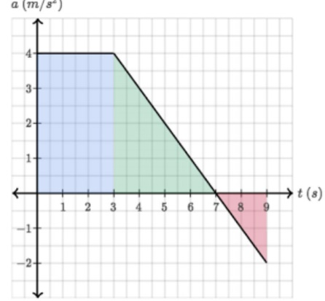
3.What does the area under the curve of an acceleration vs. time graph tell us?

4. Suppose we graph the acceleration of a sticky Nerf dart that is shot across the room, sticking to the opposite wall. How can #2, above, help us draw that graph more correctly? Try it, and we will see.

Chapter 1 & 2 Test 2015-2016
1-D Kinematics Practice Test, Version 1

I. MULTIPLE CHOICE: Select the one best answer for each question. Where g is used, assume it equals 10 m/s² and neglect air resistance for falling/moving objects.

1. Which of the following five position versus time graphs represents the motion of an object moving with an increasingly negative velocity?
A B C D E

2. The slope of a position versus time graph gives
A) position. B) velocity. C) acceleration. D) displacement.

3. Which one of the following situations is impossible?
A) A body having a positive velocity and a negative acceleration
B) A body having a negative velocity and a negative acceleration
C) A body having zero velocity and positive acceleration
D) A body having constant acceleration and positive velocity
E) A body having constant velocity and positive acceleration

4. A particle moves on the x axis. When its velocity is positive and increasing:
A) its acceleration must be positive
B) its acceleration must be negative
C) its acceleration must be zero
D) it must be slowing down
E) none of the above must be true

5. The slope of a velocity versus time graph gives
A) position. B) velocity. C) acceleration. D) displacement.

6. Consider the following five graphs (note the axes carefully!). Which of these represent(s) motion at constant velocity?

A) IV only
B) IV and V only
C) I, II, and III only
D) I and II only
E) I and IV only
7. A particle moves along the x axis from x₀ to x. Of the following values of the initial and final coordinates, which results in the displacement with the largest magnitude?

A) x₀= –4 m, x = 2 m
B) x₀ = –4 m, x = 4 m
C) x₀ = 4 m, x = –2 m
D) x₀ = 4 m, x = 6 m
E) x₀ = –4 m, x = –8 m

Questions 8-11
A car starts from Burlington, goes 60 km in a straight line to Montpelier, immediately turns around, and returns to Burlington. The time for this round trip is 2 hours.

8. What is the average speed for this round trip?
A) 0 B) 30 km/hr C) 60 km/hr D) 120 km/hr

9. What is the average velocity for this round trip?
A) 0 B) 30 km/hr C) 60 km/hr D) 120 km/hr

10. What is the distance traveled on this round trip?
A) 0 B) 30 km C) 60 km D) 120 km

11. What is the displacement for this round trip?
A) 0 B) 30 km C) 60 km D) 120 km

12. A car starts from rest and goes down a slope with a constant acceleration of 5 m/s². After 6 seconds the car reaches the bottom of the hill. Its speed at the bottom of the hill is:
A) 5 m/s B) 12 m/s C) 25 m/s D) 30 m/s E) 180 m/s

13. The graph represents the straight line motion of a car. How far does the car travel between t = 5 seconds and t = 9 seconds?
A) 4 m
B) 12 m
C) 24 m
D) 36 m
E) 60 m

14. A ball is tossed straight up. Upward is taken to be the positive direction. The acceleration due to gravity of the ball is:
A) positive during both ascent and descent
B) negative during both ascent and descent
C) negative during ascent and positive during descent
D) positive during ascent and negative during descent
E) none of the above

15. The area under a curve in an acceleration versus time graph gives
A) change in acceleration. B) change in velocity. C) displacement. D) position.

16. A freely falling body has a constant acceleration of -10 m/s². This means that:
A) the speed of the body increases by 10 m/s during each second
B) the body falls 10 m during each second
C) the body falls 10 m during the first second
D) the acceleration of the body increases by 10 m/s² during each second
E) the acceleration of the body decreases by 10 m/s² during each second

17. An object is thrown straight up from ground level with a speed of 50 m/s. What is its upward speed above ground level 3.0 seconds later? Assume g = 10 m/s².
A) 0 m/s B) 50 m/s C) 40 m/s D) 30 m/s E) 20 m/s

18. A stone is dropped from a cliff. The graph (carefully note the axes) that best represents its speed while it falls is:
A B C D E

19. Suppose that an object travels from one point in space to another. Make a comparison between the displacement and the distance traveled. (Note: The path is not necessarily a direct straight-line path.)
A) The displacement is either greater than or equal to the distance traveled.
B) The displacement is always equal to the distance traveled.
C) The displacement is either less than or equal to the distance traveled.
D) The displacement can be either greater than, smaller than, or equal to the distance traveled.

20. The area under a curve in a velocity versus time graph gives
A) acceleration. B) velocity. C) position D) displacement..
21. Suppose a ball is thrown straight up. Make a statement about the velocity and the acceleration when the ball reaches the highest point.
A) Both its velocity and its acceleration are zero.
B) Its velocity is zero and its acceleration is not zero.
C) Its velocity is not zero and its acceleration is zero.
D) Neither its velocity nor its acceleration is zero.

II. PROBLEMS: Solve these problems on a separate sheets of white page. Do not solve them here. For full credit, show your starting equation(s), show your work and circle your answer. Where g is used, assume it equals 9.80 m/s² for these problems.

1. A car is traveling at a speed of 95.0 kilometers per hour. What is its speed in meters per second?

2. The average distance between the Mars and the Sun is 2.28 x 10⁸ km and it makes one orbit around the Sun in 687 days. Calculate the average speed of Mars in its orbit in kilometers per hour assuming a circular orbit.

3. The new pitcher for the Boston Red Sox, Hekuva Fastball (the fans call him HF for short), can throw a baseball at 0.800 c (0.800 times the speed of light). The distance between home plate is 60 feet 6 inches (18.4 m). Assuming the ball does not burn up due to friction, how long does it take the ball to reach home plate? [Note: Whenever HF is scheduled to pitch, all of the catchers call in sick.] c = 3.00 x 10⁸ m/s

4. A car travelling at 24.0 m/s slows down to 15.0 m/s in 3.00 s. How many meters will the car travel during this time?

5. A car travelling at 12.0 m/s accelerates at 2.80 m/s2 for 6.00 s. What is the car’s final speed?

6. A potato is launched from a potato gun straight up at 60.0 m/s. How much time will elapse before it smashes back into the potato gun? (Look out below!)

7. Consider a grey squirrel falling out of a tree to the ground. If we ignore air resistance in this case (only for the sake of this problem), determine a squirrel’s velocity just before hitting the ground, assuming it fell from a height of 6.00 m.
Extended Kinematics Problems Practice

1. A car accelerates from rest at a constant rate of -4m/s². After accelerating at this rate for a distance of 500m, the car turns off its engine and begins to coast. The car coasts for 22 seconds with constant deceleration before finally coming to rest. Sketch a helpful diagram and then answer the questions below.

a. What was the car’s maximum speed during this event?

b. What was the car’s velocity when it reached its maximum speed?

c. At what time did the car reach that velocity?

d. What was the car’s acceleration during its coasting period?

e. How far did the car travel after its motor turned off?

f. What was the car’s total displacement?

a. 63.2m/s b. -63.2m/s c. 15.8s d. 2.87m/s² e. 695m f. -1195m
2. A plastic action figure is launched vertically upward from a point 10m above the ground [At t₀ = 0s, the height of the action figure is 10m above the ground]. From t=0s to t=6s, the action figure travels solely under the influence of gravity. Air resistance can be ignored for this time period. At t=6s, the action figure’s height is 40m. Between t=6s and t=7s, a parachute pops out of the figure and deploys, causing the figure’s speed to decrease at a constant rate for that 6s to 7s time period. At t=7s, the figure’s speed is 3m/s. From t=7seconds onward, the action figure floats the rest of the way to the Earth (height = 0m) at a constant speed of 3m/s. Sketch a helpful diagram and then answer the questions below – Some o you may have to change you diagram after part b.

a. What was the action figure’s initial velocity?

b. What was the action figure’s velocity at t=6s?

c. What was the figure’s average acceleration between t=6s and t=7s?

d. What was the figure’s displacement between t=6s and t=7s?

e. What was the figure’s elevation at t=7s?

f. How long did the entire trip last?

g. What was the figure’s average speed for the entire trip?

a. 34.3m/s b. -24.5m/s c. 21.5m/s² d. -13.8m e. 26.3m f. 15.75s g. 8.25m/s
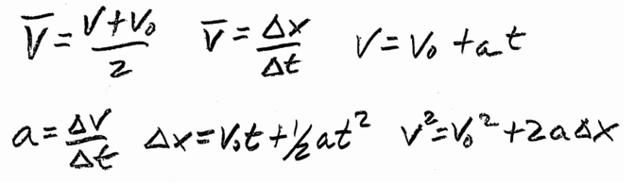
1-D Kinematics Practice Test, Version 2

Part I:

1) Describe an example of motion that has negative velocity and positive acceleration.

2) Describe an example of motion that has zero velocity and negative acceleration.

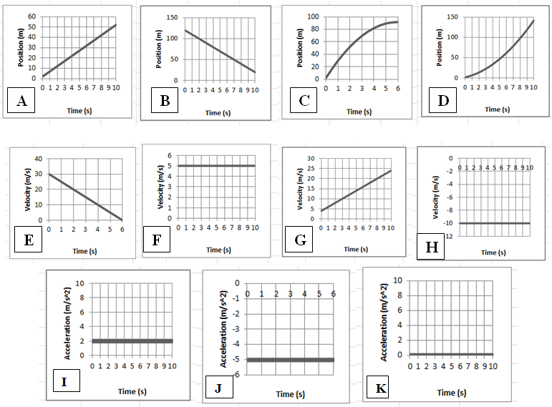

3) Three parts:

_____ i. Which velocity graph shows the same motion depicted in position graph C?

_____ ii. Which position graph shows the same motion depicted in acceleration graph I?

_____ iii. Which position graph shows the same motion depicted in velocity graph H?

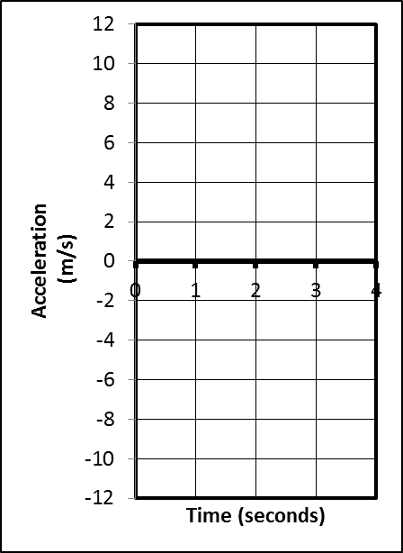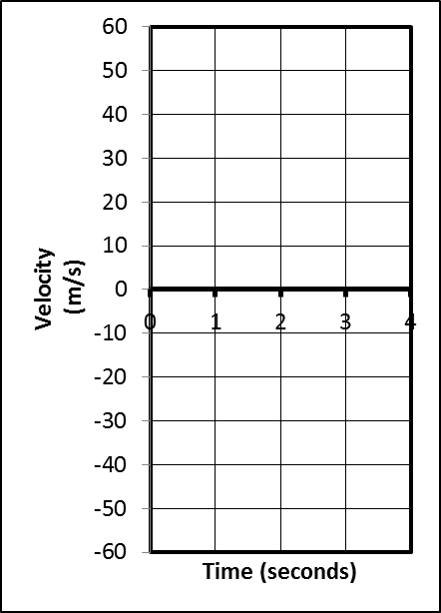4) (2pts) Suppose an object is launched directly upward in the absence of air resistance (i.e. freefall). The object goes up and comes down, remaining in the air for 4 seconds. On the graphs to the right, sketch the object’s approximate velocity and acceleration at each point in the 4 second trip.

5. Sketch an acceleration vs. time graph for the entire event described here... A car that is traveling at the speed limit comes to a stop light and stops. The car waits for the light to turn green. Then it resumes traveling at the speed limit until it comes to a stop at the next stop light and stops once more.

Problems (4 points each)
- +2 points for writing out the correct formula(s)-- and no extraneous ones – in their original form
- +1/2 point for correct units
- -1/2 for minor math error; -1 for major math error (apparent misunderstanding)

1. Video analysis of a car shows that it is able to start from rest and reach a speed of 6.00 m/s over a distance of 6m meters. Calculate the car’s acceleration.

2. A car is traveling at a constant rate of 60m/s. At some point, the car begins to undergo constant acceleration of 4m/s². If this acceleration lasts for 5 seconds, how many meters does the car travel during the acceleration period?

3. A pumpkin is dropped from the top of a tall building. If the pumpkin freefalls to ground level in a time of 2.5 seconds, what is its velocity when it hits the ground?

4. In the absence of air resistance (freefall), a soccer ball is kicked straight up in the air and then returns directly to Earth. If the soccer ball makes the round trip in 10 seconds, how high does the ball go?

5. There are 24 students in each class, and during a fire drill, the building is emptied at a rate of 10 seconds per class. If the average bone mass of an average student is 9kg, calculate the rate of bone leaving the building during a fire drill in grams per hour.

Extended Problem (12 points)

A student is stuck on a one-dimensional line in the X dimension. She can move left and right, but not up, down, back, or forth. Starting from rest at point A (x=0m, t=0s), she accelerates to the right at a rate of 2.5m/s² until she reaches point B a time of 6 seconds. At t=6s, (as she passes point B) her acceleration instantly changes to
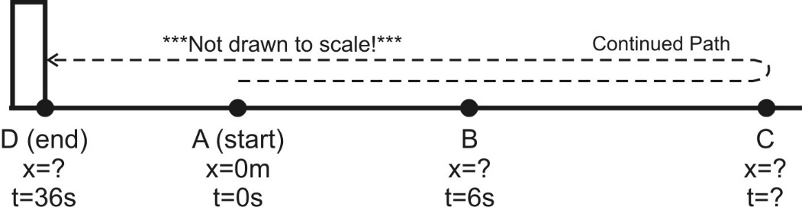 -1.5m/s² (leftward acceleration). She continues traveling with this same -1.5m/s² acceleration until she reaches point D 30 seconds later (at t=36s). After leaving point B, and before reaching point D, she reverses direction at point C. At point D she crashes into an immovable wall and stops.

Acceleration between points A and B = 2.5m/s²
Acceleration between points B and D =
-1.5m/s²

(a) What is her velocity at point B?

(b) What is the distance of point B from the origin (Point A, x=0m)?

(c) How much time elapses as she travels from point B to point C?

(d) What is the distance between points B and C?

(e) What is her velocity when she reaches point D (before she stops, while she is still moving)?

(f) What is her total displacement (not distance traveled!) for the entire trip – through all points A-D?
More Kinematics Problems

57. A person jumps from a fourth-story window 15.0 m above a firefighter’s safety net. The survivor stretches the net 1.0 m before coming to rest. What was the average deceleration experienced by the survivor when she was slowed to rest by the net? (b) What would you do to make it “safer” (that is, to generate a smaller deceleration): would you stiffen or loosen the net? Explain.

58. The acceleration due to gravity on the Moon is about one-sixth what it is on Earth. If an object is thrown vertically upward on the Moon, how many times higher will it go than it would on Earth, assuming the same initial velocity?

59. A person who is properly constrained by an over-the-shoulder seat belt has a good chance of surviving a car collision if the deceleration does not exceed about 30 “g’s” Assuming uniform deceleration of this value, calculate the distance over which the front end of the car must be designed to collapse if a crash brings the car to rest from

60. Agent Bond is standing on a bridge, 12 m above the road below, and his pursuers are getting too close for comfort. He spots a flatbed truck approaching at which he measures by knowing that the telephone poles the truck is passing are 25 m apart in this country. The bed of the truck is 1.5 m above the road, and Bond quickly calculates how many poles away the truck should be when he jumps down from the bridge onto the truck to make his getaway. How many poles is it?

Problem Answers: 57. 146m/s² 58. 6x higher 59. 1.31m 60. 1.46 poles

