Physics 200 Name: ___________________________
1-D Kinematics: Free-fall (mostly), plus Areas Under Curves

Free-fall: The state of being acted upon by only the force of gravity [Note that an upward-moving object may be in free-fall.]
g: the absolute value of free-fall acceleration near the Earth’s surface.
Free-fall acceleration: -9.8m/s² or -g
The diagram below is intended to represent an object that is launched vertically upward in the absence of air resistance (i.e. in free-fall). The diagram appears to show the ball moving sideways, but it isn’t moving sideways. The apparent sideways motion is unavoidable if we’re going to separate upward-moving objects from the downward-moving objects (as we need to do for clarity).
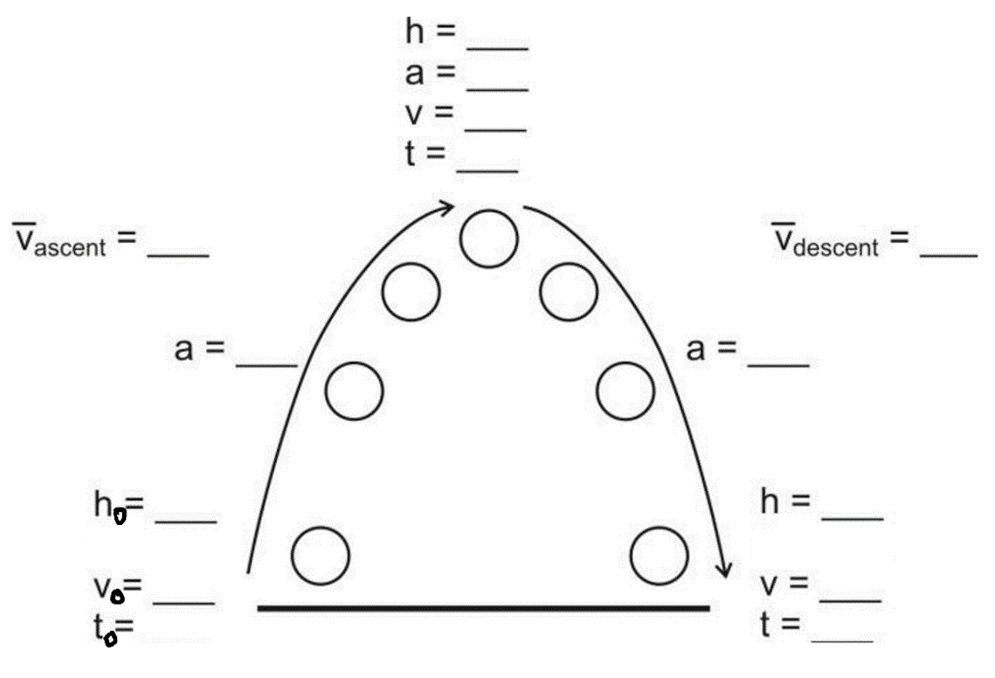
1. Fill in one of the blanks in the diagram with a made-up value. Based on that value, fill in the rest. Estimate by using g=10m/s²

Free-Fall Hint #1: Free-falling objects that go up and then come down have symmetric flights. The trip up is the same as the trip down, only backward. It is often easier to analyze the fall rather than the ascent, because we know the initial velocity of the fall is _____.
Example 1: A ball is launched directly upward from ground level (in the absence of air resistance). It stays in the air for 10 seconds. What height did it reach at its highest point?

Helpful Hint #2: Draw a diagram. Identify any “separate events” where accelerations are different.
Helpful Hint #3: If you’re having trouble getting started, list all of the usual variables and fill in the ones you know.
Example 2: A ball is released, from rest, above a couch. After free-falling for 4 seconds, the ball contacts the couch cushion and then travels another 0.2m downward before coming to a stop. What is the ball’s acceleration while it is being stopped by the couch cushion?

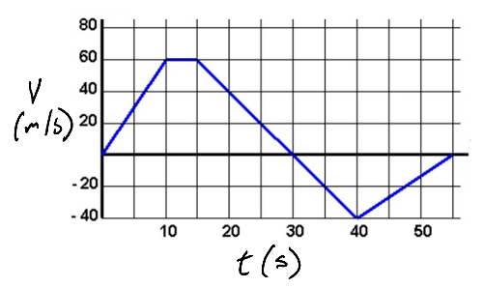
Areas “Under” curves:
1. What kinematic information can we get by calculating the area "under" the curve of a velocity vs. time graph?

2. Why did I put quotation marks around “under?”

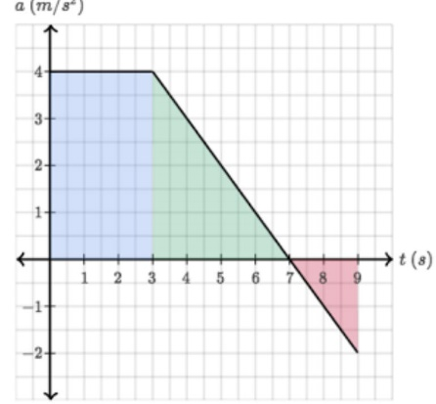
3.What does the area “under the curve” of an acceleration vs. time graph tell us?

4. How can this knowledge be put to use if we are creating an acceleration vs. time graph for an object that starts at rest and returns to rest.

