Name____________________ Essex High School
1-D Kinematics Practice Test #2
Formulas and info:
$$∆x= v_{0}t+\frac{1}{2}at^{2}$$

$$v=v_{0}+at$$

$$v^{2}=v_{0}^{2}+2a∆x$$

1mile = 5280 feet
1ft = 0.305m
Part I:

1) Describe an example of motion that has negative velocity and positive acceleration.

2) Describe an example of motion that has zero velocity and negative acceleration.

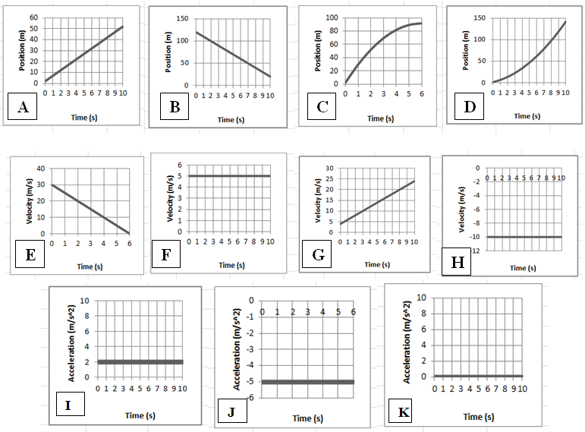

3) Three parts:

_____ i. Which velocity graph shows the same motion depicted in position graph C?

_____ ii. Which position graph shows the same motion depicted in acceleration graph I?

_____ iii. Which position graph shows the same motion depicted in velocity graph H?

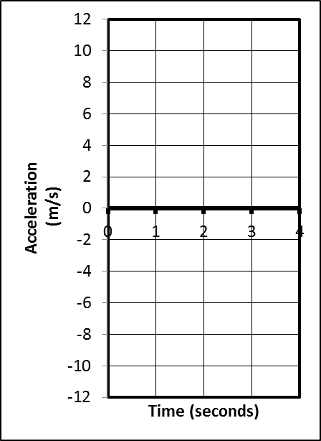
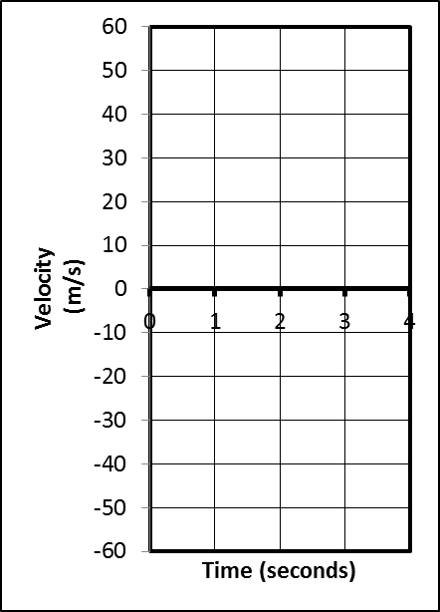
4) (2pts) Suppose an object is launched directly upward in the absence of air resistance (i.e. freefall). The object goes up and comes down, remaining in the air for 4 seconds. On the graphs to the right, sketch the object’s approximate velocity and acceleration at each point in the 4 second trip.

5. Sketch an acceleration vs. time graph for the entire event described here... A car that is traveling at the speed limit comes to a stop light and stops. The car waits for the light to turn green. Then it resumes traveling at the speed limit until it comes to a stop at the next stop light and stops once more.

Problems (4 points each)
- +2 points for writing out the correct formula(s)-- and no extraneous ones – in their original form
- +1/2 point for correct units
- -1/2 for minor math error; -1 for major math error (apparent misunderstanding)

1. Video analysis of a car shows that it is able to start from rest and reach a speed of 6.00 m/s over a distance of 6m meters. Calculate the car’s acceleration.

2. A car is traveling at a constant rate of 60m/s. At some point, the car begins to undergo constant acceleration of 4m/s². If this acceleration lasts for 5 seconds, how many meters does the car travel during the acceleration period?

3. A pumpkin is dropped from the top of a tall building. If the pumpkin freefalls to ground level in a time of 2.5 seconds, what is its velocity when it hits the ground?

4. In the absence of air resistance (freefall), a soccer ball is kicked straight up in the air and then returns directly to Earth. If the soccer ball makes the round trip in 10 seconds, how high does the ball go?

5. There are 24 students in each class, and during a fire drill, the building is emptied at a rate of 10 seconds per class. If the average bone mass of an average student is 9kg, calculate the rate of bone leaving the building during a fire drill in grams per hour.

Physics 200 Extended Problem (12pts) Name: _________________
Chapter 2 Practice Test (2 points each)

A student is stuck on a one-dimensional line in the X dimension. She can move left and right, but not up, down, back, or forth. Starting from rest at point A (x=0m, t=0s), she accelerates to the right at a rate of 2.5m/s² until she reaches point B a time of 6 seconds. At t=6s, (as she passes point B) her acceleration instantly changes to
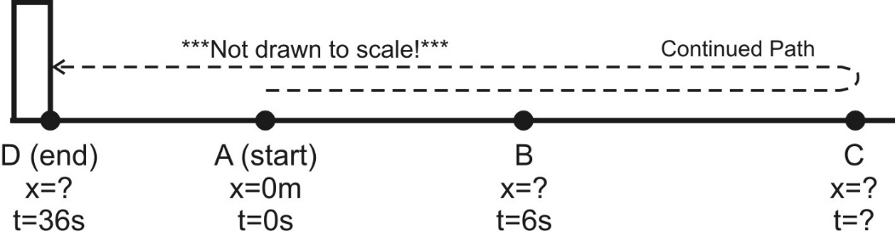
-1.5m/s² (leftward acceleration). She continues traveling with this same -1.5m/s² acceleration until she reaches point D 30 seconds later (at t=36s). After leaving point B, and before reaching point D, she reverses direction at point C. At point D she crashes into an immovable wall and stops.

Acceleration between points A and B = 2.5m/s²
Acceleration between points B and D =
-1.5m/s²

(a) What is her velocity at point B?

(b) What is the distance of point B from the origin (Point A, x=0m)?

(c) How much time elapses as she travels from point B to point C?

(d) What is the distance between points B and C?

(e) What is her velocity when she reaches point D (before she stops, while she is still moving)?

(f) What is her total displacement (not distance traveled!) for the entire trip – through all points A-D?

