Physic 200 Unit 9 Handout Name: ____________________
Electrostatics
Notes – 18.1 Static Electricity and Charge: Conservation of Charge

1. All the macroscopic forces that we experience directly, such as the sensations of touch and the tension in a rope, are due to the _________________________. This force is one of the four fundamental forces in nature. The gravitational force, another fundamental force, is actually sensed through the electromagnetic interaction of molecules, such as between those in our feet and those on the top of a bathroom scale. (The other two fundamental forces are the weak nuclear force and the strong nuclear force).

2. What are the two types of charges?

3. Like charges __________ and unlike charges __________.

4. In atoms, ______________ carry negative charge and _______________ carry positive charge.

5. The SI unit of charge is the coulomb (C). The charge on an electron ( q_{e}) is equal to __________________.

6. When materials are rubbed or pressed together, charges can be separated, particularly if one material has a greater __________________________________ than another.

7. Law of Conservation of Charge:

8. Whenever a charged particle is created such as in collisions in particle accelerators, another having an ________________ charge is always created along with it, so that the total charge created is _________.

9. Besides charge, name three other conserved physical quantities that we have studied.
Static Electricity – “Scotch” Tape Activity

**Important: At some points during this activity, your tape’s charge may leak away, so you may need to create new tapes A, B, C, and D.

1. Tape a ruler firmly to the edge of your table so that 20 - 25cm is protruding off of the table.

2. Get a piece of clear tape that is 8-10 cm long. Fold over the last 1-1.5 cm and stick it to itself. Stick this tape firmly and evenly to the surface of a desk. Label the folded part “A.”

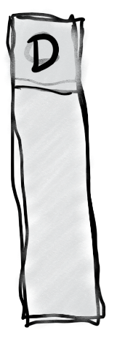
2. Repeat with another piece of tape, and stick this tape right on top of tape A. Label this tape “B.”

3. Do the same thing you did with tapes A and B, but this time label the tapes C and D. C goes on the bottom, and D goes on the top.

4. Grab the non-sticky end of your A/B pair of tapes and pull it off of the desk surface, all in one piece. Hold it near your free hand and observe the force experienced by the tape.

What happens when you hold the A/B pair close to your hand (circle one)? Attracts Repels
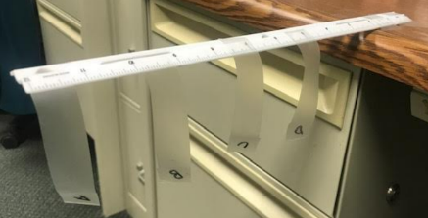
5. Separate pair A/B. Stick both tapes to your ruler, as shown in the picture below. Then stick the two pieces to your ruler, near the end, so that their lettered ends hang off the side of the ruler, as shown. Make sure that they’re separated by an inch or so.

6. Grab the non-sticky end of your C/D pair of tapes and pull it off of the desk surface, all in one piece. Hold it near your free hand. Then hold it next to tape A. After that, hold it next to tape B. Then separate the two tapes (C and D), and hold each one next to A and then next to B. Finally, stick them to the ruler in the same way that you attached A and B.

What happens when you hold C/D next to your free hand? Attracts Repels

What happens when you hold the C/D pair next to tape A? Attracts Repels

What happens when you hold the C/D pair next to tape B? Attracts Repels

What happens when you hold tape C next to A? Attracts Repels

What happens when you hold tape C next to B? Attracts Repels

What happens when you hold tape D next to A? Attracts Repels

What happens when you hold tape D next to B? Attracts Repels

7. Now use a Styrofoam (polystyrene) block and some fabric to determine the actual charges of the items in this activity. Conduct a short internet search to find a triboelectric series including polystyrene and the fabric that you used (or a similar fabric). Identify the charge that the items will take on when they are rubbed together:

Styrene Charge: _________ Fabric Charge: _________

8. Create a charge number line, with zero charge in the middle. Insert the following items on the number line, indicated their approximate net charges, relative to one another.

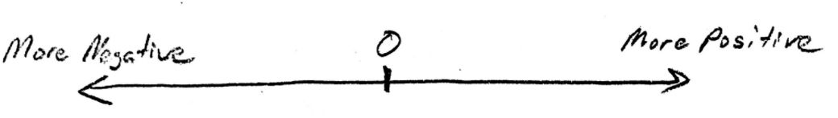
Tape A, Tape B, Tape C, Tape D, Tape pair A/B, Tape Pair C/D, Your Hand

9. You should have seen that all of the items above were attracted to your hand. Explain why.

10. Propose a Theory of Clear Tape Electron Transfer that explains your charge number line diagram, above. How and/or why does each item wind up where it is on the number line? What’s going on with the tape? Feel free to conduct more tests.

Notes – 18.2 Conductors and Insulators

1. _____________ allow electrons to easily move through them. List some examples.

2. _______________ do not allow electrons to move through them. List some examples.

3. Protons ___________ (can/cannot) flow through solid conductors.

4. The two figures below are examples of _________________. Please make sure you understand what is happening here. [See the online textbook for a complete discussion.]

5. a. What’s fishy and misleading about the diagrams above?

b. Re-draw top right diagrams a and b to be more realistic.
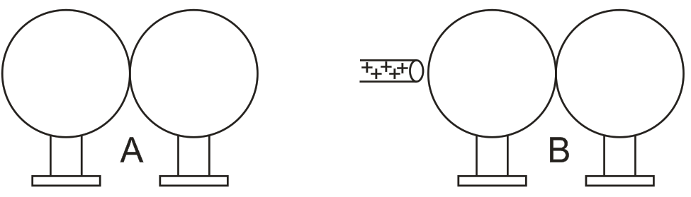
6. Ground: Usually a large, nearly neutral reservoir of charge (e.g. the Earth) into which excess charge can flow (from higher concentration to lower concentration). In reality, the ground usually serves as large source or sink or electrons, which flow into or out of the ground to neutralize the charge on some other object. It is important that the “ground” is a large enough reservoir of charged particles so that adding or subtracting electrons does not significantly change its overall charge concentration. In this way, the ground can maintain a lower charge concentration than the source of “excess” charge.
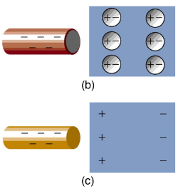
7. What is polarization?

8. The diagram on the right shows polarization by negatively charged rods. A conductor is polarized in diagram ______, and an insulator is polarized in diagram ______.

9. If you were holding the charged rods in figures b and c, how might you feel the effects of this polarization?

Notes – 18.3 Coulomb’s Law

1. Write the equation for Coulomb’s Law.

2. k =

3. The electrostatic force is a __________ quantity and is expressed in units of newtons. What direction is this force?

4. Compare the electrostatic force between an electron and proton separated by 0.530 x 10⁻¹⁰ m with the gravitational force between them. This distance is their average separation in a hydrogen atom.
A. Electric Force – Show your work

F_{E} =

B. Gravitational Force – Show your work

F_{G} =

C. Comparison

F_{E} /F_{G} =

5. As the example above implies, gravitational force is completely negligible on a small scale, where the interactions of individual charged particles are important. On a large scale, such as between the Earth and a person, the reverse is true. Most large objects are nearly ____________________, and so attractive and repulsive Coulomb forces nearly ___________________. Gravitational force on a large scale dominates interactions between large objects because it is always attractive, while Coulomb forces tend to cancel. Large objects that do have significant positive or negative charge tend to not stay charged for long, because they are ______________________ by other objects that donate or receive the necessary charge.

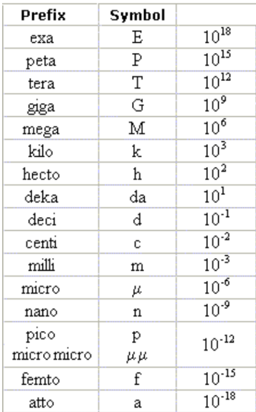
Practice – 18.3 Coulomb’s Law

1. What is the repulsive force between two pith balls that are 8.00 cm apart and have equal charges of –30.0 nC?

5. If two equal charges each of 1.00 C each are separated in air by a distance of 1.00 km, what is the magnitude of the force acting between them? You will see that even at a distance as large as 1 km, the repulsive force is substantial because 1 C is a very significant amount of charge.

Answers:
1. 1.26 x 10⁻³ N 5. 1.46 x 10¹³ electrons

Simulation #1: Balloons and Static Electricity

Access: Go to http://phet.colorado.edu, click on “Play with Sims”, then choose “Electricity, Magnets, and Circuits” simulation. Click on “Balloons and Static Electricity” and click on “Run Now”.

1) Use the mouse to rub the balloon on the sweater. What has happened to the net charge of the balloon and the net charge of the sweater? What has happened to the net charge of the entire balloon/sweater/wall system?

2) Use the mouse to move the balloon away from the sweater and release it. What happens? Why?

3) Move the balloon against the wall. Did the wall’s net charge change? Why does the balloon stick to the wall?

Simulation #2: John Travoltage

Access: Go to http://phet.colorado.edu, click on “Play with Sims”, then choose “Electricity, Magnets, and Circuits” simulation. Click on “John Travoltage” and click on “Run Now”.

1) Use the mouse to rub his foot on the carpet. What do you observe?

2) Why do the charges spread out in John?

3) Use the mouse to bring his hand close to the door knob. What is the net charge of the door knob, before he touches it?

4) Why do the charges flow out of John?

5) Find a way to charge John with maximum negative charge. Why don’t the charges leak back to the ground through his feet?

6) Does this simulation leave you with any unanswered questions? If so, what are they?

Notes – 18.4 Electric Field

1. What is a field?

2. What is the definition and equation for electric field in terms of force?

3. What is the equation for electric field in terms of charge and distance from that charge?

4. Calculate the strength and direction of the electric field E due to a point charge of 2.00 nC at a distance of 5.00 mm from the charge. Show your starting equation and your work.

5. What force does the electric field of magnitude 7.20 x 10⁵ N/C exert on a point charge of –0.250 μC? Show your starting equation and your work.

Practice – 18.4 Electric Field

1. What is the magnitude and direction of an electric field that exerts a 2.00 x 10⁻⁵ N upward force on a –1.75 μC charge?

2. What is the magnitude and direction of the force exerted on a 3.50 μC charge by a 250 N/C electric field that points due east?

3. Calculate the magnitude of the electric field 2.00 m from a point charge of 5.00 mC (such as found on the terminal of a Van de Graaff).

Answers: 1. 11.4 N/C downward 2. 8.75 x 10⁻⁴ N east 3. 1.12 x 10⁷ N/C

Notes – 18.5 Electric Field Lines: Multiple Charges

1. Drawings using lines to represent electric fields around charged objects are very useful in visualizing field strength and direction. Since the electric field has both ________________ and ________________, it is a vector. Like all vectors, the electric field can be represented by an arrow that has length proportional to its ________________ and that points in the correct direction. However, electric fields are often represented with lines whose magnitude is represented by ________________ rather than length.

2. Electric field lines point in the direction of electric force acting on positive charge. Therefore, properties of electric field lines for any charge distribution can be summarized as follows:
1. Field lines must begin on _____________ charges and terminate on _____________ charges (or at infinity in the hypothetical case of isolated charges).
2. The number of field lines leaving a positive charge or entering a negative charge is proportional to the _____________ of the charge.
3. The strength of the field is proportional to the _____________ of the field lines.
4. The direction of the electric field is _____________ to the field line at any point in space.
5. Field lines can never cross. This last property means that the field is _____________ at any point. The field line represents the direction of the field; so if they crossed, the field would have two directions at that location (an impossibility if the field is unique).

3. Draw the electric field lines for positive point charges of +e and +2e.

4. Draw the electric field lines for negative point charges of-e and -2e.

5. Draw the electric field lines for 2 negative point charges in close proximity and 2 positive point charges in close proximity.

6. Draw the electric field lines for a negative and a positive point charge in close proximity.

Practice – 18.5 Electric Field Lines: Multiple Charges

1. A. Sketch the electric field lines near a point charge +q.

B. Do the same for a point charge -3.00q.

3. Three arrangements of electric field lines are shown below. In each arrangement, a proton is released from rest at point A and is then accelerated through point B by the electric field. Points A and B have equal separations in the three arrangements. Rank the arrangements according to the linear momentum of the proton at point B, greatest first?

4. The electric field lines on the left have twice the separation of those on the right.
A. If the magnitude of the field at A is 40.0 N/C, what is the magnitude of the force on a proton at A?

B. What is the magnitude of the field at B?

Answers: 3. a, b, c 4. A. 6.40 x 10⁻¹⁸ N B. 20.0 N/C
Notes – 18.7 Conductors and Electric Fields in Static Equilibrium

1. Conductors contain free charges (i.e. electrons) that move ____________. When excess charge is placed on a conductor or the conductor is put into a static electric field, charges in the conductor quickly respond to reach a steady state called electrostatic ___________________.

2. The free charges move until the field is ________________ to the conductor’s surface.
3. A conductor placed in an electric field will be _______________. A very important point is that the charges will rearrange themselves such that no ________________ exists inside the conductor. If there were a field inside the conductor, free charges in the conductor would continue moving in response to that field until it was neutralized.

4. Properties of a Conductor in Electrostatic Equilibrium
1. The electric field is inside a conductor is _________.
2. Just outside a conductor, the electric field lines are ________________ to its surface, ending or beginning on charges on the surface.
3. Any excess charge resides entirely on the ______________ of a conductor.
5. Two metal plates with equal, but opposite, excess charges. The field between them is ____________ in strength and direction except near the edges.

6. Applications of Conductors
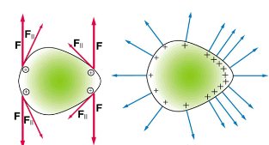
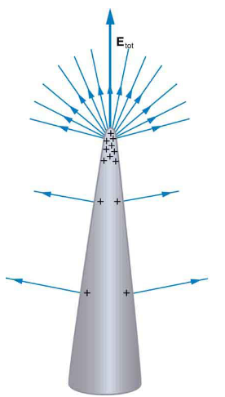
A. On a very sharply curved surface, the charges are so concentrated at the point that the resulting electric field can be great enough to remove them from the surface. As the top left diagram shows, this is because, at sharp points, the repulsive forces (F) of neighboring charges are not as parallel to the surfaces on which the charges reside. Lightning rods work best when they are most pointed. The large charges created in storm clouds induce an opposite charge on a building that can result in a lightning bolt hitting the building. The induced charge is bled away continually from the concentrated charge at the top of a lightning rod, preventing the more dramatic lightning strike.
B. On the other hand, smooth surfaces are used on high-voltage transmission lines and Van de Graaff generators, for example, to avoid leakage of charge into the air.

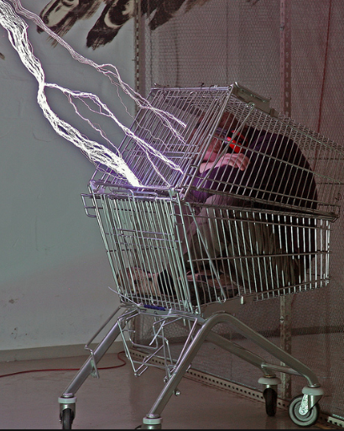
C. Another device that makes use of some of these principles is a Faraday cage. This is a metal shield that encloses a volume. All electrical charges will reside on the outside surface of this shield, and there will be no electrical field inside. A Faraday cage is used to prohibit stray electrical fields in the environment from interfering with sensitive measurements.
D. During electrical storms if you are driving a car, it is best to stay inside the car as its metal body acts as a Faraday cage with zero electrical field inside. If in the vicinity of a lightning strike, its effect is felt on the outside of the car and the inside is unaffected, provided you remain totally inside. This is also true if an active (“hot”) electrical wire was broken (in a storm or an accident) and fell on your car.

