Physic 200 Unit 9 Handout Name: ____________________
Electrostatics
Notes – 18.1 Static Electricity and Charge: Conservation of Charge

1. All the macroscopic forces that we experience directly, such as the sensations of touch and the tension in a rope, are due to the _________________________. This force is one of the four fundamental forces in nature. The gravitational force, another fundamental force, is actually sensed through the electromagnetic interaction of molecules, such as between those in our feet and those on the top of a bathroom scale. (The other two fundamental forces are the weak nuclear force and the strong nuclear force).

2. What are the two types of charges?

3. Like charges __________ and unlike charges __________.

4. In atoms, ______________ carry negative charge and _______________ carry positive charge.

5. The SI unit of charge is the coulomb (C). The charge on an electron ( q_{e}) is equal to __________________. It takes _________________ electrons to make 1.00 C.

6. When materials are rubbed together, charges can be separated, particularly if one material has a greater __________________________________ than another.

7. Law of Conservation of Charge:

8. Whenever a charged particle is created such as in collisions in particle accelerators, another having an ________________ charge is always created along with it, so that the total charge created is _________.

9. Besides charge, name three other conserved physical quantities that we have studied.
Static Electricity – “Scotch” Tape Activity

**Important: At some points during this activity, your tape’s charge may leak away, so you may need to create new tapes A, B, C, and D.

1. Tape a ruler firmly to the edge of your table so that 20 - 25cm is protruding off of the table.

2. Get a piece of clear tape that is 8-10 cm long. Fold over the last 1-1.5 cm and stick it to itself. Stick this tape firmly and evenly to the surface of a desk. Label the folded part “A.”

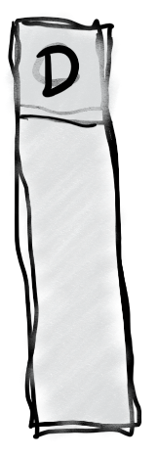
2. Repeat with another piece of tape, and stick this tape right on top of tape A. Label this tape “B.”

3. Do the same thing you did with tapes A and B, but this time label the tapes C and D. C goes on the bottom, and D goes on the top.

4. Grab the non-sticky end of your A/B pair of tapes and pull it off of the desk surface, all in one piece. Hold it near your free hand and observe the force experienced by the tape.

What happens when you hold the A/B pair close to your hand (circle one)? Attracts Repels
5. Separate pair A/B. Stick both tapes to your ruler, as shown in the picture below. Then stick the two pieces to your ruler, near the end, so that their lettered ends hang off the side of the ruler, as shown. Make sure that they’re separated by an inch or so.

6. Grab the non-sticky end of your C/D pair of tapes and pull it off of the desk surface, all in one piece. Hold it near your free hand. Then hold it next to tape A. After that, hold it next to tape B. Then separate the two tapes (C and D), and hold each one next to A and then next to B. Finally, stick them to the ruler in the same way that you attached A and B.

What happens when you hold C/D next to your free hand? Attracts Repels

What happens when you hold the C/D pair next to tape A? Attracts Repels

What happens when you hold the C/D pair next to tape B? Attracts Repels

What happens when you hold tape C next to A? Attracts Repels

What happens when you hold tape C next to B? Attracts Repels

What happens when you hold tape D next to A? Attracts Repels

What happens when you hold tape D next to B? Attracts Repels

7. Now use a Styrofoam (polystyrene) block and some fabric to determine the actual charges of the items in this activity. Conduct a short internet search to find a triboelectric series including polystyrene and the fabric that you used (or a similar fabric). Identify the charge that the items will take on when they are rubbed together:

Styrene Charge: _________ Fabric Charge: _________

8. Create a charge number line, with zero charge in the middle. Insert the following items on the number line, indicated their approximate net charges, relative to one another.

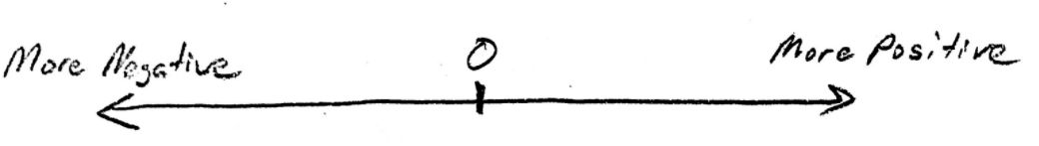
Tape A, Tape B, Tape C, Tape D, Tape pair A/B, Tape Pair C/D, Your Hand

9. You should have seen that all of the items above were attracted to your hand. Explain why.

10. Propose a Theory of Clear Tape Electron Transfer that explains your charge number line diagram, above. How and/or why does each item wind up where it is on the number line? What’s going on with the tape? Feel free to conduct more tests.

Notes – 18.2 Conductors and Insulators

1. _____________ allow electrons to easily move through them. List some examples.

2. _______________ do not allow electrons to move through them. List some examples.

3. Protons ___________ (can/cannot) flow through solid conductors.

4. The two figures below are examples of _________________. Please make sure you understand what is happening here. [See the online textbook for a complete discussion.]

5. a. What’s fishy and misleading about the diagrams above?

b. Re-draw top right diagrams a and b to be more realistic.
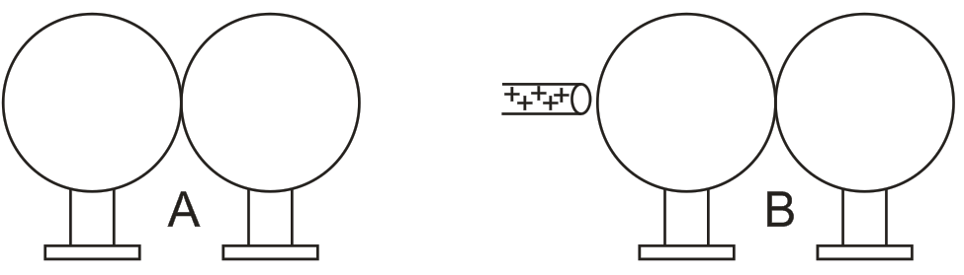
6. Ground: Usually a large, nearly neutral reservoir of charge (e.g. the Earth) into which excess charge can flow (from higher concentration to lower concentration). In reality, the ground usually serves as large source or sink or electrons, which flow into or out of the ground to neutralize the charge on some other object. It is important that the “ground” is a large enough reservoir of charged particles so that adding or subtracting electrons does not significantly change its overall charge concentration. In this way, the ground can maintain a lower charge concentration than the source of “excess” charge.
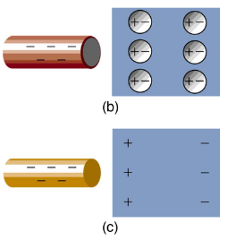
7. What is polarization?

8. The diagram on the right shows polarization by negatively charged rods. A conductor is polarized in diagram ______, and an insulator is polarized in diagram ______.

9. If you were holding the charged rods in figures b and c, how might you feel the effects of this polarization?

Practice – 18.1 Static Electricity and Charge: Conservation of Charge

1. There are very large numbers of charged particles in most objects. Why, then, don’t most objects exhibit static electricity? In other words, why doesn’t static electricity cause most things to repel one another or stick together?

2. Why do most objects tend to contain nearly equal numbers of positive and negative charges? [Hint: what would happen if they they didn’t?]

3. Common static electricity involves charges ranging from nanocoulombs to microcoulombs. [If you don’t know what nano and micro mean, look them up.]
A. How many electrons are needed to form a charge of –2.00 nC?

B. How many electrons must be removed from a neutral object to leave a net charge of 0.500 μC [µ means micro]?

4. If 1.80 x 10²⁰ electrons move through a pocket calculator during a full day’s operation, how many coulombs of charge moved through it?

5. To start a car engine, the car battery moves 3.75 x 10²¹ electrons through the starter motor. How many coulombs of charge were moved?

6. A certain lightning bolt moves 40.0 C of charge. How many fundamental units of charge ∣q_{e}∣ is this? [q_{e} is the charge of one electron.]

Solutions:
3. A. 1.25 x 10¹⁰ e⁻ B. 3.13 x 10¹² e⁻
4. 28.8 C
5. -6.00 x 10² C
6. 2.50 x 10²⁰ q_{e}
Notes – 18.3 Coulomb’s Law

1. Write the equation for Coulomb’s Law.

2. k =

3. The electrostatic force is a __________ quantity and is expressed in units of newtons. What direction is this force?

4. Compare the electrostatic force between an electron and proton separated by 0.530 x 10⁻¹⁰ m with the gravitational force between them. This distance is their average separation in a hydrogen atom.
A. Electric Force – Show your work

F_{E} =

B. Gravitational Force – Show your work

F_{G} =

C. Comparison

F_{E} /F_{G} =

5. As the example above implies, gravitational force is completely negligible on a small scale, where the interactions of individual charged particles are important. On a large scale, such as between the Earth and a person, the reverse is true. Most objects are nearly _______________ neutral, and so attractive and repulsive Coulomb forces nearly ___________. Gravitational force on a large scale dominates interactions between large objects because it is always attractive, while Coulomb forces tend to cancel.
Practice – 18.3 Coulomb’s Law

1. What is the repulsive force between two pith balls that are 8.00 cm apart and have equal charges of –30.0 nC?

2. Two point charges exert a 5.00 N force on each other. What will the force become if the distance between them is increased by a factor of three?

3. Two point charges are brought closer together, increasing the force between them by a factor of 25. By what factor was their separation decreased?

5. If two equal charges each of 1.00 C each are separated in air by a distance of 1.00 km, what is the magnitude of the force acting between them? You will see that even at a distance as large as 1 km, the repulsive force is substantial because 1 C is a very significant amount of charge.

5. Suppose a coin is made of 5.00 g of pure nickel. How many electrons, removed and placed 1.00 m above the coin, would support the weight of this coin? Assume that the mass of an electron is negligible.

Solutions:
1. 1.26 x 10⁻³ N 2. 0.556 N 3. 5
4. 8.99 x 10³ N 5. 1.46 x 10¹³ electrons

Simulation #1: Balloons and Static Electricity

Access: Go to http://phet.colorado.edu, click on “Play with Sims”, then choose “Electricity, Magnets, and Circuits” simulation. Click on “Balloons and Static Electricity” and click on “Run Now”.

1) In the beginning, does the balloon have a net charge? How do you know?

2) In the beginning, does the sweater have a net charge? How do you know?

3) Use the mouse to rub the balloon on the sweater. What is the new net charge on each object?

4) Use the mouse to move the balloon away from the sweater and release it. What happens? Why?

5) Move the balloon against the wall. Why does the balloon stick to the wall?

6) Did the wall’s net charge change?

Simulation #2: John Travoltage

Access: Go to http://phet.colorado.edu, click on “Play with Sims”, then choose “Electricity, Magnets, and Circuits” simulation. Click on “John Travoltage” and click on “Run Now”.

1) Use the mouse to rub his foot on the carpet. What do you observe?

2) Why do the charges spread out?

3) Use the mouse to bring his hand close to the door knob. What do you observe?

4) What is the net charge of the door knob, before he touches it?

5) Why do the charges flow out of John?

6) Find a way to charge John with maximum negative charge. Why don’t the charges leak back to the ground through his feet?

7) Does this simulation leave you with any unanswered questions? If so, what are they?

Notes – 18.4 Electric Field

1. What is a field?

2. What is the definition and equation for electric field in terms of force?

3. What is the equation for electric field in terms of charge and distance from that charge?

4. Calculate the strength and direction of the electric field E due to a point charge of 2.00 nC at a distance of 5.00 mm from the charge. Show your starting equation and your work.

5. What force does the electric field of magnitude 7.20 x 10⁵ N/C exert on a point charge of –0.250 μC? Show your starting equation and your work.
Practice – 18.4 Electric Field

1. What is the magnitude and direction of an electric field that exerts a 2.00 x 10⁻⁵ N upward force on a –1.75 μC charge?

2. What is the magnitude and direction of the force exerted on a 3.50 μC charge by a 250 N/C electric field that points due east?

3. Calculate the magnitude of the electric field 2.00 m from a point charge of 5.00 mC (such as found on the terminal of a Van de Graaff).

4. What magnitude point charge creates a 10,000 N/C electric field at a distance of 0.250 m?

5. Calculate the initial (from rest) acceleration of a proton in a 5.00 x 10⁶ N/C electric field. m_{p} = 1.67 x 10⁻²⁷ kg

Solutions:
1. 11.4 N/C downward 2. 8.75 x 10⁻⁴ N east 3. 1.12 x 10⁷ N/C
4. 6.95 x 10⁻⁸ C 5. 4.79 x 10¹⁴ m/s²

Notes – 18.5 Electric Field Lines: Multiple Charges

1. Drawings using lines to represent electric fields around charged objects are very useful in visualizing field strength and direction. Since the electric field has both ________________ and ________________, it is a vector. Like all vectors, the electric field can be represented by an arrow that has length proportional to its ________________ and that points in the correct direction. However, electric fields are often represented with lines whose magnitude is represented by ________________ rather than length.

2. Electric field lines point in the direction of electric force acting on positive charge. Therefore, properties of electric field lines for any charge distribution can be summarized as follows:
1. Field lines must begin on _____________ charges and terminate on _____________ charges (or at infinity in the hypothetical case of isolated charges).
2. The number of field lines leaving a positive charge or entering a negative charge is proportional to the _____________ of the charge.
3. The strength of the field is proportional to the _____________ of the field lines.
4. The direction of the electric field is _____________ to the field line at any point in space.
5. Field lines can never cross. This last property means that the field is _____________ at any point. The field line represents the direction of the field; so if they crossed, the field would have two directions at that location (an impossibility if the field is unique).

3. Draw the electric field lines for positive point charges of +e and +2e.

4. Draw the electric field lines for negative point charges of-e and -2e.

5. Draw the electric field lines for 2 negative point charges in close proximity and 2 positive point charges in close proximity.

6. Draw the electric field lines for a negative and a positive point charge in close proximity.

Practice – 18.5 Electric Field Lines: Multiple Charges

1. A. Sketch the electric field lines near a point charge +q.

B. Do the same for a point charge -3.00q.

2. A. In what direction does the electric field point at Point P?
d
d

B. If d = 1.00 m, -q = -4.00 μC and the distance from Point P to the x-axis is 1.00 m, what is the magnitude of the electric field at Point P?

3. Three arrangements of electric field lines are shown below. In each arrangement, a proton is released from rest at point A and is then accelerated through point B by the electric field. Points A and B have equal separations in the three arrangements. Rank the arrangements according to the linear momentum of the proton at point B, greatest first?

4. The electric field lines on the left have twice the separation of those on the right.
A. If the magnitude of the field at A is 40.0 N/C, what is the magnitude of the force on a proton at A?

B. What is the magnitude of the field at B?

5. The nucleus of a plutonium-239 atom contains 94 protons. Assume that the nucleus is a sphere with radius 6.64 fm (1 fm = 10⁻¹⁵ m) and with the charge of the protons uniformly spread through the sphere. At the nucleus surface, what are the magnitude and direction (radially inward or outward) of the electric field produced by the protons?

6. What is the magnitude of a point charge whose electric field 50.0 cm away has the magnitude 2.00 N/C?

Solutions:
2. A. downward B. 2.54 x 10⁴ N/C
3. a, b, c
4. A. 6.40 x 10⁻¹⁸ N B. 20.0 N/C
5. 3.07 x 10²¹ N/C, radially outward
6. 5.56 x 10⁻¹¹ C
Notes – 18.7 Conductors and Electric Fields in Static Equilibrium

1. Conductors contain free charges (i.e. electrons) that move ____________. When excess charge is placed on a conductor or the conductor is put into a static electric field, charges in the conductor quickly respond to reach a steady state called electrostatic ___________________.

2. The free charges move until the field is ________________ to the conductor’s surface.
3. A conductor placed in an electric field will be _______________. A very important point is that the charges will rearrange themselves such that no ________________ exists inside the conductor. If there were a field inside the conductor, free charges in the conductor would continue moving in response to that field until it was neutralized.

4. Properties of a Conductor in Electrostatic Equilibrium
1. The electric field is inside a conductor is _________.
2. Just outside a conductor, the electric field lines are ________________ to its surface, ending or beginning on charges on the surface.
3. Any excess charge resides entirely on the ______________ of a conductor.
5. Two metal plates with equal, but opposite, excess charges. The field between them is ____________ in strength and direction except near the edges.

6. Applications of Conductors
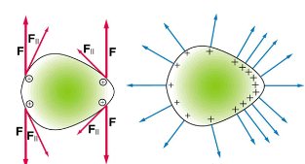
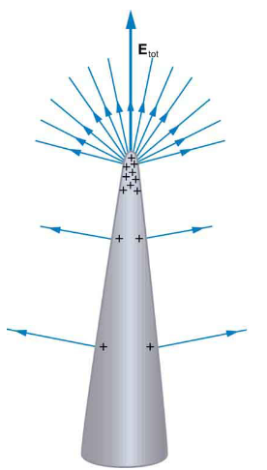
A. On a very sharply curved surface, the charges are so concentrated at the point that the resulting electric field can be great enough to remove them from the surface. As the top left diagram shows, this is because, at sharp points, the repulsive forces (F) of neighboring charges are not as parallel to the surfaces on which the charges reside. Lightning rods work best when they are most pointed. The large charges created in storm clouds induce an opposite charge on a building that can result in a lightning bolt hitting the building. The induced charge is bled away continually from the concentrated charge at the top of a lightning rod, preventing the more dramatic lightning strike.
B. On the other hand, smooth surfaces are used on high-voltage transmission lines and Van de Graaff generators, for example, to avoid leakage of charge into the air.

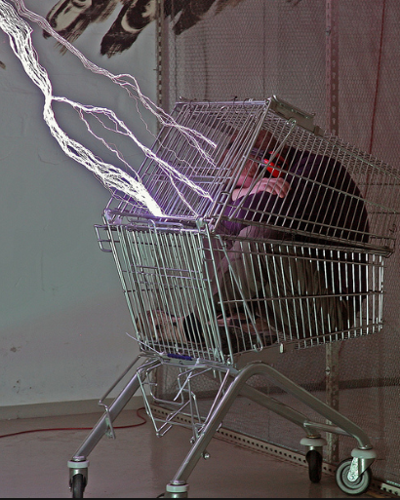
C. Another device that makes use of some of these principles is a Faraday cage. This is a metal shield that encloses a volume. All electrical charges will reside on the outside surface of this shield, and there will be no electrical field inside. A Faraday cage is used to prohibit stray electrical fields in the environment from interfering with sensitive measurements.
D. During electrical storms if you are driving a car, it is best to stay inside the car as its metal body acts as a Faraday cage with zero electrical field inside. If in the vicinity of a lightning strike, its effect is felt on the outside of the car and the inside is unaffected, provided you remain totally inside. This is also true if an active (“hot”) electrical wire was broken (in a storm or an accident) and fell on your car.

Practice – 18.7 Conductors and Electric Fields in Static Equilibrium

Equations and Helpful Information:

Prefixes: n=10⁻⁹ µ = 10⁻⁶ m = 10⁻³
q_{electron} = -1.6x10⁻¹⁹C $F_{e}=\frac{k\left|q_{1}q_{2}\right|}{r^{2}}$ $E=\frac{kQ}{r^{2}}$ $E= \frac{F}{q}$ k = 8.99x10⁹Nm²/C²
$\sum{F=ma}$ $\sum{F=sum of individual forces}$ w = mg
v_{f} = v₀ + at v_{f}² = v₀² + 2aΔx $F_{centripetal}=\frac{{mv}^{2}}{r}$

1. Calculate the linear velocity and the angular velocity ω of an electron assuming it orbits a proton (even though technically it does not) in the hydrogen atom, given the radius of the orbit is 0.530 x 10^{–10} m. You may assume that the proton is stationary and the centripetal force is supplied by Coulomb attraction. m_{e} = 9.11 x 10⁻³¹ kg

2. An electron has an initial velocity of 5.00 x 10⁶ m/s in a uniform 2.00 x 10⁵ N/C strength electric field. The field accelerates the electron in the direction opposite to its initial velocity.
A. What is the direction of the electric field?

B. How far does the electron travel before coming to rest?

C. How long does it take the electron to come to rest?

Answers on back ↓

18.7 Answers:
1. 2.18 x 10⁶ m/s, 4.12 x 10¹⁶ rad/s
2. A. In the direction of the electron’s initial velocity
B. 3.56 x 10⁻⁴ m
C. 1.42 x 10⁻¹⁰ s

Practice – 18.8 Electrostatic Applications

1. Sketch the electric field between the two conducting plates shown below using the principles of electric fields and charges in and around conductors. Assume the top plate is positive and an equal amount of negative charge is on the bottom plate. Also indicate the distribution of charge on the plates.

2. What is the direction and magnitude of an electric field that supports the weight of a free electron (m_{e} = 9.11 x 10⁻³¹ kg) near the surface of Earth? Discuss what the small value for this field implies regarding the relative strength of the gravitational and electrostatic forces.

3. Earth has a net charge that produces an electric field of approximately 150 N/C downward at its surface.
A. What is the magnitude and sign of the excess charge, noting the electric field of a conducting sphere is equivalent to a point charge at its center? R_{Earth} = 6371 km

B. What acceleration will the field produce on a free electron near Earth’s surface?

C. What mass object with a single extra electron will have its weight supported by this field?

4. The practical limit to an electric field in air is about 3.00 x 10⁶ N/C. Above this strength, sparking takes place because air begins to ionize and charges flow, reducing the field.
A. Calculate the distance a free proton must travel in this field to reach 3.00% of the speed of light, starting from rest. m_{p} = 1.67 x 10²⁷ kg, c = 3.00 x 10⁸ m/s

B. Is this practical in air, or must it occur in a vacuum?

Solutions:
2. 5.58 x 10⁻¹¹ N/C toward the Earth’s surface
3. A. -6.77 x 10⁵ C B. 2.63 x 10¹³ m/s² upwards C. 2.45 x 10⁻¹⁸ kg
4. A. 0.141 m
Physics 200 Chapter 18 Practice Test (Pennington)

Equations and Helpful Information:

Prefixes: n=10⁻⁹ µ = 10⁻⁶ m = 10⁻³
q_{electron} = -1.6x10⁻¹⁹C $F_{e}=\frac{kq_{1}q_{2}}{r^{2}}$ $E=\frac{kQ}{r^{2}}$ $E= \frac{F}{q}$ k = 8.99x10⁹Nm²/C²
F = ma w = mg v_{f} = v₀ + at v_{f}² = v₀² + 2aΔx a_{centripetal} = mv²/r
I. Multiple Choice

1. Which is a true statement?
A. Electric field lines are parallel to the surface of a conductor.
B. Electric field lines are perpendicular to the surface of a conductor.
C. Electric field lines are at an angle of 45 degrees to the surface of a conductor.
D. The angle electric field lines make with the surface of a conductor can vary.

2. When placed in an electric field,
A. both a proton and an electron will be accelerated in the same direction as the electric field.
B. both a proton and an electron will be accelerated in the opposite direction of the electric field.
C. the proton will be accelerated in the same direction as the electric field and the electron will be accelerated in the opposite direction.
D. the electron will be accelerated in the same direction as the electric field and the proton will be accelerated in the opposite direction.

3. Which diagram correctly depicts the direction of the electric field from charge -q?
-q
-q
-q
-q

A. B. C. D.

4. In electrostatic equilibrium, the electric field inside a conductor is equal to
A. B. F/q C. zero D.

5. Given two protons separated by a given distance, which of these statements is true.
A. The gravitational force between them is much stronger than the electric force.
B. The electric force between them is much stronger than the gravitational force.
C. The electric force and gravitational force are approximately the same strength.
6. Charge moves much more freely and easily in a
A. conductor.
B. insulator.
C. semiconductor
D. Charge moves just as freely and easily in all of the above.

7. At which point is the electric field greater?
A. A
B. B
C. The electric field strength is the same at A and B.

8. Two uncharged metal spheres, L and M, are in contact. A negatively charged rod is brought close to L, but not touching it, as shown. The two spheres are slightly separated and the rod is then withdrawn. As a result:
A. both spheres are neutral
B. both spheres are positive
C. both spheres are negative
D. L is negative and M is positive
E. L is positive and M is negative
+ + + + +
- - - - -
9. Two parallel plates are shown to the right. The top plate is negatively charged and the bottom plate is positively charged. In which direction does the electric field between the plates point?
A. Left
B. Right
C. Out of the page towards you
D. Down
E. Up

10. What is the unit of acceleration?
A. N B. N/C C. C D. m/s² E. kg

11. What is the unit of electric field?
A. N B. N/C C. C D. m/s² E. kg

12. What is the unit of electric charge?
A. N B. N/C C. C D. m/s² E. kg

13. What is the unit of electric force?
A. N B. N/C C. C D. m/s² E. kg

14. What is the unit of mass?
A. N B. N/C C. C D. m/s² E. kg

15. If the distance between two charges increases by a factor of 3X, what happens to the size of the electric force F on each charge?
A. 1/16 F B. 1/9 F C. 1/3 F D. 9 F E. 16 F

16. Two charges exert an electric force of magnitude F on one another. If the charge on each particle is increased by a factor of 3X, what happens to the size of the electric force F on each charge?
A. 1/16 F B. 1/9 F C. 1/3 F D. 9 F E. 16 F

17. If a negatively-charged rod is brought close to a small neutral conducting sphere,
A. the electrons on the sphere move toward the rod and the sphere will then be repelled by the rod.
B. electrons on the sphere move away from the rod and the sphere will then be attracted to the rod.
C. protons on the sphere move toward the rod and the sphere will then be attracted to the rod.
D. protons on the sphere move away from the rod and the sphere will then be repelled by the rod.

18. Like charges (such as two positive charges or two negative charges) will
A. attract each other.
B. repel each other.
C. both attract and repel each other.
D. annihilate each other in a burst of energy.

19. In response to bringing a charged particle close to a metal conductor,
A. only the negatively-charged electrons move.
B. only the positively-charged protons move.
C. both the electrons and protons flow in the same direction.
D. the electrons flow in one direction and the protons flow in the other.

20. Three arrangements of electric field lines are shown below. In each arrangement, a proton is released from rest at point A and is then accelerated through point B by the electric field. Points A and B have equal separations in the three arrangements. In which arrangement is the linear momentum of the proton at point B the greatest?

21. An electron travels from left to right through a small hole in a uniformly-charged plate. Once through the hole the electron accelerates to the right. What is the sign of the charge on the plate and what is the direction of the electric field on the right hand side of the plate.

 | A | B | C | D | E
Charge on Plate | Positive | Negative | Positive | Negative | Positive
Direction of E Field | Right | Right | Left | Left | Down

II. Problems: On a separate sheet of paper, show your starting equation(s), show your work and box your answer. 5 points each.
Correct Starting equation / Helpful diagram: 1 point
Work and correct answer: 3.5 points
Answer with Correct Units: 0.5 points

1. What is the electric force between two 40.0 μC charges that are 22.0 cm apart?

2. How far apart must two point charges (25.0 mC each) be to exert an electric force of 1.00 N on each other?

3. What is the magnitude and direction of the electric force exerted on a -3.30 μC charge by a 480 N/C electric field that points in the positive x-direction?

4. What magnitude point charge creates a 5.50 x 10⁴ N/C electric field at a distance of 0.400 m?

5. A proton (1.67x10⁻²⁷kg) has an initial velocity of 2.00 x 10⁶ m/s in a uniform electric field whose magnitude is 5.00 x 10⁴ N/C. The field accelerates the proton in the direction opposite to its initial velocity. How long does it take the proton to come to rest?

6. Earth has a net charge that produces an electric field of approximately 150 N/C straight downward at its surface. What mass object with an excess of 3.60 x 10⁴ electrons will have its weight supported by this field?

7. Derive an expression for the velocity v of an electron with mass m_{e} in a circular “orbit” of radius r around a proton with mass m_{p}. Your answer should be an equation starting with “v =” and be in terms of mass, radius, charge and any appropriate constants.

8. Write an equation for the momentum (p = mv) of a charged particle of mass m and charge q after a time t when it starts from rest in a uniform electric field E. Your answer should be an equation starting with “p = “ followed by an expression using the variables given in bold, above.

