Physics 200 Name: ____________________________
Static Electricity – Clear tape Activity

**Important: At some points during this activity, your tape’s charge may leak away, so you may need to create new tapes A, B, C, and D.

1. Tape a ruler firmly to the edge of your table so that 20 - 25cm is protruding off of the table.

2. Get a piece of clear tape that is 8-10 cm long. Fold over the last 1-1.5 cm and stick it to itself. Stick this tape firmly and evenly to the surface of a desk. Label the folded part “A.”

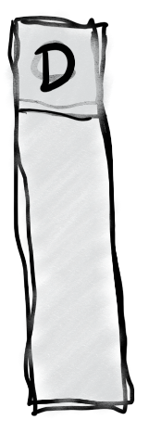
2. Repeat with another piece of tape, and stick this tape right on top of tape A. Label this tape “B.”

3. Do the same thing you did with tapes A and B, but this time label the tapes C and D. C goes on the bottom, and D goes on the top.

4. Grab the non-sticky end of your A/B pair of tapes and pull it off of the desk surface, all in one piece. Hold it near your free hand and observe the force experienced by the tape.

What happens when you hold the A/B pair close to your hand (circle one)? Attracts Repels
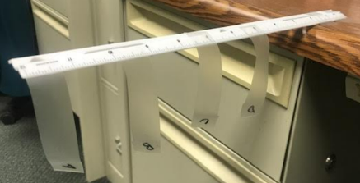
5. Separate pair A/B. Stick both tapes to your ruler, as shown in the picture below. Then stick the two pieces to your ruler, near the end, so that their lettered ends hang off the side of the ruler, as shown. Make sure that they’re separated by an inch or so.

6. Grab the non-sticky end of your C/D pair of tapes and pull it off of the desk surface, all in one piece. Hold it near your free hand. Then hold it next to tape A. After that, hold it next to tape B. Then separate the two tapes (C and D), and hold each one next to A and then next to B. Finally, stick them to the ruler in the same way that you attached A and B.

What happens when you hold C/D next to your free hand? Attracts Repels

What happens when you hold the C/D pair next to tape A? Attracts Repels

What happens when you hold the C/D pair next to tape B? Attracts Repels

What happens when you hold tape C next to A? Attracts Repels

What happens when you hold tape C next to B? Attracts Repels

What happens when you hold tape D next to A? Attracts Repels

What happens when you hold tape D next to B? Attracts Repels
7. Now use a Styrofoam (polystyrene) block and some fabric to determine the actual charges of the items in this activity. Conduct a short internet search to find a triboelectric series including polystyrene and the fabric that you used (or a similar fabric). Identify the charge that the items will take on when they are rubbed together:

Styrene Charge: _________ Fabric Charge: _________

8. Create a charge number line, with zero charge in the middle. Insert the following items on the number line, indicated their approximate net charges, relative to one another.

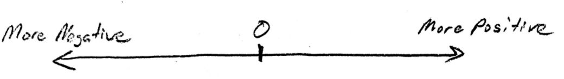
Tape A, Tape B, Tape C, Tape D, Tape pair A/B, Tape Pair C/D, Your Hand

9. You should have seen that all of the items above were attracted to your hand. Explain why.

10. Propose a Theory of Clear Tape Electron Transfer that explains the phenomena that you have observed. How do electrons get transferred onto or off of clear tape? Provide evidence to support your theory. Feel free to conduct more tests.

