Physics 200 Midterm Problem Review
Most of these problems come directly from unit test problems, but there are also problems from other sources.
**The test problems will not be identical to these problems. Most, if not all, of the concepts that appear in the test problems are represented here in some fashion. However, the precise natures of the test problems will differ, and I do not absolutely guarantee that everything is completely covered here.
**Answers and solutions links will be posted on the class website, under class 38.5 or 39.

Unit 1: 1-D Kinematics:

Unt 1 Test, Problem 2. A car traveling at a rate of 20m/s accelerates at a rate of 3m/s² in order to pass another car. If this acceleration last for 4 seconds, what is the velocity of the passing car at the end of those 4 seconds?

Unt 1 Test, Problem 3. How long does it take a racehorse to travel a distance of 300m if it is running at a constant speed of 22m/s?

Unt 1 Test, Problem 4. . A trapeze artist slips, falls, and lands on a net far below. The performer’s velocity is -20m/s when he first touches the net. If the net slows down the performer at a rate of 90m/s², how far does the performer travel after touching the net and before coming to a complete stop?

Unt 1 Test, Problem 5. A grape is shot directly upward in the absence of air resistance. After 15 seconds, the grape returns to the same elevation from which it was launched. How high above the launch point did the grape travel?

Unit 2: 2-D Kinematics:

New Unit 2 Practice #1. A force vector F has a magnitude of 29N and a direction 23 degrees below -X. What are its X and Y components?

New Unit 2 Practice #2. An acceleration vector A has components A_{x} = 24m/s² and A_{y}= -16 m/s². Provide the magnitude and direction of vector A.
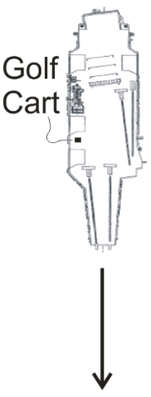
Unit 2 Test, Problem 1. (8 Points) An aircraft carrier is traveling at a rate of 10m/s southward. An airman driving a golf cart uses a compass to head eastward across the moving carrier, perpendicular to the carrier’s length. The golf cart’s speedometer reads 6m/s.

a. What is the actual speed of the golf cart, relative to the Earth?
b. What is the golf cart’s direction of travel? Describe the direction in degrees relative to North, South, East, or West.

Unit 2 Retake, Problem 1. (8 Points) A boat with a speed of 10m/s in still water heads due East across the ocean. However, because there is a an ocean current, the boat's actual velocity, relative to the Earth, is 15m/s in a directly northward direction.

a. What is the speed of the ocean current?
b. What is the direction of the ocean current? Describe the direction in degrees relative to North, South, East, or West.
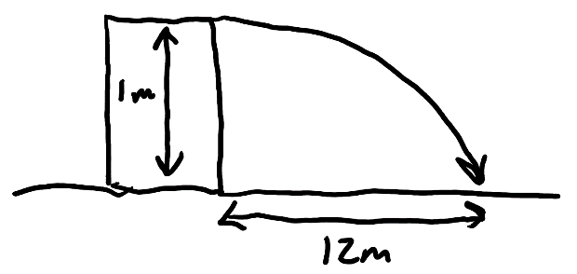
Unit 2 Test, Problem 3. You shoot a projectile horizontally from a table top. The projectile flies 12m horizontally before it hits the floor. The point of impact on the floor is 1m lower in elevation than the projectile’s release point.

a. How long is the projectile in the air?
b. What was the projectile’s initial speed as it left the launcher?

Unit 2 Test, Problem 4. An athlete executing a long jump leaves the ground at a 28.0º angle above horizontal and with an initial speed of 8m/s. His landing point is at the same elevation as his take-off point. Determine the following.

a. What was his total time aloft?
b. What horizontal distance did he travel?

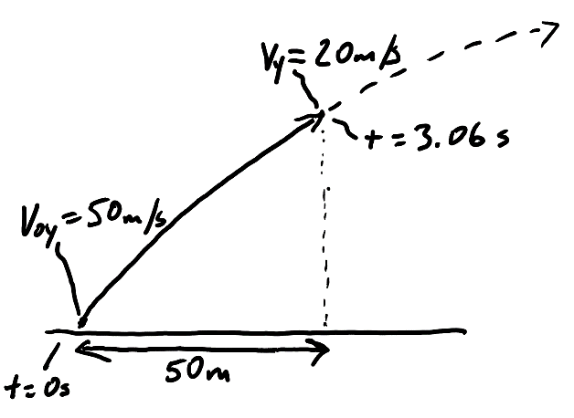
Unit 2 Test, Problem 5. A projectile is launched from the ground with an initial y velocity of 50m/s. After 3.06 seconds, the projectile’s y velocity has decreased to 20m/s. During this 3.06 second time period, the projectile has traveled a horizontal distance of 50m.

a. What is the projectile’s height at the moment when its y velocity is 20m/s?
b. What is the projectile’s initial speed?
c. At what angle (relative to horizontal) was the projectile launched?

Unit 3: Newton’s Laws 1-D

Problems:

Unit 3 Test, Problem 1. A student weighs 800N on Earth

a. What is his mass?
b. On Neptune, falling objects accelerate 1.14 times faster than they do on Earth ( g_{Neptune} = 1.14g_{Earth}). How much would same student weigh on Neptune?
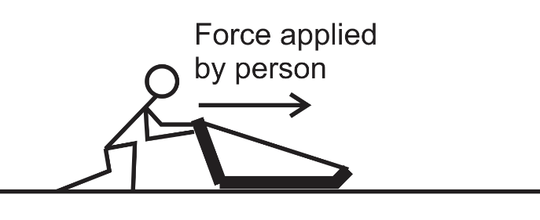
Unit 3 Test, Problem 2. A 15kg sled is being pushed horizontally by a person.

a. In a frictionless environment, how much force must the person apply in order accelerate the sled horizontally at a rate of 3m/s²?
b. If the coefficient of friction between the sled and the ground is µ_{k} =0.4, calculate the force of friction while the sled is sliding horizontally to the right.
c. If µ_{k} =0.4, what force does the person need to apply in order to move the sled, horizontally, at a constant velocity?

Unit 3 Test, Problem 3. Consider the same 15kg sled, with µ_{k} =0.4. The person applies a constant force that accelerates the sled from an initial velocity of 2m/s to a final velocity of 5m/s, over a distance of 12m.

a. Calculate the sled’s acceleration over this distance.
b. What force does the person apply to the sled in order to cause that acceleration?

Unit 3 Test, Problem 4. A student who weighs 600N is standing on a bathroom scale in an elevator, and the scale currently reads 900N.
a. What is elevator’s current acceleration? b. Is that acceleration upward or downward?

Unit 3 Test, Problem 5. A 4kg tasty treat hangs motionless at the bottom end of a massless rope. Meredith, standing on a cliff above, is holding the other end of the rope. If Meredith fails to raise the tasty treat a height of 5 meters in a time of 3 seconds, an oncoming train will collide with the treat and destroy it.

a. Assuming that the treat is starting from rest, what minimum acceleration is required of the tasty treat to prevent its collision with the train?
b. If Meredith raises the treat with this acceleration, how much tension will there be in the rope while the treat is ascending?
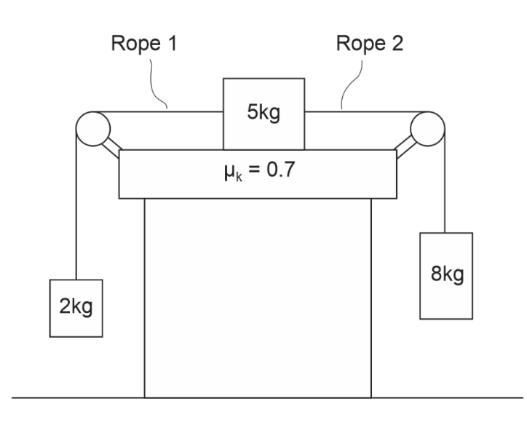
Unit 3 Test, Problem 6. The diagram on the right shows three masses connected by frictionless, massless strings passing over frictionless pulleys. The surface that is in contact with the 5kg mass has a µ_{k} = 0.7. The masses and strings are in motion.

a. Find the acceleration of the entire system of masses and ropes.
b. Find the tension in Rope 1
c. Find tension in Rope 2.

Unit 4: Newton’s Laws in 2-D:
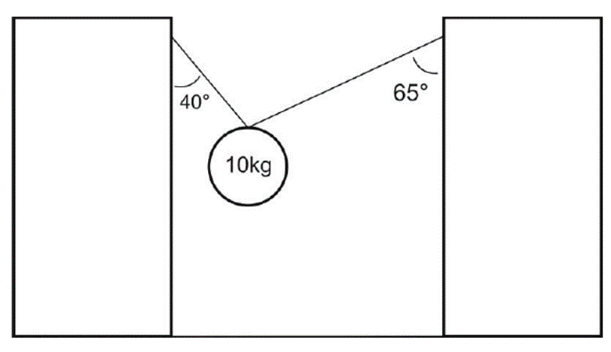
Unit 4 Practice Problem 1 (class #30). Find the tensions in the strings on the right.

Unit 4 Practice Problem 2 (class #30). Find the acceleration of the blocks below, and the tension in the string.
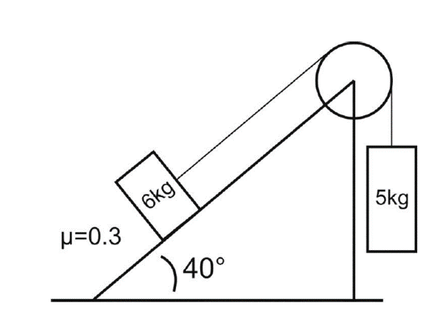

Unit 5: Work and Energy:
Unit 5 Test, Problem #4. Suppose a 450kg racehorse is initially at rest. The horse accelerates across level ground by generating constant power at 15,000W for a full 6 seconds.

a. How much work does the racehorse do during this 6 second period?
b. Assuming that none of this work is lost to “other energy,” what is the kinetic energy of the horse after 6 seconds?
c. What is the horse’s speed after 6 seconds?

Unit 5 Test, Problem #5. A 0.15kg graduation cap is tossed directly upward at a graduation ceremony (in a vacuum, on Earth’s surface). The cap is released from the thrower’s hand when it is 2m above the ground. At that point it is moving upward with 6J of kinetic energy.

a. How much PE does the graduation cap have at the moment when it is released? (at h=2m)
b. How much PE does the graduation cap have when it reaches its maximum height?
c. How much kinetic energy will the graduation cap have just before it hits the ground?

Unit 5 Test, Problem #6. Starting from rest, a 600kg roller coaster leaves point A and travels frictionlessly down a ramp to point B. At point B, the coaster travels horizontally while its brakes apply a -2,500 N force of friction to slow it down. As friction continues to slow the coaster, the coaster contacts a huge spring (k=10,000N/m), finally coming to stop at point C, after compressing the spring a distance of 3m. When the coaster comes to a stop, the spring pushes it back again.
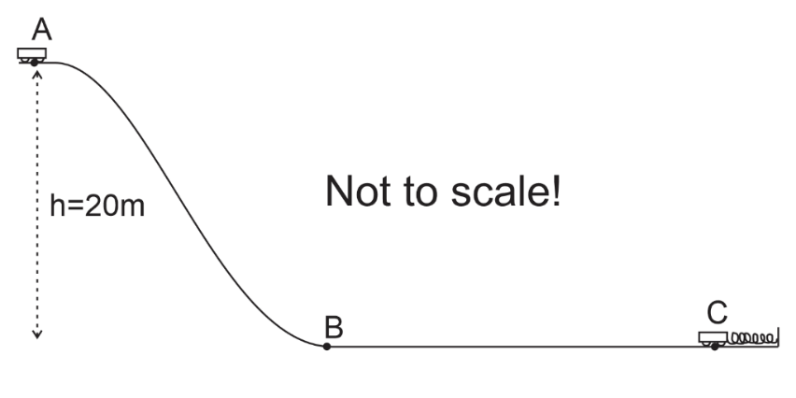
A. Find the coaster’s PE at point A.
B. Find the coaster’s KE at point B.
C. Find the PE stored in the spring, when it is compressed by the coaster arriving at point C.
D. Between points B and C the coaster experienced friction from its brakes. What is the distance from B to C?
E. How much force does the spring exert on the coaster when the spring is fully compressed (compressing over a distance of 3m) at point C?

Unit 5 Test, Multiple Choice #8 . A 2-kg object is moving at a rate of 5 m/s. If a 6N force is applied in the direction of the object’s motion as the object travels an additional 4 m, what is the object’s new velocity after traveling those 4m?
Unit 5 Test, Multiple Choice #9 . The velocity of a dropped mass m that has been free-falling downward a distance h is equal to…
Unit 5 Test, Multiple Choice #10. An extension spring with constant k is dangling from a ceiling. A mass m is attached to the end of the spring and released. Eventually the bobbing mass comes to rest, with the spring stretched some distance. What distance is the spring stretched at this time (when the mass and spring are stretched and at rest)?
Unit 5 Test, Multiple Choice #11 . A 1kg mass with initial speed of 10m/s slides a linear distance of 10m up a ramp, coming to rest at a height 1m above its starting point What constant force of friction is acting on the mass during its slide?

