Physics 200 Unit 8 Handout, Part 3 Name: _____________________

Electric Charge and Electric Force:
1. What are the two types of charges?

2. Like charges _______________ and unlike charges ________________.

3. In atoms, __________________ carry negative charge and __________________ carry positive charge.

4. The SI unit of charge is the coulomb (C). The charge on an electron ( q_{e}) is equal to

__________________.

5. Coulomb’s Law relates the attractive or repulsive force between charges to their magnitude and separation distance.

Coulomb’s Law:

6. “Coulomb’s Law Constant” = k = 8.99x10⁹Nm²/C²

7. Calculate the electrostatic force between an electron and proton separated by 0.530 x 10⁻¹⁰ m. Compare that force with the gravitational force between them (already calculated below). F.Y.I. this distance is their average separation in a hydrogen atom, and their masses are: proton = 1.67x10⁻²⁷kg, electron = 9.1x10⁻³¹kg.

A. Electric Force –

F_{E} =

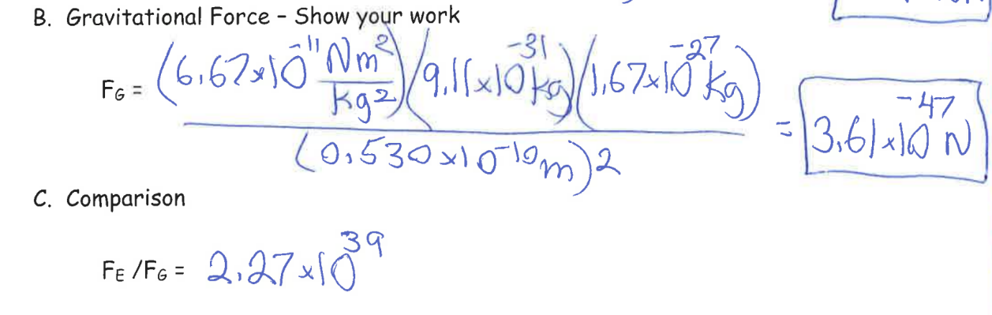
Conductors and Insulators:

8. _____________ are materials that allow electrons to easily move through them.

9. _______________ are materials that do not allow electrons to move through them.

10. Protons ___________ (can/cannot) flow through solid conductors.

Electric Fields:

11. What is a field? A map of a physical quantity showing its value throughout some region

A ______________________ field is a map of gravitational forces acting on masses.

A ________________________ field is a map of magnetic forces acting on magnets.

An ______________________ field is a map of the electric forces – specifically those

experienced by a _________________ charge (Ben’s fault again) at any point in the map area.

12. The units for electric field are __________ or ___________ so these two equations can be used for calculations involving electric field:

13. Don’t do this, but suppose we connected a 3m long homogenous wire to the two electrodes of a 12V battery. Calculate the magnitude of the electric field in the wire in the moments before the wire is destroyed.

14. What force would be exerted on a +5C charge inside that wire? What would be the direction of the force exerted on that charge?

Drawing Electric Fields:

15. Drawings using lines to represent electric fields around charged objects are very useful in visualizing field strength and direction. Since the electric field has both ________________ and ________________, it is a vector. Like all vectors, the electric field can be represented by an arrow that has length proportional to its ________________ and that points in the correct direction. However, electric fields are often represented with lines whose magnitude is represented by ________________ rather than length (like contour map lines).

16. Electric field lines point in the direction of electric force acting on positive charge. Therefore, properties of electric field lines for any charge distribution can be summarized as follows:
1. Field lines must begin on _____________ charges and terminate on _____________ charges (or at infinity in the hypothetical case of isolated charges).
2. The number of field lines leaving a positive charge or entering a negative charge is proportional to the _______________ of the charge.
3. The strength of the field is proportional to the _______________ of the field lines.
4. The direction of the electric field is ________________ to the field line at any point in space.

17. Draw the electric field lines for positive point charges of +e and +2e.

18. Draw the electric field lines for negative point charges of-e and -2e.

19. Draw the electric field lines for 2 negative point charges in close proximity and 2 positive point charges in close proximity.

20. Draw the electric field lines for a negative and a positive point charge in close proximity.

Physics 200 Electricity Practice Test (25-26) Name: ________________________________

Info:
Coulomb’s Law Constant = 8.99x10⁹Nm²/C² Charge of 1 electron = -1.6x10⁻¹⁹C
Charge of 1 proton = 1.6x10⁻¹⁹C
Multiple Choice

1. Joules:
Current Power Voltage Resistance Potential Energy Charge Electric Field
2. Joules per Coulomb:
Current Power Voltage Resistance Potential Energy Charge Electric Field
3. Change in Joules per Coulomb:
Current Power Voltage Resistance Potential Energy Charge Electric Field
4. Coulombs per second:
Current Power Voltage Resistance Potential Energy Charge Electric Field
5. Together, they determine the amount of current flowing through a circuit (pick 2).
Current Power Voltage Resistance Potential Energy Charge Electric Field
6. Joules per second:
Current Power Voltage Resistance Potential Energy Charge Electric Field
7. Volts per meter or Newtons per Coulomb:
Current Power Voltage Resistance Potential Energy Charge Electric Field
8. I:
Current Power Voltage Resistance Potential Energy Charge Electric Field
9. Coulombs:
Current Power Voltage Resistance Potential Energy Charge Electric Field
10. Amperes:
Current Power Voltage Resistance Potential Energy Charge Electric Field
11. Ohms:
Current Power Voltage Resistance Potential Energy Charge Electric Field
12. A map showing forces that would be experienced by a positive charge in various locations:
Current Power Voltage Resistance Potential Energy Charge Electric Field
13. Watts:
Current Power Voltage Resistance Potential Energy Charge Electric Field
14. In the water model for circuits, the pressure that pushes water through the pipes represents:
Current Power Voltage Resistance Potential Energy Charge Electric Field
15. In the water model for circuits, Mr. Stapleton’s hairballs in pipes represent:
Current Power Voltage Resistance Potential Energy Charge Electric Field
16. In the energy distribution model, the number of delivery trucks per day represents:
Current Power Voltage Resistance Potential Energy Charge Electric Field
17. In the energy distribution model, the number of packages per truck represents:
Current Power Voltage Resistance Potential Energy Charge Electric Field
18. In the energy distribution model, the number of packages delivered per day represents:
Current Power Voltage Resistance Potential Energy Charge Electric Field

19. In a simple circuit, a 6 volt battery powers an 18W light bulb. On the diagram show what is happening in the circuit during each second. For each wire segment…
a. Draw a circle to represent each Coulomb of charge.
b. Draw a dot to represent each Joule of energy.
c. Label a charge with its potential. Use traditional units for potential and alternative units.
d. Label the light bulb with its power consumption in traditional units (18W) and alternative units.
e. Use an arrow to indicate the current. Label the arrow with the symbol for current and the magnitude of the current in both traditional and alternative units.

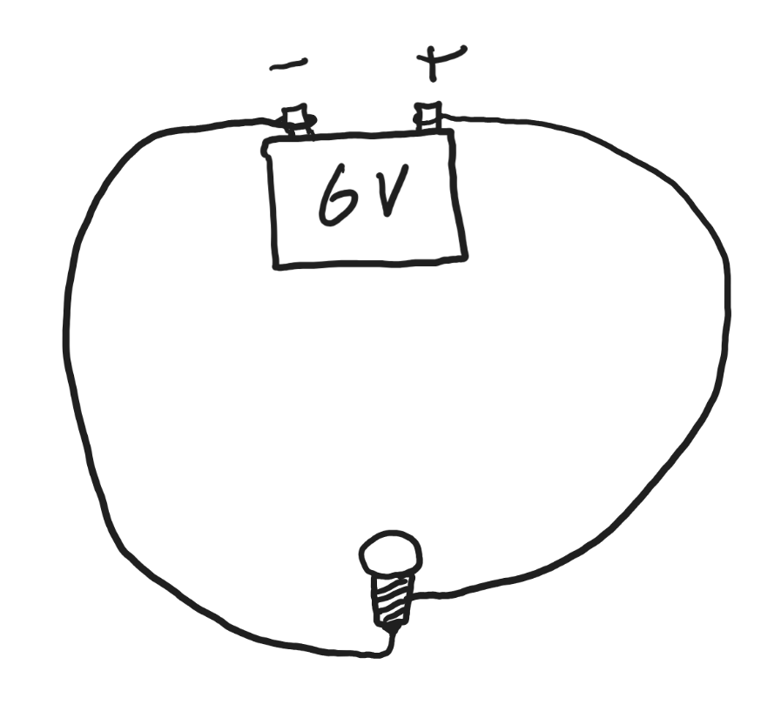

f. How many electrons pass through the bulb each second?

g. What is the resistance of the light bulb?

h. At an energy rate of $0.21 per kWh, how much would it cost to power the bulb for 1,000 hours?

20. Suppose we obtain another 6V battery and we connect a plain wire to both of its electrodes . The wire is 2m long and homogeneous (constant thickness and material).

a. The wire will probably burn up, but before it burns up, what is the magnitude of the electric field in the wire?

b. How much force would that electric field exert on 2C of positive charge in that wire? In which direction?

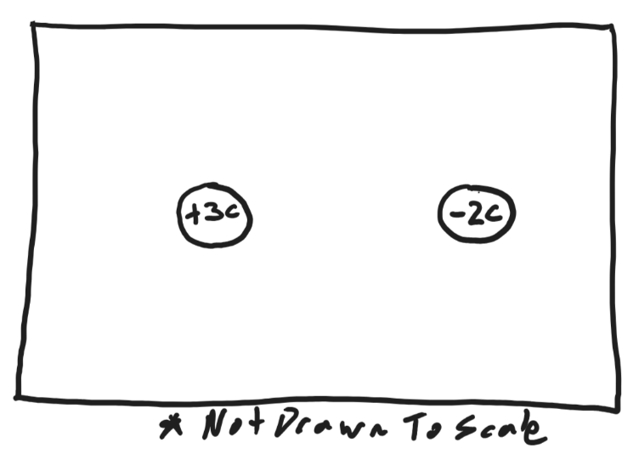
21. One of the particles on the right has a charge of +3C. The other particle’s charge is -2C. They are separated by a distance of 10m. [The diagram is NOT drawn to scale.]

a. Find the magnitudes of the forces the charges exert on one another and describe the directions of those forces.

b. Draw electric field lines for the area inside the box. Assume that the two charges are the only charges affecting the electric field.

22-24: Circuit Solving:
1) “Circle” and label the areas of equal potential.
2) Label the distinct currents.
3) Enter the data into the tables.
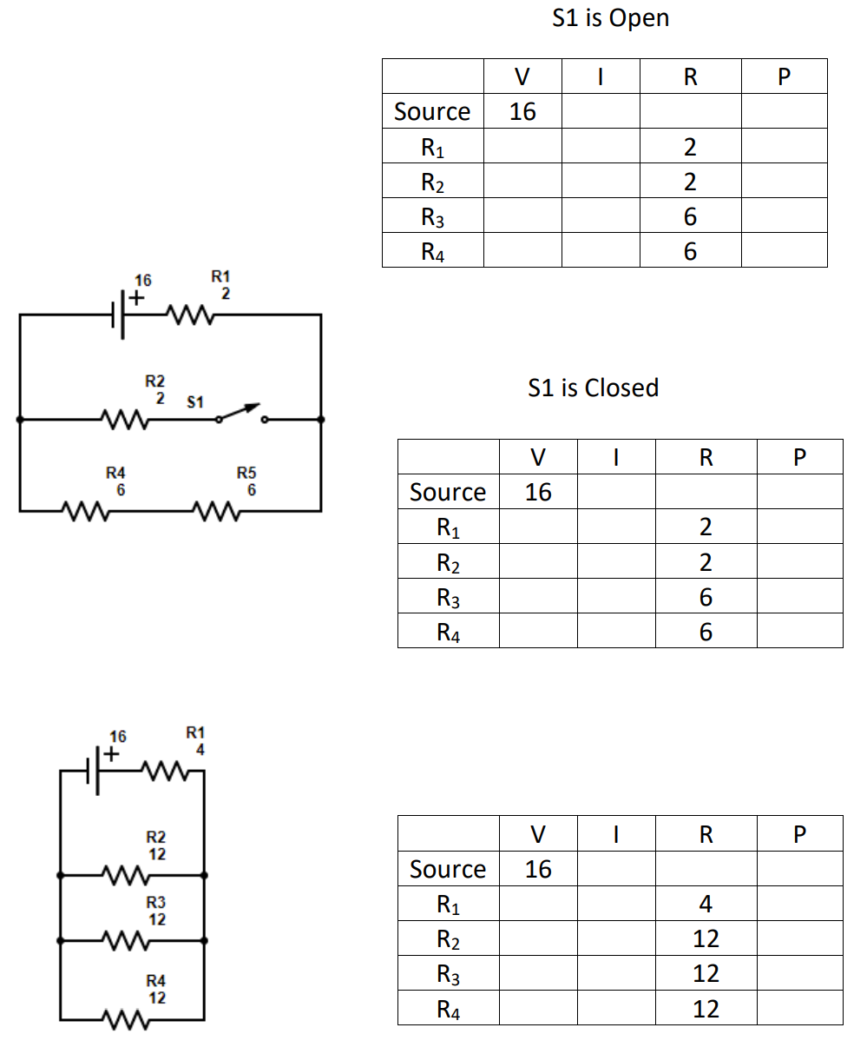

Applying Kirchoff’s Rules:

25. For each of the items below, choose the correct direction of current flow (conventional current) and give the magnitude of the current.

Item | Magnitude of Current (A) | In which direction does current (conventional current) flow through this item? Circle the Correct answer.
Resistor 1 |  | Upward Downward
Resistor 3 |  | Leftward Rightward
9V Battery |  | Upward Downward
