Physics 200 Unit 8 Handout, Part 2 Name: _____________________
Electric Current Again (some new stuff and some review)

1. Write the equation for electric current (and identify the symbols):

2. The unit of electric charge is the _________________________, which is equal in

absolute magnitude to the charge of _________________ electrons or protons.

3. 1 ampere = 1”Amp” = 1A = 1 ___________________ /second.

4. If a cell phone is charging with a current of 0.5A, how many electrons are passing through its circuit each second?

5. By convention, the direction of current flow is from _____________ to _____________. The direction of conventional current is the direction that _____________ charge would flow, if it did (but it doesn’t -- in wires).

6. In metal wires, current is carried by _____________. So it is _____________ charges that are moving, and they are moving oppositely to conventional current.

7. The fact that conventional current is taken to be in the direction that positive charge would flow can be traced back to American politician and scientist ______________________. He named the type of charge associated with electrons

8. Electrical signals are known to move very rapidly. Most electrical signals carried by currents travel at speeds on the order of ______ m/s, a significant fraction of the speed of light. However, the actual electrons move much more slowly on average, typically drifting at speeds on the order of _______ m/s. This means it takes an electron in a wire about __________________ seconds to travel one meter. Another example of sending messages quickly, across great distances, via a slowly-moving medium is provided by

_______________________________________________________

9. Show the directions of the electron drift velocity v_{d} and the current I.
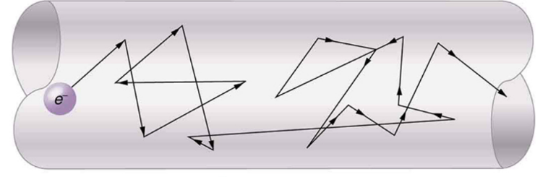

Resistances:
10. Resistances range over many orders of magnitude. Some ceramic insulators, such as those used to support power lines, have resistances of 10¹² Ω or more. A dry person may have a hand-to-foot resistance of 10⁵ Ω, whereas the resistance of the human heart is about 10³ Ω. A meter-long piece of large-diameter copper wire may have a resistance of _____________ , and superconductors have a resistance of _______.

Electric Power and Energy

11. Power (P) is the ______________ of energy use or energy conversion.

12. Voltage (change in electric potential) can be expressed as J/C, and Current (Amperes) can be expressed as C/s.

J/C x C/s = J/s. Therefore, _______ = P

13. The unit for power is the _________________.

14. 1 W = 1 ______________

15. Power companies charge their customers in units of kWh (kilowatt-hours). Kilowatt-hours isn’t power. What is it? What’s its equivalent in the units that we ordinarily use in this class?

16. Green Mountain Power presently charges about $0.215 for each kWh. At that rate, how much would it cost to leave a 30W LED lightbulb on for 24 hours?

The Truth About Voltage

In a circuit, Potential Energy is the amount electric energy (Joules) stored in the charges – and delivered by them as they travel through the resistors. Potential (without the “energy”) is the ratio of potential energy per unit of charge (Joules per Coulomb). If the potential is 3 J/C, and the current is 2A (2C/s), then 6J/s (6 Watts) of power is being consumed. Potential has the same units as Voltage (V).
Potential Difference (a.k.a. Voltage) is the change in potential between one part of the circuit and another. If the potential upstream from a resistor is 7V, and the potential downstream from the resistor is 3V, then the voltage across the resistor is -4V. This is often called the “voltage drop,” even though it’s redundant.

Another Circuit Analogy: Electric Circuits as Distribution Networks

Amazon Distribution Network Component(s) | Electricity Analog | Symbols | Units | Source Units
Packages | Energy | E | Joules (J)
 |  | Q | Coulombs (C)
 |  | V | Volts (V) | J/C
 |  | I | Amperes (A) | C/s
 |  | P | Watts (W) | J/s

Something the analogies/models don’t explain – why do more powerful devices have less resistance?
Here’s what works for me…
Imagine that each electrical device gets its energy from one or more tiny water wheels that turn as water flows by. Further imagine that each water wheel is fed by its own water pipe and that every pipe with its water wheel is identical to every other. A powerful device has more pipes for current to travel through. A low-power device has very few pipes – maybe just one. These pipes are essentially “holes” passing through the device (even though they have some resistance, due to the wheels). More holes passing through a device means water can flow through more easily, so there is less overall resistance. More holes/pipes also means more water wheels are getting turned, so the device gets more power.

Practice Analyzing A Circuit From an Energy Distribution Standpoint:
- Illustrate/label potential, voltage, current, power, resistance, and energy in the circuit below. Use the information from the key.
- Show the charges passing through each wire segment during 1 second.
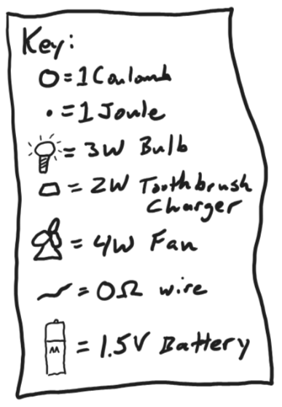

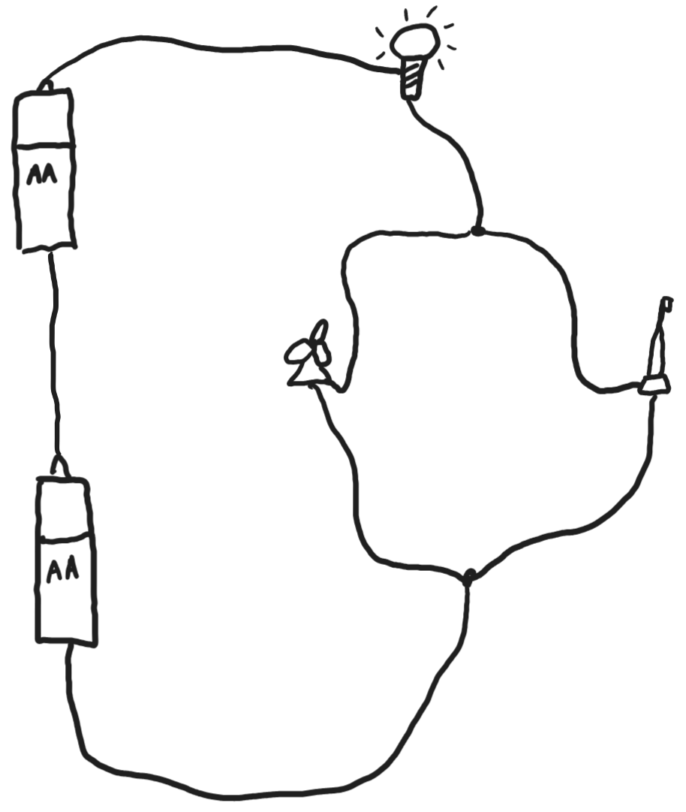

Practice: Someone is using a car battery to power a mini-amplifier and a wireless router. This is a little complicated because the two devices require 9V, but car batteries produce 12V. To solve the problem a resistor has been added, and the two devices are getting the power and voltage that they need.

- Illustrate/label potential, voltage, current, power, resistance, and energy in the circuit below. Use the information from the key.
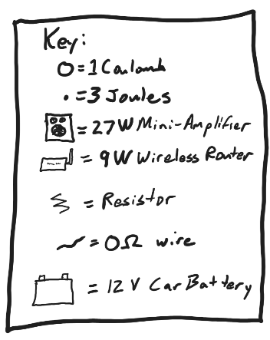
- Note that, for this circuit, we are using one dot for 3J of energy, so you don’t have to draw so many dots.
- Show the charges passing through each wire segment during 1 second.
- Don’t make this at home! The resistor would get really hot!
- Start this one by first finding all of the resistances.

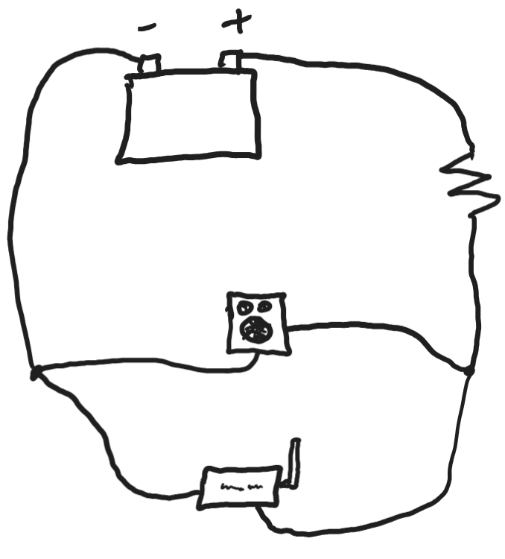

Circuit Reduction Practice – The Nine Companions

Use these formulas to find equivalent resistances of the following circuits:
$R_{Tot Series}= R_{1}+R_{2}+R_{3}$… $\frac{1}{R_{Tot Parallel }}= \frac{1}{R_{1}}+ \frac{1}{R_{2}}+\frac{1}{R_{3}}…$
Assume each resistor has a value of 10 Ohms.

1.
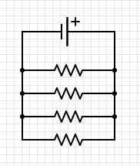
2.
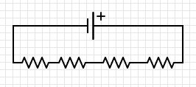

4.
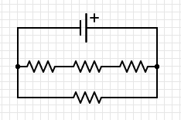
3.
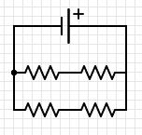

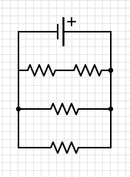
5. 6.
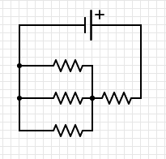

7. 8.
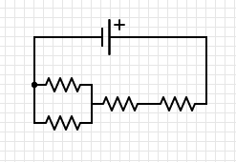
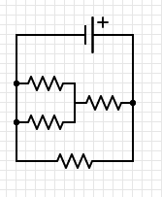

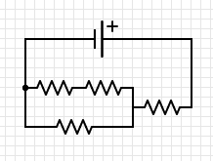
9

Answers:
1. 2.5 Ω 2. 40 Ω 3. 10 Ω 4. 7.5 Ω
5. 13.3 Ω 6. 4 Ω 7. 6 Ω 8. 25 Ω 9. 16.7Ω

Circuit Practice: Find everything in the table.
