Physics 200 Name: ________________________
25-26 Circuit Practice Lab
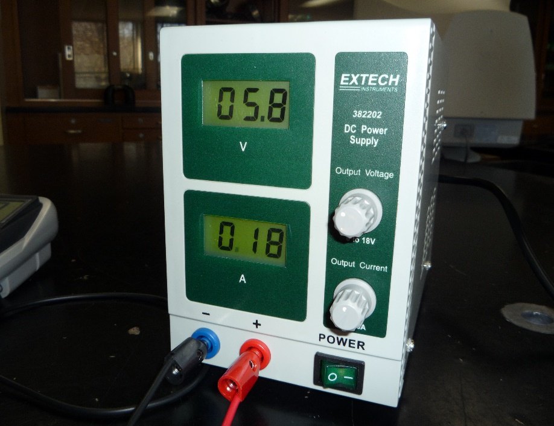
Source
Voltage Reading
Source Current Reading
Voltage Control (set = 0 before turning on)
Current Control (set = ½ max before turning on)
Using the Power Supply:
Step 1: Set Voltage to Zero
Step 2: Set current to ½ of maximum.
Step 3: Turn on power supply. Keep voltage at or below 6V – keep an eye on changes!
Do NOT use the DMM to measure current! You can use the voltage source for finding total current. You must infer the current through each resistor (bulb).
Use the Continuity Tester (sound wave symbol) to check for burned out bulbs or broken alligator clip wires. If it beeps, there is continuity (a continuous conductor between the two points), which means the bulb or wire should work.
Some differences between real vs theoretical circuits:
- Real wires have resistance, so they are going to be taking some of the potential. The sum of the resistors’ voltages should be a little smaller than the source (power supply) voltage.
- Incandescent bulbs are “non-ohmic.” This means their resistances vary depending on the amount of voltage they receive. So, when you are collecting data, keep the voltage constant! One trick for determining a bulb’s resistance at a particular voltage is to create a simple circuit with just that bulb, and adjust the voltage to the voltage in question. Then read the current from the power source.

Directions:
- Build each of the circuits and find V, I, R, and P for each bulb and the power source.
- Some circuits specify a “bulb B”. Make sure that bulb is different from your other bulbs. The other bulbs can be the same.
- Try the continuity tester. It is useful for checking cords and bulbs.
- Try measuring the resistances of some things – wires, for instance.
- On the series circuits page, calculate V, I, R, and P for the wires. You don’t have to do this on the other pages, even though the wires are still using some power.
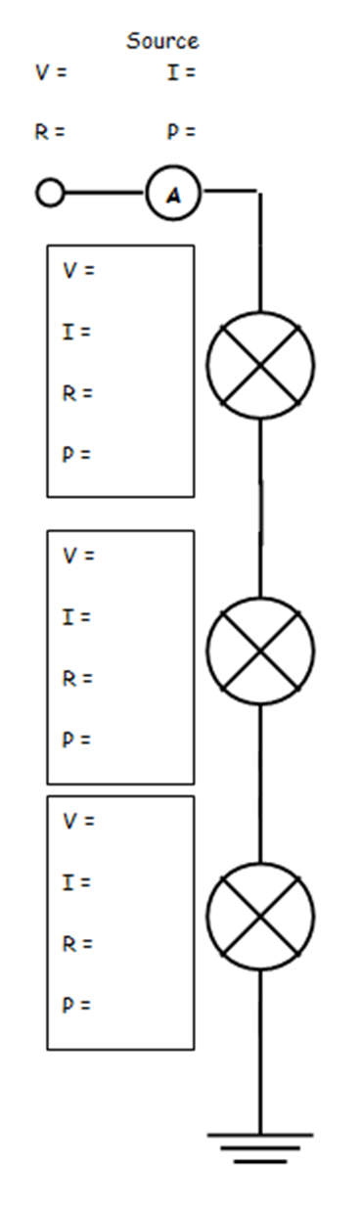
About The Circuit Diagrams: The small circle at the top left end of the circuit represents the red (positive) terminal of the power source. Each X represents a bulb (resistor). The ground symbols (three dashes of diminishing length) represent connections to the black (negative) terminal on the power source. The “A” represents the presence of the internal ammeter that is built into the power source. “Type B” means you are supposed to use a different type of bulb (compared to the other bulbs) in this position.

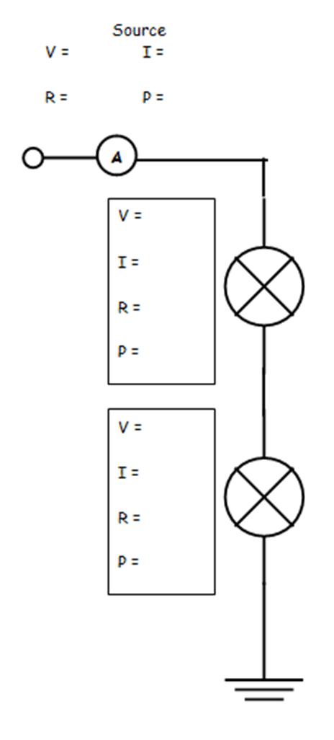

Wires:
V =
I =
R =
P =
Wires:
V =
I =
R =
P =
