Unit 6 Handout #2: Rotational Motion Name: ___________
τorque Notes
I. τorque

A. The rotational equivalent of force is _____________. Its symbol is _______.
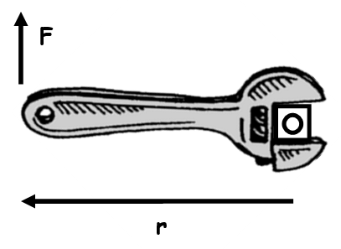

B. Torque = rF = lever arm (r) x perpendicular force (F).

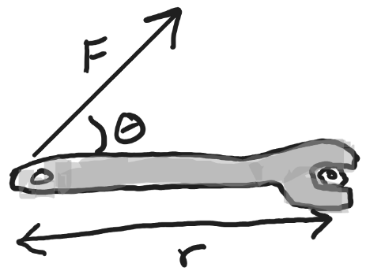
C. When F is not perpendicular to r,

Torque = ______________

II. Rotational Equilibrium

A. In rotational equilibrium,
In other words, the clockwise torques = the counterclockwise torques

B. Examples of rotational equilibrium:

2.0 m
100 N
4.0 m
?
1.

2.
?
4.0 m
600 N
800 N

Notes –Angular Speed and Acceleration

1. What is the definition of angular speed ω? What are the units of ω?

2. How are linear velocity and angular speed related?

3. What is the definition of angular acceleration α? What are the units of α?

4. Use a diagram to distinguish between tangential acceleration (a_{t}) and centripetal acceleration (a_{c})?

5. How are tangential acceleration and angular acceleration related?

6. How are linear acceleration, tangential acceleration, and angular acceleration related?

Notes – 10.3 Dynamics of Rotational Motion: Rotational Inertia

1. Rotational Inertia (a.k.a. moment of inertia) is a rotational version of _____________. Whereas mass and ordinary inertia cause resistance to linear acceleration, an object’s moment of inertia describes its resistance to _____________________________. The rotational inertia of an object depends both on its mass and the distance of that mass from the object’s axis of rotation. As an example, consider a door. If the door’s mass is increased, it will have a __________________(higher,lower) resistance to rotational acceleration, and its moment of inertia will be _________________ (higher,lower). If the door’s mass is shifted “inward,” so that it is closer to its axis of rotation, the door will have a __________________ (higher,lower) resistance to rotational acceleration, and its moment of inertia will be _________________ (higher,lower). The opposite is true if the door’s mass is shifted away from its hinge.

2. Starting with Newton’s 2nd Law, derive an expression for torque t in terms of mass m, lever arm r and angular acceleration α (and introduce I – “Rotational Inertia” or “moment of inertia”)

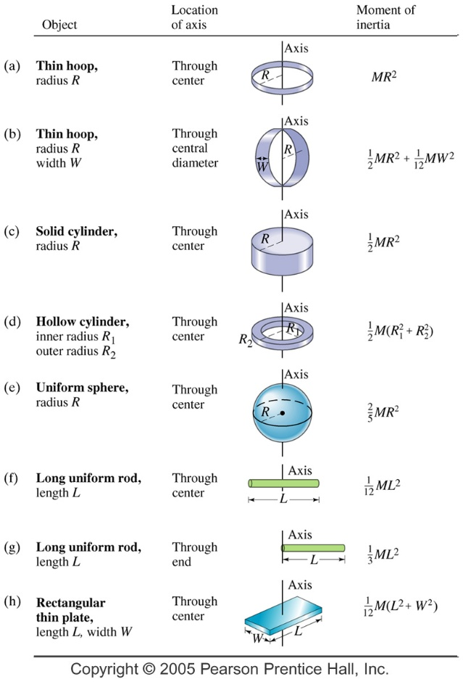
3. The two definitions of torque:

4. Rotational Inertia (I) of Various Objects

A. A single point mass:

B. Multiple point masses:

C. Specific shapes – see chart or web search

Notes – 10.4 Rotational Kinetic Energy

1. Starting with the linear (or tangential) kinetic energy formula, derive a formula for the rotational kinetic energy of a single mass m, with a velocity v, revolving around an axis at a radius r. The formula should be in terms of I and ω.

2. Calculate the final speed of a solid cylinder that rolls down a 2.00-m-high incline. The cylinder starts from rest, has a mass of 0.750 kg, and has a radius of 4.00 cm.

3. Calculate the final speed of a hoop of the same radius (4cm) that is allowed to roll down an incline of the same height (2m)

4. Find the moment of inertia of a rubber band car rear wheel and axle (2 wheels, plus an axle, connected together) that achieves a final velocity of 3m/s after rolling down a ramp from a height of 1m. The wheel and axle has a radius of 0.06m and a mass of 0.12kg.

Notes – 10.5 Angular Momentum and Its Conservation

1. Write the equation for linear momentum.

2. Write the equation for angular momentum.

3. State the Law of Conservation of Angular Momentum in words.

4. Write the equation for the Conservation of Angular Momentum.

5. Suppose an ice skater is spinning at 0.800 rev/ s with her arms extended. She has a moment of inertia of 2.34 kg⋅m² with her arms extended and a moment of inertia equal to 0.363 kg⋅m² with her arms close to her body. (These moments of inertia are based on reasonable assumptions about a 60.0-kg skater.)

A. What is her initial angular velocity, in rad/s?

B. What is her initial angular momentum?

C. What is her final angular velocity?

B. What is her rotational kinetic energy before and after she does this? Why does her KE_{R} change?

Notes: Rubber Band Car Calculations with Energy
Linear Distance Rolled (m) | 2.8
Drive Wheel Radius(m) | 0.08
Time to roll down ramp (s) | 2.5
Drop in height during descent down ramp (m) | 0.28
Wheel and Axle Mass (kg) | 0.12

Notes Part 1: MOI Determination, Method 2:
Some students use a different method to find the moment of inertia of their drive wheel and axle. They remove the wheel and axle from their car and let it roll down a ramp. They release it from rest and record its vertical drop, time to descend, mass, and outer radius.

1. What is the average linear velocity of the wheel and axle as it rolls down the ramp?

2. What is the final linear velocity of the wheel and axle when it reaches the bottom of the ramp?

3. Use the law of conservation of energy to write an equation comparing the wheel and axle’s energy at the top of the ramp to its energy at the bottom. Assume that there is no non-conservative work done.

4. Rewrite the equation, converting to all “linear” (not rotational) terms – except for moment of inertia (I).

5. Plug-in the givens (data above) and solve for the moment of inertia of the wheel and axle.

Notes Part 2: Measuring Motor Output Energy:

Video Frame Rate (fps) | 240
Video Frames During 1 Rotation (at max speed) | 11
The wheel and axle is returned to the car. The students use a marker to make a dark mark on one of the drive wheels. They wind up the car and “launch it” while holding the drive wheels in the air and recording slow motion video. By “scrubbing” carefully as they watch the video, they use the mark on the wheel to determine the number of video frames that elapse during one rotation of the wheel when it is at its maximum speed. Their data are on the right.

6. How many seconds does 11 video frames represent?

7. What is the maximum angular velocity (in radians per second) of the drive wheel and axle during this test?

8. How much energy (output energy) does the motor give to the wheel and axle?

Practice: Rubber Band Car Calculations with Energy
Linear Distance Rolled (m) | 1.21
Drive Wheel Radius(m) | 0.051
Time to roll down ramp (s) | 1.79
Drop in height during descent down ramp (m) | 0.15
Wheel and Axle Mass (kg) | 0.0878

Practice Part 1: MOI Determination, Method 2:
Some students use a different method to find the moment of inertia of their drive wheel and axle. They remove the wheel and axle from their car and let it roll down a ramp. They release it from rest and record its vertical drop, time to descend, mass, and outer radius.

1. What is the average linear velocity of the wheel and axle as it rolls down the ramp?

2. What is the final linear velocity of the wheel and axle when it reaches the bottom of the ramp?

3. Use the law of conservation of energy to write an equation comparing the wheel and axle’s energy at the top of the ramp to its energy at the bottom. Assume that there is no non-conservative work done.

4. Rewrite the equation, converting to all “linear” (not rotational) terms – except for moment of inertia (I).

5. Plug-in the givens (data above) and solve for the moment of inertia of the wheel and axle.

Practice Part 2: Measuring Motor Output Energy:

Video Frame Rate (fps) | 240
Video Frames During 1 Rotation (at max speed) | 15
The wheel and axle is returned to the car. The students use a marker to make a dark mark on one of the drive wheels. They wind up the car and “launch it” while holding the drive wheels in the air and recording slow motion video. By “scrubbing” carefully as they watch the video, they use the mark on the wheel to determine the number of video frames that elapse during one rotation of the wheel when it is at its maximum speed. Their data are on the right.

6. How many seconds does 15 video frames represent?

7. What is the maximum angular velocity (in radians per second) of the drive wheel and axle during this test?

8. How much energy (output energy) does the motor give to the wheel and axle?

