Unit 6: Momentum/Impulse/Collisions

Physics 200, 25-26 Name: ___________________________

Notes - 8.1 Linear Momentum and Force

1. Write the symbol and equation for momentum.

2. Why is the symbol for momentum a lowercase p?

3. What are the units for momentum?

4. Calculate the momentum of a 110-kg football player running at 8.00 m/s.

Notes - 8.2 Impulse

5. Use Newton’s 2nd Law and the basic acceleration formula to write an equation for ∆p in terms of Force and time.

6. F_{net} Δt (more commonly written as Ft) is called ________________.

7. Impulse is equivalent to a change in ______________________.

8. Imagine a ball falling to the floor and then bouncing upward to a height of 40cm. Now imagine someone throwing the same ball upward a height of 40cm. In which case is a greater impulse applied to the ball? Why?

9. The effect of a force on an object depends on the force’s _____________________ and __________________. A very large force acting for a short time will have a great effect on the momentum of a tennis ball. A small force could cause the same change in momentum, but it would have to act for a ________________________.

10. Use the impulse formula to show how the same change in momentum can be accomplished by a variety of forces and times.

11. Example Problem: Suppose a 60kg human is falling from the sky at a rate of 20m/s. If the human is brought to a stop by hitting the bare ground, the average force applied to the person during impact is 24,000N. What is the duration over which the impact force is applied?

12. Describe a few ways in which impulse can be manipulated to used to save lives:

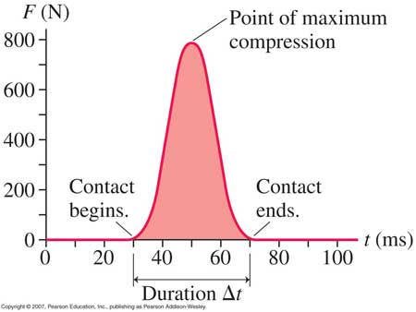
13. What does the area under a force-time graph represent? Can you guess what was being graphed here?

Notes - 8.3 Conservation of Momentum

14. Since F_{net} Δt = Δp, whenever F_{net} = 0, Δ p = __________ (i.e. the total momentum is constant).

15. Law Of Conservation of Momentum: For any isolated mechanical system, total momentum in the system is ______________________ [An isolated mechanical system is one that does not experience any external forces (in other words, F_{net} = 0)].

16. Another way to look at this is to apply Newton’s 3rd Law to prove that momentum is conserved during any collision. When two objects collide…

17. Conservation of momentum formula for 2 objects (This does not apply if there is an external force acting on the system. In that case, an outside force adds or removes momentum to or from the total.)

18. Example Problem: A 3kg object has a velocity of 2m/s before it crashes into a second object that has been traveling with a velocity of -5m/s. After the collision, the 3kg object has a velocity of 1m/s, and the other object has a velocity of 2m/s. What is the mass of the second object?

Notes - 8.4 & 8.5 Elastic and Inelastic Collisions

19. Characteristics of Elastic (a.k.a. perfectly elastic) Collisions:
- Kinetic energy ____________________________________________
- “Separation Speed”__________________________________ “Closing Speed”
- Thermal energy ___________________________
20. Characteristics of Inelastic Collisions:
- Kinetic energy _____________________________________________
- “Separation Speed”__________________________________ “Closing Speed”
- Thermal energy ___________________________
21. Give some examples of nearly elastic collisions between macroscopic objects

22. Give an example of a totally inelastic (a.k.a. perfectly inelastic) collision:

Momentum and Impulse problems

1. What is the magnitude of the momentum of a 28-g sparrow flying with a speed of 8.4 m/s?

2. A constant friction force of 25 N acts on a 65-kg skier for 20s. What is the skier’s change in velocity?

3. A 0.145-kg baseball pitched at 39.0 m/s is hit in a horizontal line drive straight back toward the pitcher at 52.0 m/s. If the contact time between bat and ball is 3.00x10⁻³s, calculate the average force between the ball and bat during contact.

4. Calculate the force of a rocket’s thrust, given that the propelling gases are expelled away from the rocket at a rate of 1500 kg/s with a speed of 4.00x10⁴m/s (at the moment of takeoff). [Hint: The force on the gas expelled in one second can be found from its change in momentum. ]

5. A golf ball of mass 0.045 kg is hit off of a tee at a speed of The golf club was in contact with the ball for Find (a) the impulse imparted to the golf ball, and (b) the average force exerted on the ball by the golf club.

6. You are the design engineer in charge of the crashworthiness of new automobile models. Cars are tested by smashing them into fixed, massive barriers at (30 mph). A new model of mass 1500 kg takes 0.15 s from the time of impact until it is brought to rest. (a) Calculate the average force exerted on the car by the barrier. (b) Calculate the average deceleration of the car.

Conservation of Momentum – Basic Problems
7.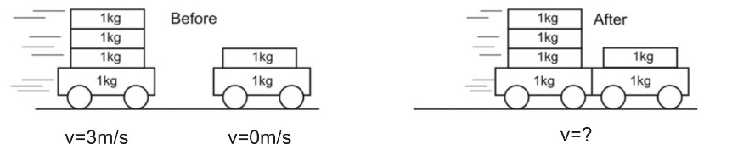

8.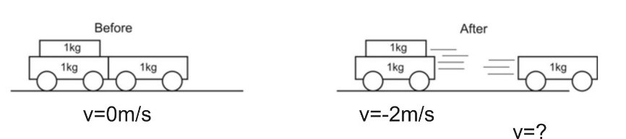

9. 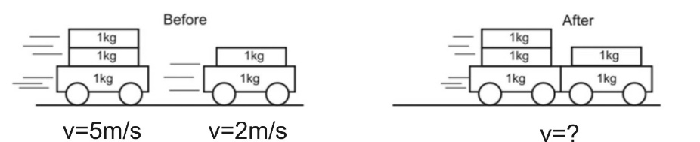

10. A child in a boat throws a 6.40 kg package out of the boat horizontally with a speed of 10.0 m/s. Calculate the velocity of the boat immediately after, assuming that it was initially at rest. The mass of the child is 26.0 kg, and that of the boat is 45.0 kg. Ignore water resistance.

11. A 12,600-kg railroad car travels alone on a level frictionless track with a constant speed of 18.0m/s. A 5350-kg load, initially at rest, is dropped onto the car. What will be the car’s new speed?

Elastic/Inelastic Collision Problems (Conservation of Momentum and, possibly Conservation of KE)
13. Boat A has a mass of 10kg and a velocity of 3m/s. Boat B has a mass of 15kg and a velocity of -1m/s. The two boats collide and bounce away from one another. The collision lasts for 0.1 second, and after the bounce, boat B has a velocity of 1.4m/s.

a. What is the velocity of boat A after the bounce?

b. What impulse is experienced by boat A during the collision?

c. What impact force is felt by boat A?

d. What impulse is experienced by boat B?

e. What impact force is felt by boat B?

f. Is this collision elastic or inelastic? Explain.

Answers:
1. 0.235kgm/s 2. 7.69m/s 3. 4,398N 4. 6.0 x 10⁷N 5. 2.025kgm/s, 579N 6. 139,000N, 93m/s²
7. 2m/ 8. 4m/s 9. 3.8m/s 10. -0.901m/s 11. 12.6m/s
13a. -0.6m/s 13b. -36kgm/s 13c. -360N 13d. 36kgm/s 13e. 360N
13f Inelastic because the separation speed (2m/s) is slower than the closing speed (4m/s). Also, if you calculate total KE, it decreases.

Physics 200 (Stapleton) Name: ________________________________
25-26 Practice Test: Momentum and Impulse

Multiple Choice

1. Which of the following are correct units for momentum?
- Kgm/s b. N/ms² c. Nm d. Nm/s e. Kgm/s²

2. Which other units are also acceptable units for momentum?
- Js b. kW/s c. Ns d. JKg e. Kgm²/s

3. A 2kg pinata is initially swinging with a velocity of 2m/s. A stick, moving with a velocity of -10m/s, hits the pinata, causing the pinata’s velocity to change to 1m/s. During this collision, what impulse is imparted to the stick?
A. 1Ns B. 2Ns C. 3Ns D. 4Ns E. 5Ns

4. A motionless bean in a microwave suddenly explodes into two parts that fly in opposite directions. One part has a mass of 0.6g, and it flies away with a speed of 12m/s. The other part has a mass of 0.4g. If there are no outside forces acting on the system of the bean, what is the speed of the 0.4g bean fragment when it flies away?
- 18m/s B. 20m/s C. 22m/s D. 24m/s E. 26m/s

5-7. In the game of egg toss, someone tosses a raw egg to you from a great distance, and you try to catch it without breaking the egg. Your friend holds their hands still to catch the egg, stopping the egg immediately as it reaches their hands. You catch your egg by moving your hands backward as the egg makes contact, bringing the your egg to rest more slowly than your friend’s egg. The two eggs have exactly the same mass (70g), and they arrive at your hand and your friend’s hand with the same velocity (10m/s).

5. What happens to your egg’s momentum as you catch it?
- Its momentum increases b. Its momentum decreases c. no change

6. Whose egg experiences the greatest force during the catch?
a. Your Friend’s Egg b. Your egg
c. Neither; they’re the same d. There’s no way to tell for certain.

7. Whose egg experiences the greatest impulse during the catch?
a. Your Friend’s Egg b. Your egg c. Neither; they’re the same d. Can’t tell
Cart Name: | Average Impact Force (N) | Impact Time (s)
Cart A | 7 | 0.04
Cart B | 8 | 0.03
Cart C | 2 | 0.13
Cart D | 6 | 0.05

8-10. The table on the right shows data collected from collisions of carts with a stationary (non-moving) force sensor. Each of these carts collided with the sensor at exactly the same closing speed, and each of these carts had exactly the same mass (0.2kg). Exactly one of these collisions was totally inelastic. Based on this information…

8. Which cart experienced the totally inelastic collision?
A. Cart A B. Cart B C. Cart C D. Cart D E. There’s not enough information to tell.

9. All of the carts had the same mass (0.2kg) and closing speed. What was that closing speed?
A. 0.6m/s B. 0.8m/s C. 1.0m/s D. 1.2m/s E. Can’t tell

10. Which of the carts, if any, experienced a perfectly elastic collision?
A. Cart A B. Cart B C. Cart C D. Cart D E. None of the carts
11. An archer floating in the vacuum of space shoots an arrow that sticks into a target that is also floating freely in space. If the “system” includes only the target and the arrow, and no other outside forces are applied to the system, we can be sure that…
- Momentum and kinetic energy are both conserved.
- Neither momentum nor kinetic energy is conserved.
- Momentum is conserved, but kinetic energy is not.
- Momentum is not conserved, but kinetic energy is conserved.
- There is no way to tell for sure that any of these is true.

Problems:

1. A 70kg hockey player was skating at a constant speed of 7m/s. Then a 0.3 second long collision slowed her to 3m/s.

a. (2pts) What was the player’s momentum before the collision?

b. (2pts) What force was exerted on the hockey player during the collision?

2. Ned kicked a 0.4kg rock, exerting an average force of 30N. The rock was stationary before Ned kicked it, and Ned’s applied force lasted for 0.12seconds.

a. (2pts) What impulse was applied to the rock?

b. (2pts) what was the speed of the rock when it left Ned’s foot?

3. A 15kg child riding a 3kg longboard is moving with a velocity of 4m/s (and so is the longboard). When the child jumps off of the longboard, the board continues in moving in the same direction, but it travels at a new velocity of 8m/s. What is the child’s velocity just after she jumps off?

