Physics 200 Name: __________________________
Unit 5 Handout:
Centripetal Acceleration and Gravity

Centripetal Acceleration: An object traveling in an arc of a circle at a constant speed is accelerating toward the center of the circle. This acceleration is called centripetal acceleration (a_{c}). Centripetal means “toward the center.” Its magnitude is $a_{c}=\frac{v^{2}}{r}$, where v is the speed of the object and r is the radius of the circle.
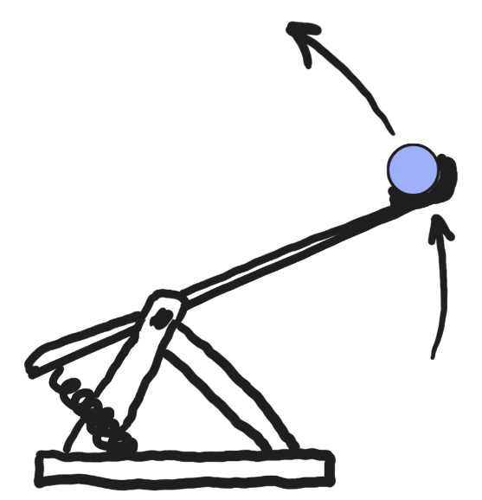
An object that is following an arc can also have tangential acceleration (i.e. it can be speeding up as well as circling), but in this unit, speed will be constant.

The projectile in the catapult is undergoing both centripetal acceleration and tangential acceleration.
- Show the direction of both kinds of acceleration.
- Make a note regarding the acceleration we will not be dealing with in this unit.

When an object is traveling in a circle at a constant speed, the net force acting on the object is the centripetal force.

During “uniform circular motion”, centripetal Force = ΣF =

Of the five forces we have dealt with, four of them can provide this centripetal force. Draw a diagram for each of them showing how this could work.

Which force won’t work to provide consistent centripetal force?

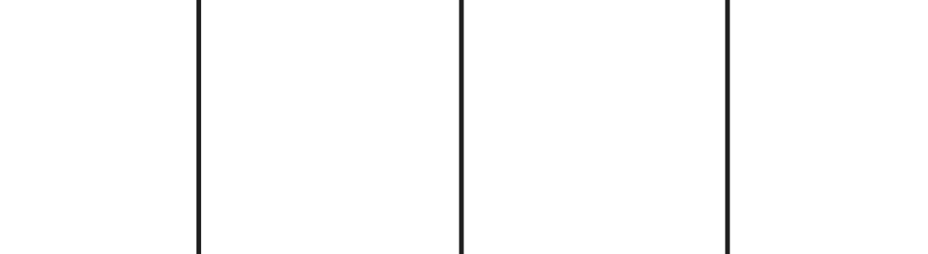

Problem Situations you may face -- Type of circle and source of centripetal force
- Horizontal circle – friction (e.g. someone running in a circle)
- Horizontal circle – normal force (e.g. centrifuge or carnival ride – “spaceship 2000,” “Gravitron…”)
- Vertical circle – tension and gravity – bottom or top (e.g. a ball on a string)
- Vertical circle – normal force and gravity, always facing inward – bottom or top (e.g. roller coaster in loop-the-loop)
- Vertical circle – normal force and gravity, always facing upward – bottom or top (e.g. riding a ferris wheel)
- Circle in “outer space” – gravity (e.g. satellite, moon, or planet in orbit)
- Circle in “outer space” – normal force, facing inward (e.g. rotating space station)

Problems:

1. (horizontal circle -- friction) A 500kg car drives in a circle with a radius of 20m. If the car maintains a constant speed of 20m/s, what net force acts on the car? If the driving surface is flat and horizontal, what provides the force? How many g’s does the driver feel as a result of the turn?

2. (vertical circle – normal force always facing inward) A 60kg teenager is riding a roller coaster that is going through several circular “loop-the-loops.” She is currently traveling in a uniform circular path with a radius of 4m, and her speed is constant at 7m/s. A bathroom scale “beneath” her measures the normal force that she experiences.
a. What is the scale reading when she is at the top of the circle (upside-down)?
b. What is the scale reading when she is at the bottom of the circle (right-side-up)?

3. A typical indoor track has turns with a radius of 20m. A runner running a 400m split of 53 seconds has an average speed of approximately 7.55m/s. If the track were flat, and spikes were not allowed, what force of friction would be required in order for a 68kg runner to make the turns at this speed? What value of µ (between shoes and track) would be necessary?

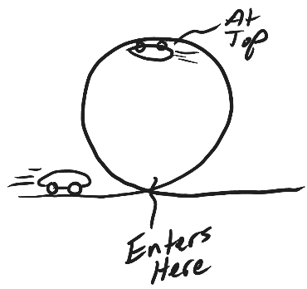

4. A 1,000kg car is approaching a “loop-the-loop” with a radius of 15m. What speed does the car need to maintain so that the g’s experienced the driver approach zero at the top? At this speed, what normal force does the car experience when it is at the bottom of the loop? How many g’s are experienced at the bottom?

5. A child weighing 200N is standing on a bathroom scale inside a Ferris Wheel that is rotating at a constant rate. If the radius of the circles made by the child is 10m, and the scale reads 100N at the top, what is the child’s speed? What does the scale read when the child is at the bottom?

Newton’s Law of Universal Gravitation:

$F_{gravity}=G\left(\frac{m_{1}m_{2}}{r^{2}}\right)$ —or—$G\left(\frac{Mm}{r^{2}}\right)$, where G is the gravitational constant (an empirically measured quantity), m₁ and m₂ are two different masses, and r is the distance between their centers of mass. When one mass orbits the other, r is also referred to as the “orbital radius.” [Often, M is used for a planetary mass, and m is used for its satellite.]
$$G=6.67x{10}^{-11}\frac{{Nm}^{2}}{{kg}^{2}}$$

Altitude: the distance from an object to the surface of the Earth
Altitude + Earth’s Radius = orbital radius

6. Calculate the force of gravity between a 100kg student and a 60kg student whose centers of mass are 1.7m apart.

Combining Circular Motion and The Law of Gravitation:

7. Find the value of g at Earth’s surface. Earth’s mass is (5.972x10²⁴kg) and its average radius (6.371x10⁶m). Solve this problem algebraically before plugging in the values.

8. What is the velocity of a space station that is orbiting the Earth with an orbital radius of 30,000km? Solve this problem algebraically before plugging in the values.

9. What is that space station’s period of revolution? Period (T) is the amount of time it takes for a satellite to complete a full orbit. First find T algebraically, in terms of v and r. Then plug in the values.

10. Every 40 Earth days, object A orbits object B in a circular orbit with a radius of 3.7x10⁶m.

a. Find the velocity of object A.

b. Find the mass of object B.

More Practice:
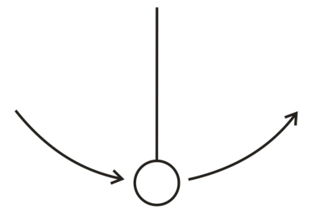
11. [Warning: This is a “trick question.” Read the entire question and pay close attention to the bold words.] A playful lunar explorer swings a ball on a string. The 1kg ball is traveling in 0.5m radius vertical circles at a constant speed of 5m/s. The value of g on the moon is 1.63m/s². Give the magnitude and direction of the net force that is acting on the ball at the top of its swing.

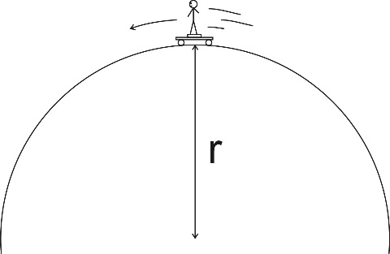
12. A skateboarder stands on a bathroom scale on top of a skateboard as she travels over the top of a circular skate park feature. Her mass is 55kg, and you may assume that her speed is 8m/s. If the scale reads 400N at the top of the hill, what is the radius of the hill’s curve?

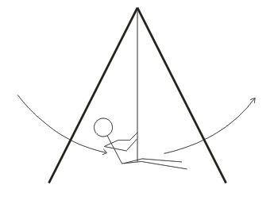
13. A 40kg child is swinging on a massless swing in a vacuum. The child is swinging in arcs with a radius of 3m. At the lowest point in her swing, her speed is 3m/s. Assuming that her speed is constant in this part of her swing, what is the tension in the rope when she is at this lowest point?

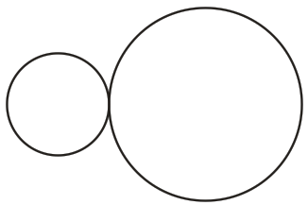
14. One sphere has a radius of 0.1m, and the other sphere has a radius of 0.2m. They both have a mass of 0.7kg, and they are touching. Calculate the gravitational force between them.

15. A spacecraft orbits a planet at an altitude of 2x10⁶m. The Earth’s radius is 6.3713 x 10⁶m, and its mass is 5.979 x 10²⁴kg.

a. What is the spacecraft’s orbital radius?

b. What value of “g” is experienced by an explorer on the spacecraft?

16. Extraterrestrial explorers insert a satellite into a circular orbit around a newly discovered planet in a distant solar system. The satellite has a period of 1.20x10⁵seconds and an orbital radius of 5.60x10⁷m.

a. What is the speed of the satellite?

b. What is the mass of the planet around which the satellite orbits?

More Circular Motion Practice:

Helpful Information:
G = 6.67 x 10⁻¹¹ Nm²/kg² M_{Earth} = 5.97 × 10²⁴ kg M_{Moon} = 7.35 x 10²² kg Earth Radius = 6.378 x 10⁶ m Earth Orbital Radius = 1.50 x 10¹¹ m Moon Radius = 1.74 x 10⁶m

1. A 0.2kg ball on a string is swinging in vertical circles with a radius of 0.3m. The ball’s speed is constant at 4m/s.

- Where in the ball’s path is string tension highest?

- What is the string tension at that point?

2. A rock is orbiting a planet in a stable, circular orbit with a constant speed of 800m/s. The rock’s orbital radius is 30,000m. What is the mass of the planet that is being orbited?

3. What is the force of gravitational attraction between the Earth and an astronaut orbiting the Earth at an orbital radius of 3.5x10⁷ m? The astronaut’s mass is 65kg.

4. On a spacecraft traveling at a constant speed to planet X, “artificial gravity” is preparing the astronauts for the much stronger gravity of the new planet. The spacecraft creates this sensation of gravity by rotating, causing each astronaut to move at a constant speed of 15m/s (for simplicity, assume the astronauts stand still the whole time). One particular astronaut, who weighs 700N on Earth, experiences a sensation of weight equal to 1,200N on the spacecraft.

- Draw a diagram showing the following: the astronaut, the space station, and the individual force(s) acting on the astronaut.

- What is the net force acting on the astronaut in your diagram? Give both magnitude and direction.

Magnitude of Net Force = ______________ Direction of Net force: ____________________

- Calculate the radius of the astronaut’s rotations.

5. The people of Earth have decided that gravity is too strong. We’re too heavy, and we’re tired of putting up with g=9.8m/s². We want to lose some weight by reducing the value of g at Earth’s surface to a more tolerable 8m/s². How could we do this? Describe the value(s) you would have to change – and what you would have to change those value(s) to -- in order to adjust g in this way.

