Physics 200 Name: _______________________________
Sledding Energy Problems

1. To find µ_{k}, a sled was given a push. After it was released, it traveled across a level surface a distance of 10.5m before coming to rest in a time of 4.4s. Using simple kinematics, we can show that the sled’s average velocity was 2.386m/s, so it’s initial velocity must have been double that -- V₀ = 4.77m/s. Use energy equations to find µ_{k} for the sled on the snow. We will ignore drag, which is minimal at these speeds.
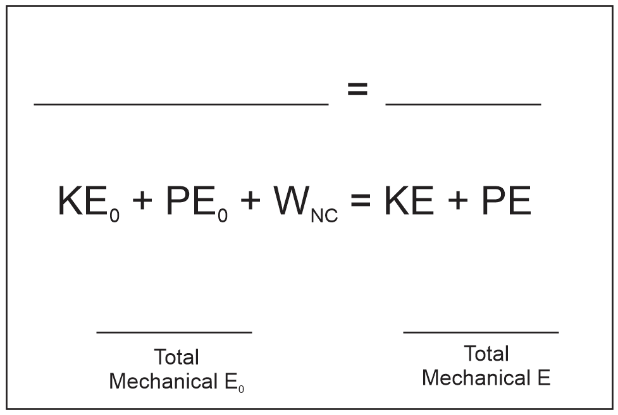
a. First sketch a graphical version of the mechanical energy conservation formula, as it applies to the sled in this situation. For positive Joules, use upward bars. For negative, use downward bars. For anything that’s zero, write a zero. Label the work bar to explain what is doing the work.

b. Write an expression for the sled’s initial kinetic energy, in terms of its mass and velocity (using the KE formula).

c. Write an expression for the work done on the sled by friction (using the work formula).

d. Write an expression for the force of friction acting on the sled, in terms of µ_{k}, the sled mass, and g (using the friction formula).

e. Now do what you did in part A, but with numbers. Use the conservation of mechanical energy equation to put everything together and solve for µ_{k}.
[KE_{initial} +PE_{initial} + W_{nc} = KE_{final} + PE_{final}]

2. Over a distance of 17.4m, the blue sled plus a 74.2kg student were accelerated from rest to a velocity of 11.86m/s. The sled’s mass was 7.54kg. The force pulling the sled was provided by ropes whose force came from 18 students. The coefficient of friction between the sled and snow was µ_{k} = 0.12.

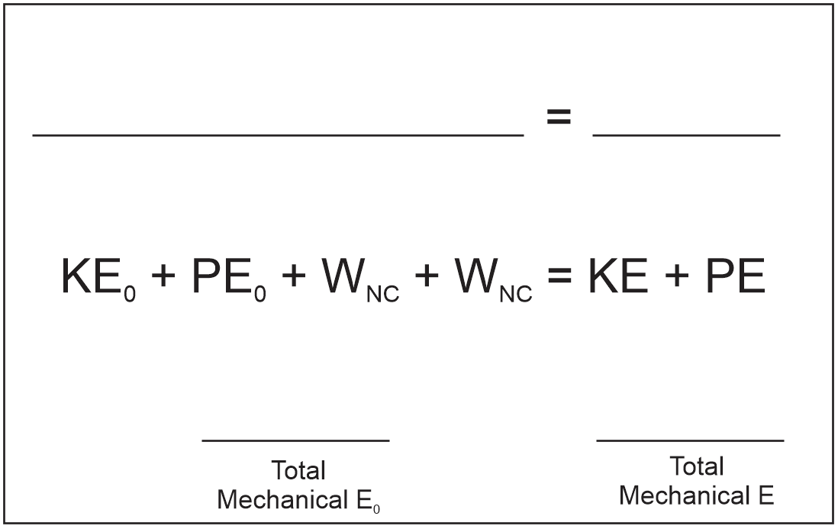
a. As in #1a, sketch a graphical version of this equation as it applies to this event. Notice that there should be two kinds of work being done. Label each of them to indicate what is doing the work.

b. What force of friction was acting on the sled?

c. How much total non-conservative work was done on the student + sled? Use the Conservation of Mechanical Energy formula -- KE_{initial} +PE_{initial} + W_{nc} = KE_{final} + PE_{final.}

d. How much of the non-conservative work was done by friction? Was that work positive or negative?

e. How much work was done by the rope pulling the sled (and, therefore, by the people pulling the sled)?

f. What average force did the pullers exert on the sled (via the rope)?

g. On average, how much force did each individual puller apply? Answer in both N/puller (“Newtons per puller”) and lbs/puller. [**Consider this – but you don’t have to write anything down. How does this force compare to the force that each puller applies to the rope in their hands?]

h. If the sled had traveled on a frictionless surface (µ_{k} = 0) how fast would it have gone? Answer in both m/s and mph.

3. A student is about to be accelerated in the sled. When we ask their usual weight, their answer is “250 pounds.” We add 8 pounds for clothing weight, so that brings their total weight to about 258 pounds. How many average pullers do we need to have pulling the ropes if we want to make this student go 28mph? [From previous questions: acceleration distance = 17.4m, µ_{k} = 0.12, Sled mass = 7.54kg, Rope Force Per Puller = 23.7N/puller ]

a. Total mass being accelerated =

b. Total weight being accelerated =

c. F_{Friction} =

d. Final KE =

e. Work done by friction

f. Total work done by the rope (or by the pullers, depending on how you look at it)
[KE_{initial} +PE_{initial} + W_{nc} = KE_{final} + PE_{final}]

g. Total required pulling force =

h. # of required pullers =

