Unit 3 Handout Name: __________________________
Friction and Forces on Inclines
Physics 200

Part 1: Friction

1. What is friction?

2. When there is relative motion between objects in contact, the friction is called _____________ friction. The symbol for its “coefficient” is ______.

3. When there is no motion between objects in contact, the friction is called _____________ friction. The symbol for its “coefficient” is ______.

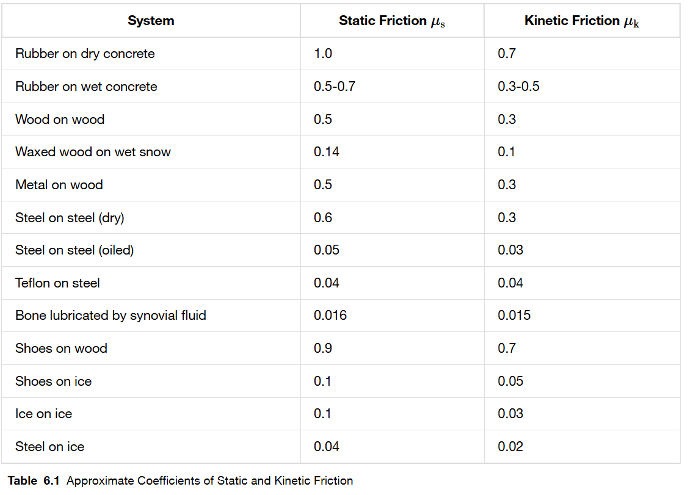
4. According to the table, which type of friction is stronger?

5. Aside from the materials involved, what else affects the force of friction between two surfaces?

6. Write the equation for the magnitude of static friction.

7. Write the equation for the magnitude of kinetic friction.

8. Someone slides a 1kg textbook rightward across the classroom floor. The book accelerates at a rate of -4.9m/s². Find µ_{k} for the book on the floor. What would µ_{k} have been if the book’s mass had been 2kg?

Practice: Force Problems with Friction and Some Kinematics
1. Someone slides a 20kg rock across a horizontal floor. If the person does this by applying a 150N horizontal force, and the rock accelerates at 3.5m/s², what is the coefficient of friction between the desk and the floor?

2. If the coefficient of kinetic friction between a 35-kg crate and the floor is 0.30…
a. What horizontal force is required to move the crate at a steady speed across the floor?

b. What horizontal force is required if is zero?

3. A force of 48.0 N is required to start a 5.0-kg box moving across a horizontal concrete floor.
a. What is the coefficient of static friction between the box and the floor?

b. If the 48.0-N force continues, the box accelerates at What is the coefficient of kinetic friction?

4. Suppose that you are standing on a train accelerating at 0.20g. What minimum coefficient of static friction must exist between your feet and the floor if you are not to slide?

5. Drag-race tires in contact with an asphalt surface have a very high coefficient of static friction. Assuming a constant acceleration and no slipping of tires, estimate the coefficient of static friction needed for a drag racer to cover 1.0 km in 12 s, starting from rest.

6. A box is given a push so that it slides across the floor. How far will it go, given that the coefficient of kinetic friction is 0.20 and the push imparts an initial speed of

7. Some runners are racing on an extremely slippery floor (µ_{s} = 0.015). Starting from rest, what is the shortest amount of time in which one of the runners can run a distance of 10m?

Part 2: Forces on Inclines
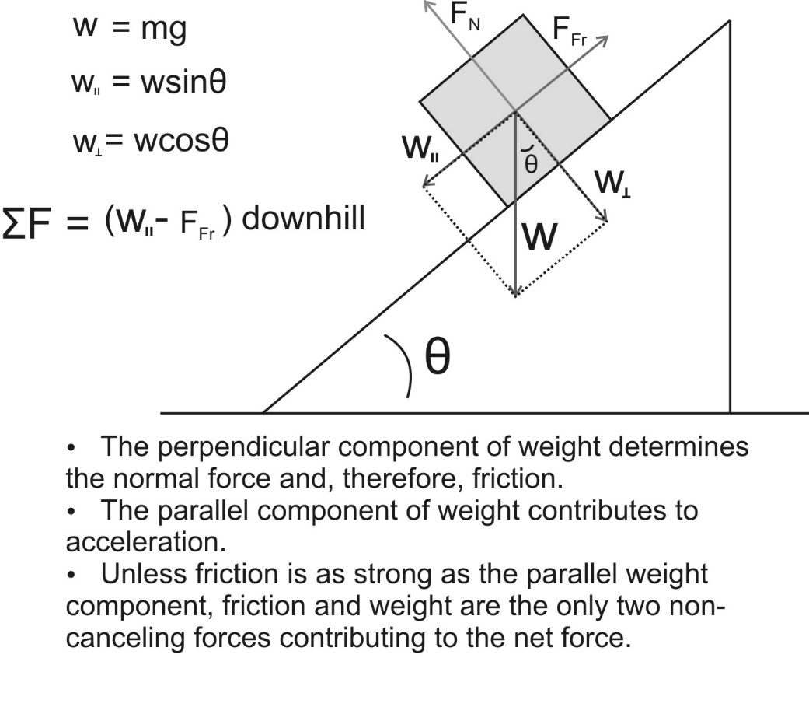
Practice Problem: Fill in the remaining cells in the table below.

Item | Direction (When applicable) | Magnitude
coefficient of friction | NA | 0.4
θ (degrees) | NA | 30
Mass of object (kg) | NA | 2
Weight of object (N)
Perpendicular Weight Component (N)
Parallel Weight Component (N)
Normal force (N)
Force of Friction ( N)
Net force on object (N)
Acceleration (m/s²)
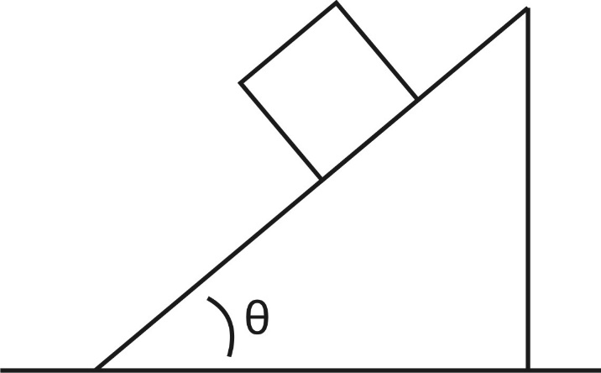
1a. The figure to the right shows a block on an incline. Draw and label the forces acting on the block. Resolve weight into perpendicular and parallel components, relative to the surface.

1b. Fill in the table below for the block on the ramp The block is the “item.”

Item | Direction (When applicable) | Magnitude
coefficient of friction | NA | .6
θ (degrees) | NA | 60
Mass of object (kg) | NA | 2
Weight of object (N)
Perpendicular Weight Component (N)
Parallel Weight Component (N)
Normal force (N)
Force of Friction ( N)
Net force on object (N)
Acceleration (m/s²)

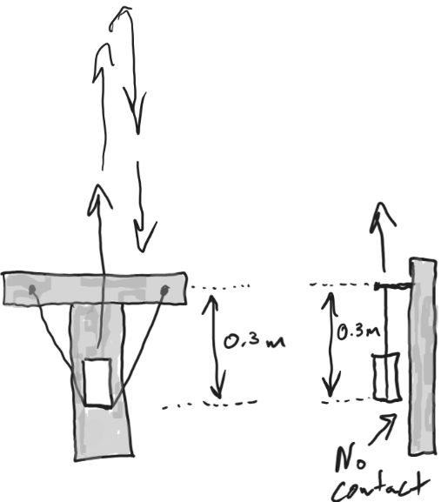
Part 3: Projectile Launcher Applications:
(assume zero air resistance)

1. A 0.4kg block of wood is launched vertically. The block accelerates over a distance of 0.3m. It remains aloft for 1.4s before returning to the same elevation from which it was launched There is no contact between the launcher surface and the block. Find:
a. The muzzle velocity of the projectile
b. The acceleration of the projectile as it speeds up
c. The average net force acting on the projectile as it speeds up.
d. The average force exerted on the projectile by the elastic bands

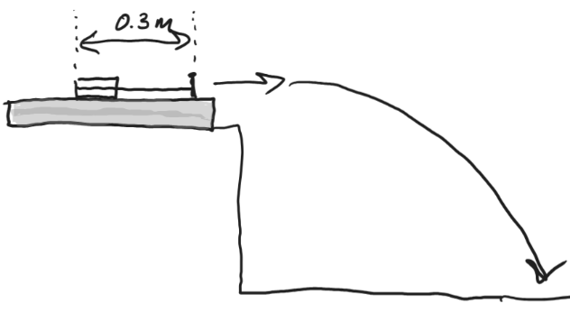
2. The same 0.4kg block of wood is launched horizontally from the same launcher with the same acceleration distance (0.3m) and the same average band force as the vertical launch. In this case, the block of wood slides along the surface of the launcher. The block is launched from a height of 0.92m, and it travels a horizontal distance of 3.06m before hitting the ground. Find:
a. The muzzle velocity of the projectile
b. The acceleration of the projectile as it speeds up
c. The average net force acting on the projectile as it speeds up
d. The force of friction acting on the projectile as it speeds up
e. The value of µ_{k} between the block and the surface of the launcher.

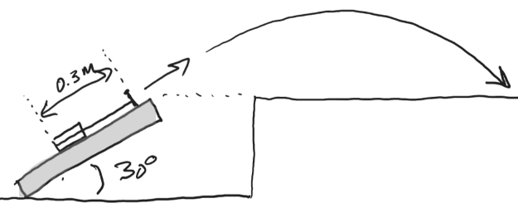
3. The same 0.4kg block of wood is launched at a 30 degree angle. It is accelerated at this angle for a distance of 0.3m with the same average band force and the same µ_{k} between the block and the surface of the launcher. Find:
a. The normal force exerted on the projectile by the barrel on the projectile
b. The force of friction exerted on the projectile by the barrel
c. The average net force exerted on the projectile as it speeds up
d. The average acceleration of the projectile as it speeds up (net force in the parallel dimension)
e. The projectile’s muzzle velocity
f. The projectile’s horizontal displacement, assuming that it lands at the muzzle height
g. The horizontal displacement that would be expected if the muzzle velocity were the same as in #2a.

