Physics 200 Name: ____________________
Simulating The Projectile Contest

Overview: Perform the calculations that you will need to perform in the contest, and calculate a score based on example results.

1. The symmetric shot range is 3.2m and the angle is 55 degrees. Y displacement is zero. Calculate the required initial velocity.

Vo = ___________

2. No calculations, just consider this… If you have a calibration graph, you can reference it to find out where to set your trigger. If you don’t have one, you will have to guess.

3. The diagram on the right shows the impact point for your symmetric shot. How many symmetric shot bonus points were earned ?

__________ [Note that you only get bonus points if this is your first shot.]

4. The diagram also shows the actual distance of the projectile impact point to the muzzle launcher. Use this range to calculate the actual initial velocity of the projectile.

Actual initial velocity = __________

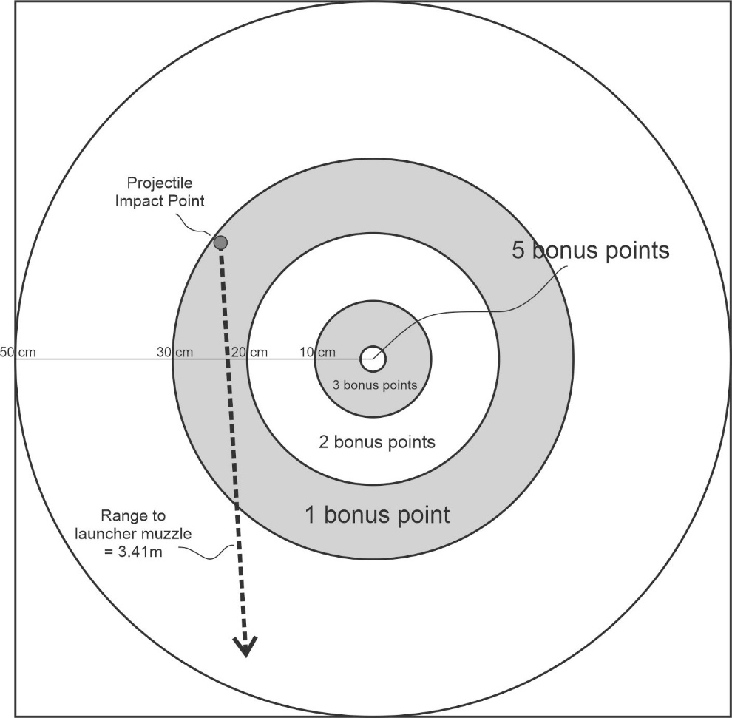
5. The asymmetric shot will have a y-displacement of -0.85m. Use the launch angle and the projectile’s actual initial velocity to calculate a predicted x-displacement for the asymmetric shot.
X-displacement =
____________

6. The diagram on the right shows the impact points for the asymmetric shot. Calculate the average miss distance in the longitudinal and lateral dimensions.
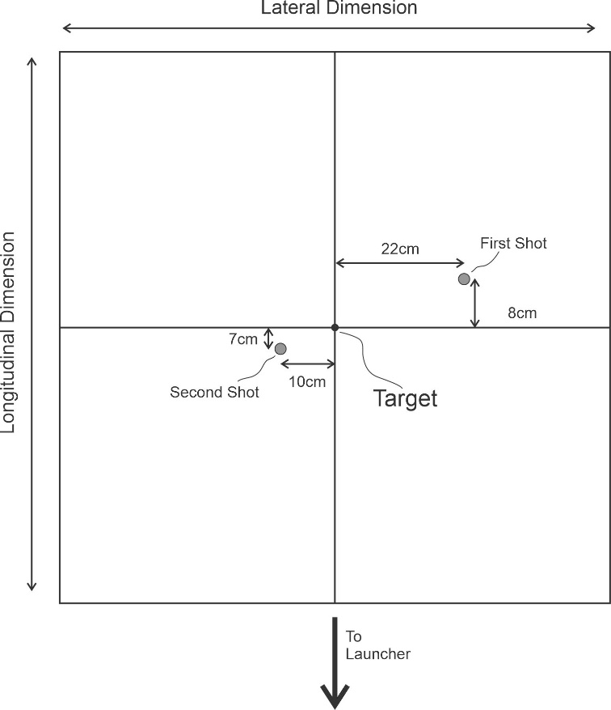
a. Average Longitudinal Error = _________

b. Average Lateral Error = _________

7. What is the base score? ________ [base score = average longitudinal error.]

8. How many asymmetric shot bonus points

were earned? _________
[These bonus points are based on average lateral error: 0-5cm = 3 pts; 5-10cm = 2pts; 10-20cm = 1pt]

9. The free-throw x displacement is 2.2m and the y displacement is 0.9m. Choose a combination of launch angle and initial velocity that will land in the center of the target.

Angle = _________ Initial Velocity = ________

10. No calculations, just consider this… If you have a calibration graph, you can reference it to find out where to set the trigger to achieve this initial velocity. If you don’t have one, you will have to guess.

12. During the free throw contest, 3 buckets were made, and 3 buckets = 3 bonus points.
Now open the projectile contest score calculator (link on website) to calculate the overall contest score and performance grade. Fill out the yellow cells.

12a. Contest Score = __________ 12b.Performance Grade = __________

Answer Key:

1. 5.78m/s 3. 1 bonus point 4. 5.96m/s 5. 3.92m 6a. 7.5cm 6b. 16cm
7. 7.5cm 8. 1bonus point
9. There are many possibilities – 60֯ and 5.71m/s would work 12a. 4.25 cm 12b. 100

