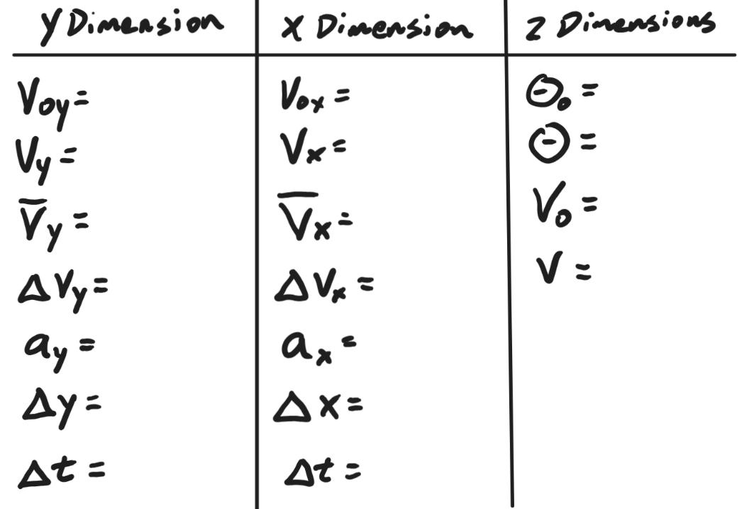
Name: ___________________________

Name: ___________________________

Name: ___________________________

