Physics 200 (Stapleton) Name: _______________
Unit 2 Handout: 2-D Kinematics / Projectile Motion

1. One baseball is dropped from rest. At the same instant, another is thrown horizontally from the same height and follows a curved path. Which baseball hits the ground first?

2. The 2-D motion “BIG IDEA” -- The horizontal and vertical components of two-dimensional motion are independent of each other. Any motion in the horizontal direction does not affect motion in the vertical direction, and vice versa.
An effective way to analyze “2D” motion is to resolve (separate) the motion into separate X and Y vectors, which can be numerically added and subtracted with other vectors of the same dimension.

When a problem has zero acceleration in both the X and Y dimensions, some call it a_____________________

problem, because the classic example features ______________________________________________________.

When a problem has zero acceleration in the X dimension, but an acceleration of -9.8m/s² in the Y

dimension, we call it a ______________________________________________________ problem. An

example of this type of motion is: _________________________________________________________________.

3. Vectors may be added using the head-to-tail method. Multiple “component” vectors are added by connecting them head-to-tail. The “resultant” (or sum) of the component vectors may then be drawn as a single vector from the open tail to the open head of the string of components. In the spaces below, draw component vectors (x and y) and resultant vectors representing the trajectories of a boat heading across a river and a projectile launched at an angle to horizontal.
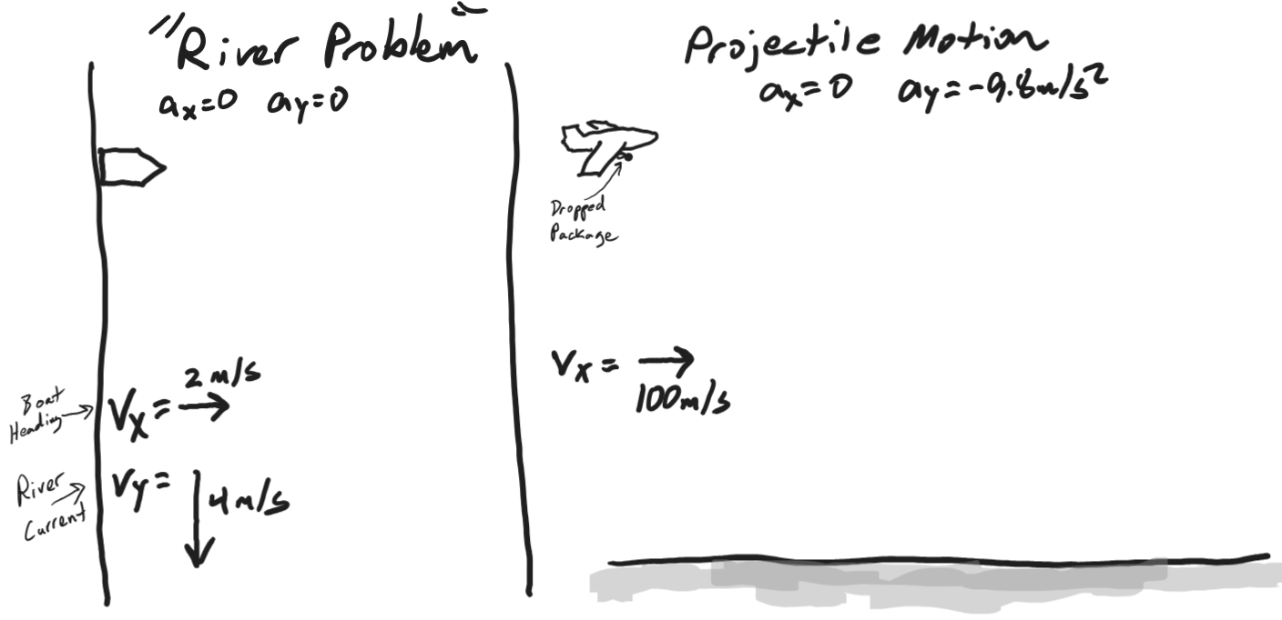
Vector Addition Practice:
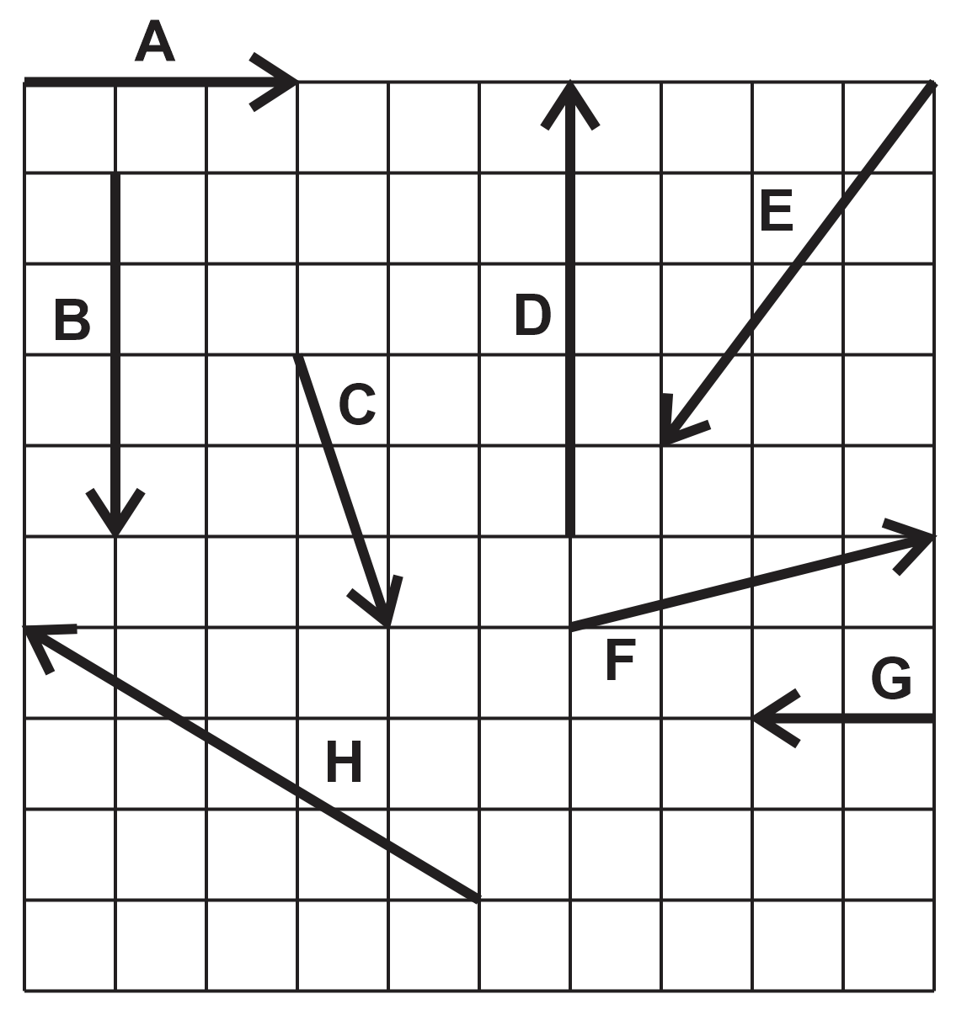

1. Find the resultant vector that is produced by adding vectors A and B.

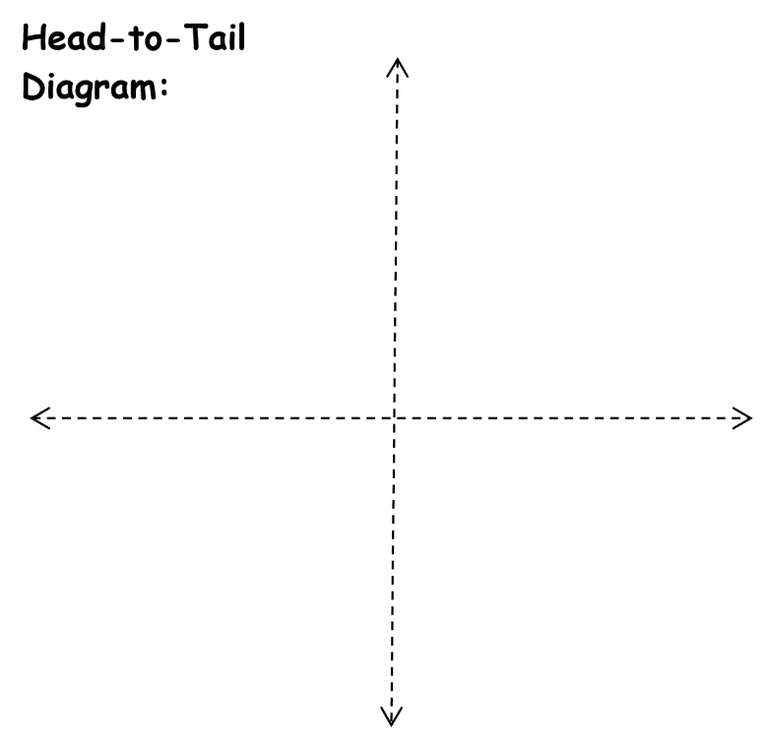
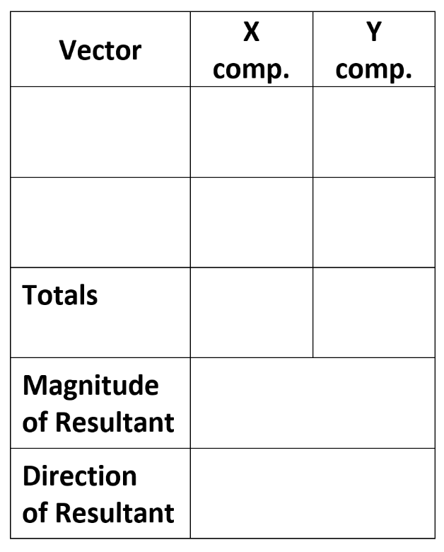

2. Add vectors E and C.

3. What is are the magnitude and direction of the resultant vector that is produced by adding vectors D, C, and A?

Find the resultant vectors from the additions of…
4. E + H
5. C + F
6. E + H + G

Answers: 1. 5, 53.1° below positive x axis 2. 7.3, 74° below negative x axis
3. 4.5, 26.5°above +x axis 4. 8.1, 7.1° below -x
5. 5.4, 21.8° below +x 6. 10.05, 84.2° left of -y axis

Projectiles:

1. A projectile is launched horizontally and to the left from the top of a tall building in the absence of air resistance. Sketch the path of the projectile as it falls to the ground. Use the head-to-tail method to represent the object’s V_{net}, Vx, and Vy at the topmost point and at some other points during the fall.

2. Another bit of practice… Sketch the parabolic flight path of a projectile launched from left to right. Draw V_{x}, V_{y}, and V_{net} for one point during the ascent, one point during the descent, and also at apogee*. Make sure that your vectors are properly proportioned in length and pointing in the correct directions.

3. Updated Motion Formulas (basic kinematics, plus range).

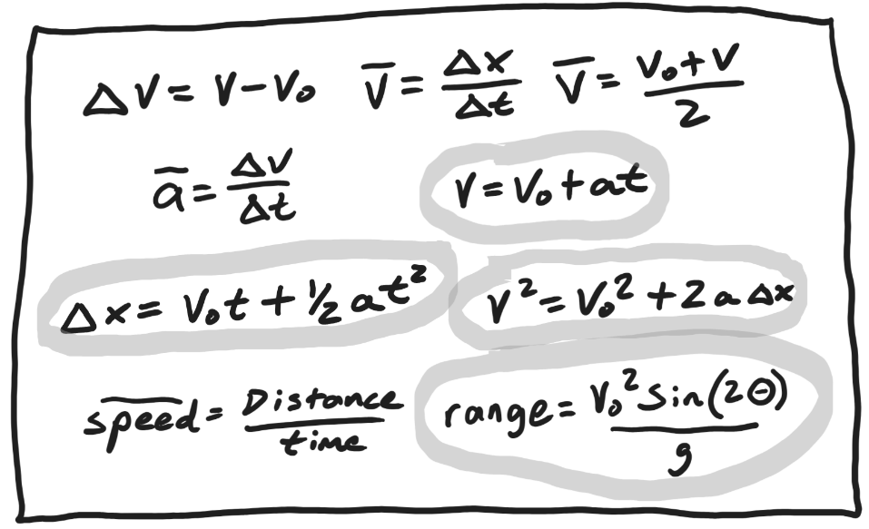

Which formulas work for the X dimension (where there is no acceleration)? Explain.
4. Create a sketch showing the initial conditions in this problem. Show the initial velocity vector. Also resolve the initial velocity vector into X and Y components and sketch those components.

5. Use trig identities to express the values of Vox and Voy.

Vox =

Voy =

6. Deriving The Range Formula
a. First, derive an equation for time aloft (you will need this in part b). Which component vector determines the time that the projectile remains in flight?

b. Derive an equation for the x displacement of a projectile with the same starting and ending height. This is known as the range formula.

Projectile Practice Problems: Assume for all problems that there is no air resistance.

1. A car traveling at 60mph drives horizontally off of a cliff and falls to the ground 100m below. Find everything.

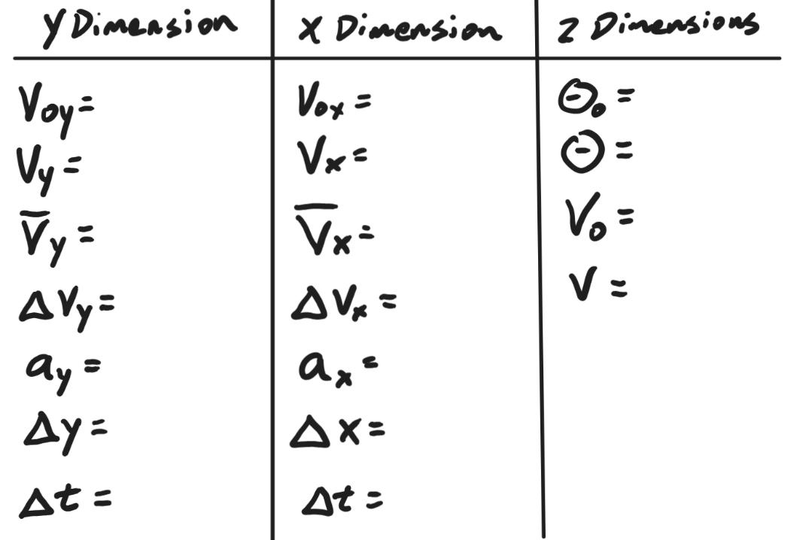

2. You throw a ball at a 70° angle with an initial speed of 30mph. The ball flies in an arc and lands on a shelf at the same height from which you released it. Find everything.

3. A ball is launched upward and to the right. 2 seconds after the ball is launched, it enters an open window at a height that is 20m above the ball’s launch point. The ball enters the window at an angle 27° above rightward. Find everything about the ball’s flight from its starting point to the open window.

4. A skier takes flight at a 30° angle. They travel a horizontal distance of 15m before landing at the same height at which they leave the snow. Find everything for the first half of the flight (take-off to apogee).

5. A projectile experiences a 7 second flight, during which it undergoes a displacement of 25m leftward (and no vertical displacement). Find “everything” for this flight.
6. On a practice field that is not level, an Olympic athlete throws a javelin at an angle of 34° above horizontal. The release point of the javelin is 1.3m above the ground. The javelin travels a horizontal distance of 90 meters and lands after a time aloft of 3.7 seconds. Find “everything” about the flight.

