Physics 200 Name: ________________________________

- Suppose a rocket's thrust lasts for 0.055s. Immediately after thrust ends, the rocket is 2.4m above the ground. Its velocity is 56m/s, upward. Its mass (now that the water is gone) is 0.182kg. The rocket’s drag coefficient is 0.25, and its cross-sectional area is 0.01m². The density of the air surrounding the rocket is 1.27kg/m³. The rocket does not have a parachute, and its characteristics (drag coefficient and Area) do not change during flight.
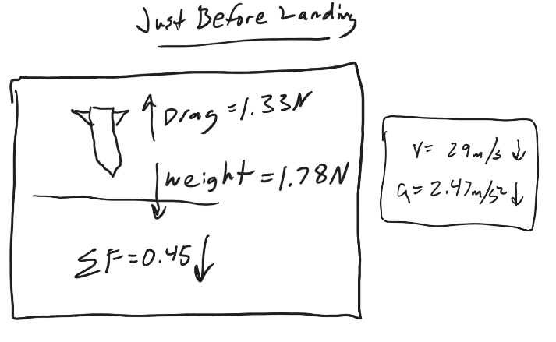
  - Find the rocket's total time aloft 8.065s
  - Find the rocket's maximum height 78.9m
  - For the moment just before the rocket lands (just before the time you gave as an answer to part a, sketch a diagram showing…
    - the rocket
    - all of the individual forces (and the net force) acting on the rocket
    - the net force acting on the rocket
    - the rocket’s acceleration
    - the rocket’s velocity
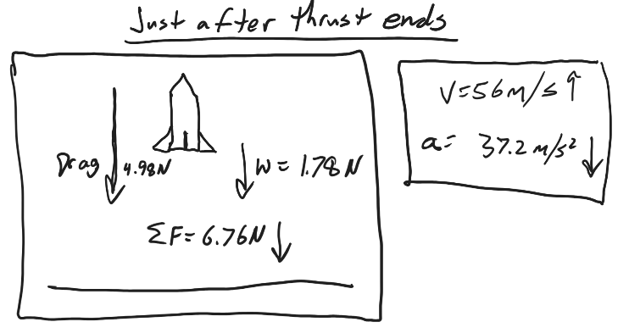
  - For the moment just after thrust ends (t=0.055s), sketch a diagram showing…
    - all of the individual forces (and the net force) acting on the rocket
    - the net force acting on the rocket
    - the rocket’s acceleration
    - the rocket’s velocity
- [The numbers provided here are estimates, but use them as if they were precise measurements.] Wiffle® ball has a mass of about 19g and a diameter of about 7cm. A baseball has a mass of about 145g and a diameter of about 7.4cm. Suppose someone throws each of them directly upward at a speed of 30mph. Let’s assume that they are released from a height of 1.4m. Let’s also assume that they each have a drag coefficient of 0.5, and that the density of the air surrounding each of them is 1.27kg/m³…
  - For the baseball, find…
    - It’s cross-sectional area 0.0043008m²
    - Maximum height reached. 9.903m
    - Total time aloft. 2.745s
    - Terminal Velocity -32.25m/s
    - Maximum drag force (ignore sign) -0.24493N
    - Find the crashdown speed (speed just before landing)? 13.35m/s
  - For the Wiffle ball, find…
    - It’s cross-sectional area 0.0038485m²
    - Maximum height reached. 7.48m
    - Total time aloft. 2.375s
    - Terminal Velocity -12.3m/s
    - Maximum drag force (ignore sign) -0.2192N
    - Find the crashdown speed (speed just before landing)? 9.7m/s

